CHAROTAR UNIVERSITY OF SCIENCE AND TECHNOLOGY (CHARUSAT)
CSPIT — Department of Computer Engineering · ITUE203 Web Development Frameworks
Student Name | Dhruv Bhoi | Student ID | D26CE154
Academic Year | 2026–27 (ODD) | Semester | 3rd Semester, B.Tech CE
――――――――――――――――――――――――――――――――――――――――――――――――――――――――――

Practical 8: MySQL Schema Design, ER Model, Database Connectivity, and Diagnostics
Practical Aim & Tools
Aim: Design a normalized (3NF) relational database schema for StudentHub, construct an ER model, establish PDO and MySQLi connections, and implement a diagnostic connection test suite.
Tools & Technologies: MySQL 8.x, InnoDB Engine, Foreign Key Constraints, PDO, MySQLi Prepared Statements

1. Entity-Relationship Model & 3NF Normalization
The StudentHub database (`studenthub`) is designed in Third Normal Form (3NF) to eliminate data redundancy and ensure relational integrity:
• `users`: Authentication credentials, roles (admin/student), password hashes, and activity status.
• `students`: Academic profiles (course, year, contact, student ID) bound to `users.id` with a 1-to-1 foreign key and `ON DELETE CASCADE`.
• `events`: Campus events, dates, venues, capacities, and poster image filenames.
• `registrations`: Student-to-event registrations (Many-to-Many mapping) with a `UNIQUE KEY (event_id, student_id)` preventing duplicate registrations.
• `remember_tokens`: Cryptographic selectors and SHA-256 token hashes for persistent 'Remember Me' sessions.
• `audit_logs`: Immutable security audit trail recording user logins, updates, IP addresses, and timestamps.
• Stored Procedures: `sp_registrations_by_month` (analytics grouping) and `sp_event_registration_count` (dynamic count aggregation).

2. Implementation Code: Dual Database Driver (`includes/db.php`)
Listing: includes/db.php — UTF-8MB4 Dual PDO and MySQLi Initialization
// includes/db.php - Secure Dual Database Driver
define('DB_HOST', 'localhost');
define('DB_NAME', 'studenthub');
define('DB_USER', 'root');
define('DB_PASS', '');
// 1. PDO Driver (Object-Oriented, Exception-driven)
$dsn = 'mysql:host=' . DB_HOST . ';dbname=' . DB_NAME . ';charset=utf8mb4';
$opt = [
PDO::ATTR_ERRMODE => PDO::ERRMODE_EXCEPTION,
PDO::ATTR_DEFAULT_FETCH_MODE => PDO::FETCH_ASSOC,
PDO::ATTR_EMULATE_PREPARES => false,
];
$pdo = new PDO($dsn, DB_USER, DB_PASS, $opt);
// 2. MySQLi Driver (For explicit prepared statements & multi-queries)
$mysqli = new mysqli(DB_HOST, DB_USER, DB_PASS, DB_NAME);
$mysqli->set_charset('utf8mb4');

3. Verification Screenshot: Comprehensive DB Diagnostic Test Suite
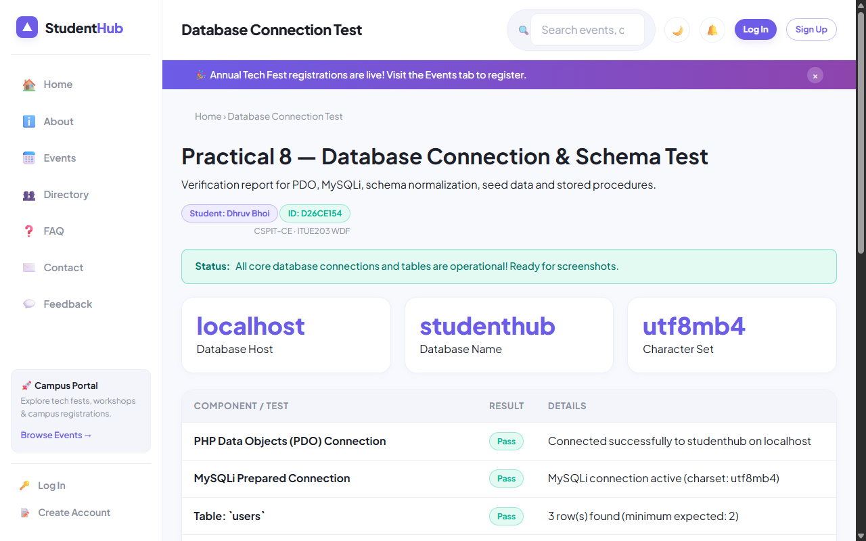
Figure: Live Diagnostic Test Suite (db-test.php) Demonstrating 6/6 PASS for Dhruv Bhoi

4. Key Questions & Analysis
Q: Is the schema normalized properly into 3NF?
Ans: Yes. 1NF is satisfied (all attributes are atomic; no repeating groups). 2NF is satisfied (no partial dependencies on composite keys). 3NF is satisfied (no transitive dependencies; non-key attributes depend solely on the primary key).
Q: Why is `ATTR_EMULATE_PREPARES => false` specified in PDO?
Ans: Native prepared statements ensure that SQL statement parsing and user data binding happen in separate network packets inside MySQL server. This completely eliminates SQL Injection vulnerabilities regardless of character encodings.

Practical 8 Conclusion & Learning Outcomes
Designed a normalized (3NF) relational database schema for StudentHub across 6 tables and 2 stored procedures. Configured dual PDO and MySQLi database drivers with UTF-8MB4 encoding and verified connectivity through an automated 6-point diagnostic test suite (db-test.php).

