CHAROTAR UNIVERSITY OF SCIENCE AND TECHNOLOGY (CHARUSAT)
CSPIT — Department of Computer Engineering · ITUE203 Web Development Frameworks
Student Name | Dhruv Bhoi | Student ID | D26CE154
Academic Year | 2026–27 (ODD) | Semester | 3rd Semester, B.Tech CE
――――――――――――――――――――――――――――――――――――――――――――――――――――――――――

Practical 3: Responsive UI Design using CSS Grid, Flexbox, and Modern SaaS Theme
Practical Aim & Tools
Aim: Design a responsive modern UI using CSS Grid, Flexbox, media queries, CSS variables, and modern SaaS dashboard layout (Acade UI) for mobile, tablet, and desktop screens.
Tools & Technologies: CSS3, CSS Grid, Flexbox, CSS Custom Properties, Responsive Media Queries

1. Design System & CSS Custom Properties
StudentHub utilizes a modern SaaS design system based on a violet/lavender color scheme (`#6C5CE7` primary brand, `#EEECFE` subtle tinted backgrounds, `#2D3436` high-contrast slate text). All design tokens are declared as CSS Custom Properties (`:root`) allowing seamless dynamic dark mode switching.

2. Responsive App Shell & Grid Layouts
• Desktop Layout (≥ 1024px): 2-column flex app shell with a fixed 240px sidebar and fluid `app-main` viewport.
• Timetable Cards: CSS Grid (`grid-template-columns: repeat(auto-fit, minmax(220px, 1fr))`) rendering class schedule cards with lavender badges.
• Circular SVG Progress Rings: Donut cards displaying 92% Attendance and 85% Activity completion with pure CSS stroke-dashoffset animations.
• Mobile Layout (< 768px): The sidebar collapses into an off-canvas drawer controlled via the topbar hamburger button, switching grids into 1-column stacks.

3. Implementation Code: CSS Tokens & Responsive Shell
Listing: Core Responsive CSS Grid & SaaS Design Tokens
:root {
--primary: #6C5CE7;
--primary-hover: #5A49E0;
--primary-light: #EEECFE;
--bg: #F7F7FD;
--surface: #FFFFFF;
--text: #2D3436;
--muted: #8395A7;
--border: #E8E8F3;
--radius-lg: 18px;
--shadow-sm: 0 4px 16px rgba(108, 92, 231, 0.06);
}
.app-layout { display: flex; min-height: 100vh; background: var(--bg); }
.app-sidebar { width: 240px; background: var(--surface); border-right: 1px solid var(--border); }
.app-main { flex: 1; display: flex; flex-direction: column; min-width: 0; }
.app-topbar { height: 70px; background: var(--surface); display: flex; align-items: center; justify-content: space-between; padding: 0 2rem; }
/* Responsive Media Queries */
@media (max-width: 1024px) {
.app-sidebar { position: fixed; left: -260px; z-index: 1000; transition: left 0.3s ease; }
.app-sidebar.open { left: 0; }
}
@media (max-width: 768px) {
.grid.cols-3 { grid-template-columns: 1fr; }
.app-topbar { padding: 0 1rem; }
}

4. Verification Screenshot: Responsive Layout & About Credentials
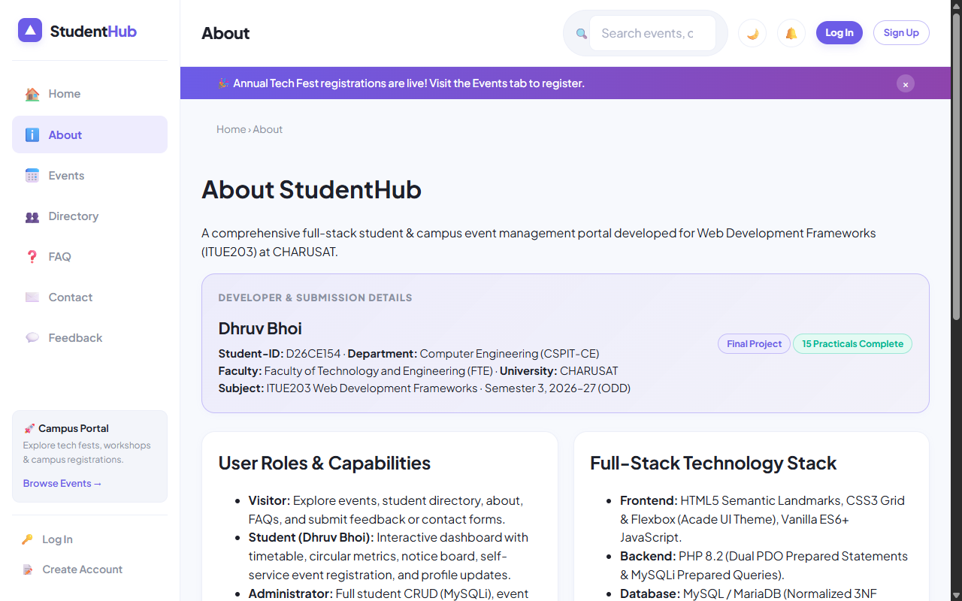
Figure: Modern Acade UI Shell & Student Developer Credentials Card (Dhruv Bhoi)

5. Key Questions & Analysis
Q: How does the layout adapt for mobile, tablet, and desktop screens?
Ans: Using a mobile-first responsive approach. Desktop screens display the persistent left navigation sidebar and multi-column grid cards. Tablet and mobile devices collapse the sidebar into an accessible slide-out drawer, transform grid layouts into single-column cards, and enable smooth touch scrolling.
Q: Which layout technique is used and why?
Ans: A hybrid approach: CSS Flexbox is used for 1-dimensional components (topbar headers, button groups, breadcrumbs, nav pills), while CSS Grid is used for 2-dimensional structures (dashboard timetable rows, event catalogs, stats cards, and multi-field forms).

Practical 3 Conclusion & Learning Outcomes
Engineered a modern, responsive user interface utilizing CSS Grid, Flexbox, media queries, and CSS variables. Redesigned the portal to match the Acade SaaS dashboard theme, featuring timetable schedule cards, circular SVG progress rings, a notice feed, and mobile off-canvas drawer navigation.

