CHAROTAR UNIVERSITY OF SCIENCE AND TECHNOLOGY (CHARUSAT)
CSPIT — Department of Computer Engineering · ITUE203 Web Development Frameworks
Student Name | Dhruv Bhoi | Student ID | D26CE154
Academic Year | 2026–27 (ODD) | Semester | 3rd Semester, B.Tech CE
――――――――――――――――――――――――――――――――――――――――――――――――――――――――――

Practical 4: JavaScript DOM Manipulation, Event Handling, and UI Interactivity
Practical Aim & Tools
Aim: Implement UI interactivity, DOM manipulation, event handling, dark/light theme switcher with localStorage, accordion FAQ, modal popups, banner notifications, and carousel slider.
Tools & Technologies: Vanilla ES6+ JavaScript, DOM APIs, Event Delegation, HTML5 LocalStorage

1. DOM Interactivity Modules
StudentHub features lightweight, dependency-free Vanilla ES6+ JavaScript (`assets/js/main.js`) powering five key UI features:
1. Theme Switcher: Reads and writes user preference (`light` or `dark`) to `localStorage`. An inline IIFE prevents theme flash on page load.
2. Collapsible Accordion: Implemented in `faq.php` with keyboard accessibility and ARIA expanded state management.
3. Accessible Modal Dialog: Accessible trap focus dialog for Quick Tours and Registration previews.
4. Sliding Highlights Carousel: Automated and keyboard-accessible slide transitions on the homepage.
5. Dismissible Status Banner: Persistent notification banner with smooth dismissal animations.

2. Implementation Code: Theme Toggle & Accordion
Listing: main.js — Theme Switcher and Accessible Accordion
// Theme Toggle with LocalStorage Persistence
const themeToggle = document.getElementById('themeToggle');
themeToggle?.addEventListener('click', () => {
const current = document.documentElement.getAttribute('data-theme') || 'light';
const target = current === 'dark' ? 'light' : 'dark';
document.documentElement.setAttribute('data-theme', target);
localStorage.setItem('sh_theme', target);
themeToggle.textContent = target === 'dark' ? '☀️' : '🌙';
});
// Accessible FAQ Accordion
document.querySelectorAll('.accordion-header').forEach(btn => {
btn.addEventListener('click', () => {
const expanded = btn.getAttribute('aria-expanded') === 'true';
btn.setAttribute('aria-expanded', !expanded);
const body = btn.nextElementSibling;
body.hidden = expanded;
});
});

3. Verification Screenshot: Interactive FAQ Accordion
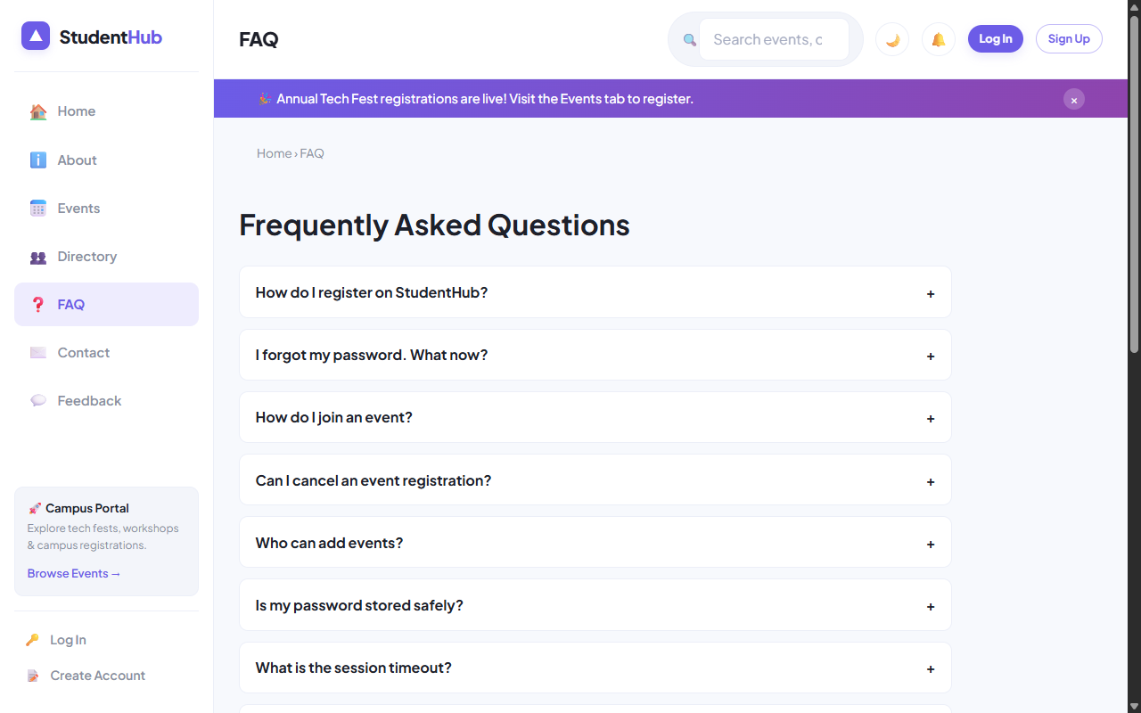
Figure: Interactive FAQ Accordion with Search and Dark/Light Mode Support

4. Key Questions & Analysis
Q: How are DOM elements selected and modified?
Ans: Elements are selected using modern `document.querySelector()` and `document.querySelectorAll()`. Modifications use secure DOM APIs like `element.textContent`, `element.setAttribute()`, and `element.classList.toggle()` to prevent cross-site scripting (XSS) risks.
Q: Is localStorage used for remembering user theme preferences?
Ans: Yes. When the theme toggle button is clicked, `localStorage.setItem('sh_theme', target)` persists the state. An immediate synchronous inline script in `<head>` executes before the DOM renders to prevent visual flickering.

Practical 4 Conclusion & Learning Outcomes
Implemented rich client-side interactivity using Vanilla ES6+ JavaScript. Features include persistent dark/light theme switching via localStorage, accessible FAQ accordion panels, modal dialog popups with focus traps, and animated highlight sliders.

