**Software Requirement Specification for TRAINING AND PLACEMENT PORTAL COLLEGE NEXUS**

Prepared by: **Sanjana Yadav**

**Khushi Badera**

**Dhruv Deshpande**

Mentor: **Dr. Parmindar Kaur**

**Prof. Sanket Milke**

Date: 1/12/2023

**Title: Training and Placement Portal Problem Statement:**

The current system for managing student records, registration, and communication with the Training and Placement department is manual, time-consuming, and prone to inefficiencies. The

administrator is burdened with the tedious task of manually referring to records dating back several years to obtain necessary details. As the number of users, particularly students, increases, the

challenges associated with this manual process become more apparent, also there are fewer interfaces between student and Training and Placement department.

# INTRODUCTION

* 1. **PURPOSE**

This Software Requirements Specification provides a description of all the functions and constraints of the Training and Placement Portal.

The Training and Placement Portal is for the users which maintains the database for the students where all the students’ records are entered including their academic details and their personal details. It will also manage the data of the Company which would

comprise of the profile of the Company, eligibility criteria and the facilities or the package it provides etc. The Portal would provide the facility of viewing both the

personal and academic information of the student and company; it would also search for eligible students and Company and deal with the insertion and deletion of records.

# INTENDED AUDIENCE

* + 1. Students
    2. Faculty Coordinator
    3. TnP Admin

# SCOPE

* + 1. Student Registration
    2. Students can view Notices and Events
    3. Students can apply to upcoming drives
    4. Students can view profile
    5. Students can request access for updating profile
    6. Students can view Schedule
    7. Coordinator and TnP login
    8. Coordinator and TnP can upload notices
    9. Coordinator and TnP can schedule events
    10. Coordinator can grant access for updating student profile
    11. Coordinator and TnP has provision for a To-do list
    12. Coordinator and TnP can view student data
    13. Coordinator and TnP has access to the data of applied students
    14. Coordinator can download desired data in excel format
    15. Tnp Admin can generate notice template and share with coordinators
    16. Tnp Admin can create new coordinators, department.
  1. **Reference**
     1. UGC Research Paper: <http://junikhyatjournal.in/no_1_Online_21/58.pdf>
     2. You Tube: <https://www.youtube.com/watch?v=83-S5Qu6VP8>

# TECHNICAL STACK

* 1. FRONTEND: REACT JS
  2. BACKEND: DJANGO
  3. DATABASE: MYSQL

# UML DIAGRAMS

* 1. **USE CASE DIAGRAM**

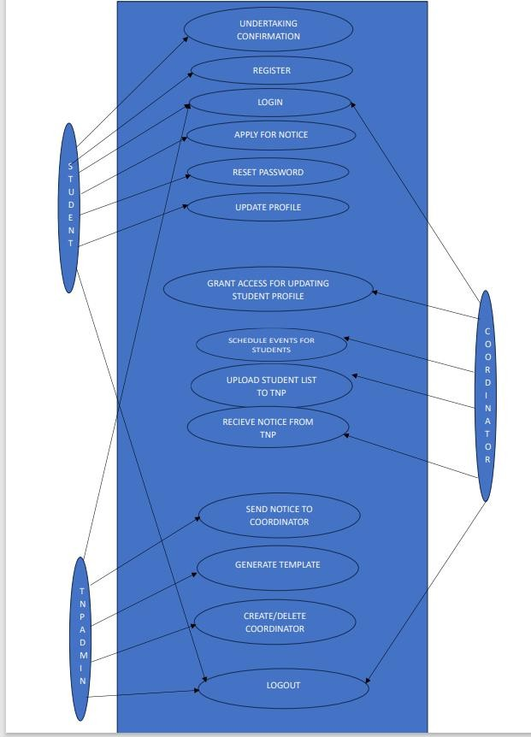

**Fig 1.0**

# CLASS DIAGRAM

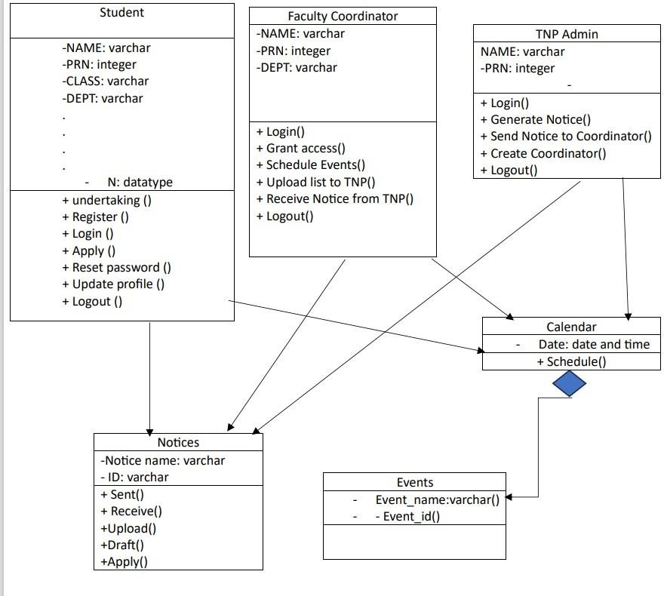

**Fig 1.1**

# SEQUENCE DIAGRAM

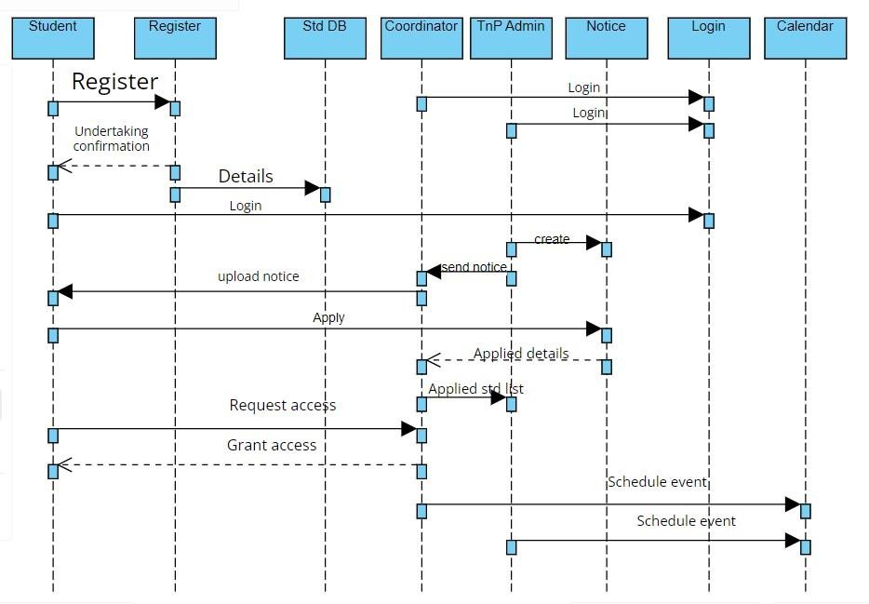

**Fig 1.2**