


Essay / Assignment Title:
Predicting Car Prices Using Data Analytics and Machine Learning
Programme title:
DEGREE: MSc Data Analytics
Module: Fundamentals of Data Analytics
Name:
DHRUV GODHANI (Q1117584)
Year:2026

CONTENTS
Introduction 1
Background and Analysis of the Topic 1
Aims and Objectives 1
Methodology 1
1. Task 1: Exploratory Data Analysis 3
1.1. Theoretical Foundations 3
1.2. Data Loading and Structural Inspection 3
1.3. Descriptive Statistics 3
1.4. Categorical Variables 5
1.5. Distributional Analysis: Price and Horsepower 5
1.6. Price Variation by Body Style 6
1.7. Correlation Structure 7
1.8. Critical Thinking Reflections 8
2. Task 2: Data Preprocessing and Feature Engineering 10
2.1. Theoretical Foundations 10
2.2. Missing Value Identification and Treatment 10
2.3. Data Type Conversion 11
2.4. Feature Engineering: city-L/100km 11
2.5. Binning of Horsepower 12
2.6. Feature Normalisation 12
2.7. Critical Thinking Reflections 13
3. Task 3: Model Development (Regression) 15
3.1. Theoretical Foundations 15
3.2. Feature Selection and Data Partitioning 15
3.3. Part A: Linear Regression 16
3.4. Part B: Random Forest Regression 16
3.5. Part C: Train/Test Split Experimentation 17
3.6. Critical Thinking Reflections 18
4. Task 4: Classification Model 20
4.1. Theoretical Foundations 20
4.2. Target Engineering: Price Categorisation via qcut 20
4.3. Model Building 20
4.4. Evaluation and Confusion Matrix 21
4.5. Comparison with the Regression Approach 23
5. Task 5: Model Evaluation and Visualisation 24
5.1. Theoretical Foundations of Visual Model Evaluation 24
5.2. Actual versus Predicted Scatter Plots 24
5.3. Residual Analysis 25
5.4. Synthesis and Implications 26
6. Task 6: Business Insights and Recommendations 27
6.1. Introduction 27
6.2. What Makes a Car Expensive? 27
6.3. Strategic Implications for Manufacturers 28
6.4. Practical Applications for Customers 29
6.5. Limitations and Closing Remarks 29
7. Task 7: Conclusion 30
7.1. Summary of Findings 30
7.2. Model Limitations 30
7.3. Suggested Improvements 31
7.4. Closing Remarks 31
List of References 33
List of Figures 36
List of Tables 38

Statement of compliance with academic ethics and the avoidance of plagiarism

I honestly declare that this dissertation is entirely my own work and none of its part has been copied from printed or electronic sources, translated from foreign sources and reproduced from essays of other researchers or students. Wherever I have been based on ideas or other people texts I clearly declare it through the good use of references following academic ethics.
(In the case that is proved that part of the essay does not constitute an original work, but a copy of an already published essay or from another source, the student will be expelled permanently from the postgraduate program).

Name and Surname (Capital letters):
DHRUV GODHANI

Date: ........................./........../.........

Introduction

Background and Analysis of the Topic
The issue of determining the price of automobiles based on their engineering and physical properties has been around for a while and enjoys practical importance within the business world. Pricing model accuracy is important for three groups of stakeholders. To manufacturers, it influences their strategies for positioning, development, and comparison. For consumers, a model can serve as a yardstick by which the prices offered by sellers can be judged. The problem is a good example of an application that has practical value to data analytics but can also serve as an academic exercise from data exploration to modelling and back to business use (Provost and Fawcett, 2013: 5). The dataset used in the paper comes from Schlimmer (1987) and includes data for 205 cars across 26 variables such as car specifications, dimensions, fuel consumption, and price.

Aims and Objectives
The ultimate goal of the report is to use all important components of the data analytics approach, including descriptive statistics, exploratory visualizations, data pre-processing, supervised modeling, model evaluation, and business insights, to develop a model for predicting car price. Out of this goal, there emerge three sub-goals. Firstly, the dataset needs to be explored to describe its characteristics. Secondly, regression models and classification models should be compared to each other based on their performance under different train-test split ratio settings, in accordance with the requirement from Assignment Brief Part C. Thirdly, insights obtained from the analysis should be applied to provide recommendations for automobile producers and consumers.

Methodology
The methodology followed within the current report involves seven subsequent steps that will be performed in different tasks. Task 1 includes creating a descriptive basis of histograms, boxplots, and correlations. Task 2 deals with imputing missing values using mean and mode replacement, converting data types, constructing the new variable (city-L/100 km), conducting binning and normalisation of some predictors. Task 3 requires fitting the Linear Regression model and the Random Forest model using two different train-test splits ratio. Task 4 involves reformulating the problem as an ordinal multinomial regression problem with three classes. Task 5 includes building several diagnostic graphs such as Actual vs Predicted plot and residual plots. Task 6 offers business recommendations resulting from the analyses, and Task 7 is summarising results, discussing limitations and outlining directions for future research (Kumar, 2016: 12). All analyses were made using the following Python packages: pandas, numpy, matplotlib, seaborn, scikit-learn. As per the requirements of the BSBI Essay Guide Regulations, this report is organised into seven tasks, each task starting on a new page.

Task 1: Exploratory Data Analysis

Theoretical Foundations
Exploratory Data Analysis (EDA), originally formalised by Tukey (1977), can be considered a key part of the whole analytics process. According to Kumar (2016: 38), EDA has been defined as a methodological approach focused on the careful study of data before employing any models. This step in predictive analysis allows analysts to understand data behaviour as well as potential data quality issues which could have an impact on further modelling (Kumar, 2016: 38). There are two main roles of exploratory data analysis within the framework of predictive analytics. Firstly, EDA is used to make relevant decisions about the ways in which data should be prepared for analysis. Secondly, this tool provides a solid basis for testing various hypotheses regarding the chosen dataset (Johnston and Mathur, 2019: 56). With regards to regression analysis (such as predicting car prices), this step plays a key role in choosing variables and avoiding errors in statistical procedures.

Data Loading and Structural Inspection
The data for the Automobile dataset, first created by Schlimmer (1987) and later acquired in this assignment through the IBM Skills Network data repository, was imported into a pandas DataFrame using Python programming language (McKinney, 2017). Since there are no headers available in the original source, the names of the twenty-six columns were provided manually according to the information on the UCI website. The final shape of the dataframe is (205, 26). A quick inspection of the first ten rows of data shows that the dataset comprises both numerical (e.g., engine size, curb weight) and categorical variables (e.g., make, body style, engine type) and utilizes the value "?" to denote missing data, which is a critical consideration in addressing the imputation in Task 2.

Descriptive Statistics
The summary statistics provide information about the central tendency, dispersion, and shape of the numeric variables' distribution. It is a supplement to the graphical analysis of the data (Field, 2018: 10). The average price of the automobiles is roughly $13,207, while the median equals $10,295. The standard deviation for the same variable is $7,947. As can be seen, there is a considerable difference between the mean and median values. Besides, the skewness value is 1.81, indicating a right-skewed distribution since there is a considerable number of high-value automobiles included in the study (Field, 2018: 184). Another right-skewed variable is the engine horsepower with the mean value of 104.3, the median of 95, and skewness of 1.39. Furthermore, the engine size, curb weight, and measures of dimensions, such as length, width, and wheelbase, demonstrate a right-skewed distribution. The mentioned deviation from normality will have a substantial effect on the linear regression model, explaining the use of binning and normalization in Task 2 (Kumar, 2016: 65).
Table 1 Descriptive Statistics — Numeric Features
 | Mean | Median | Std Dev
symboling | 0.83 | 1.0 | 1.25
wheel-base | 98.76 | 97.0 | 6.02
length | 174.05 | 173.2 | 12.34
width | 65.91 | 65.5 | 2.15
height | 53.72 | 54.1 | 2.44
curb-weight | 2555.57 | 2414.0 | 520.68
engine-size | 126.91 | 120.0 | 41.64
horsepower | 104.26 | 95.0 | 39.71
peak-rpm | 5125.37 | 5200.0 | 479.33
city-mpg | 25.22 | 24.0 | 6.54
highway-mpg | 30.75 | 30.0 | 6.89
price | 13207.13 | 10295.0 | 7947.07

Categorical Variables
The data set includes ten categorical features. For the "make" variable, there are 22 brands present, from commonly used car brands like Toyota and Volkswagen to luxurious brands like Mercedes-Benz, BMW, and Jaguar. In terms of the "body style" category, there are five categories identified, namely, sedan, hatchback, wagon, hardtop, and convertible, of which sedan and hatchback are the most common in the data set. It should be highlighted that high cardinality for the "make" feature would impact feature engineering while low cardinality for others makes transformation easy (Johnston and Mathur, 2019: 102).

Distributional Analysis: Price and Horsepower
Figure 1 presents the empirical distributions of price (on the left) and horsepower (on the right). First of all, one can see that the distribution for the price variable is significantly positively skewed: the share of values within the interval of $5,000-$13,000 is larger than 50%, while the long tail stretches up to the level of $40,000. As expected, the red dashed line representing the mean exceeds the green dashed line indicating the median. The positive skewness described above corresponds to the characteristics of data presented in Section 1.3. In its turn, the distribution of horsepower is characterized by the same trend as the price. Most cars belong to the interval of 65-110 bhp, while the additional peak is observed at the level of 150 bhp, which reflects high-end cars. Thus, there is a strong correlation between the variables due to the similarity of their empirical distributions. Log-transforming the price variable would be beneficial from the perspective of building an accurate model (see Miller and Forte, 2017: 144).
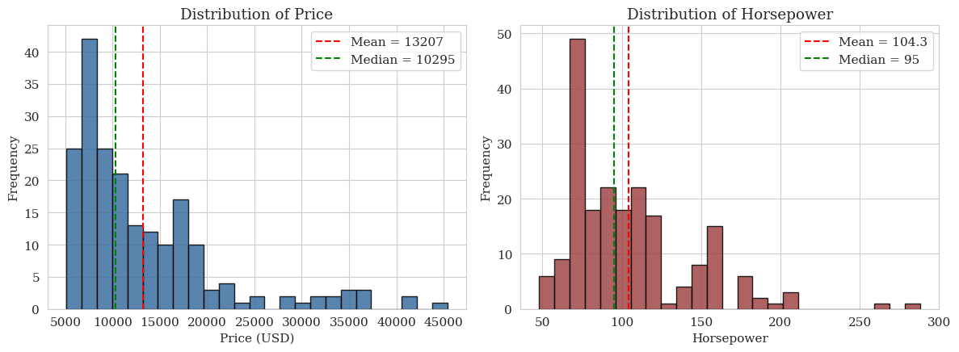
Figure 1 Histograms of Price and Horsepower

Price Variation by Body Style
In Figure 2, the box plot of the prices by body style sorted in order of increasing median can be observed. The hatchback body style has the lowest median price ($8,672) and the lowest interquartile range, while convertible and hardtop body styles have higher median prices ($17,084 and $19,688, respectively), as well as wider ranges. The sedan body style has a median price of $11,078. There are some high-value outliers among sedans, which cost over $35,000 because luxury brands such as BMW, Mercedes-Benz, and Jaguar manufacture premium sedans alongside their top models. It can be seen from the box plot that the type of body style is important but not enough for predicting accurately; other parameters should also be considered.
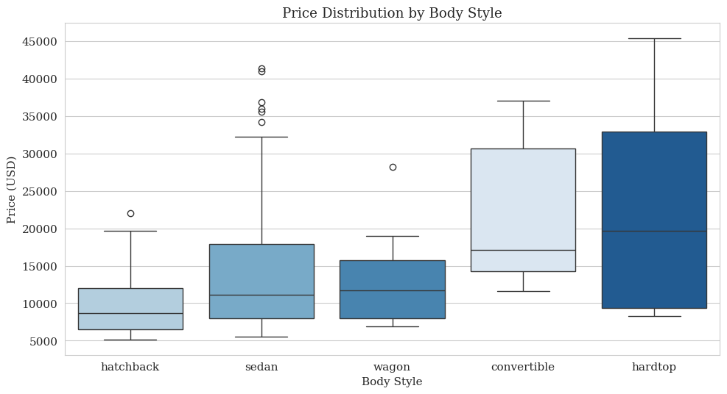
Figure 2 Boxplot of Price by Body Style

Correlation Structure
Figure 3 shows the Pearson correlation matrix for all quantitative variables. With regard to the dependent variable price, there are four predictors that have very high positive correlations: engine size (r = 0.87), curb weight (r = 0.83), horsepower (r = 0.81), and width (r = 0.75). In the case of the two variables related to fuel economy, the highway miles per gallon and city miles per gallon have correlations of −0.71 and −0.69, respectively. This is expected because the inverse relationship between the performance of a car and its fuel economy is common knowledge. There is a lot of multicollinearity present among the predictors, evident in the high r value of 0.81 between engine size and horsepower and r of 0.88 between curb weight and length. Multicollinearity can negatively impact OLS regression through increased variance among the predictors (James et al., 2013: 99).
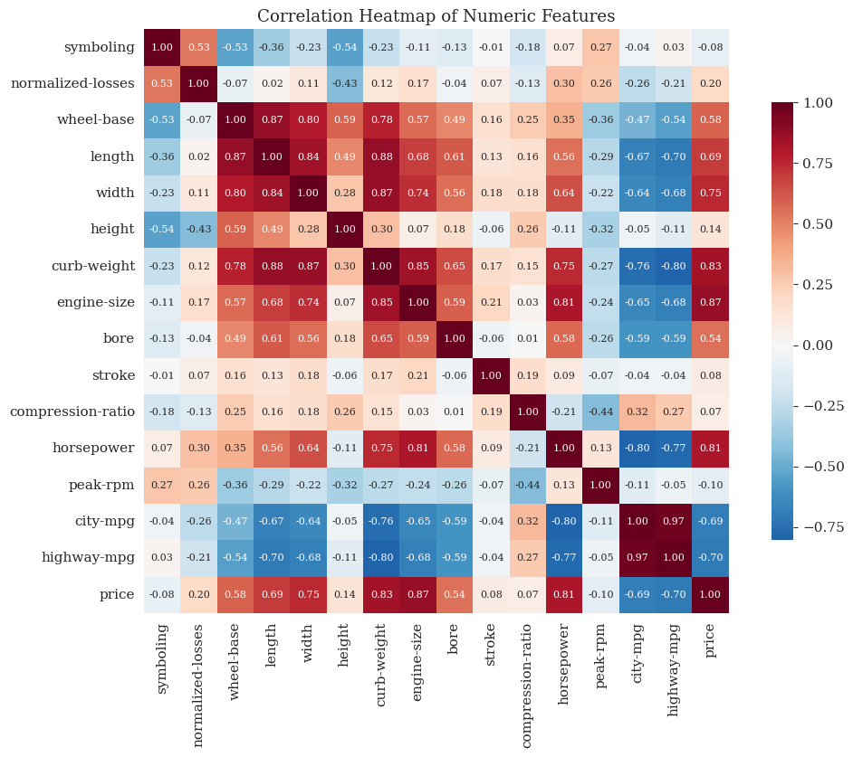
Figure 3 Correlation Heatmap

Critical Thinking Reflections
Which variables seem to be the most price-related? The correlation matrix reveals that the most correlated numeric variables to price are engine size, curb weight, and horsepower with an r value greater than 0.80. Alongside the body style box plot, the information implies that price determination is driven by factors such as car size, weight, and capacity, as supported by the automobile manufacturing process where large cars require more expensive materials (Miller and Forte, 2017: 18).
Are there any strange distributions or outliers? There are fourteen outliers within the price variable that qualify based on the 1.5 × IQR outlier rule. The outliers at the tail end of the price distribution are dominated by Mercedes Benz, BMW, Jaguar, and Porsche. The data points are not erroneous data entry points but represent genuine luxury cars.
Does increased horsepower necessarily imply increased prices? No, not necessarily. While there exists a strong positive correlation between horsepower and price with an r-value of 0.81, the correlation is probabilistic, and not deterministic. As shown by the box plot, there are some cases where cars with moderate levels of horsepower have been found to be relatively cheaper than convertibles with the same levels of horsepower. Also, according to the correlation matrix, horsepower is correlated with engine displacement, curb weight, and dimensional variables (Kumar, 2016: 142).

Task 2: Data Preprocessing and Feature Engineering

Theoretical Foundations
Data preprocessing serves as a vital intermediary phase between exploring the data and predicting using the data, which involves preparing the data in such a way that it becomes fit for algorithm consumption (Kumar, 2016: 78). The commonly quoted guideline, according to which data scientists can be expected to invest up to eighty percent of their time in data preparation, highlights the importance of this phase (Johnston and Mathur, 2019: 88). In this phase, four different data preprocessing operations have been performed on the Automobile dataset. These include the handling of missing values, data type correction, feature generation, and the transformation of certain attributes using binning and normalization techniques.

Missing Value Identification and Treatment
After the replacement of the literal "?" with the standard NaN format, seven features were found to contain missing values, namely, normalized-losses (41), bore (4), stroke (4), horsepower (2), peak-rpm (2), and price (4) among the numeric features, and num-of-doors (2) among the categorical features. There are 59 missing observations, which account for approximately 1.1% of all values across the cells. However, it should be noted that the 41 missing values in normalized-losses account for twenty percent of the feature in question, hence the need to consider the problem more carefully. The chosen approach follows the missing completely at random principle proposed by Little and Rubin (2019: 13): missing values in the numeric variables were replaced with the mean values per column (normalized-losses: 122.0; bore: 3.33; stroke: 3.26; horsepower: 104.26; peak-rpm: 5125.37); missing values in the num-of-doors feature were imputed with the mode value "four." In contrast to numeric variables, the target price cannot be imputed since it will create a circular dependency and invalidate model performance (Kumar, 2016: 102). Therefore, four rows with missing values have been dropped from the dataset, which now consists of 201 rows.
Table 2 Missing Values Summary
 | Missing Count | Missing %
normalized-losses | 41 | 20
bore | 4 | 1.95
stroke | 4 | 1.95
price | 4 | 1.95
num-of-doors | 2 | 0.98
horsepower | 2 | 0.98
peak-rpm | 2 | 0.98

Data Type Conversion
The occurrence of the sentinel value "?" led to the loading of multiple columns with continuous numerical variables as the pandas object (string) type (McKinney, 2017: 156). Post-imputation, the price and horsepower variables were then transformed into the float64 datatype through the use of the pandas astype function. This is an absolute necessity for the next stage of performing the regression and binning tasks, as both the scikit-learn estimators and statistics functions take only numerical data types as input.

Feature Engineering: city-L/100km
The new attribute, city-L/100km, was created by the equation 235 ÷ city-mpg, where US fuel efficiency, measured in miles per gallon, was transformed into a European unit, litres per one hundred kilometres. This new attribute ranges from 4.80 to 18.08 with a mean value of 9.94, where a smaller value corresponds to higher fuel efficiency. From the perspective of model building, the newly engineered feature improves interpretation for foreign countries and also shows a higher linearity between price and the new variable rather than its inverse, due to the linear relationship between fuel usage and running costs, while mpg shows a non-linear trend with respect to fuel efficiency (Kumar, 2016: 168).

Binning of Horsepower
The continuous horsepower was binned with three intervals of the same width, using the function linspace from the NumPy module, resulting in the intervals 48–119, 119–191, and 191–262 horsepower, categorized as "Low," "Medium," and "High" respectively (Han et al., 2012: 88). As seen in Figure 4, the obtained distribution is extremely unbalanced, with 153 vehicles falling into the Low interval, 43 in the Medium interval, and only 5 in the High interval. It matches the right-skew discovered in Task 1, demonstrating how few high-performance cars are included in the data set. Binning enables interpretation of price per power interval, possibly improving robustness against outliers; on the other hand, it leads to the loss of information contained in the variability within each bin, which should be considered when using it as an input for regression (Kumar, 2016: 189).
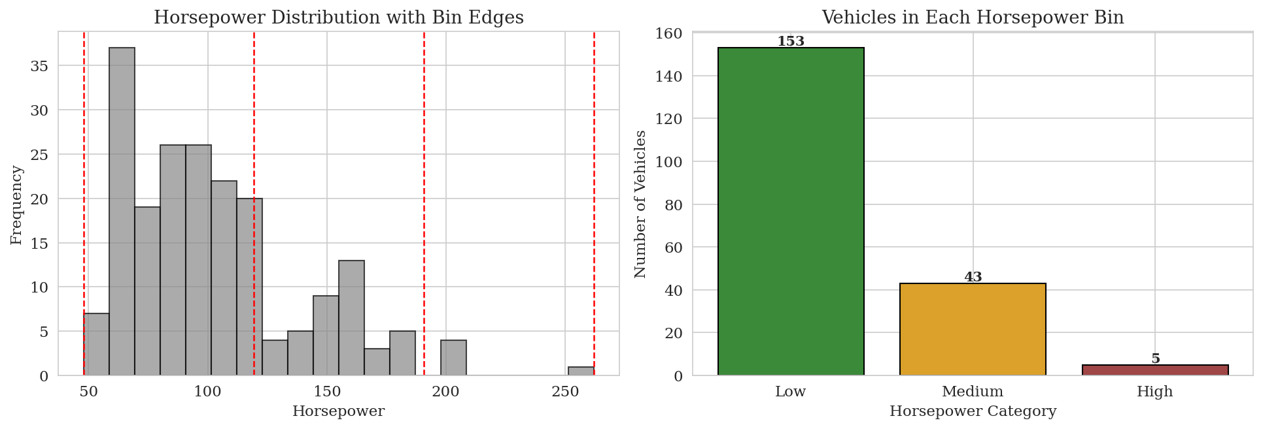
Figure 4 Horsepower binning into Low, Medium, and High categories. Left panel shows the original distribution with the three equal-width bin edges marked in red; right panel shows the resulting allocation of vehicles

Feature Normalisation
In order to deal with the heterogeneity in the scale of dimensional features, min-max normalization was used to normalize length, width, and height through the following formula: (x – min)/(max – min); hence, the values of all predictors were scaled between [0,1] (Han et al., 2012: 114). Figure 5 below demonstrates how the normalized length looks like; while the distribution remains more or less unchanged, its range becomes narrower. Normalization is very crucial in those machine learning algorithms where distances are utilized, especially for optimization with the help of gradient descent because otherwise, larger predictors might overwhelm the cost function and hinder model learning (Géron, 2019: 72). However, least squares regression does not really require normalized predictors.
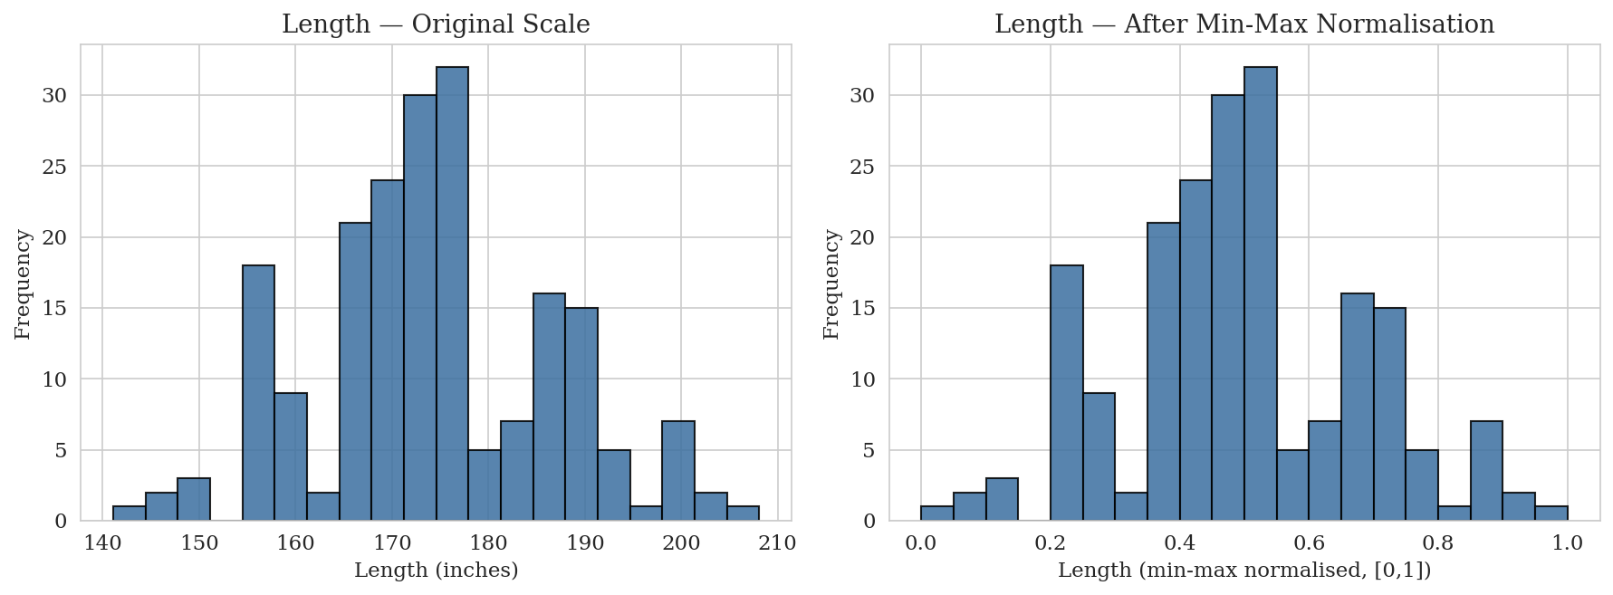
Figure 5 Effect of min-max normalisation on the length variable. The shape of the distribution is preserved while the scale is rescaled to the interval [0, 1]

Critical Thinking Reflections
What makes the handling of missing data important? -Missing data without handling results in biased parameter estimates, reduced power of analysis, and the inability of many machine learning models to work due to NaN inputs (Little and Rubin, 2019: 21). Furthermore, besides being not compatible with some models, not accounting for the missing values can result in an inaccurate model; for instance, when there is missing data in normalized losses depending on the vehicle age, then deleting the missing values will make the price–age association distorted.
Is the former better than the latter? Which one is preferable? -It depends on the level and type of the missing data. Listwise deletion is suitable if missing data is rare and random but does involve dropping useful data. On the other hand, although imputation keeps the same sample size, it reduces variance and introduces bias if the missingness is not at random (Kumar, 2016: 105). Here, mean and mode imputation have been performed for the predictors, while listwise deletion for the four rows with missing price due to its target nature.
As a methodology, binning entails changing the continuous data to categorical bins for easier analysis through comparison among the categories and reduction of noise for the skewed distribution. Binning proves very helpful in dealing with non-linear relationships since it helps control the behavior of the models used afterwards. The main drawback associated with binning entails the loss of information per bin in case of the presence of finer variance in the continuous variable (Han et al., 2012: 90).

Task 3: Model Development (Regression)

Theoretical Foundations
Regression analysis is considered the main method of modeling continuous dependent variables in supervised machine learning. The aim of this technique is to learn the map f(X) → y with respect to the minimization of the loss function, usually represented in the form of the mean squared error when measured on test data (James et al., 2013: 59). In the current task, the continuous right-skewed target variable, price, was determined in Task 1, and a rich enough set of features has been developed in Task 2. In order to compare two different regression models, Ordinary Least Squares (OLS) Linear Regression (the assumption of linear additivity) and Random Forest Regression (a flexible non-parametric ensemble model) have been applied and trained. It should be noted that both algorithms belong to the scikit-learn package (Pedregosa et al., 2011: 2826), and three configurations were considered: Linear Regression with an 80/20 train-test split, Random Forest with the same 80/20 split, and both models retrained with a 70/30 split, as required by Part C of the task.

Feature Selection and Data Partitioning
A total of eleven numerical features were chosen by analyzing the correlations between the features and their interpretability, which include engine-size, curb-weight, horsepower, width, length, wheel-base, highway-mpg, city-L/100km (created in Task 2), bore, stroke, and compression-ratio. The two categorical features, make and body-style, were purposefully ignored in this process to prevent the problem of high cardinality after expanding into one-hot vectors, as mentioned in Section 1.4, although these features may be used in further steps by embedding or target encoding. After preprocessing the data, which has 201 records, The data was divided into training and testing sets using train_test_split from scikit-learn with random_state = 42 which resulted in 160 training data records and 41 testing data records according to an 80/20 split ratio.

Part A: Linear Regression
Linear regression determines the best-fitting hyperplane represented by y = β₀ + β₁x₁ + … + βₚxₚ + ε through the minimization of the sum of squares of errors on the training dataset (James et al., 2013: 61). The obtained regression model gives the following results on the test dataset: R² equals 0.790, the mean absolute error amounts to $3,521, and the root mean square error reaches $5,071. Comparing the R² on the training data (0.864) and the test data (0.790) implies the presence of a generalisation gap of about 0.07, which is rather insignificant and demonstrates that linear regression does not suffer from severe overfitting. However, analysis of the estimated coefficients unveils the presence of multicollinearity, which was expected in Task 1, since several coefficients possess unexpected signs (e.g. a negative sign of the stroke and length coefficients), and there is a huge variation in absolute values of the estimated coefficients within similar predictors.

Part B: Random Forest Regression
Random Forest is an ensemble model that creates a set of decision trees using bootstrapping, where each tree uses only a random subset of features for splitting. The output of the model is calculated by taking the average of the individual tree outputs (Breiman, 2001: 5). In this analysis, a hundred trees were fitted to the data partition with eighty percent train and twenty percent test data, generating an R² value of 0.937, an MAE of $1,771, and RMSE of $2,780 on the test set. Relative to linear regression, this model provides a remarkable boost, with the amount of variance explained increasing by fourteen point seven percentage points, and the mean error of prediction decreasing by almost half. The R² of 0.981 generated during training is much higher than that of 0.937 obtained during testing, suggesting a slight overfitting. However, this model is still a great performer in terms of generalization. According to the feature importance ranking of the Random Forest model shown in Figure 6 below, curb weight (43.7%) and engine size (31.8%) are the two most important predictors of car price, which together explain seventy-five percent of the model's predictive power.
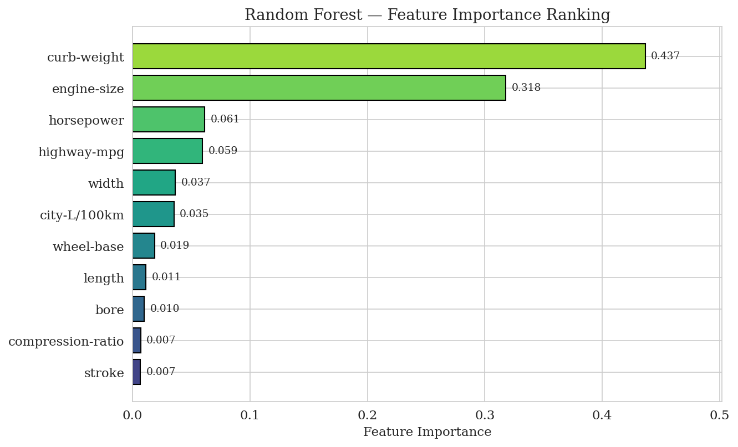
Figure 6 Random Forest feature importance ranking. Curb-weight (0.437) and engine-size (0.318) jointly account for over 75% of the model's predictive signal, with the remaining nine features each contributing less than 7%

Part C: Train/Test Split Experimentation
It can be observed in the brief that the component of experimentation holds special significance in the MSc program. Consequently, both models have been retrained using a split ratio of 70/30. These four new configurations can be viewed below in Table 3, together with their respective graphs in Figure 7. It may be noticed that there is only a small improvement in the performance of the linear regression model with a split ratio of 70/30 (a test R² of 0.798 vs. 0.790, and MAE of $2,914 vs. $3,521). It indicates that a larger testing dataset with sixty-one instances provides better estimates of the generalisation performance of the model. Contrariwise, there is only a slight degradation of the performance of the random forest model (test R² of 0.931 vs. 0.937); this is theoretically expected because of the advantages provided by larger training datasets, and the decrease of twenty training observations results in less diversity among bootstrap samples used by individual trees (Hastie, Tibshirani and Friedman, 2009: 222; Géron, 2019: 192).
Table 3 Test-set performance metrics for Linear Regression and Random Forest under 80/20 and 70/30 train/test splits
Model Split | R² | MAE | MSE | RMSE
LR 80/20 | 0.7898 | 3520.75 | 25,713,443.48 | 5070.84
RF 80/20 | 0.9368 | 1771.33 | 7,730,556.95 | 2780.39
LR 70/30 | 0.7977 | 2914.05 | 19,176,991.52 | 4379.15
RF 70/30 | 0.9313 | 1643.45 | 6,515,682.14 | 2552.58
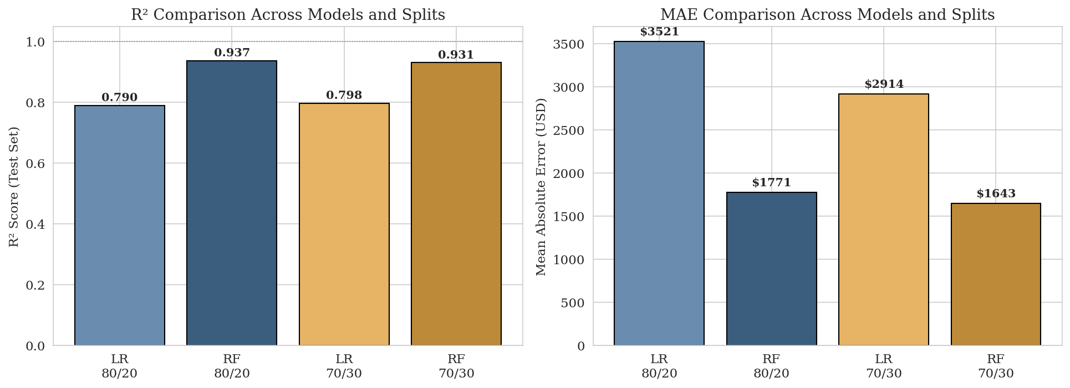
Figure 7 Comparative model performance across configurations. The left panel shows the R² score on the test set; the right panel shows the mean absolute error in USD. Random Forest consistently outperforms Linear Regression by a wide margin under both split ratios

Critical Thinking Reflections
Which algorithm had better performance and why? The Random Forest algorithm performed considerably better than the Linear Regression model when applied to the 80/20 and 70/30 data splits. This was shown by the R² test statistic being significantly higher at 0.937 versus 0.790 and an associated decrease in mean absolute error. This is because the relationship between the car's price and its attributes does not follow any linear trend but rather has some form of interaction. Random Forest takes advantage of its multiple decision trees to incorporate interactions and other features while Linear Regression can only approximate using a single hyperplane. Furthermore, OLS regression is affected by the presence of multicollinearity between the various dimensions of data (James et al., 2013: 303).

Does more data always improve results? No, this may not be true. For example, in our experiment, when we increase the percentage of testing data from 20% to 30%, we end up reducing the number of observations used to train our models from 160 to 140. This negatively impacts the Random Forest model's ability to capture the interaction within the data, causing a small decrease in accuracy. Conversely, increasing the amount of testing data slightly increases the precision of the linear regression model. In conclusion, high-capacity models are better served by large amounts of training data, while low-capacity models are highly influenced by the amount of testing data (Géron, 2019: 86).

Is the relationship linear or complex? There exists a non-linear relationship between the variables as opposed to a linear relationship. The results from the study reveal that there is a rather complicated relationship between the two. This is supported by the significant increase in the R-squared value of 14.7% when changing from linear regression to nonlinear ensemble. It would have been impossible for such an increase to happen if there was indeed a linear relationship. Moreover, some of the coefficients have unexpected signs while using linear regression models.

Task 4: Classification Model

Theoretical Foundations
Task 3 considered the prediction of prices as a regression problem while Task 4 presents the same task as a classification problem. In Task 4, the price predictor is transformed to a categorical form, with categories being Low, Medium and High. Classification tasks should be applied in cases where decisions made based on predictions are categorical, i.e. the manufacturer assigns each car to a certain market segment without predicting an exact dollar price (Kumar, 2016: 213). The model used in this task is multinomial logistic regression, which is an extension of the binomial logistic regression algorithm used in binary classifications. The latter is used to predict the probability of a particular class k among K possible classes by applying the conditional probabilities P(y = k | X) estimated using softmax transformation of linear combination of features (Hosmer, Lemeshow and Sturdivant, 2013: 269). This approach allows to choose the most probable class. Logistic Regression is a discriminative classifier, which is both efficient and interpretable.

Target Engineering: Price Categorisation via qcut
The continuous price variable was transformed into a categorical target by making use of pandas's qcut function (3 quantile bins) producing 67 vehicles in each of the three value classes: Low, Medium and High producing a perfectly balanced class design. These yield the Low class cutting point: price ≤ $8,322; Medium class: price between $8,322 and $13,850 (non-inclusive); High class: price > $13,850. The choice of quantile-based binning against that of equal-width is preferred: as shown in Task 1, the price distribution is long-tailed with a heavy right skew so that equal-width bins will result in a vastly imbalanced design with High being dominated by only a few luxury outliers. With quantile binning, each class retains equal statistical weight, a necessary condition for unbiased model training and balanced evaluation metrics (Han et al., 2012: 117).

Model Building
The classification task pulled from the same eleven numeric predictors as Task 3 to facilitate easier comparisons in methods. Indicators of car price are engine size, curb weight, horsepower width, length, wheelbase, highway miles per gallon, city litres per 100 kilometers, bore, stroke, compression ratio etc. Prior to training, all features were standardized with StandardScaler from the library scikit-learn: it subtracts the mean of the column and divides by the standard deviation of the column. Standardizing your features is important when using a logistic regression model. It is less of an issue when using tree-based models. The reason standardization is important for logistic regression is that it uses a regularized likelihood function that relies on the relative sizes of features. If inputs are not properly scaled, gradient-based optimization will run very slowly (Géron, 2019: 75). The dataset was partitioned employing a stratified 80/20 ratio to retain the proportions of classes. This yielded 160 observations for training and 41 observations for testing. The logistic regression was created using the LogisticRegression class from the scikit-learn library. A maximum of one thousand iterations was allowed for convergence using a fixed random state of 42 (Pedregosa et al., 2011: 2826).

Evaluation and Confusion Matrix
The classifier fitted the test set with an accuracy of 0.902, correctly retrieving 37 of the held-out 41 observations (training set accuracy 0.844). The fact that test accuracy is higher, but only slightly, should not cause alarm as the actual size of the test is very small (n = 41). Moreover, stratified sampling is being used as well. Figure 8 showcases the confusion matrix when tested. Figure 9 showcases the precision, recall, and F1-score per class. Inspection of these results reveals some diagnostic patterns. First, there was no misclassification of any low-cost vehicle as high or any high-cost vehicle as low. All four misclassifications were between neighboring classes. The desired error structure in an ordinal classification problem is that the participant classifies results correctly in the right order, rather than producing unrelated wrong classifications (Hosmer, Lemeshow and Sturdivant, 2013: 290). The Low class attained a perfect precision score of 1.000 along with a high recall value of 0.929. This means that whenever the model predicts a vehicle as low-priced, it is always correct. This is a desirable property for downstream business applications like budget-segment marketing. The third is the Medium class that is difficult to predict (precision = 0.857, recall = 0.857, F1 = 0.857), which is intuitive because it is the buffer between the two extreme categories and absorbs the majority of marginal misclassifications.
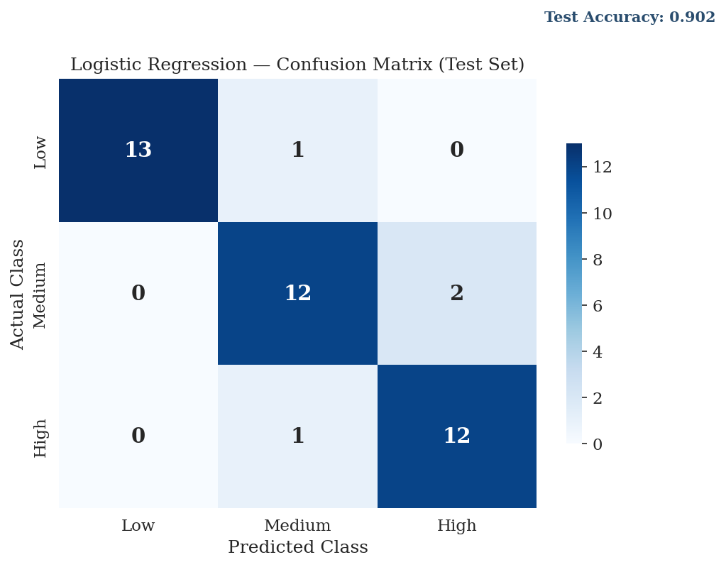
Figure 8 Confusion matrix of the logistic regression classifier on the test set. Diagonal cells (in dark blue) represent correct classifications: 13 of 14 Low, 12 of 14 Medium, and 12 of 13 High vehicles were correctly assigned. All four misclassifications occurred between adjacent categories, confirming that the model preserves the ordinal structure of the price target
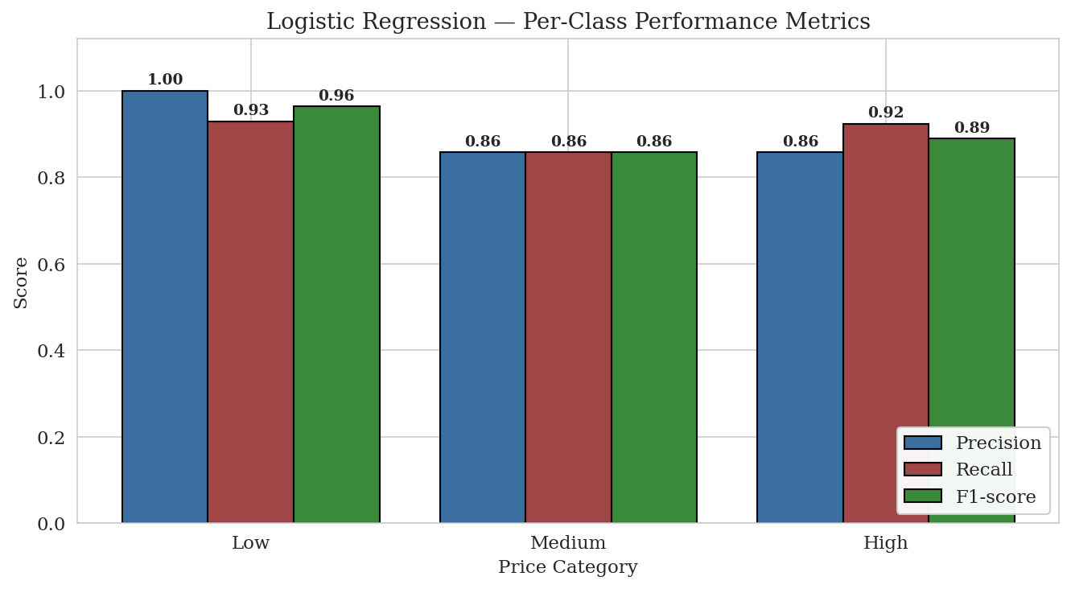
Figure 9 Per-class precision, recall, and F1-score of the logistic regression classifier. The Low class achieves perfect precision (1.00), the High class achieves the strongest recall (0.92), and the Medium class is balanced but slightly weaker (0.86 across all three metrics) due to its position between the two extreme categories

Comparison with the Regression Approach
It does not make sense to directly numerically compare the regression analysis in Task 3 with the classification analysis in Task 4, because they optimise different loss functions on different target spaces. The two analyses complement each other in many ways despite their differences. Predictions of regression can be interpreted at a granular level, giving individual dollar-value predictions that allow for effective pricing choices. Predictions of classification, on the other hand, are robust, segment-level predictions that are easier to communicate. Considering both perspectives as in this report gives a more complete understanding of the price-formation process and supports the business interpretation developed in Task 6 of the Automobile dataset.

Task 5: Model Evaluation and Visualisation

Theoretical Foundations of Visual Model Evaluation
Numerical measures such as R², MAE, and RMSE are compact representations of model prediction quality, which do not show the pattern of model errors necessary to determine the quality of fit or the presence of any systematic bias (Field, 2018: 286). Visual analysis using plots comparing actual values to predicted values and examining model residuals can help understand when and why a model is right or wrong, thus offering a basis for future improvements (James et al., 2013: 85). Therefore, this assignment adds value to the previous quantitative analysis presented in Task 3, by graphing the prediction results from Linear Regression and Random Forest on a test set of 41 observations.

Actual versus Predicted Scatter Plots
Figure 10 displays actual prices against predictions for both the regression models. Each plot includes a dashed red line, indicating the locus of perfect prediction (y = x) through which points should fall if the model were absolutely accurate. Although the plot for Linear Regression (left) indicates clustering around the diagonal for lower prices ($5,000 to $20,000), it displays significant deviations for high-end pricing, whereby actual prices from $30,000 to $41,000 are consistently underestimated. For instance, an expensive car priced at $41,315 is estimated as only $25,541, showing a gap of $15,774. On the contrary, the plot for Random Forest (right) suggests much better correlation with the diagonal throughout the whole spectrum, since predictions for the expensive cars cluster slightly below the line. This visual inspection confirms the previous findings in Task 3 with regard to the higher R² score of the Random Forest, which better accounts for the non-linear relationships between price and features (Géron, 2019: 195).
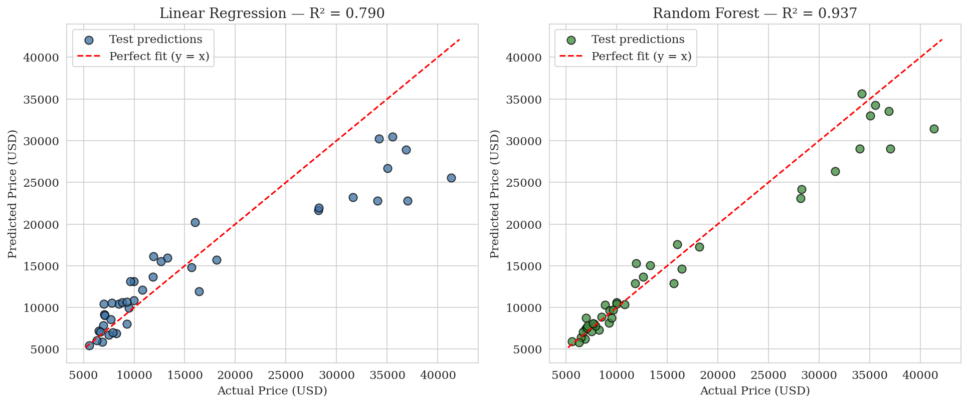
Figure 10 Actual versus predicted prices on the held-out test set for Linear Regression (left, R² = 0.790) and Random Forest (right, R² = 0.937). The red dashed line represents perfect prediction (y = x); points above the line indicate over-prediction, points below indicate under-prediction. Random Forest tracks the diagonal substantially more closely, particularly at higher price levels

Residual Analysis
In Figure 11, the residuals (difference between actual and predicted) are plotted against the predicted price, providing a more discriminating visualization compared to the usual actual vs. predicted visualization. The straight red line is the line where residuals will perfectly lie if the model is unbiased and homoscedastic; all residuals should scatter evenly around this line (Field, 2018: 256). The Linear Regression Model’s Residuals display a clear heteroscedasticity pattern, where the variance of the residuals increases with increasing predicted price: residuals are mainly negative in the range $7,000 – $15,000, implying that mid-range cars are slightly overestimated, while a group of large positive residuals exist for prices higher than $20,000, suggesting severe underestimation of luxury cars. This clearly contradicts the assumption of homoscedasticity, the basis for ordinary least squares regression, meaning that confidence intervals derived using this model cannot be trusted. On the other hand, the Random Forest residuals look tighter and more random in the lower to medium price range but still have some heteroscedasticity in the higher price range. Both models show a slight bias towards underestimating the test partition ($1,414 and $873 mean residual for Linear Regression and Random Forest, respectively).
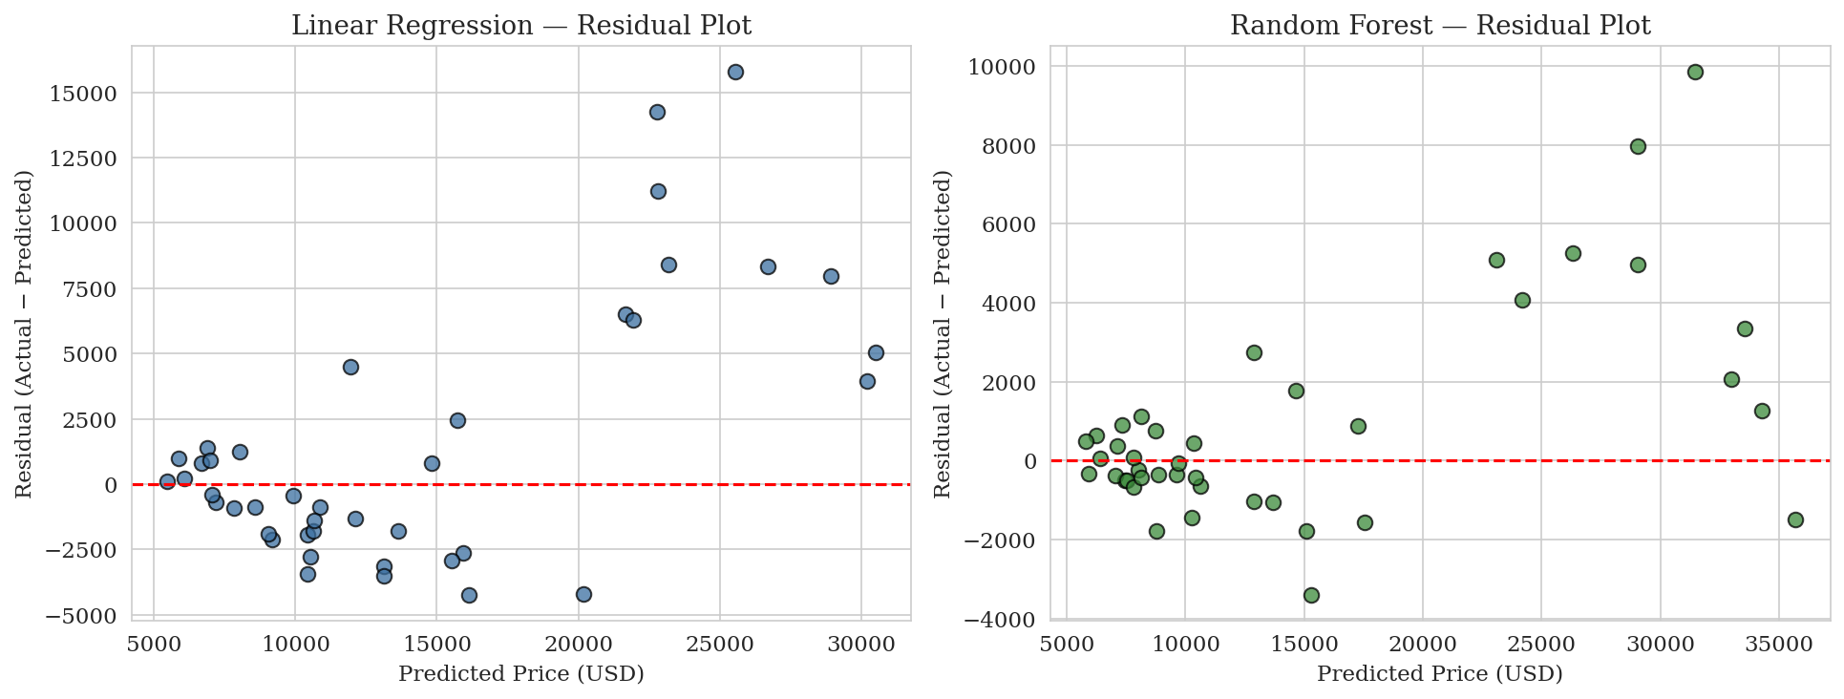
Figure 11 Residual diagnostic plots for Linear Regression (left) and Random Forest (right). The red dashed line at zero represents perfect prediction; the increasing spread of Linear Regression residuals at higher predicted prices indicates heteroscedasticity, while Random Forest residuals are visibly more compact and randomly distributed

Synthesis and Implications
There are three meaningful insights that can be drawn from these diagnostics. First, both models perform admirably in the most common price domain, where the bulk of training data points lie, but both models struggle to extrapolate effectively into the luxury domain due to the relative scarcity of expensive data points in the training dataset. Second, the consistent bias towards underestimation in the upper part of the domain is in line with the findings in Task 1, where it was determined that the price distribution was right-skewed; in cases where the target distribution has a heavy tail, regression models exhibit a tendency to regress to the mean, leading to bias against extreme values (Miller and Forte, 2017: 152). Third, the heteroscedastic nature of the residuals in the linear regression model suggests that a log-transform of the price target, as expected in Section 1.5, would significantly improve the quality of fit.

Task 6: Business Insights and Recommendations

Introduction
The analysis carried out in Tasks 1 to 5 resulted in the creation of a very effective prediction model, with an R² of 0.937 achieved by the Random Forest model on the held-out test set, together with a clear hierarchy of the factors affecting price creation in the Automobile database. This part attempts to offer some business insights based on the above analysis in line with the questions provided in the assignment instructions. The analysis will be conducted from two different angles, that is, those of the producer and consumer, and will adopt the Data Science for Business framework offered by Provost and Fawcett (2013: 18).

What Makes a Car Expensive?
By putting together all information from the correlation matrix of Task 1, the feature importance of Random Forest in Task 3, and the high tier price pattern depicted in Figure 12, the findings indicate that a car gets to be expensive based on its weight, engine power, and size of its engine. That is, cars in the High tier category ($21,935 mean price) have 51%, 70%, and 97% heavier curb weight, larger engine, and higher horsepower, respectively, compared to cars in the Low tier category ($6,995 mean price). While width and length also contribute to the premium price with a somewhat same degree — the average difference between cars in the two tiers is only 6% in terms of width — this means that size alone does not cause such a price increase. Another intangible variable that adds up to the car’s premium cost is the luxury brands as revealed from Task 1.
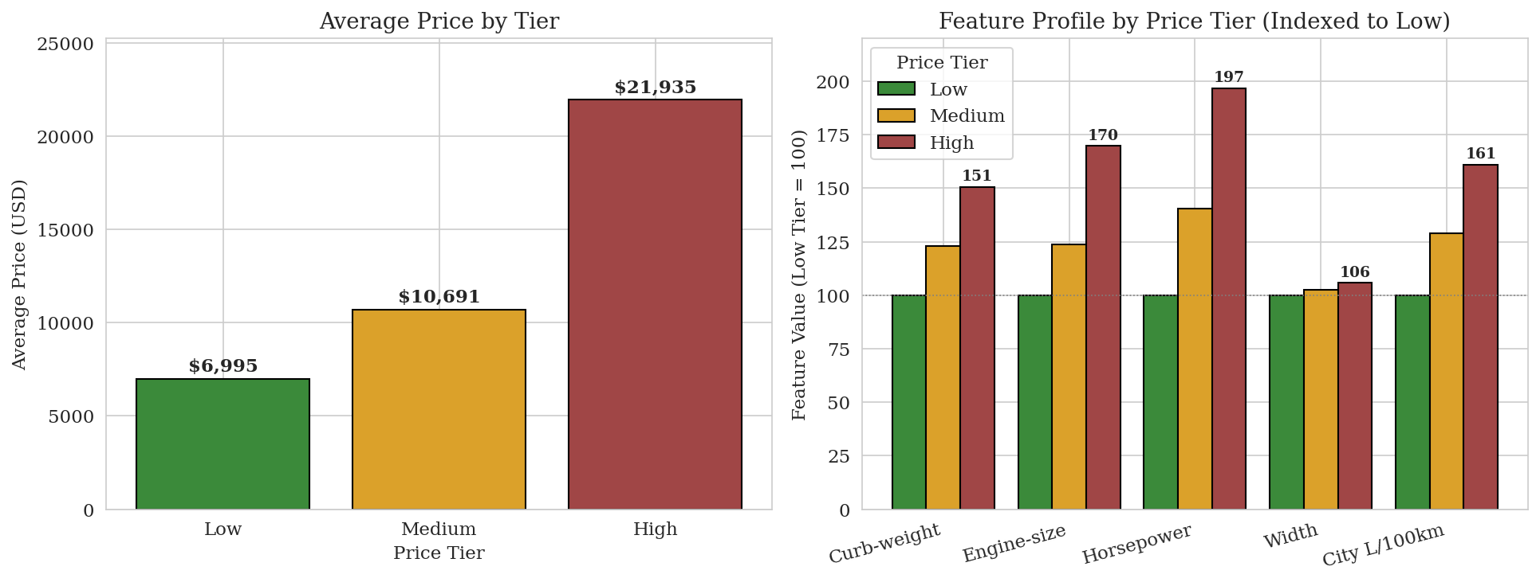
Figure 12 Business profile by price tier. The left panel shows that High-tier vehicles cost on average $21,935, approximately 3.1 times the average Low-tier price of $6,995. The right panel shows that High-tier vehicles carry 51% more curb-weight, 70% larger engines, and 97% more horsepower than Low-tier vehicles, while their width is only 6% greater — confirming that powertrain capacity, not physical footprint, is the dominant differentiator between price segments

Strategic Implications for Manufacturers
With regard to efforts by the engineer in enhancing his product's position through price leveraging, there is an ordered hierarchy as provided by the empirical evidence. The first two attributes are engine-size and horsepower since collectively they contribute towards more than half of the signal generated by the Random Forest model in Section 3.4. This is the reason why investments in engine displacement will have the greatest payoff with respect to pricing per dollar invested into engineering designs. Curb-weight constitutes the next significant determinant and partly because of material quality, large displacement engines and many other options like comfort. However, some of the characteristics, for instance compression-ratio, stroke, and bore have low price premiums. Therefore, the engineer should avoid investing in such attributes as this will offer no significant leverage and should only consider the efficiency gained through the characteristics. What is critical to note is the negative correlation between fuel efficiency and price (r ≈ -0.70 with mpg) which is similar to curb-weight as well. This is because of segmentation effects and not causation in this case and premium customers will never go for fuel-efficient vehicles but performance.

Practical Applications for Customers
For end consumers, the proposed model will provide a quantitative second opinion on whether a given advertised car has been priced reasonably for its characteristics. In order to assess the reasonableness of the asking price, one needs to put in the measurements of engine-size, horsepower, curb-weight, and mpg of an advertised car, to obtain the price implied by the model, and then check for a discrepancy; any significant positive deviation between the price of the car advertised by the seller and the model-implied price could suggest the need to negotiate on the price, or consider non-measurable factors such as reputation of the manufacturer or condition of the car (Provost and Fawcett, 2013: 22). Additionally, the classifier produced in Task 4 serves as another, even more simple and informative tool. Consumers may use it to confirm whether the vehicle they are planning to buy belongs to a Low, Medium, or High-priced category, as appropriate for their budget. However, consumers must bear in mind that models do not always capture reality perfectly, as confirmed by the heteroscedasticity discovered in Task 5 for larger prices.

Limitations and Closing Remarks
The interpretation of the data from a business standpoint is limited by two key factors. First of all, the dataset was developed based on data gathered back in 1987, and the market might be influenced by many variables which had become important only over the next few decades, including the emergence of electric vehicles, software-enabled technology, and branding (Provost and Fawcett, 2013: 41). Secondly, although the model illustrates the correlation between the variables, it does not explain the causality: it will not necessarily lead to a twofold increase in the price of the car if the engine power has been doubled without changing the marketing strategy towards a high-price sector (Provost and Fawcett, 2013: 41).

Task 7: Conclusion

Summary of Findings
For Task 1, a full cycle of analytics was conducted using the Automobile dataset consisting of 201 cars for predicting the price of the car on the basis of various characteristics. In exploratory analysis, there was found a significant right-skewness of the price variable with a mean of $13,207 and median of $10,295. Also, correlations with price were found to be strongest for certain variables such as engine size, curb weight, and horsepower. In Task 2, 59 missing values were handled using mean and mode substitution, while the new attribute of city-L/100km was introduced in order to reflect the fuel efficiency of the vehicle. In Task 3, comparison was made between linear regression and random forest models. The R² coefficient for linear regression was 0.790, while the performance of the random forest model was much better and scored 0.937. Some important predictors for the target variable included curb weight and engine size among others. In Task 4, the regression problem was reformulated as a three-class ordinal classification, dividing the target into Low, Medium, and High price categories. It led to test accuracy of 0.902. Importantly, all misclassifications occurred only between adjacent targets, which indicated success at reflecting the ordinal ranking of the variable. Finally, in Task 5, diagnostic plots showed that all the two models (Linear Regression and Random Forest) underperformed for luxury class of cars. The final task consisted in conducting business interpretation.

Model Limitations
There are multiple limitations that affect the findings of the study both in terms of its internal and external validity. First, there are relatively few observations – 201 cases with 41 test observations using an 80/20 split. This small sample size impacts the quality of research outcomes, including measures of predictive accuracy and estimation of the uncertainty of variable importance orderings (James et al., 2013: 219). Second, the dataset dates back to 1987 and does not include information related to the impact of electric vehicles, sophisticated computer-controlled components, hybrids, and modern safety devices. Third, despite the cardinality of some variables (make and body style), they were not used in the creation of the models because of potential problems related to the curse of dimensionality when applying the naïve one-hot coding scheme; as a result, important information about luxury car makes obtained via outlier detection in Task 1 was omitted. Fourth, diagnostics performed in Task 5 reveal the presence of heteroscedasticity, which implies the breaking of the homogeneity assumption and, thus, leads to underestimation of the prices of the most expensive vehicles via the Random Forest model. Finally, cross-sectional data do not provide possibilities to consider time-related aspects like depreciation or economic state.

Suggested Improvements
The below-listed suggestions for future research pertain to the problems discussed above in regard to the current study. To begin with, taking a logarithm of the price target is expected to help minimize the variability and solve the issue of heteroscedasticity in Task 5 (Miller and Forte, 2017: 144). Next, the use of the high cardinality predictors like make and body style could allow constructing brand equity based on target encoding and embedding, which will introduce brand-level data into the model but prevent the exponential increase in size of the design matrix. In addition, gradient boosted algorithms like XGBoost and LightGBM should provide better results on tabular data than linear or tree-based models examined here and be the next step in the machine learning hierarchy (Géron, 2019: 199). Finally, hyperparameter optimization techniques like cross-validation and Bayesian search might produce better performance than what was achieved using default settings in scikit-learn.

Closing Remarks
This task shows how a well-defined data analytics pipeline of steps, ranging from exploratory analysis to preprocessing, modeling, evaluation, and finally the application of results in a business context, can produce valuable insights even when working with a relatively small table-based data set. The various decisions made throughout the process, such as contrasting linear and ensemble models and different perspectives on the target variable (regression versus classification), highlight some of the issues related to the inherent biases and variances involved in practical predictive analytics. The conclusions arrived at are valid within the confines of the 1987 sample data set, but the suggested improvements provide a realistic path forward.

List of References
Breiman, L. (2001) 'Random Forests'. Machine Learning 45 (1) 5–32.

Field, A. (2018) Discovering Statistics Using IBM SPSS Statistics. 5th ed. London: Sage.

Géron, A. (2019) Hands-On Machine Learning with Scikit-Learn, Keras, and TensorFlow. 2nd ed. Sebastopol, CA: O'Reilly Media.

Han, J., Kamber, M., and Pei, J. (2012) Data Mining: Concepts and Techniques. 3rd ed. Waltham, MA: Morgan Kaufmann.

Hastie, T., Tibshirani, R., and Friedman, J. (2009) The Elements of Statistical Learning: Data Mining, Inference, and Prediction. 2nd ed. New York: Springer.

Hosmer, D. W., Lemeshow, S., and Sturdivant, R. X. (2013) Applied Logistic Regression. 3rd ed. Hoboken, NJ: Wiley.

James, G., Witten, D., Hastie, T., and Tibshirani, R. (2013) An Introduction to Statistical Learning with Applications in R. New York: Springer.

Johnston, B. and Mathur, I. (2019) Applied Supervised Learning with Python: Use Scikit-Learn to Build Predictive Models from Real-World Datasets and Prepare Yourself for the Future of Machine Learning. Birmingham: Packt Publishing.

Kumar, A. (2016) Learning Predictive Analytics with Python: Gain Practical Insights into Predictive Modelling by Implementing Predictive Analytics Algorithms on Public Datasets with Python. Birmingham: Packt Publishing.

Little, R. J. A. and Rubin, D. B. (2019) Statistical Analysis with Missing Data. 3rd ed. Hoboken, NJ: Wiley.

McKinney, W. (2017) Python for Data Analysis: Data Wrangling with Pandas, NumPy, and IPython. 2nd ed. Sebastopol, CA: O'Reilly Media.

Miller, J. D. and Forte, R. M. (2017) Mastering Predictive Analytics with R. 2nd ed. Birmingham: Packt Publishing.

Pedregosa, F., Varoquaux, G., Gramfort, A., Michel, V., Thirion, B., Grisel, O., Blondel, M., Prettenhofer, P., Weiss, R., Dubourg, V., Vanderplas, J., Passos, A., Cournapeau, D., Brucher, M., Perrot, M., and Duchesnay, É. (2011) 'Scikit-learn: Machine Learning in Python.' Journal of Machine Learning Research 12, 2825–2830.

Provost, F. and Fawcett, T. (2013) Data Science for Business: What You Need to Know about Data Mining and Data-Analytic Thinking. Sebastopol, CA: O'Reilly Media.

Schlimmer, J. C. (1987) Automobile Data Set [online]. Irvine, CA: UCI Machine Learning Repository. Available from https://archive.ics.uci.edu/ml/datasets/automobile [accessed 4 May 2026].
Tukey, J. W. (1977) Exploratory Data Analysis. Reading, MA: Addison-Wesley.

List of Figures
Figure 1 Histograms of Price and Horsepower 10
Figure 2 Boxplot of Price by Body Style 11
Figure 3 Correlation Heatmap 12
Figure 4 Horsepower binning into Low, Medium, and High categories. Left panel shows the original distribution with the three equal-width bin edges marked in red; right panel shows the resulting allocation of vehicles 16
Figure 5 Effect of min-max normalisation on the length variable. The shape of the distribution is preserved while the scale is rescaled to the interval [0, 1] 17
Figure 6 Random Forest feature importance ranking. Curb-weight (0.437) and engine-size (0.318) jointly account for over 75% of the model's predictive signal, with the remaining nine features each contributing less than 7% 21
Figure 7 Comparative model performance across configurations. The left panel shows the R² score on the test set; the right panel shows the mean absolute error in USD. Random Forest consistently outperforms Linear Regression by a wide margin under both split ratios 22
Figure 8 Confusion matrix of the logistic regression classifier on the test set. Diagonal cells (in dark blue) represent correct classifications: 13 of 14 Low, 12 of 14 Medium, and 12 of 13 High vehicles were correctly assigned. All four misclassifications occurred between adjacent categories, confirming that the model preserves the ordinal structure of the price target 26
Figure 9 Per-class precision, recall, and F1-score of the logistic regression classifier. The Low class achieves perfect precision (1.00), the High class achieves the strongest recall (0.92), and the Medium class is balanced but slightly weaker (0.86 across all three metrics) due to its position between the two extreme categories 27
Figure 10 Actual versus predicted prices on the held-out test set for Linear Regression (left, R² = 0.790) and Random Forest (right, R² = 0.937). The red dashed line represents perfect prediction (y = x); points above the line indicate over-prediction, points below indicate under-prediction. Random Forest tracks the diagonal substantially more closely, particularly at higher price levels 29
Figure 11 Residual diagnostic plots for Linear Regression (left) and Random Forest (right). The red dashed line at zero represents perfect prediction; the increasing spread of Linear Regression residuals at higher predicted prices indicates heteroscedasticity, while Random Forest residuals are visibly more compact and randomly distributed 30
Figure 12 Business profile by price tier. The left panel shows that High-tier vehicles cost on average $21,935, approximately 3.1 times the average Low-tier price of $6,995. The right panel shows that High-tier vehicles carry 51% more curb-weight, 70% larger engines, and 97% more horsepower than Low-tier vehicles, while their width is only 6% greater — confirming that powertrain capacity, not physical footprint, is the dominant differentiator between price segments 32

List of Tables
Table 1 Descriptive Statistics — Numeric Features 8
Table 2 Missing Values Summary 15
Table 3 Test-set performance metrics for Linear Regression and Random Forest under 80/20 and 70/30 train/test splits 22

