

INTERNSHIP PROJECT REPORT

Project Title:
Supply and Operation Planning Chain

Submitted To:
Ms. Ruchika (Data Analyst)
Mr. Manish (IT Manager)
VE Commercial Vehicles Ltd. (VECV) - Pithampur
Submitted By:
Rahul Sharma
B. Tech. Data Science
IPS Academy, Indore

Date of Submission: 19/05/2026

Index

Title | Page no.
Sudden Jump Analysis | 1-26

Acknowledgement

We would like to express our sincere gratitude to Volvo Eicher Commercial Vehicles Limited (VECV) for providing the opportunity to work on this project and gain practical exposure to real-world data analysis and reporting systems. Working on this project helped in understanding how data-driven analysis is used in industry environments for monitoring patterns, identifying behavioral changes, and generating meaningful business insights.

We are especially thankful to Ms. Ruchika Ma'am for her continuous support, guidance, and encouragement throughout the project. Her valuable suggestions and coordination helped in staying focused and completing the project successfully.

We would also like to express heartfelt thanks to our mentor, Mr. Manish Sir, for sharing his knowledge, technical guidance, and practical insights during every stage of the project. His mentorship helped in building a strong understanding of Python scripting, data preprocessing, behaviour analysis, dashboard creation, and problem-solving approaches.

This project provided hands-on experience in:
- Large-scale data handling
- Python automation
- Data preprocessing
- Transition and pattern analysis
- Dashboard visualization using Power BI
- Report generation and interpretation

Synopsis
This project focuses on analyzing behavior patterns from large datasets containing location-wise daily values. The objective of the project is to identify transitions, sudden changes, first-time occurrences, and new behavior patterns using color-based logic.
The system processes data using Python scripts and generates meaningful outputs such as:
- Jump Count
- First Time Hit Count
- New Norms Added Count
- Dangerous Transitions
- Dashboard Visualizations
The processed outputs are then visualized in Power BI dashboards for easy interpretation and monitoring.

Goals of the Project
The major goals of the project are:
- Analyse large datasets efficiently.
- Detect behavioural changes between dates.
- Track color transitions and movement patterns.
- Count sudden jumps and first-time hits.
- Generate automated outputs using Python.
- Create dashboard visualizations using Power BI.
- Improve data interpretation through graphs and tables.

Dataset Description
The dataset contains:
Feature | Description
Locations | 13 Different Locations
Rows | Around 100,000 Records
Date Columns | Multiple Daily Values
Null Values | Missing Data Handled Separately
Output Metrics | Jump Count, First Time Hit, New Norms

Color Logic Used
The project uses color classification based on value ranges.
Value Range | Color
0 to 33.32 | Green
33.33 to 66.65 | Yellow
66.66 to 100 | Red
Negative Values | Blue / White (based on logic version)
Null Values | Grey

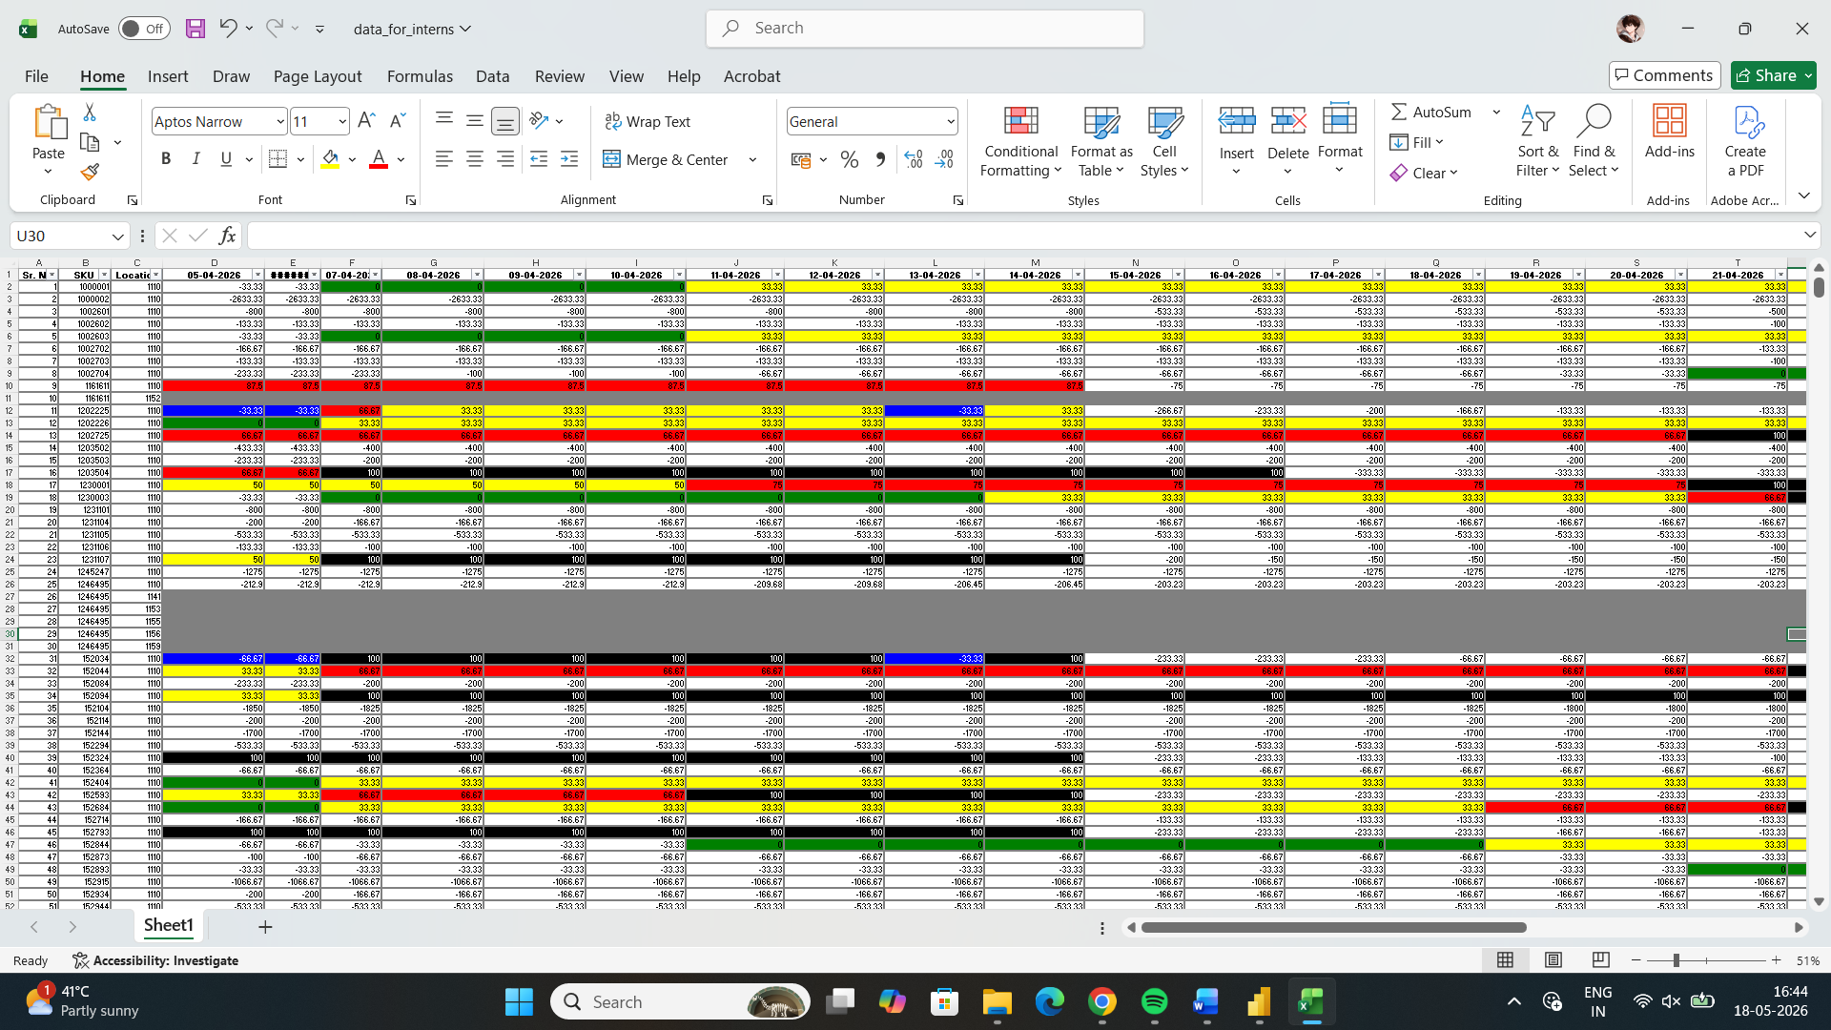

Required Analysis
The project analysis is based on identifying color transitions between consecutive dates for each location.
The main objective is:
- To identify sudden color jumps
- To detect first-time hits
- To identify newly added norms
The color transition rules used in the project are defined below.

Color Transition Rules
Sr No. | Previous Color | Current Color | Result
1 | Blue | Green | Jump
2 | Blue | Yellow | Jump
3 | Blue | Red | Jump
4 | Blue | Black | Jump
5 | White | Yellow | Jump
6 | White | Red | Jump
7 | White | Black | Jump
8 | Green | Red | Jump
9 | Green | Black | Jump
10 | Yellow | Black | Jump
11 | Gray | Black | First Time Hit
12 | Gray | Red | New Norm Added
13 | Gray | Yellow | New Norm Added
14 | Gray | Green | New Norm Added
15 | Gray | Blue | New Norm Added
16 | Gray | White | New Norm Added

Assumptions and Logic Decisions
During the analysis process, certain assumptions were made to simplify transition tracking and improve consistency in output generation.

Assumption Used
The dataset did not contain a fixed transition pattern for the Blue color.
To maintain consistency in analysis, the Blue color was treated similarly to White during transition calculations.
For processing and analysis purposes, both Blue and White were grouped under a common negative category and handled as White.

Reason for This Assumption
This assumption was taken because:
- No separate transition rules were defined for Blue color in several cases.
- Blue and White both represented negative or inactive conditions.
- Treating Blue separately created unnecessary complexity in transition analysis.
- Combining them simplified jump calculations and pattern detection.
- It improved consistency while processing large datasets containing more than 100,000 rows.

1. Sudden Jump Analysis
A sudden jump occurs whenever the color changes according to the predefined jump rules.
These transitions indicate significant behavioural changes between two consecutive dates.

Examples of Jump Transitions
Previous | Current | Result
Blue | Red | Jump
White | Yellow | Jump
Green | Black | Jump

Logic Used
If:
- Previous Color != Current Color AND
- Transition exists in jump rules
Then:
- Jump Count + 1

2. First Time Hit Analysis
A first-time hit occurs when:
Previous Color | Current Color
Gray | Black
This indicates the first occurrence of a critical or detected condition.

3. New Norms Added Analysis
A new norm is added whenever Gray changes to another valid color except Black.

Valid New Norm Transitions
Previous | Current
Gray | Red
Gray | Yellow
Gray | Green
Gray | Blue
Gray | White

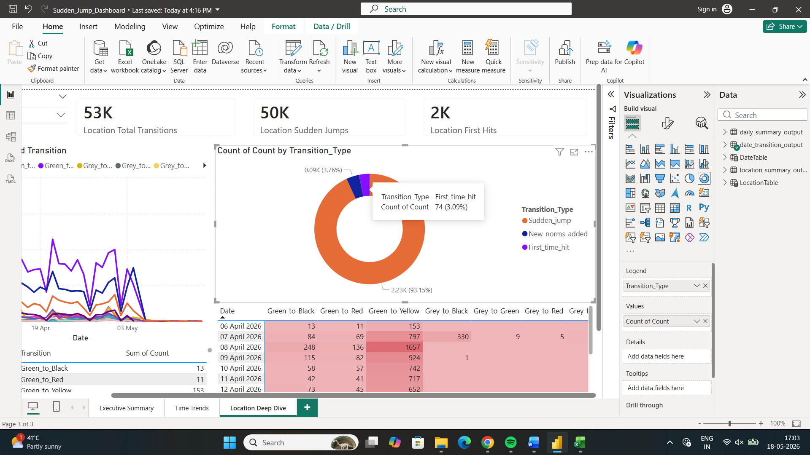

Methodology
The project methodology was designed to process large-scale behavioral datasets and identify important transitions between consecutive dates using Python and Pandas.
The complete workflow consists of data preprocessing, color classification, transition detection, summary generation, and dashboard visualization.

Step 1: Data Collection
The dataset was collected in CSV format containing:
- SKU-wise records
- Location details
- Multiple date columns
- Numerical values representing behavior patterns
The dataset contained more than 100,000 rows and data from 13 different locations.

Activities Performed
- Imported CSV data using Pandas
- Enabled low memory loading for large dataset handling
- Standardized column names
- Cleaned Location column values

Python Logic Used
df = pd.read_csv(
"raw_data/data_for_interns.csv",
low_memory=False
)
df.columns = df.columns.str.strip()

Location Cleaning
df["Location"] = (
df["Location"]
.astype(str)
.str.strip()
.str.replace(".0", "", regex=False)
)

Purpose
This step ensured:
- Proper dataset loading
- Clean column names
- Standardized location values
- Better preprocessing consistency
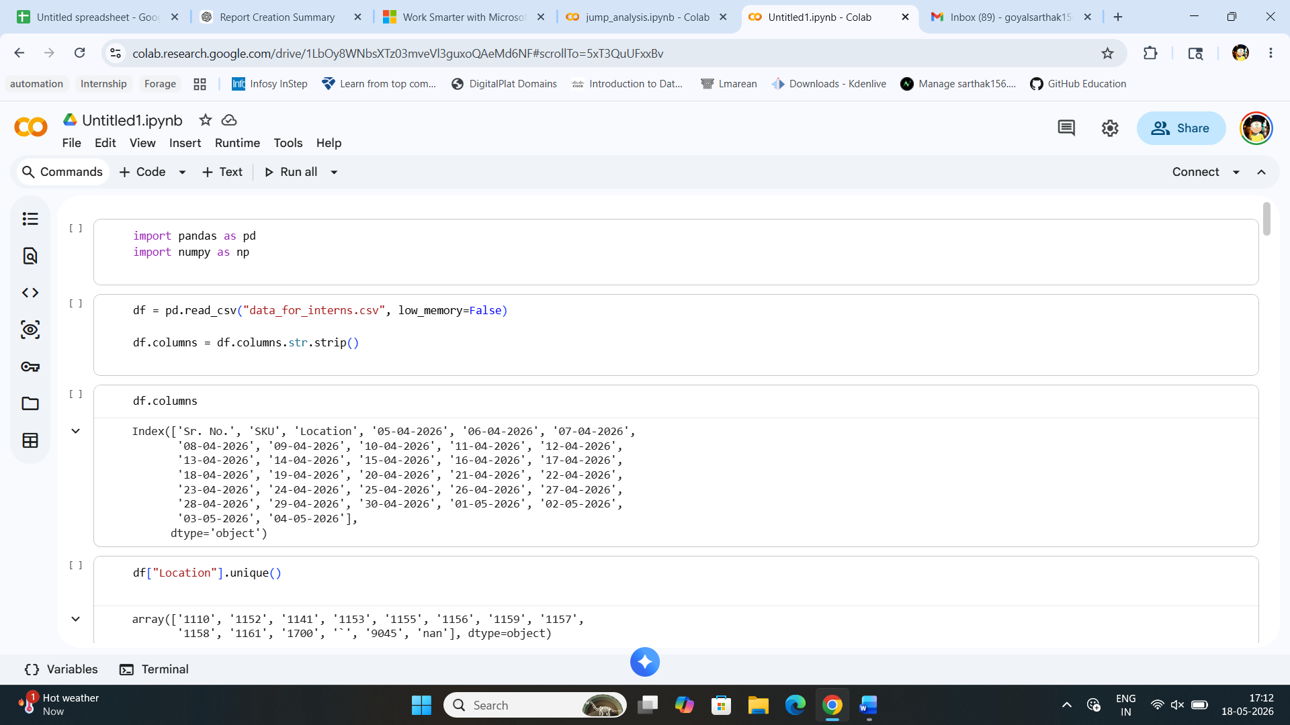

Step 2: Date Column Identification
The dataset contained multiple date columns representing daily observations.
The system automatically identified all date columns dynamically.

Python Logic Used
date_cols = [
col for col in df.columns
if "-" in str(col)
]

Purpose
This approach helped:
- Automatically detect date columns
- Avoid manual column selection
- Make the script scalable for future datasets

Step 3: Color Mapping Logic
Each numerical value was converted into a specific color category using predefined ranges.

Color Rules Used
Value Range | Color
Null Values | Grey
100 | Black
66.67 to 99.99 | Red
33.33 to 66.66 | Yellow
0 to 33.32 | Green
Negative Values | White

Python Function Used
def color(value):
if pd.isna(value):
return "Grey"
value = float(value)
if value == 100:
return "Black"
elif value >= 66.67:
return "Red"
elif value >= 33.33:
return "Yellow"
elif value >= 0:
return "Green"
else:
return "White"

Purpose
This step converted raw numerical data into categorical behavior states for easier transition analysis.

Step 4: Transition Rule Definition
Three main transition categories were created:
- Sudden Jump
- First Time Hit
- New Norms Added

4.1 Sudden Jump Rules
Sudden jumps represent major transitions between consecutive dates.

Rules Used
jump = {
("White", "Green"),
("White", "Yellow"),
("White", "Red"),
("White", "Black"),
("Green", "Yellow"),
("Green", "Red"),
("Green", "Black"),
("Yellow", "Red"),
("Yellow", "Black")
}

Purpose
This analysis identifies:
- Sudden behavioral changes
- Rapid increases in severity
- Unstable transition patterns

4.2 First Time Hit Rules
First-time hits represent initial critical occurrences.

Rule Used
first_time_hit = {
("Grey", "Black")
}
Purpose
This helps identify:
- Newly detected critical states
- First occurrence of maximum severity

4.3 New Norms Added Rules
New norms indicate new activity appearing from null values.

Rules Used
new_norms_added = {
("Grey", "White"),
("Grey", "Green"),
("Grey", "Yellow"),
("Grey", "Red")
}

Purpose
This analysis tracks:
- Newly appearing activity
- Emerging behavioral trends
- Expansion of observations

Step 5: Transition Detection Process
The system iterated through every row and compared consecutive date colors.

Workflow
- Read each row
- Extract SKU and Location
- Convert all date values into colors
- Compare current color with previous color
- Detect valid transitions
- Store detected transitions

Core Processing Logic
for i in range(1, len(colors)):
previous_color = colors[i - 1]
current_color = colors[i]

Transition Identification
if transition in jump:
transition_type = "Sudden_jump"
elif transition in first_time_hit:
transition_type = "First_time_hit"
elif transition in new_norms_added:
transition_type = "New_norms_added"

Stored Information
The system stored:
- SKU
- Location
- Date
- Previous Color
- Current Color
- Transition Name
- Transition Type

Purpose
This step created the complete transition dataset used for reporting and dashboards.

Step 6: Transition DataFrame Creation
All detected transitions were converted into a structured DataFrame.

Python Logic Used
transition_df = pd.DataFrame(
transition_rows
)

Purpose
This allowed:
- Structured storage
- Easy aggregation
- Dashboard integration
- Export to CSV files

Step 7: Summary Generation
Different summaries were generated for analysis.

7.1 Date-wise Transition Summary
The project generated daily transition counts.

Logic Used
transition_summary = (
transition_df
.groupby(
[
"Date",
"Location",
"Transition",
"Transition_Type"
]
)
.size()
.reset_index(name="Count")
)

Output Generated
outputs/date_transition_output.csv

Purpose
This summary helped analyze:
- Daily transition frequency
- Location-wise transition behavior
- Trend monitoring

7.2 Location Summary
Location-based summaries were generated using pivot tables.

Transition Summary
location_transition_summary = (
transition_summary
.pivot_table(
index="Location",
columns="Transition",
values="Count",
aggfunc="sum",
fill_value=0
)
)

Transition Type Summary
location_type_summary = (
transition_df
.pivot_table(
index="Location",
columns="Transition_Type",
aggfunc="size",
fill_value=0
)
)

Final Merge
location_summary = (
location_transition_summary
.merge(
location_type_summary,
on="Location",
how="left"
)
)

Output Generated
outputs/location_summary_output.csv

Purpose
This summary helped:
- Compare locations
- Identify risky locations
- Generate dashboard KPIs

7.3 Daily Summary Generation
The system also generated daily overall transition summaries.

Logic Used
daily_summary = (
transition_df
.groupby(
["Date", "Transition_Type"]
)
.size()
.reset_index(name="Count")
)

Pivot Table Creation
daily_pivot = (
daily_summary
.pivot_table(
index="Date",
columns="Transition_Type",
values="Count",
aggfunc="sum",
fill_value=0
)
)

Total Transition Calculation
daily_pivot["Total_Transitions"] = (
daily_pivot.iloc[:, 1:]
.sum(axis=1)
)

Output Generated
outputs/daily_summary_output.csv

Purpose
This helped analyze:
- Daily activity trends
- Overall transition intensity
- Peak transition dates

Step 8: Output File Generation
The project generated multiple output CSV files automatically.

Generated Files
File Name | Purpose
date_transition_output.csv | Date-wise transition records
location_summary_output.csv | Location-based summary
daily_summary_output.csv | Daily transition statistics

Final Output Message
print("All output files generated successfully.")

Purpose
This automation enabled:
- Fast report generation
- Dashboard integration
- Scalable analysis workflow

Python Processing Script
Main script:
sudden_jump_analysis.py
The script:
- Reads raw CSV
- Detects date columns dynamically
- Converts values to colors
- Detects transitions
- Calculates metrics
- Creates output CSV files

A. location_summary_output.csv
Location-wise summary.

Structure
Column | Description
Location | Location ID
Green_to_Black | Transition count
White_to_Green | Transition count
... | ...
Sudden_jump | Total jumps
First_time_hit | Total first hits
New_norms_added | Total new norms

B. daily_summary_output.csv
Daily summary metrics.

Structure
Date | First_time_hit | New_norms_added | Sudden_jump | Total_Transitions

C. date_transition_output.csv
Detailed transition log.

Structure
Date | Location | Transition | Transition_Type | Count

Dummy Data Simulation
To simulate future incoming data:
Created:
dummy_data.csv
Containing:
- 100+ rows
- Multiple locations
- Random SKUs
- Null values
- New dates from:
05-05-2026 → 15-05-2026
Locations used:
1110
1141
1152
1153
1155
1156
1157
1158
1159
1161
1700
9045

Dummy Output Files
Generated:
dummy_location_summary_output.csv
dummy_daily_summary_output.csv
dummy_date_transition_output.csv

Append Simulation
Created script:
append_original.py
Purpose:
- Append dummy outputs into existing production outputs
- Simulate real-world incoming data refresh

Power BI Dashboard Creation

Imported Files
Imported into Power BI:
location_summary_output.csv
daily_summary_output.csv
date_transition_output.csv

Tables Created in Power BI

A. DateTable
Created using:
DateTable =
CALENDAR(
MIN(daily_summary_output[Date]),
MAX(daily_summary_output[Date])
)
Purpose:
- Common date filtering
- Slicer synchronization
- Time intelligence

B. LocationTable
Created for clean filtering.
Used distinct locations from:
location_summary_output

Relationships Created

Relationship 1
DateTable[Date]
→
daily_summary_output[Date]
Type:
One to Many

Relationship 2
DateTable[Date]
→
date_transition_output[Date]
Type:
One to Many

Relationship 3
LocationTable[Location]
→
date_transition_output[Location]
Type:
One to Many

Measures Created

Total Locations
Total Locations =
DISTINCTCOUNT(location_summary_output[Location])

Total Transitions
Total Transitions =
SUM(daily_summary_output[Total_Transitions])

Total Sudden Jumps
Total Sudden Jumps =
SUM(daily_summary_output[Sudden_jump])

Total First Time Hits
Total First Time Hits =
SUM(daily_summary_output[First_time_hit])

Total New Norms
Total New Norms =
SUM(daily_summary_output[New_norms_added])

Peak Daily Transitions
Peak Daily Transitions =
MAX(daily_summary_output[Total_Transitions])

Average Daily Transitions
Average Daily Transitions =
AVERAGE(daily_summary_output[Total_Transitions])

Dashboard Pages Created

Page 1: Executive Summary
Contains:
- Cards
- Donut Chart
- Location Transition Bar Chart
- Transition Matrix
- Date Slicer
Purpose:
- High-level overview of entire system

Page 2: Time Trends
Contains:
- Peak daily transitions
- Average transitions
- Most active day
- Transition trend charts
- Daily movement analysis
Purpose:
- Analyze behavior over time

Page 3: Location Deep Dive
Contains:
- Location slicer
- Transition distribution
- Transition trend by date
- Transition matrices
- Detailed tables
Purpose:
- Deep analysis of individual locations

Dashboard Features

Dynamic Date Detection
When new date columns are added:
- New outputs are generated
- Power BI updates after refresh

Auto Refresh Workflow
New Raw Data
↓
Run Python Script
↓
Output CSV Updated
↓
Refresh Power BI
↓
Dashboard Updated

Slicers Used

Date Slicer
Connected across all pages using:
Sync Slicers

Location Slicer
Used in:
Location Deep Dive

Visualizations Used
Visualization | Purpose
Cards | Summary metrics
Donut Chart | Transition distribution
Line Charts | Trends over time
Area Charts | Transition type analysis
Bar Charts | Location comparison
Matrix Tables | Detailed transition counts
Slicers | Interactive filtering

Final Architecture
Raw CSV Data
↓
Python Processing
↓
Output CSV Files
↓
Power BI Import
↓
Relationships + Measures
↓
Interactive Dashboard

Technologies Used
Tool | Purpose
Python | Data processing
Pandas | Data manipulation
NumPy | Numerical handling
Power BI | Dashboard creation
CSV | Intermediate storage

Key Achievements
- Dynamic date handling
- Transition detection engine
- Automated metric generation
- Real-time dashboard refresh simulation
- Multi-page interactive dashboard
- Dummy data simulation pipeline
- Location-wise and date-wise analytics
- Scalable for large datasets (~100k rows+)

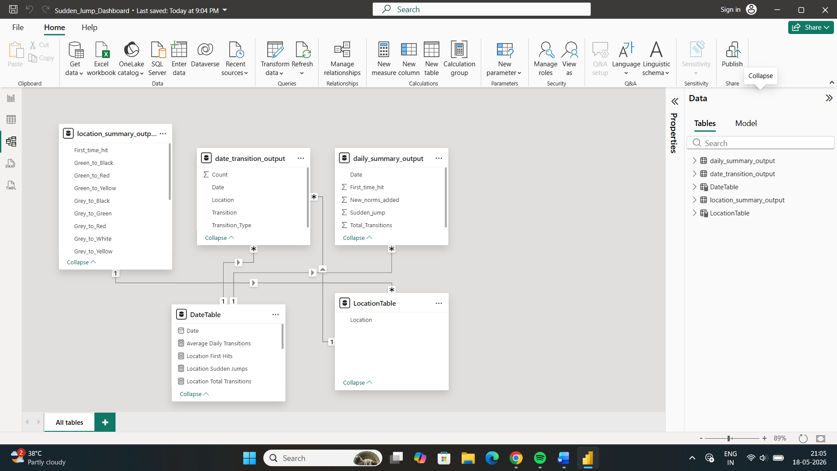

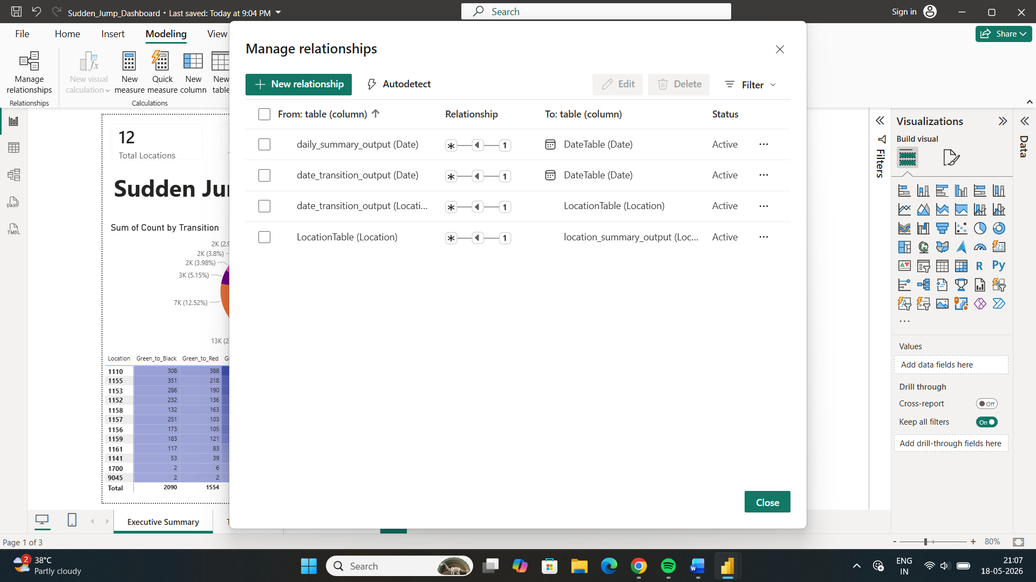

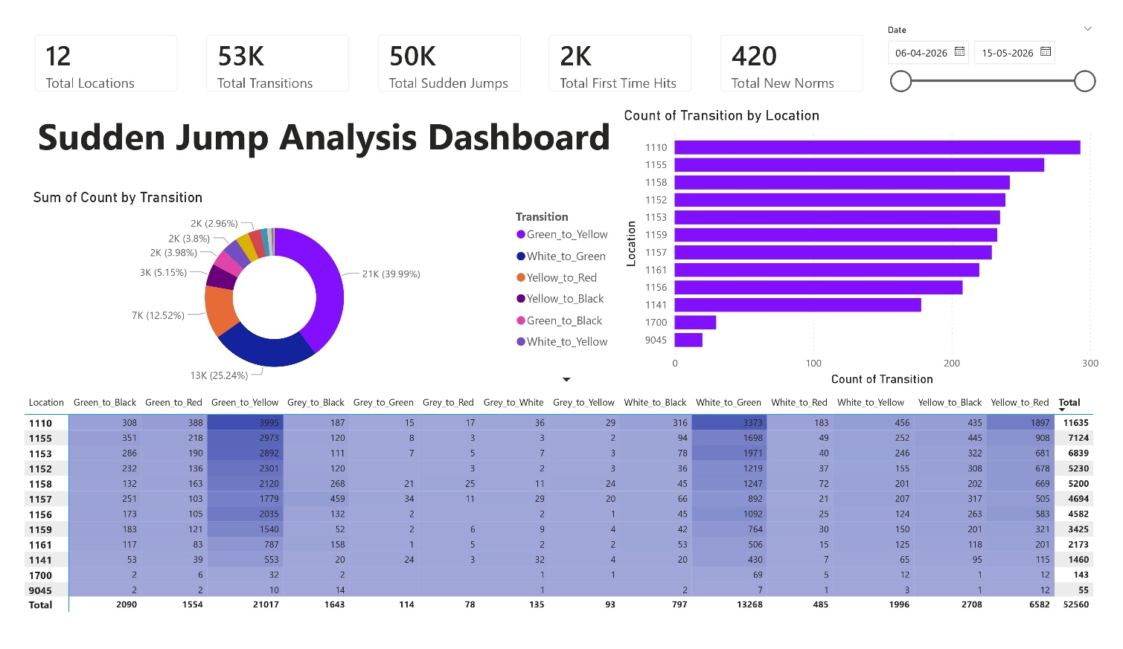

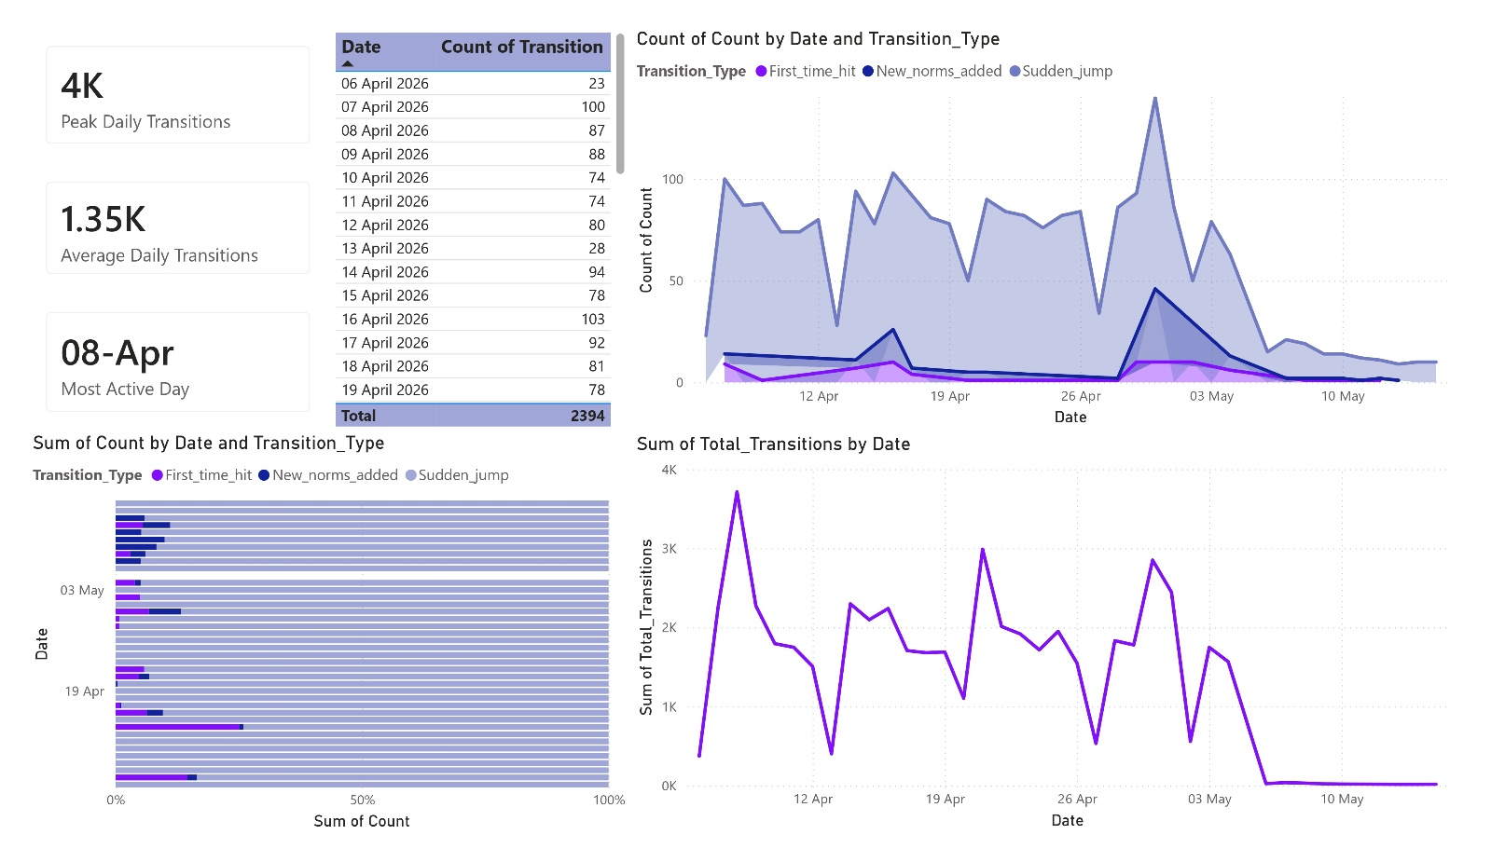

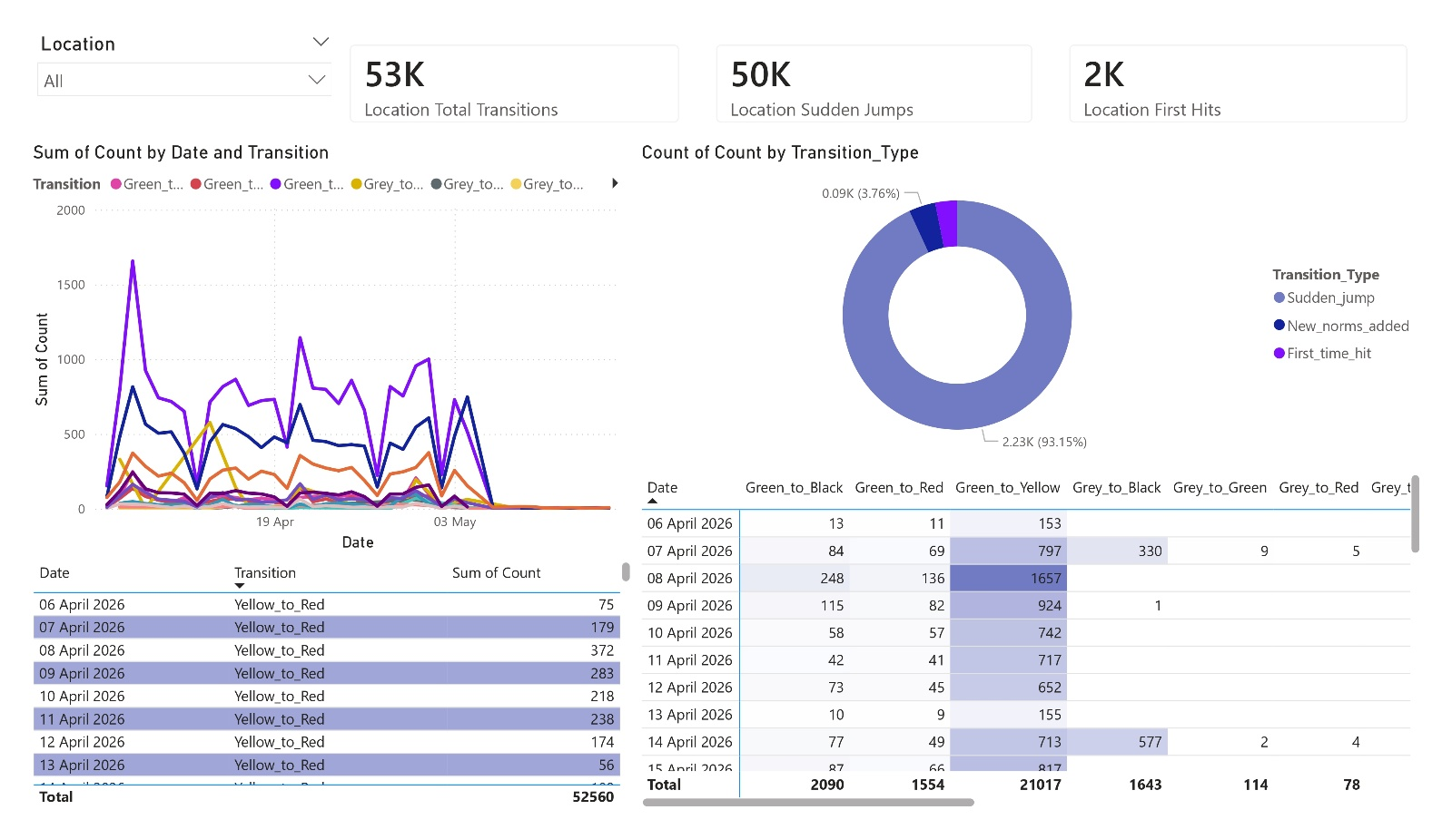

Conclusion
The project successfully analyzed large-scale behavior data and generated automated outputs using Python. Different metrics such as Jump Count, First Time Hit, and New Norms Added were calculated to understand changing patterns.
The generated Power BI dashboard made the analysis easier to understand through graphs, KPI cards, heatmaps, and tables.
This project improved understanding of:
- Data analysis
- Automation
- Pattern detection
- Dashboard development
- Real-world problem solving

Daily Work Summary
Day | Work Done
Day 1 | Requirement gathering and planning
Day 2 | Data understanding and preprocessing
Day 3 | Python script development
Day 4 | Optimization and count logic
Day 5 | Dashboard and report creation

