ER diagrams(put yours here)
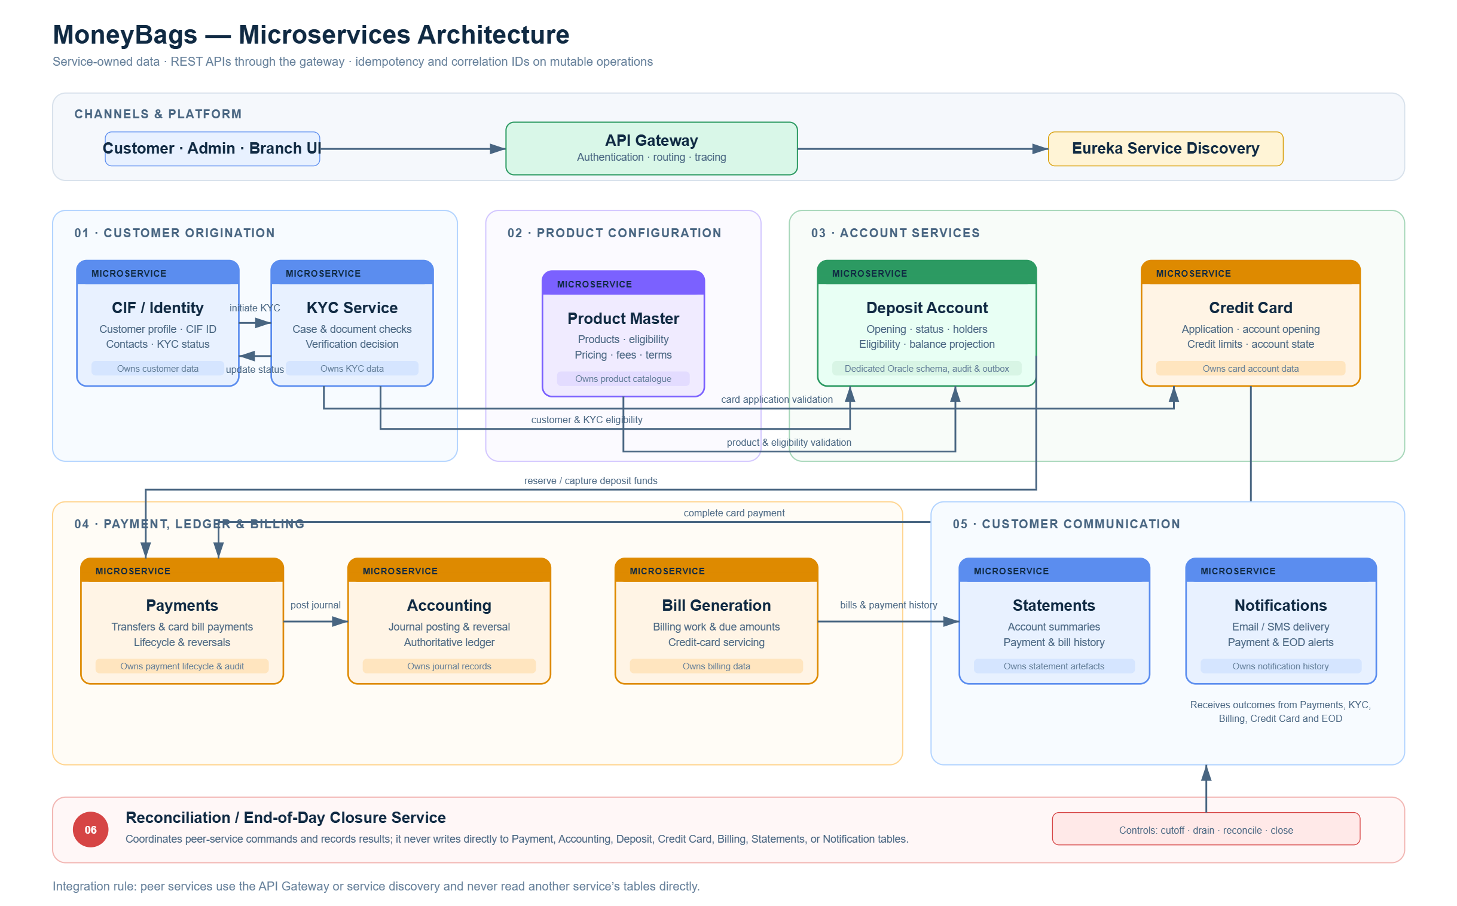
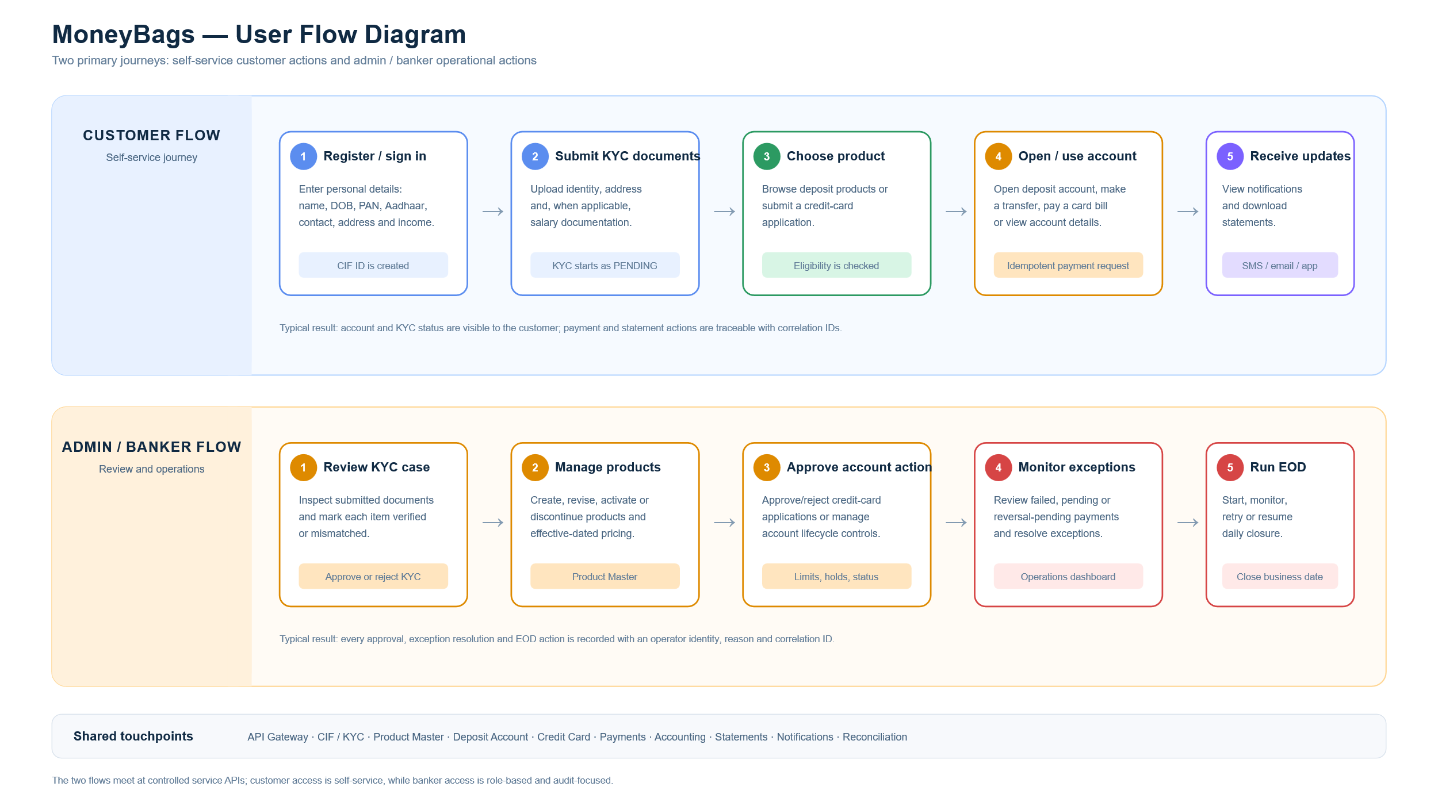
Use restclient, liquibase

Stage | functional area | service | member | Dependancies | ports
origination | CIF | identity | Bhavansh S | *** | 8081
origination | KYC & Compliance | KYC | Devansh | CIF | 8082
setup | Product Master | deposit | Gauresh | *** | 8083
 | credit card/ account creation | credit card | Devika | product master | 8084
orignation |  |  |  |  | 8085
 | Deposit Account-> account creation | deposit creation | Dhruv Hs | product master | 8086
servicing | Transaction/bill generation | bill generation | Dhruv V | credit card account creation | 8087
 | Payments | payment | Droov W | credit card account creation
servicing | Ledger & Accounting | accounting | Chinmay | credit card account creation | 8088
servicing | Statements | statements | Charuvi | credit card account creation | 8089
 | Notification(email/sms) | notification | Charuvi | credit card account creation | 8090
servicing | End-of-Day Closure | reconcilation | Drishti | credit card account creation | 8091

Product Master Service | API Contract Template
Service  PRODUCT-MASTER-SERVICE | Owner / squad  Gauresh Bagayatkar | Gateway base URL  :8080

Product Master owns reusable deposit, loan, and credit-card programme definitions. It publishes product lifecycle, eligibility, fees, effective-dated pricing, and credit-card terms for the frontend and peer microservices.
Peer services use the API gateway or service discovery and must not read PRODUCT_* tables directly. The gateway path is http://localhost:8080/api/products; port 8084 is the direct Product Master service URL.
Ownership boundary: Product Master does not issue cards or store PAN/CVV, customer-approved or available limits, balances, statements, authorisations, or card transactions. Those are owned by the Credit Card Issuance / Account service.

Exposed API inventory

Real endpoints with dummy JSON beside the API
Consumer | API | Purpose | Dummy JSON (request or response) | Notes
Frontend / Admin | POST /api/products | Create draft product | {"productCode":"SAV-001","productName":"Classic Savings","category":"DEPOSIT","effectiveFrom":"2026-08-10"}
Frontend | GET /api/products?category=DEPOSIT | List/filter products | {"content":[{"productCode":"SAV-001","status":"ACTIVE"}],"page":0,"size":20}
Frontend / Peer | GET /api/products/{productCode} | Get definition + rule groups | {"productCode":"SAV-001","currencyCode":"INR","fees":[],"features":[]} | 404 if absent
Frontend / Admin | PUT /api/products/{productCode} | Replace product definition | {"productName":"Classic Savings Plus","changedBy":"admin.user"} | Validated ProductRequest
Frontend / Admin | PATCH /api/products/{productCode}/status | Change lifecycle status | {"status":"ACTIVE","changedBy":"admin.user"} | DRAFT / ACTIVE / DISCONTINUED
Frontend / Admin | DELETE /api/products/{productCode} | Discontinue product | {"changedBy":"admin.user"} | 204 No Content
Frontend / Peer | GET /api/products/active | All effective active products | [{"productCode":"SAV-001","status":"ACTIVE"}] | Read-only catalogue
Frontend / Peer | GET /api/products/category/{category}/active | Active DEPOSIT or Credit products | [{"productCode":"HOME-001","category":"LOAN"}] | category enum path variable
Frontend / Peer | GET /api/products/{productCode}/eligibility | Get eligibility rules | [{"minimumAge":18,"customerType":"INDIVIDUAL","kycRequired":true}] | Rule DTO array
Frontend / Peer | GET /api/products/{productCode}/pricing | Get pricing configuration | {"productCode":"HOME-001","interestRule":{"pricingMode":"BENCHMARK_LINKED"}} | Product response shape
Deposit Account | POST /api/products/{productCode}/validate-account-opening | Validate account opening | Request: {"openingAmount":5000,"age":29,"customerType":"INDIVIDUAL","kycCompleted":true}  Response:  {  "eligible": true,  "validationMessages": [  "Product is active and available for account opening.",  "Opening amount meets the minimum balance requirement.",  "KYC requirement satisfied."  ],  "applicableFees": [  {  "feeType": "ACCOUNT_OPENING",  "feeAmount": 0.00,  "feePercentage": null,  "frequency": "ONE_TIME",  "active": true  }  ],  "applicableInterestRule": {  "annualInterestRate": 3.50,  "pricingMode": "FIXED",  "benchmarkCode": null,  "productSpread": null,  "minimumRate": 3.00,  "maximumRate": 4.00,  "targetProfitPercentage": null,  "effectiveFrom": "2026-01-01",  "effectiveTo": null,  "policyVersion": "V1",  "interestCalculationMethod": "DAILY_BALANCE",  "interestCalculationFrequency": "DAILY",  "interestPostingFrequency": "MONTHLY",  "loanRepaymentFrequency": null,  "interestType": "SIMPLE"  },  "applicableAmountRules": {  "minimumOpeningBalance": 1000.00,  "minimumBalance": 500.00,  "maximumBalance": 1000000.00,  "minimumAmount": null,  "maximumAmount": null,  "minimumTenureMonths": null,  "maximumTenureMonths": null,  "overdraftAllowed": false,  "overdraftLimit": null  }  } | Response has eligible, fees and rules
Loan Lending | POST /api/products/{productCode}/validate-loan-request | Validate loan request | DEPRECATED | Response has eligible, fees and rules
Frontend / Peer | GET /api/products/{productCode}/rate-quote?quoteDate=2026-08-10 | Calculate effective rate | {"offeredAnnualRate":7.25,"benchmarkCode":"RBI_REPO","policyVersion":"V2"} | principal/tenure for NPV_TARGET
Treasury Admin | POST /api/products/{productCode}/interest-policies | Add policy version | {"pricingMode":"FIXED","annualInterestRate":7.25,"policyVersion":"V2","effectiveFrom":"2026-09-01"} | 201 Created
Frontend / Peer | GET /api/products/{productCode}/interest-policies | List policy versions | [{"policyVersion":"V2","pricingMode":"FIXED"}] | Effective-dated policies
Credit Card Issuance | POST /api/products/{productCode}/validate-credit-card-application | Validate card application  Note: verify | POST /api/products/CC-PLAT-001/validate-credit-card-application  {"requestedCreditLimit":100000.00,"age":29,"monthlyIncome":85000.00,"customerType":"INDIVIDUAL","kycCompleted":true}  Response fields: eligible, validationMessages, applicableFees, applicableInterestRule, applicableCreditCardRule | The credit card rule has the fllowing as an eg:
Treasury Admin | POST /api/benchmarks | Publish benchmark | {"benchmarkCode":"RBI_REPO","annualRate":6.50,"effectiveFrom":"2026-08-10","createdBy":"treasury.user"} | 201 Created
Frontend / Peer | GET /api/benchmarks/{benchmarkCode}/effective?effectiveOn=2026-08-10 | Get effective benchmark | {"benchmarkCode":"RBI_REPO","annualRate":6.50,"effectiveFrom":"2026-08-10"} | 404 if no effective value
Frontend / Peer | GET /api/benchmarks/{benchmarkCode}/history | Get benchmark history | [{"annualRate":6.50,"effectiveFrom":"2026-08-10"}] | Chronological rate versions

Expected APIs / data from other microservices

Dependencies to confirm
Provider | API / data expected | Why Product Master needs it | SLA / fallback
Discovery Server | Eureka registry at /eureka/ | Service registration and peer resolution | Required at startup; configured default zone
API Gateway | Routed /api/products/** traffic + X-Correlation-ID | External entry point and request tracing | Gateway is the public access path
<Other provider> | [API or event] | [Business purpose] | [Timeout / fallback]

Contract completion checklist
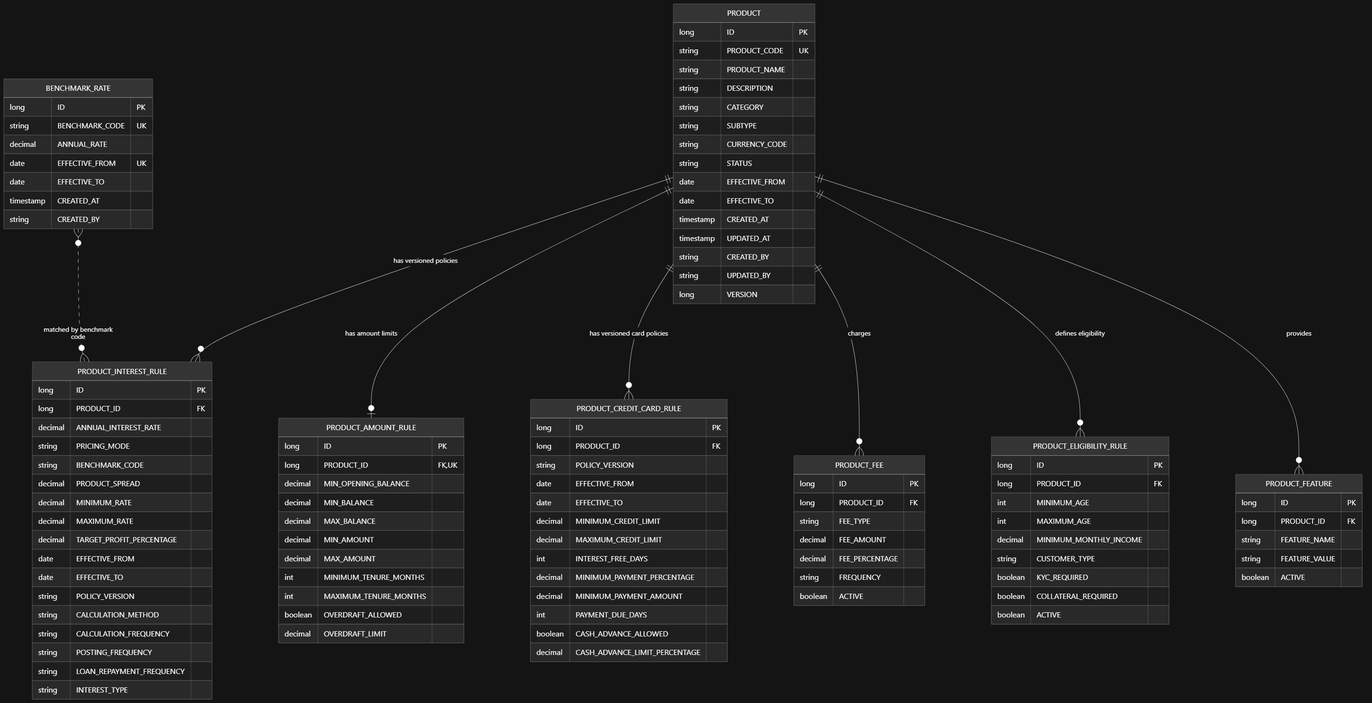

CIF Service

Table
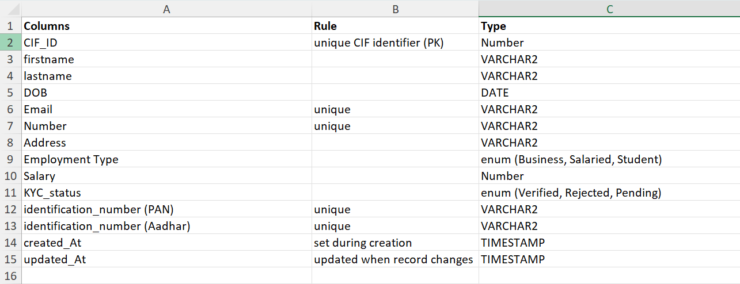
Scope :
- Customer will provide info: firstName, lastName, DOB, Email, Number, Address, Employment Type, Salary (Invalid incase of student), PAN, Aadhaar.
- After the user submits the details, CIF_ID will be autogenerated. KYC_status will be by default "PENDING".
- Then the CIF service will call an API of KYC service to send the data for KYC verification.
- KYC service will use CIF’s PATCH request API to update KYC_status in CIF table.

Expected API Call: POST request to KYC,

Exposed API Call:
- one for PATCH KYC-status
PATCH /api/v1/cifs/{cifId}/kyc-status

- one for details needed by credit card account creation,
GET /api/v1/cifs/{cifId}/credit-card-details

- one for details required by notifications & statements,
GET /api/v1/cifs/{cifId}/customer-contact-details

- one for details needed by deposit account creation
GET /api/v1/cifs/{cifId}/deposit-creation-details
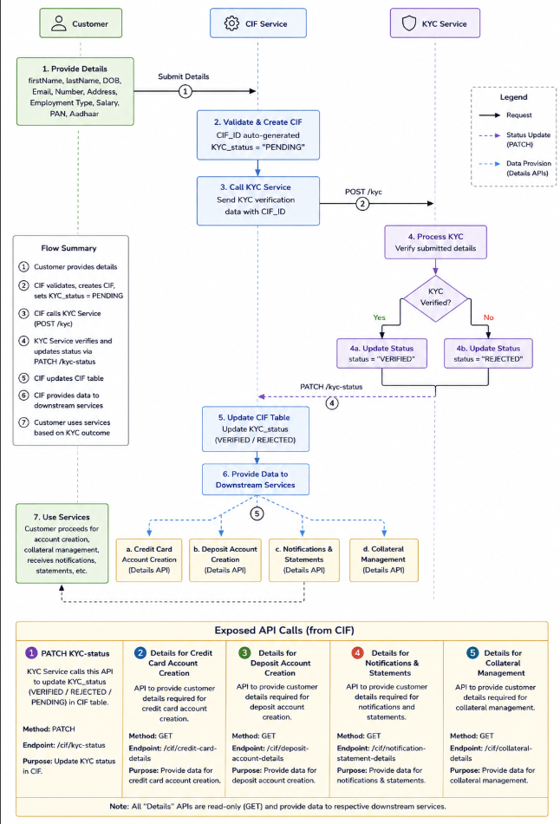

Deposit Account Service | API Contract Template
Service | Owner / squad | Gateway base URL
DEPOSIT-ACCOUNT-SERVICE | Dhruv Hogade

Scope:
The Deposit Account Service manages the lifecycle and configuration of customer deposit accounts created from Product Master products.
Its scope includes:
- Creating Savings, Current, Fixed Deposit, Recurring Deposit, and similar accounts using an approved product ID/version.
- Validating customer/KYC eligibility and product rules through CIF/KYC and Product Master.
- Generating account numbers and maintaining account status: pending activation, active, blocked, frozen, dormant, closing, and closed.
- Managing account holders, nominees, mandates, operating instructions, and account-level limits.
- Providing account details, balance projections, status history, and debit/credit eligibility to other services.
- Maintaining audit logs, correlation tracking, concurrency control, and idempotent account opening.

Exposed API inventory
Real endpoints with dummy JSON beside the API

Method | Endpoint | Purpose | Request / response note
POST | /api/v1/deposit-accounts | Open deposit account | Idempotency-Key; customerIds, productId, branch, amount
POST | /eligibility-check | Validate before opening | customerId, productId, productVersion, currency, amount
GET | /{accountId} | Account detail | Returns ETag/version
GET | / | Search accounts | customerId, status, page, size
GET | /{accountId}/balance | Balance projection | ledger, available, blocked, asOf
GET | /{accountId}/status-history | Lifecycle history | Append-only status changes
POST | /{accountId}/holders | Add holder | customerId, role, authorizationType
DELETE | /{accountId}/holders/{customerId} | Remove holder | Idempotency-Key
PUT | /{accountId}/nominees | Replace nominees | Nominee list and allocation
PUT | /{accountId}/limits/{limitType} | Upsert account limit | amount, currency, effective dates
POST | /{accountId}/mandates | Add mandate | authorizedCustomerId, type, dates
DELETE | /{accountId}/mandates/{mandateId} | Revoke mandate | Idempotency-Key
POST | /{accountId}/commands/{command} | Lifecycle command | reasonCode, reasonText, If-Match

All mutable operations require Idempotency-Key. Use X-Correlation-Id for traceability and ETag / If-Match where concurrent changes must be guarded.
Expected APIs / data from other microservices
Dependencies to confirm
Service | Current API / state | Deposit usage
CIF | GET /api/v1/cifs/{cifId}/deposit-creation-details | Validates customer ACTIVE status and KYC VERIFIED status
Product Master | GET /api/products/{productCode} | Reads product name, active state and currency
Product Master | POST /api/products/{productCode}/validate-account-opening | Validates opening amount, age, customer type and KYC completion
KYC | No direct Deposit call | CIF supplies synchronized KYC status
Branch Master / IFSC | Not implemented | Target: validate branch and snapshot IFSC
Ledger / Payment | Not implemented | Target: balance events, funding and closure checks

- 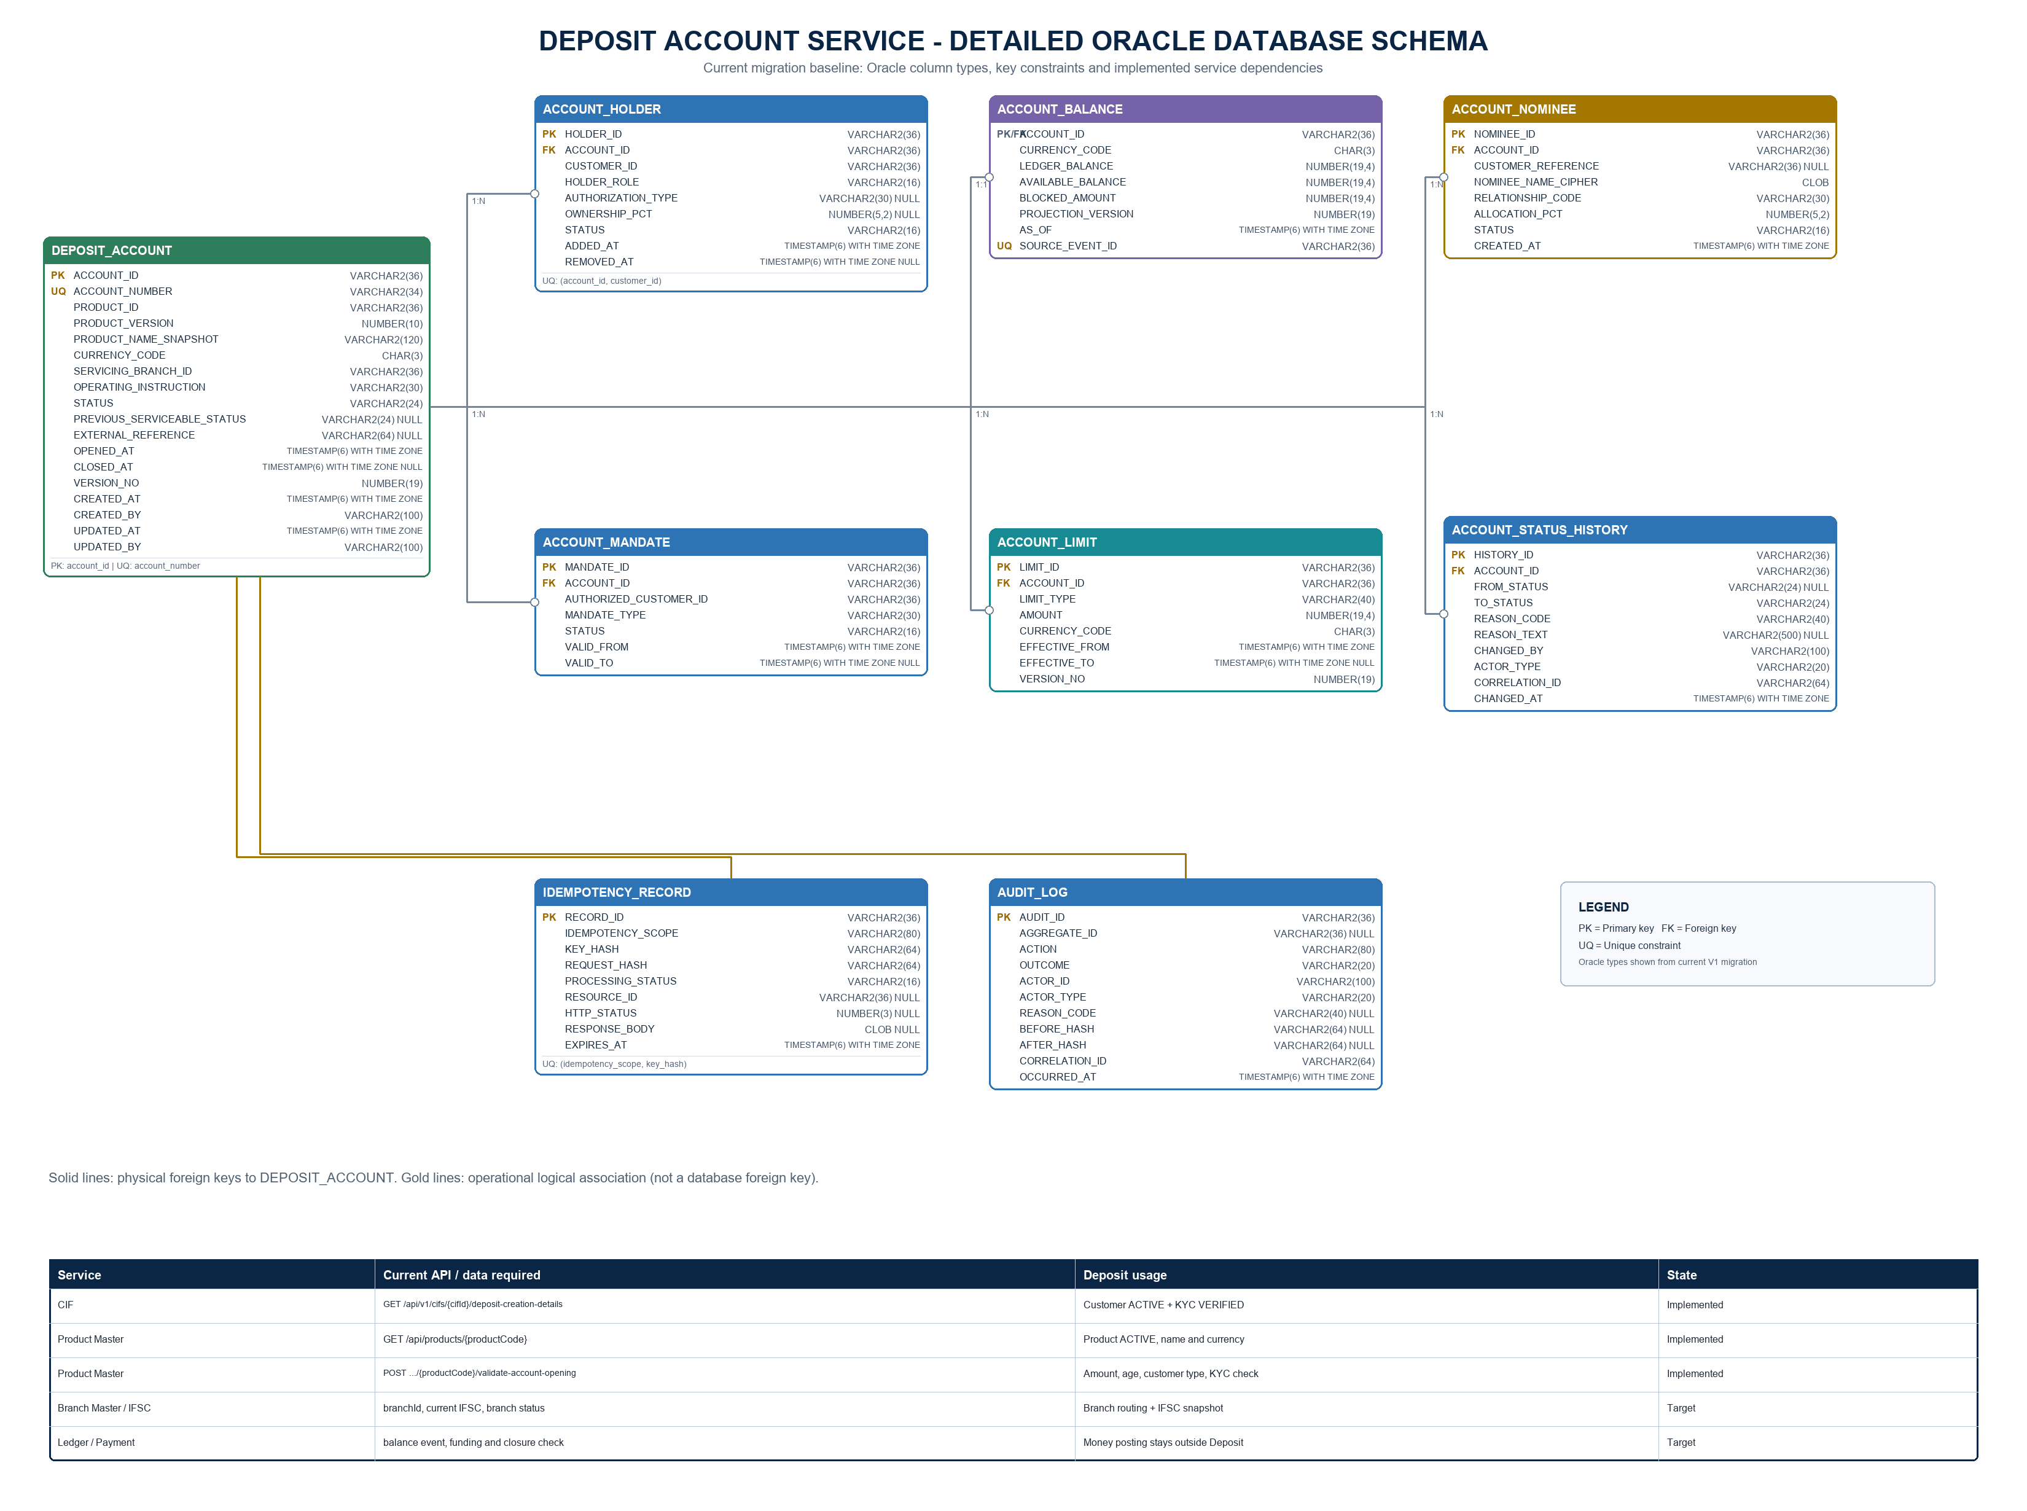

KYC

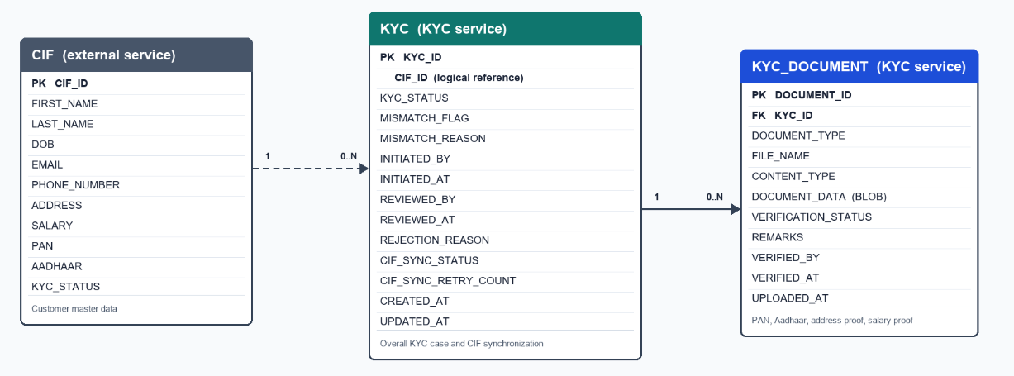

APIs exposed by KYC Service
These are APIs other systems or frontend users call on KYC.
Caller | Method & endpoint | Purpose
Frontend / CIF | POST /api/v1/kycs | Initiate a KYC case using cifId and initiatedBy
Frontend | POST /api/v1/kycs/{kycId}/documents | Upload PAN, Aadhaar, address proof, or salary proof
Frontend / Backoffice | GET /api/v1/kycs/{kycId} | Get KYC case and customer snapshot
Frontend / Backoffice | GET /api/v1/kycs?cifId={cifId} | Get all KYC cases for a customer
Frontend / Backoffice | GET /api/v1/kycs/{kycId}/documents | List document metadata and verification states
Frontend / Backoffice | GET /api/v1/kycs/{kycId}/documents/{documentId} | Download/preview a stored document
Verifier | PATCH /api/v1/kycs/{kycId}/documents/{documentId}/verification | Mark one document VERIFIED or MISMATCH
Reviewer | PATCH /api/v1/kycs/{kycId}/decision | Approve or reject the KYC case

CIF → KYC expected call
If CIF initiates the process, it calls the same KYC initiation API:
- POST /api/v1/kycs
Content-Type: application/json
{
"cifId": 1001,
"initiatedBy": "cif-service"
}
Get a KYC case, including customer snapshot
- GET /api/v1/kycs/{kycId}

Statements and Notifications
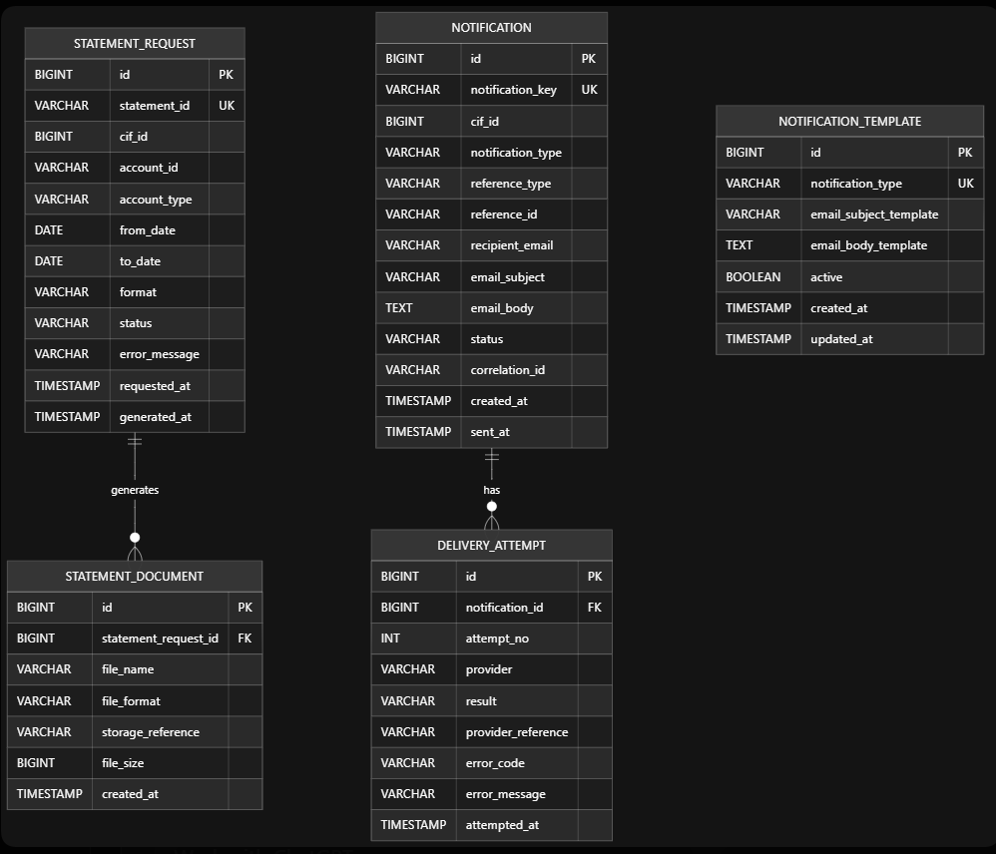

Statements module

Exposed API
- GET /api/statements/{statementId}/download
- POST /api/statements
- GET /api/statements/{statementId}

Expected API
- Deposit Service - GET /api/v1/deposit-accounts/{accountId}
- Payment Service - GET /internal/payments?accountId={accountId}&from={fromDate}&to={toDate}
- Credit Card Service - GET /internal/credit-card-accounts/{accountId}
- Bill Generation Service - GET /internal/bills?accountId={accountId}&billingPeriod={period}
- Identity/CIF - GET /internal/cif/{cifId}
- Notifications module - Internal Java service call

Notifications module

Exposed API
- KYC Service - POST /internal/notifications
- Payment Service - POST /internal/notifications
- Deposit / Deposit Creation Service - POST /internal/notifications
- Bill Generation Service - POST /internal/notifications
- Credit Card Service — POST /internal/notifications
- Statements module - Internal Java service call
- Frontend / Customer - GET /api/notifications?cifId={cifId}

Expected API
- Identity / CIF Service - GET /internal/cif/{cifId}

Payments Service | API Contract Template

Purpose
Payments Service orchestrates payment journeys. It receives customer payment requests, applies idempotency, coordinates Deposit Account, Credit Card, Accounting, and Notification services, and maintains the payment lifecycle.
Payments does not own deposit balances, card limits, accounting journals, customer contact details, or notification delivery.

Scope
- Internal book transfers between two deposit accounts.
- Credit-card bill repayment from a deposit account.
- Future merchant payment using a credit card.
- Payment request validation, idempotency, status, retries, and audit trail.
- Coordinate deposit fund reservation, debit, and book-transfer settlement.
- Coordinate Credit Card hold, capture, repayment application, and reversal.
- Request Accounting journal posting/reversal.
- Trigger payment outcome notifications.
- Provide settled payment history to Statements and EOD/Reconciliation.

Ownership boundary
Payments owns | Payments does not own
Payment request and payment ID | Deposit account balances/reservations
Payment status and history | Card outstanding/available limit
Idempotency and request fingerprint | Accounting journals/GL rules
Integration references | Customer email/mobile
Retry, failure, reversal orchestration | SMS/email delivery

Payment statuses
PENDING_VALIDATION
PENDING_RESERVATION
PENDING_ACCOUNTING
PENDING_SETTLEMENT
SETTLED
FAILED
CANCELLED
REVERSAL_PENDING
REVERSED

Payments Service dependency diagram
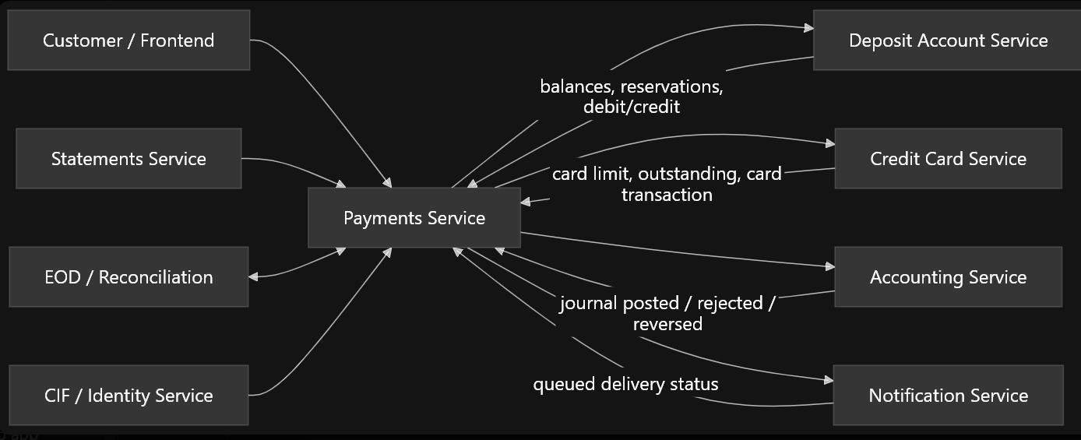

Payments-owned tables

1. PAYMENT
Column | Purpose
payment_id | Unique payment identifier
requestor_cif_id | Customer who initiated the payment
idempotency_key | Prevent duplicate customer requests
request_fingerprint | Detect same key used with different data
payment_type | BOOK_TRANSFER, CREDIT_CARD_REPAYMENT, CREDIT_CARD_MERCHANT_PAYMENT
source_instrument_type | DEPOSIT_ACCOUNT or CREDIT_CARD_ACCOUNT
source_account_id | Source account/card reference
destination_instrument_type | DEPOSIT_ACCOUNT, CREDIT_CARD_ACCOUNT, or MERCHANT
destination_account_id | Target deposit/card account where applicable
merchant_id | Merchant reference for merchant payment
amount | Payment amount
currency_code | Currency, initially INR
status | Current payment lifecycle status
reference | Customer-facing payment narration
deposit_reservation_id | Deposit hold reference
card_authorization_id | Credit Card hold reference
accounting_journal_number | Accounting journal reference
provider_reference | Merchant gateway/provider reference
failure_code | Safe machine-readable failure reason
failure_message | Safe customer/operations failure description
correlation_id | End-to-end trace ID
created_at | Payment creation time
updated_at | Last status update
settled_at | Final settlement time
version | Optimistic-locking version
Constraints:
UNIQUE (payment_id)
UNIQUE (requestor_cif_id, idempotency_key)
INDEX (source_account_id, created_at)
INDEX (destination_account_id, created_at)
INDEX (status, updated_at)

2. PAYMENT_STATUS_HISTORY
Column | Purpose
id | Unique status-history ID
payment_id | Related payment
from_status | Previous status
to_status | New status
reason_code | Transition reason
reason_message | Explanation for audit/operations
correlation_id | Trace reference
changed_at | Status-change time

3. PAYMENT_ATTEMPT
Column | Purpose
attempt_id | Unique attempt ID
payment_id | Related payment
attempt_type | DEPOSIT_RESERVE, CARD_CAPTURE, ACCOUNTING_POST, etc.
target_service | Deposit, Credit Card, Accounting, or Provider
external_reference | Reservation, card transaction, or provider reference
status | Attempt result
response_code | Peer-service/provider response code
created_at | Attempt start
completed_at | Attempt completion

4. PAYMENT_OUTBOX
Column | Purpose
event_id | Unique event identifier
payment_id | Payment that produced the event
event_type | PAYMENT_SETTLED, PAYMENT_FAILED, etc.
payload | Event payload
correlation_id | Trace reference
created_at | Event creation time
published_at | Broker publication time
publish_attempts | Retry count
last_error | Last publication error

5. PAYMENT_INBOX
Column | Purpose
id | Unique inbox record
consumer_name | Consumer/handler name
event_id | Received peer event identifier
event_type | Event type
received_at | Receipt time
processed_at | Processing completion time
status | RECEIVED, PROCESSED, or FAILED
error_message | Processing failure details

Payments ER diagram
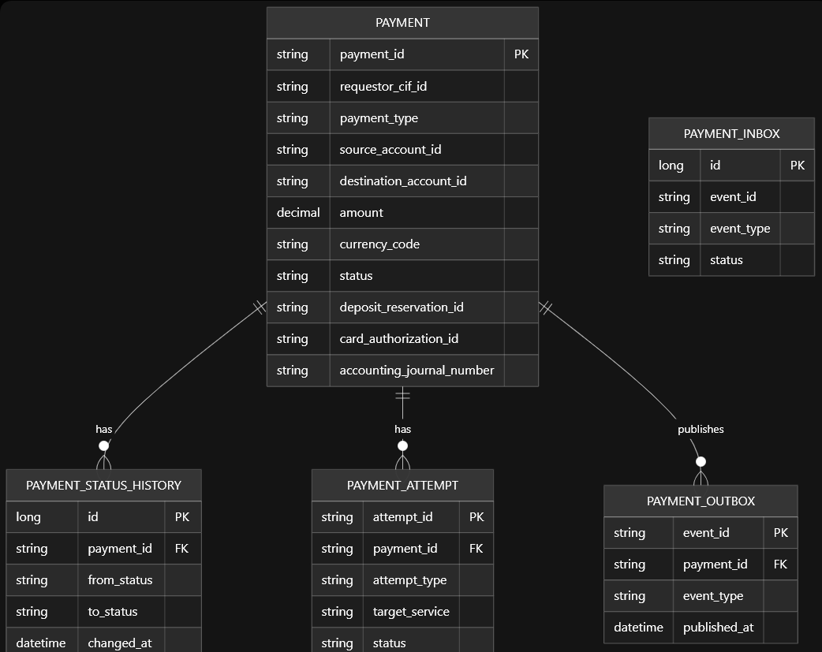

Book transfer workflow
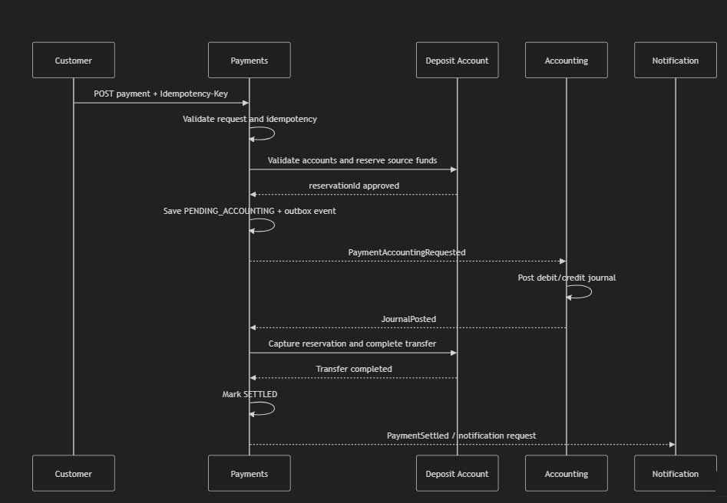
CREDIT TRANSFER TO MERCHANT WORKFLOW
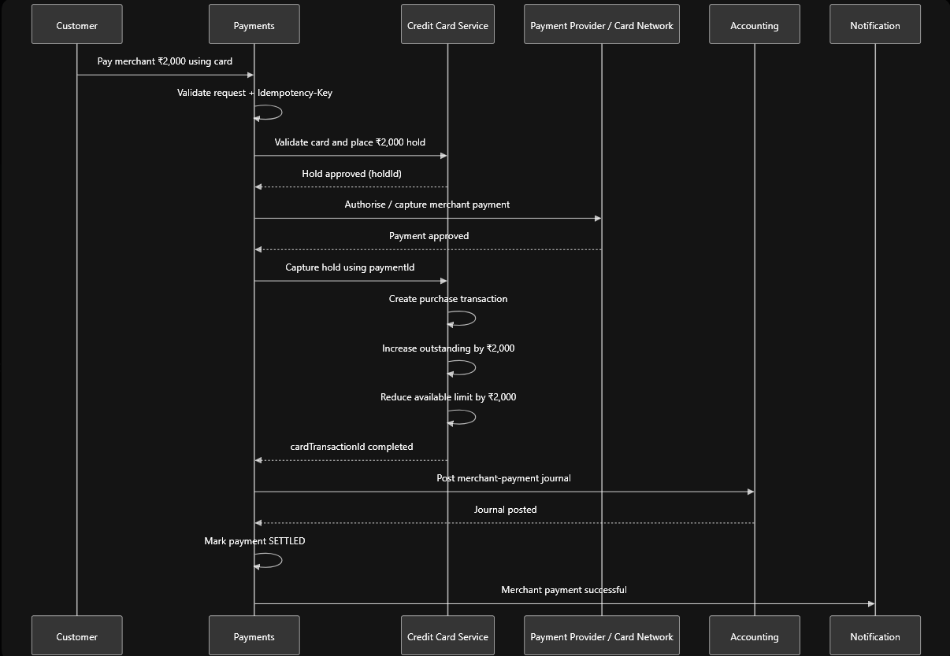

CREDIT REPAMENT BY CUSTOMER OF OUTSTANDING AMOUNT
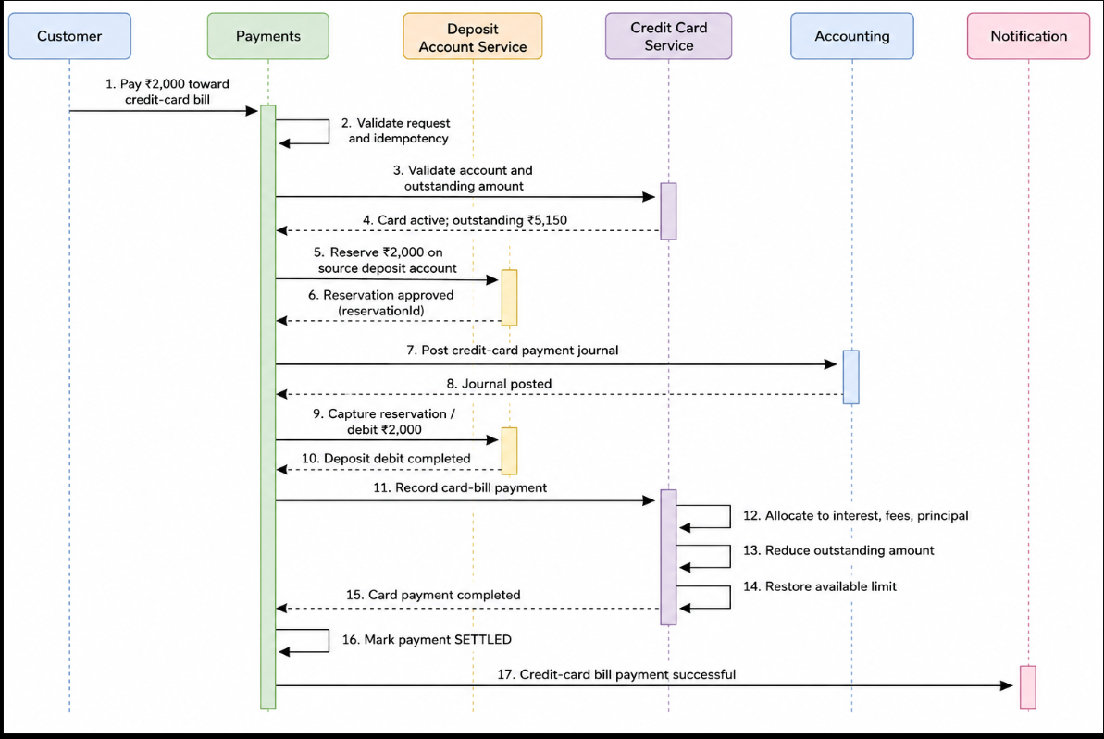

If Accounting posts the journal but Deposit settlement fails, Payments must request an accounting reversal and move to REVERSAL_PENDING.

Payments Service exposed APIs
Required | Method | Endpoint | Purpose
Now | POST | /api/v1/payments/book-transfers | Create internal deposit-account transfer
Now | POST | /api/v1/payments/credit-card-payment/repayment | Repay card debt from a deposit account
Future | POST | /api/v1/payments/credit-card-payment/merchant-payment | Pay merchant using credit-card limit
Now | GET | /api/v1/payments/{paymentId} | Retrieve payment status
Now | POST | /api/v1/payments/{paymentId}/cancel | Cancel before final settlement
Now | GET | /internal/payments?accountId=&from=&to= | Settled payment history for Statements

APIs Payments expects from other services

Deposit Account Service
Required | Endpoint | Purpose
Now | POST /internal/v1/deposit-payment-operations/book-transfers/reservations | Validate accounts and reserve source funds for book transfer
Now | POST /internal/v1/deposit-payment-operations/book-transfers/{paymentId}/settle | Atomically debit source and credit target
Now | POST /internal/v1/deposit-payment-operations/credit-card-repayments/reservations | Reserve customer deposit funds for card repayment
Now | POST /internal/v1/deposit-payment-operations/credit-card-repayments/{paymentId}/capture | Debit deposit account after successful reservation
Now | POST /internal/v1/deposit-payment-operations/reservations/{reservationId}/release | Release failed/cancelled reservation
Now | GET /internal/v1/deposit-payment-operations/{paymentId} | Recover operation outcome after timeout/retry

Credit Card Service
Required | Endpoint | Purpose
Now | POST /internal/v1/credit-card-payment-operations/repayments/validate | Validate card account and outstanding amount
Now | POST /internal/v1/credit-card-payment-operations/repayments/{paymentId}/apply | Apply repayment to fees, interest, and principal
Future | POST /internal/v1/credit-card-payment-operations/merchant-payments/authorizations | Validate card and place temporary limit hold
Future | POST /internal/v1/credit-card-payment-operations/merchant-payments/{paymentId}/capture | Convert approved hold into completed purchase
Future | POST /internal/v1/credit-card-payment-operations/authorizations/{authorizationId}/release | Release card hold after failure/cancellation
Future | POST /internal/v1/credit-card-payment-operations/merchant-payments/{paymentId}/reversal | Reverse/refund completed card purchase
Now | GET /internal/v1/credit-card-payment-operations/{paymentId} | Recover card-operation outcome after timeout

Accounting Service
Required | Endpoint | Purpose
Now, extend request | POST /internal/payment-postings/settlements | Post journal for book transfer, card repayment, or merchant payment
Now | GET /internal/payment-postings/by-reference/{reference} | Resolve uncertain journal-posting outcome
Now | POST /internal/journals/{journalNumber}/reversals | Reverse journal when downstream settlement fails
Future | POST /internal/payment-postings/refunds | Post merchant-payment refund journal

Accounting request must include:
paymentId
paymentType
source instrument and account ID
destination instrument and account/merchant ID
amount
currencyCode
occurredAt
businessDate
correlationId

Notification Service
Required | Endpoint | Purpose
Now | POST /internal/v1/notifications | Queue payment success, failure, cancellation, or reversal notification
Payments sends messageId, paymentId, cifId, notification type, amount, masked account/card references, and card-repayment allocation where applicable.

Accounting Service

Service URLs
- Direct service URL: http://localhost:8089
- API Gateway URL: http://localhost:8080
- Swagger UI: http://localhost:8089/swagger-ui.html
- Eureka service name: ACCOUNTING-SERVICE
The gateway exposes the public /api/** accounting query and administration paths. The /internal/** paths are service-to-service or controlled operational APIs and are not routed through the API Gateway.

Purpose
Accounting is the authoritative double-entry financial record for Moneybags. It converts accepted financial business facts into immutable, balanced journals and owns the chart of accounts, accounting rules, subledger-to-GL mappings, posting sequence, accounting periods, trial balances, reconciliation results, and accounting transactional outbox.
Every successful journal must satisfy:
totalDebit = totalCredit
Posted journals are never edited or deleted. A correction is represented by a new journal containing the opposite entries.

Ownership boundary
Accounting owns:
- GL accounts and their status.
- Effective-dated accounting rules and versions.
- Effective-dated subledger-to-GL mappings.
- Posting requests and idempotency outcomes.
- Journals, journal lines, and journal sequence.
- Journal reversals.
- Trial-balance runs and snapshots.
- Accounting periods.
- Payments reconciliation runs and exception items.
- Accounting outbox records.
Accounting does not own payment lifecycle, deposit balances, reservations, credit-card limits or outstanding balances, customer/CIF information, KYC information, product definitions, statements, notifications, or EOD scheduling. Peer services must not read Accounting tables directly.
Accounting has no direct Loan service dependency. It also does not call Deposit Account or Credit Card APIs. The Payments service passes opaque source references needed for posting, while the EOD service passes reconciliation control totals.

Functional scope
- Receive finalized payment settlement facts from Payments.
- Receive completed payment refund facts from Payments.
- Resolve the applicable effective-dated accounting rule.
- Create immutable double-entry journals.
- Prevent duplicate financial posting through source identifiers and request hashing.
- Return authoritative journal details and posting outcomes.
- Reverse a posted journal without modifying the original.
- Maintain GL accounts, accounting rules, and mappings.
- Generate and persist trial balances.
- Reconcile Payments control totals supplied by EOD.
- Track and resolve reconciliation exceptions.
- Open and close accounting periods.
- Persist JournalPosted, JournalRejected, and reconciliation-exception outbox records.

Exposed API inventory

Payment posting APIs
Consumer | API | Purpose | Notes
Payments | POST /internal/payment-postings/settlements | Post a settled merchant-payment fact | Same payment and same content returns the original journal; changed content returns 409.
Payments | POST /internal/payment-postings/refunds | Post a completed merchant-payment refund | Links the refund to the original paymentId.
Payments | GET /internal/payment-postings/by-reference/{reference} | Resolve an uncertain posting outcome | Returns POSTED or REJECTED and the journal when available.

Journal APIs
Consumer | API | Purpose | Notes
Frontend / Audit / Statements | GET /api/journals/{journalNumber} | Get an authoritative journal and its lines | 404 if absent.
Frontend / Audit / EOD | GET /api/journals?businessDate=&sourceService=&eventType= | Search journals | All filters are optional.
Payments / Accounting Operations | POST /internal/journals/{journalNumber}/reversals | Create an immutable opposite journal | Requires Idempotency-Key; an already reversed journal cannot be reversed again.

GL account APIs
Consumer | API | Purpose | Notes
Accounting Admin | POST /api/gl-accounts | Create a GL account | GL code must be unique.
Frontend / Accounting Admin | GET /api/gl-accounts | List GL accounts | Includes active and inactive accounts.
Frontend / Accounting Admin | GET /api/gl-accounts/{glCode} | Get a GL account | 404 if absent.
Accounting Admin | PATCH /api/gl-accounts/{glCode}/status | Activate or deactivate an account | Existing journal history is unchanged.

Accounting-rule APIs
Consumer | API | Purpose | Notes
Accounting Admin | POST /api/accounting-rules | Create an effective-dated rule version | Defines debit and credit mapping codes.
Frontend / Accounting Admin | GET /api/accounting-rules | List rule versions | New versions do not modify historical journals.

Subledger-mapping APIs
Consumer | API | Purpose | Notes
Accounting Admin | POST /api/subledger-mappings | Map a logical posting role to a GL account | Effective-dated and currency-specific.
Frontend / Accounting Admin | GET /api/subledger-mappings | List mappings | Used to explain current accounting configuration.

Trial-balance APIs
Consumer | API | Purpose | Notes
EOD / Accounting Operations | POST /internal/trial-balance | Generate and persist a trial balance | Aggregates posted journal lines by GL.
Frontend / Audit / EOD | GET /api/trial-balances/{runId} | Get a persisted trial balance | Shows debit, credit, closing balance, and balanced status.

Reconciliation APIs
Consumer | API | Purpose | Notes
EOD Processing | POST /internal/eod/reconciliation/runs | Compare EOD Payments totals with Accounting journals | Reconciled service is fixed to PAYMENTS-SERVICE.
Frontend / EOD / Audit | GET /api/reconciliation/runs/{runId} | Get expected and actual totals and exceptions | 404 if absent.
Accounting Operations | PATCH /api/reconciliation/runs/{runId}/items/{itemId}/resolution | Resolve or accept a reconciliation difference | Records resolver, explanation, and timestamp.

Accounting-period APIs
Consumer | API | Purpose | Notes
Accounting Operations / EOD | POST /internal/accounting-periods/{date}/open | Open a business date | Uses X-Actor-ID.
Accounting Operations / EOD | POST /internal/accounting-periods/{date}/close | Close a business date | Requires balanced trial balance, reconciliation, and no open blocking item.
Frontend / Peer | GET /api/accounting-periods/{date} | Get period status | Returns OPEN, CLOSING, or CLOSED.

Expected APIs / data from other microservices
Provider | API / data expected | Why Accounting needs it | Retry / fallback
Discovery Server | Eureka registry at /eureka/ | Service registration and resolution | Accounting can still run locally if discovery is disabled.
API Gateway | Routed public /api/journals/**, /api/gl-accounts/**, /api/accounting-rules/**, /api/subledger-mappings/**, /api/trial-balances/**, /api/reconciliation/**, and /api/accounting-periods/** traffic | External entry point and correlation propagation | Internal endpoints are not public gateway routes.
Payments | Settlement: paymentId, merchantId, amount, currencyCode, occurredAt, businessDate | Creates a payment settlement journal | Retry the same payment safely; use posting-outcome lookup after a timeout.
Payments | Refund: refundId, paymentId, merchantId, amount, currencyCode, occurredAt, businessDate | Creates a refund journal linked to its payment | Retry the same refund safely.
Payments | Reversal: original journalNumber, new idempotency key, businessDate, occurredAt, and reason | Reverses accounting if downstream settlement fails | Repeated identical request returns the original reversal.
EOD Processing | eodRunId, businessDate, currencyCode, expectedJournalCount, expectedTotalDebit | Reconciles Payments control totals with Accounting | Same EOD run and same totals return the existing result; changed totals return 409.
No fields or APIs are required directly from Credit Card, Deposit Account, Product Master, CIF/Identity, KYC, Statements, Notification, Collateral, Bill Generation, or Loan services.

Events / outbox records
Event | Producer | Intended consumer | Purpose
JournalPosted | Accounting | Payments, Statements, EOD | A source fact or reversal became part of the books.
JournalRejected | Accounting | Payments, Operations | A validly received posting failed an accounting control.
ReconciliationExceptionRaised | Accounting | EOD, Operations | Expected and actual Payments totals differed.
These records currently persist transactionally in OUTBOX_EVENT. A broker relay is still required before they are delivered through Kafka or RabbitMQ. The shared event envelope should ultimately contain eventId, paymentId when applicable, correlationId, eventType, occurredAt, and schemaVersion.

Current Payments-contract alignment note
The currently implemented settlement/refund endpoints support the merchant-settlement model only. The newer Payments contract also defines BOOK_TRANSFER and CREDIT_CARD_PAYMENT. Supporting those types requires extending the posting request with paymentType, source.instrumentType, source.accountId, destination.instrumentType, and destination.accountId, plus adding the corresponding deposit-liability and credit-card-receivable GL rules. Accounting should be invoked while Payments is in PENDING_ACCOUNTING; SETTLED must be assigned only after journal posting and target settlement both succeed.

JSON examples for exposed APIs

1. Post payment settlement
POST /internal/payment-postings/settlements
Request:
{
"paymentId": "payment-1001",
"merchantId": "merchant-501",
"amount": 1250.00,
"currencyCode": "INR",
"occurredAt": "2026-08-11T10:30:00Z",
"businessDate": "2026-08-11"
}
Response:
{
"journalNumber": "JRN-20260811-00000001",
"postingSequence": 1,
"externalReference": "PAYMENT:payment-1001:SETTLED",
"sourceService": "PAYMENTS-SERVICE",
"eventType": "PAYMENT_SETTLED",
"occurredAt": "2026-08-11T10:30:00Z",
"businessDate": "2026-08-11",
"currencyCode": "INR",
"status": "POSTED",
"totalDebit": 1250.00,
"totalCredit": 1250.00,
"appliedRules": "PAYMENT_SETTLED_PRINCIPAL:v1",
"originalReference": "payment-1001",
"correlationId": "trace-payment-1001",
"postedAt": "2026-08-11T10:30:01Z",
"idempotentReplay": false,
"lines": [
{
"lineNumber": 1,
"glCode": "BANK_SETTLEMENT",
"glAccountName": "Bank Settlement Account",
"componentType": "PRINCIPAL",
"ruleCode": "PAYMENT_SETTLED_PRINCIPAL",
"ruleVersion": 1,
"debitAmount": 1250.00,
"creditAmount": 0,
"narration": "Settled payment payment-1001"
},
{
"lineNumber": 2,
"glCode": "MERCHANT_SETTLEMENT_PAYABLE",
"glAccountName": "Merchant Settlement Payable",
"subledgerReference": "merchant-501",
"componentType": "PRINCIPAL",
"ruleCode": "PAYMENT_SETTLED_PRINCIPAL",
"ruleVersion": 1,
"debitAmount": 0,
"creditAmount": 1250.00,
"narration": "Settled payment payment-1001"
}
]
}

2. Post completed refund
POST /internal/payment-postings/refunds
{
"refundId": "refund-2001",
"paymentId": "payment-1001",
"merchantId": "merchant-501",
"amount": 250.00,
"currencyCode": "INR",
"occurredAt": "2026-08-11T12:15:00Z",
"businessDate": "2026-08-11"
}
The response has the same journal structure. Its first line debits MERCHANT_SETTLEMENT_PAYABLE, its second line credits BANK_SETTLEMENT, and eventType is PAYMENT_REFUNDED.

3. Resolve posting outcome
GET /internal/payment-postings/by-reference/PAYMENT%3Apayment-1001%3ASETTLED
{
"externalReference": "PAYMENT:payment-1001:SETTLED",
"outcome": "POSTED",
"journalNumber": "JRN-20260811-00000001",
"receivedAt": "2026-08-11T10:30:01Z",
"completedAt": "2026-08-11T10:30:01Z",
"journal": {
"journalNumber": "JRN-20260811-00000001",
"status": "POSTED",
"totalDebit": 1250.00,
"totalCredit": 1250.00
}
}

4. Get or search journals
GET /api/journals/JRN-20260811-00000001
Returns the complete journal structure shown in example 1.
GET /api/journals?businessDate=2026-08-11&sourceService=PAYMENTS-SERVICE&eventType=PAYMENT_SETTLED
[
{
"journalNumber": "JRN-20260811-00000001",
"externalReference": "PAYMENT:payment-1001:SETTLED",
"eventType": "PAYMENT_SETTLED",
"businessDate": "2026-08-11",
"currencyCode": "INR",
"status": "POSTED",
"totalDebit": 1250.00,
"totalCredit": 1250.00,
"lines": []
}
]

5. Reverse a journal
POST /internal/journals/JRN-20260811-00000001/reversals
Headers:
Idempotency-Key: PAYMENT:payment-1001:REVERSAL
X-Correlation-ID: trace-payment-1001
Request:
{
"businessDate": "2026-08-11",
"occurredAt": "2026-08-11T10:35:00Z",
"reason": "Deposit settlement failed after accounting posting"
}
Response excerpt:
{
"journalNumber": "JRN-20260811-00000002",
"externalReference": "PAYMENT:payment-1001:REVERSAL",
"eventType": "JOURNAL_REVERSAL",
"status": "REVERSAL",
"reversalOfJournalNumber": "JRN-20260811-00000001",
"totalDebit": 1250.00,
"totalCredit": 1250.00,
"idempotentReplay": false
}

6. Create, list, get, or deactivate a GL account
POST /api/gl-accounts
{
"glCode": "CREDIT_CARD_RECEIVABLE",
"name": "Credit Card Receivable",
"accountType": "ASSET",
"normalBalance": "DEBIT",
"currencyCode": "INR",
"parentGlCode": null,
"status": "ACTIVE",
"createdBy": "accounting.admin"
}
GET /api/gl-accounts returns an array of the same response shape. GET /api/gl-accounts/CREDIT_CARD_RECEIVABLE returns one object.
PATCH /api/gl-accounts/CREDIT_CARD_RECEIVABLE/status
{
"status": "INACTIVE"
}

7. Create or list accounting rules
POST /api/accounting-rules
{
"ruleCode": "CREDIT_CARD_PAYMENT_PRINCIPAL",
"eventType": "CREDIT_CARD_PAYMENT",
"componentType": "PRINCIPAL",
"productCode": null,
"currencyCode": "INR",
"version": 1,
"debitMappingCode": "CUSTOMER_DEPOSIT_LIABILITY",
"creditMappingCode": "CREDIT_CARD_RECEIVABLE",
"debitReferenceRole": "SOURCE_ACCOUNT",
"creditReferenceRole": "DESTINATION_ACCOUNT",
"effectiveFrom": "2026-08-11",
"effectiveTo": null,
"status": "ACTIVE",
"createdBy": "accounting.admin"
}
GET /api/accounting-rules
[
{
"id": 3,
"ruleCode": "CREDIT_CARD_PAYMENT_PRINCIPAL",
"eventType": "CREDIT_CARD_PAYMENT",
"componentType": "PRINCIPAL",
"currencyCode": "INR",
"version": 1,
"debitMappingCode": "CUSTOMER_DEPOSIT_LIABILITY",
"creditMappingCode": "CREDIT_CARD_RECEIVABLE",
"status": "ACTIVE",
"effectiveFrom": "2026-08-11",
"createdBy": "accounting.admin"
}
]

8. Create or list a subledger mapping
POST /api/subledger-mappings
{
"mappingCode": "CREDIT_CARD_RECEIVABLE",
"productCode": null,
"currencyCode": "INR",
"glCode": "CREDIT_CARD_RECEIVABLE",
"effectiveFrom": "2026-08-11",
"effectiveTo": null,
"status": "ACTIVE",
"createdBy": "accounting.admin"
}
GET /api/subledger-mappings returns an array containing id, mapping fields, status, creation time, and creator.

9. Generate or retrieve a trial balance
POST /internal/trial-balance
{
"businessDate": "2026-08-11",
"currencyCode": "INR",
"generatedBy": "eod-service"
}
GET /api/trial-balances/101 or the POST response:
{
"runId": 101,
"businessDate": "2026-08-11",
"currencyCode": "INR",
"totalDebit": 9754200.00,
"totalCredit": 9754200.00,
"balanced": true,
"generatedAt": "2026-08-11T18:05:00Z",
"generatedBy": "eod-service",
"lines": [
{
"glCode": "BANK_SETTLEMENT",
"glAccountName": "Bank Settlement Account",
"accountType": "ASSET",
"normalBalance": "DEBIT",
"debitTotal": 9754200.00,
"creditTotal": 250000.00,
"closingBalance": 9504200.00
}
]
}

10. Run, get, or resolve reconciliation
POST /internal/eod/reconciliation/runs
{
"eodRunId": "EOD-20260811-INR-PAYMENTS",
"businessDate": "2026-08-11",
"currencyCode": "INR",
"expectedJournalCount": 1842,
"expectedTotalDebit": 9754200.00
}
GET /api/reconciliation/runs/501 or the POST response:
{
"runId": 501,
"reconciledService": "PAYMENTS-SERVICE",
"businessDate": "2026-08-11",
"currencyCode": "INR",
"eodRunId": "EOD-20260811-INR-PAYMENTS",
"status": "COMPLETED",
"expectedJournalCount": 1842,
"actualJournalCount": 1841,
"expectedTotalDebit": 9754200.00,
"actualTotalDebit": 9749200.00,
"startedAt": "2026-08-11T18:10:00Z",
"completedAt": "2026-08-11T18:10:01Z",
"items": [
{
"id": 601,
"reference": "EOD-20260811-INR-PAYMENTS",
"expectedAmount": 9754200.00,
"actualAmount": 9749200.00,
"difference": -5000.00,
"blocking": true,
"status": "OPEN"
}
]
}
PATCH /api/reconciliation/runs/501/items/601/resolution
{
"resolution": "Late payment journal posted and verified against the Payments extract",
"resolvedBy": "accounting.operator",
"accepted": false
}

11. Open, close, or get an accounting period
POST /internal/accounting-periods/2026-08-11/open
Header:
X-Actor-ID: eod-service
POST /internal/accounting-periods/2026-08-11/close uses the same header.
GET /api/accounting-periods/2026-08-11 or an open/close response:
```json { "periodDate": "2026-08-11", "status": "CLOSED", "openedAt": "2026-08-11T00:00:01Z", "openedBy": "system", "closedAt": "2026-08-11T18:30:00Z", "closedBy": "eod-service"

Credit Card Service

Scope
The Credit Card Service is responsible for:
- Credit card application
- Credit card account opening
- Credit limit tracking
- Maintaining the customer's current credit-account state
- Providing account/limit information to Transaction, Payment, Bill Generation, EOD, and other authorized internal services
The service does not own:
- ledger/accounting records
- bill generation
- statement generation
- transaction processing itself
Those are handled by their respective microservices.
1. CREDIT_CARD_APPLICATION
Column Name | Purpose
APPLICATION_ID | Unique application identifier (PK)
CIF_ID | Customer applying for the credit card
PRODUCT_CODE | Credit-card product selected from Product Master
REQUESTED_CREDIT_LIMIT | Credit limit requested by customer
APPROVED_CREDIT_LIMIT | Final limit approved by admin
APPLICATION_STATUS | PENDING / APPROVED / REJECTED
KYC_STATUS_SNAPSHOT | KYC status captured during application processing
ELIGIBILITY_STATUS | Result of product/customer eligibility validation
SUBMITTED_AT | Application creation timestamp
UPDATED_AT | Last update timestamp

2. CREDIT_CARD_ACCOUNT
Column Name | Purpose
ACCOUNT_ID | Unique credit-card account identifier (PK)
APPLICATION_ID | Approved application from which account was created
CIF_ID | Customer who owns the account
PRODUCT_CODE | Product used to create the account
CARD_NUMBER | Card reference; preferably masked/tokenized
SANCTIONED_LIMIT | Final credit limit granted
PURCHASE_INTEREST_RATE_SNAPSHOT | Purchase interest rate captured at account opening
AVAILABLE_LIMIT | Currently available credit
OUTSTANDING_AMOUNT | Current unpaid amount
STATUS | ACTIVE / BLOCKED / CLOSED
OPENED_AT | Account creation timestamp

Consumer | API | Purpose
Customer | POST /api/credit-cards/applications | Submit credit-card application
Customer / Admin | GET /api/credit-cards/applications/{applicationId} | Get application details
Customer / Admin | GET /api/credit-cards/applications/cif/{cifId} | Get applications for a customer
Admin | POST /api/credit-cards/applications/{applicationId}/approve | Approve application and set approved limit
Admin | POST /api/credit-cards/applications/{applicationId}/reject | Reject application
Internal / Application flow | POST /api/credit-cards/accounts | Create account for an approved application
Customer / Internal | GET /api/credit-cards/accounts/{accountId} | Get account details
Customer / Internal | GET /api/credit-cards/accounts/cif/{cifId} | Get accounts belonging to a customer
Payment Service (or any other service) | GET /api/credit-cards/accounts/{accountId}/available-limit | Get current available credit limit
Payment Service (or any other service) | POST /api/credit-cards/accounts/{accountId}/payments/billpaid | Post completed payment and restore available limit
Payment Service (or any other service) | POST /api/credit-cards/accounts/{accountId}/ payments /complete | Post completed transaction and reduce available limit
Bill generation GET /api/credit-cards/accounts/{accountId}/interest-rate Get the saved interest rate for requested acc Id
EOD GET /api/credit-cards/accounts/eod/readiness Get readiness validation (as an object) for eod

Final API inventory

Customer / Admin
POST /api/credit-cards/applications
GET /api/credit-cards/applications/{applicationId}
GET /api/credit-cards/applications/cif/{cifId}
POST /api/credit-cards/applications/{applicationId}/approve
POST /api/credit-cards/applications/{applicationId}/reject
POST /api/credit-cards/accounts
GET /api/credit-cards/accounts/{accountId}
GET /api/credit-cards/accounts/cif/{cifId}

Payment Service
GET /api/credit-cards/accounts/{accountId}/available- limit
POST /api/credit-cards/accounts/{accountId}/payments/billpaid
POST /api/credit-cards/accounts/{accountId}/payments/complete

Bill Generation
GET /api/credit-cards/accounts/{accountId}/interest- rate

EOD
GET /api/credit-cards/accounts/eod/readiness

Bill Generation Service | API Contract Template

Purpose
Bill Generation Service produces accurate, immutable credit-card bills for each account and billing cycle. It collects the applicable credit-card product rules from Product Master, retrieves the account-specific dynamic interest rate from Credit Card Service, and uses Ledger/Accounting records as the authoritative source for financial entries.
The service calculates billed transactions, payments, reversals, fees, taxes, interest, minimum amount due, total amount due, and payment due date. It provides bill data to Statements and triggers customer notifications after a bill is successfully generated.

Ownership boundary
Bill Generation Service owns:
- Billing-cycle execution and bill status.
- Bill header, bill line items, calculation breakdown, and bill snapshot.
- Product-rule and interest-rate snapshots used for a generated bill.
- Minimum due, total due, interest, fee, and due-date calculation results.
- Bill-generation audit trail, idempotency, and correlation tracking.
Bill Generation Service does not own:
- Credit-card account status, available limit, or account-level interest rate.
- Credit-card product definitions, fee policies, grace-period rules, or calculation rules.
- Original card transactions, payments, reversals, or ledger balances.
- Accounting journal entries or the general ledger.
- Customer contact details or notification delivery.
These remain owned by Credit Card Service, Product Master, Ledger/Accounting, CIF, and Notification services respectively.

Functional scope
- Generate a bill for a credit-card account and billing period.
- Retrieve the applicable credit-card product configuration and calculation rules.
- Retrieve the dynamic interest rate saved against the credit-card account.
- Read actual financial activity from Ledger/Accounting for the billing period.
- Calculate purchases, cash advances, payments, refunds, reversals, fees, taxes, and interest.
- Calculate previous balance, total amount due, minimum amount due, and payment due date.
- Store an immutable bill snapshot with the product-policy and interest-rate versions used.
- Expose bill data for Statements, Payments, Notifications, and EOD/Reconciliation.
- Prevent duplicate generation for the same account and billing cycle.

Exposed APIs
POST /api/v1/bills/generate
GET /api/v1/bills/{billId}
GET /internal/bills?accountId={accountId}&billingPeriod={period}
GET /internal/bills/{billId}/summary
POST /internal/eod/bills/close
All mutable APIs require:
Idempotency-Key: unique-client-request-key
X-Correlation-ID: trace-id
Provider | Required API / data | Why Bill Generation needs it
Product Master | GET /api/products/{productCode} | Obtain active credit-card product definition.
Product Master | GET /api/products/{productCode}/pricing | Obtain fees, taxes, interest method, grace period, minimum-due rule, statement cycle, and rounding rules.
Product Master | GET /api/products/{productCode}/interest-policies | Identify the effective-dated policy version used in the bill snapshot.
Credit Card Service | GET /api/credit-cards/accounts/{accountId} | Validate account ownership, product code, account status, billing-cycle eligibility, and outstanding context.
Ledger / Accounting | Internal ledger-entry query for account and billing period | Read authoritative purchases, payments, refunds, reversals, adjustments, fees, and prior balance entries.
Ledger / Accounting | Internal journal-posting API | Record the required bill-generation accounting entries and receive a journal reference.
CIF / Customer | GET /api/v1/cifs/{cifId}/customer-contact-details | Obtain customer contact details for bill and due-date notifications.

End of day closure
Service | Owner / squad | Gateway base URL
RECONCILIATION-SERVICE (EOD Closure) | Drishti | :8091

End-of-Day Closure / Reconciliation Service | API Contract Template

Purpose: record the APIs the Reconciliation service exposes to the operations frontend and peer microservices, plus the data it needs to complete end-of-day controls for the Credit Card banking flow.

The Reconciliation service coordinates the daily close. It does not directly update Payment, Credit Card, Deposit Creation, Accounting, Statements or Notification tables; it sends commands to the owning service and records each result.

Exposed API inventory

Real endpoints with dummy JSON beside the API
Consumer | API | Purpose | Dummy JSON (request or response) | Notes
Frontend | GET /api/business-date | Get current business date and close state | {"businessDate":"2026-08-10","status":"OPEN","cutOffAt":"2026-08-10T18:00:00Z"} | Read-only
Frontend / | POST /api/eod/runs | Start end-of-day closure | Request: {"businessDate":"2026-08-10","startedBy":"drishti"}  Response: {"runId":"EOD-20260810-001","status":"RUNNING"} | Only one active run per date
Frontend | GET /api/eod/runs/{runId} | Get EOD run and individual step status | {"runId":"EOD-20260810-001","status":"EXCEPTION","steps":[{"step":"ACCOUNTING_RECONCILIATION","status":"FAILED"}]} | Operator dashboard
Frontend / | POST /api/eod/runs/{runId}/resume | Resume incomplete steps after a fix | {"requestedBy":"drishti","reason":"Payment service recovered"} | Completed steps are not repeated
Frontend / | POST /api/eod/runs/{runId}/steps/{step}/retry | Retry a single safe step | {"requestedBy":"drishti","reason":"Retry after peer recovery"} | Same command reference on retry
Frontend / | POST /api/eod/exceptions/{id}/resolve | Record exception resolution or approved waiver | {"resolution":"Mismatch investigated","resolvedBy":"supervisor.user"} | Audit reason required
Frontend / | POST /api/business-date/open-next | Open next business date after successful closure | {"businessDate":"2026-08-11","openedBy":"supervisor.user"} | Previous date must be CLOSED
Payment Service | GET /internal/cutoff-status | Read cutoff state before accepting payment | {"businessDate":"2026-08-10","status":"CUT_OFF","newPaymentIntake":"RESTRICTED"} | Internal endpoint

All mutable EOD operations require Idempotency-Key. Use X-Correlation-Id for traceability. Reconciliation supplies a stable commandReference to peer services so a retry cannot calculate, post or close the same work twice.

Expected APIs / data from other microservices

Dependencies to confirm
Provider | API / data expected | Why Reconciliation needs it | SLA / fallback
Credit Card Account Creation |  | Confirm credit-card account state is safe for daily closure | Block EOD if a critical account operation is incomplete
Deposit Creation |  | Complete any daily deposit-account accrual/control required by the team | Retry with same commandReference; confirm whether this is required for release 1
Payment |  | Apply payment cutoff and ensure no blocking payments remain | Blocking pending payment keeps EOD in EXCEPTION
Bill Generation |  | Finish or classify daily billing work before close | Confirm whether bill generation is critical for closure
Accounting |  | Perform official reconciliation and daily accounting control | Non-zero critical difference or unbalanced trial balance blocks closure
Statements |  | Generate scheduled credit-card statements or account summaries | Confirm whether generation is blocking or warning-only
Notification |  | Send configured EOD, bill-due or account alerts | Delivery failures usually warning-only; confirm policy

Contract completion checklist
- Confirm final endpoint names and base URLs with Payment, Accounting, Statements, Notification, Credit Card Account Creation, Deposit Creation and Bill Generation.
- Every peer request accepts businessDate, stepCode, commandReference and correlationId.
- Every peer reply returns status, commandReference, message, completedAt and relevant counts/details.
- Each peer treats commandReference as an idempotency key and returns the original result on retry.
- Confirm whether Deposit Creation and Bill Generation are mandatory EOD steps in release 1.
- Confirm which failures block closure and which are warnings.
- Confirm EOD roles/permissions with CIF / Identity.

