Project Based Learning
Activity Task 3

Academic Report
On
MINI SYSTEM SOFTWARE TOOLKIT

Subject : System Software (BE05000261)

Vishwakarma Government Engineering College
Department Of Computer Engineering

Submitted By: | Dhruvi Nileshbhai Moradiya
Enrollment No.: | 240170107037
Semester: | 5
Division: | G
Batch: | G-1
Academic Year: | 2026–27

Guided By : Prof. Karan Bhatt Sir

Vishwakarma Government Engineering College
Department Of Computer Engineering

Certificate

This is to certify that Ms. Dhruvi Nileshbhai Moradiya Enrollment No. 240170107037 of B.E. Semester 05 Computer Engineering department of this Institute (GTU Code: 017) has satisfactorily completed the Project Based Learning Task -3 for the subject System Software (BE05000261)for the academic year 2026-27.

Place: __________________
Date: __________________

Name and Sign of Faculty member

1. ABSTRACT
System software forms the fundamental infrastructural backbone of modern computing systems, serving as the bridge between application software, compiler toolchains, and hardware execution platforms. Despite its critical importance, students frequently struggle to reconcile theoretical system software concepts—such as lexical tokenization, table-driven symbol resolution, multi-pass assembly translation, macro expansion, top-down predictive parsing, intermediate code representation, link-time memory relocation, and machine-independent code optimization—with their actual programmatic mechanics.
The Mini System Software Toolkit addresses this educational gap by offering a fully functional, highly modular, menu-driven academic simulation framework implemented entirely in ISO C11. Operating over standard input files and producing deterministic output text artifacts, the toolkit integrates eight distinct core system software modules into a unified executable architecture:
- Lexical Analyzer: Scans raw source text into categorized C17 lexical tokens.
- Symbol Table: Manages identifier memory attributes, data types, scope, and addresses.
- Two Pass Assembler: Performs address allocation (Pass 1) and machine opcode encoding (Pass 2).
- Macro Processor: Processes MNT/MDT tables, formal-to-actual argument binding, and macro body expansion.
- Recursive Descent Parser: Validates arithmetic grammar using recursive descent predictive parsing.
- Quadruple Generator: Translates infix arithmetic expressions into 3-address quadruple records.
- Linker Loader: Resolves external module symbols, calculates relocation offsets, and emits a linked memory map.
- Code Optimizer: Applies constant folding, constant propagation, algebraic simplification, and dead code elimination.
Through clean software decoupling, file-based input/output transparency, and detailed execution logging, this project provides undergraduate computer engineering students with an invaluable hands-on laboratory platform for mastering system software internal engineering.

4. TABLE OF CONTENTS
Sr. No. | Section Title | Page No.
1 | Abstract | i
2 | Table of Contents | ii
3 | List of Tables | iii
4 | List of Figures | iii
5 | Introduction to System Software | 1
6 | Problem Statement | 2
7 | Project Objectives | 2
8 | System Requirements | 3
9 | System Architecture & High-Level Design | 4
10 | Project Folder Structure | 6
11 | Summary Module Overview | 7
12 | Module 1: Lexical Analyzer | 8
13 | Module 2: Symbol Table Manager | 9
14 | Module 3: Two Pass Assembler | 10
15 | Module 4: Macro Processor | 12
16 | Module 5: Recursive Descent Parser | 13
17 | Module 6: Quadruple Intermediate Code Generator | 14
18 | Module 7: Linker Loader | 15
19 | Module 8: Code Optimizer | 17
20 | System Architecture & Flowchart Visualizations | 18
21 | Comprehensive Testing & Results Verification | 19
22 | System Advantages & Engineering Strengths | 19
23 | Implementation Limitations | 20
24 | Future Enhancement Scope | 20
25 | Educational & Practical Learning Outcomes | 20
26 | Conclusion | 21
27 | References & Academic Citations | 21
28 | Appendix A: Project Repository | 21
List of Figures
Figure No. | Figure Title | Page No.
Figure 1 | Overall System Architecture and Module Data Flow Diagram | 4
Figure 2 | Main Toolkit Menu Execution Output | 5
Figure 3 | Lexical Analyzer Execution and Generated Token Output | 8
Figure 4 | Symbol Table Operations and Result Output | 9
Figure 5 | Two Pass Assembler Assembly Source Input | 11
Figure 6 | Two Pass Assembler Intermediate Code, Symbol Table, and Object Code Output | 11
Figure 7 | Macro Processor Definition and Expanded Output | 12
Figure 8 | Recursive Descent Parser Valid and Invalid Expression Result | 13
Figure 9 | Quadruple Generator 3-Address Intermediate Code Output | 14
Figure 10 | Linker Loader External Symbol Table and Linked Memory Map Output | 16
Figure 11 | Code Optimizer Input and Optimized Code Output | 17
Figure 12 | Complete Set of Control Flowcharts for Main Toolkit and All 8 Modules | 18

List of Tables
Table No. | Table Title | Page No.
Table 1 | Functional Summary Matrix of Toolkit Modules | 7
Table 2 | Assembler Instruction Set & Machine Opcode Table | 10
Table 3 | Master Test Suite Results & System Validation Matrix | 19

5. INTRODUCTION TO SYSTEM SOFTWARE
System software consists of low-level computer programs that manage hardware resources and provide essential infrastructure services required for user application programs and software toolchains. Unlike application software, which focuses on domain-specific tasks such as document processing or web browsing, system software manages execution memory, hardware interfaces, instruction compilation, program linkage, and execution environments.
In modern computing systems, program translation and execution rely on a chain of system software components that transform high-level human-readable source code into binary machine instructions executed directly by the Central Processing Unit (CPU). Understanding these components requires analyzing eight essential phases of language processing and program loading:
5.1 Core Phases of Language Processing & Execution
- 1. Lexical Analysis: The initial compiler phase that reads raw source characters, strips comments and whitespace, and groups lexemes into meaningful lexical tokens (keywords, identifiers, literals, operators).
- 2. Symbol Table Management: A central data structure created during compilation and assembly that stores information about program symbols, including data types, memory addresses, scopes, and storage allocation.
- 3. Assembly Translation: A fundamental translator that converts assembly language mnemonics into machine code. A two-pass architecture separates symbol address assignment (Pass 1) from machine code generation (Pass 2).
- 4. Macro Expansion: A specialized pre-compiler component that expands macro definitions, maintains Macro Name Tables (MNT) and Macro Definition Tables (MDT), and performs formal-to-actual argument substitution.
- 5. Recursive Descent Parsing: A syntax analysis technique that checks whether a token sequence satisfies a formal context-free grammar using a hierarchy of mutually recursive functions.
- 6. Intermediate Code Generation (Quadruples): An intermediate code generation mechanism that converts complex nested expressions into standardized 4-tuple tuples (Operator, Argument 1, Argument 2, Result Target).
- 7. Linking and Loading: System software that combines independently compiled object modules into a single executable layout, resolves external cross-references, and calculates memory relocation offsets.
- 8. Code Optimization: Code transformation passes that analyze intermediate code to reduce execution latency, eliminate redundant code, and reduce memory footprint without altering program semantics.

The Mini System Software Toolkit implements a clean, educational simulation of all eight core components in ISO C11, establishing a robust hands-on software foundation for computer engineering students.
6. PROBLEM STATEMENT
In undergraduate Computer Engineering, System Software and Compiler Design are often taught mainly through theory, formal grammars, state diagrams, and algorithms. Although students learn concepts such as lexical analysis, parsing, relocation, and code optimization, they often get limited practical experience implementing these concepts.Commercial toolchains such as GCC, LLVM, GNU ld, and NASM are highly complex and contain millions of lines of code, making it difficult for students to understand individual system software components. Similarly, isolated academic assignments usually implement components separately without showing how they work together during program translation and execution.This creates several learning challenges:
- Fragmented Understanding: Difficulty in understanding how different system software components work together.
- Limited Practical Context: Less exposure to file handling, error handling, data structures, and implementation details.
- Opaque Translation Process: Difficulty tracing how source programs are transformed into tokens, intermediate code, object code, and linked memory maps.
The Mini System Software Toolkit provides a unified, modular, menu-driven platform developed in C11, integrating 8 fundamental system software components.It uses transparent text-based I/O files to help students practically understand each stage of program translation and execution.
7. PROJECT OBJECTIVES
The main objective of the Mini System Software Toolkit is to develop a unified system software simulation environment using ISO C11. The project focuses on the following objectives:
- Menu-Driven Architecture: Develop a standalone C11 command-line application with a simple menu for accessing individual modules.
- Lexical Analysis: Implement a lexical analyzer that identifies and classifies C17 tokens, including keywords, identifiers, constants, operators, strings, comments, and separators.
- Symbol Table Management: Implement symbol table operations such as insertion, searching, updating, deletion, scope tracking, data type handling, and address assignment.
- Two-Pass Assembler: Develop Pass 1 and Pass 2 to generate intermediate code, symbol tables, and final object code.
- Macro Processing: Implement MNT and MDT structures with macro definition, invocation, and parameter substitution.
- Recursive Descent Parsing: Implement a top-down parser for arithmetic expressions using the defined grammar.
- Quadruple Generation: Generate three-address intermediate code in the form of (Operator, Argument 1, Argument 2, Result).
- Linker Loader: Simulate external symbol resolution, relocation, linking, and generation of a linked memory map using file-based input.
- Code Optimization: Implement optimization techniques including Constant Folding, Constant Propagation, Algebraic Simplification, and Dead Code Elimination.
8. SYSTEM REQUIREMENTS
The Mini System Software Toolkit is designed to be lightweight, platform-portable, and zero-dependency. It compiles cleanly on any host machine equipped with an ISO C11 compliant C compiler.
8.1 Hardware Requirements
- Processor: Intel Core i3 / AMD Ryzen 3 or higher (Compatible with any modern x86_64 or ARM processor).
- System RAM: 512 MB minimum (1 GB recommended). Toolkit memory footprint is under 15 MB during execution.
- Hard Disk Space: 50 MB available disk space for source code, build binaries, input files, and output artifacts.
- Display/Console: Standard 80x24 character console terminal (PowerShell, Command Prompt, or Linux Terminal).

8.2 Software Requirements
- Operating System: Microsoft Windows 10 / 11 (x64) or POSIX-compliant Linux / macOS environment.
- C Language Standard: ISO C11 Standard (C11 flag: -std=c11). Complies cleanly with GCC 7.0+ or Clang 6.0+.
- Compiler Toolchain: GNU Compiler Collection (GCC) 9.0 or higher (e.g., MinGW-w64 on Windows).
- Command Shell & Build Tools: Windows PowerShell 5.1+ or GNU Make (mingw32-make) for automated project compilation.
- File Processing Tooling: Standard ASCII / UTF-8 plain text editors (VS Code, Notepad++, VIM) for inspecting text artifacts.

9. SYSTEM ARCHITECTURE
The Mini System Software Toolkit is structured around a decoupled, modular software architecture. At the top level, ‘main.c’ executes an interactive menu loop that prompts the user to select one of the eight core system software modules. Each module operates independently as a self-contained C compilation unit, accepting file-based input from the ‘input/’ folder, processing the data in memory, and persisting detailed execution logs to the ‘output/’ folder.
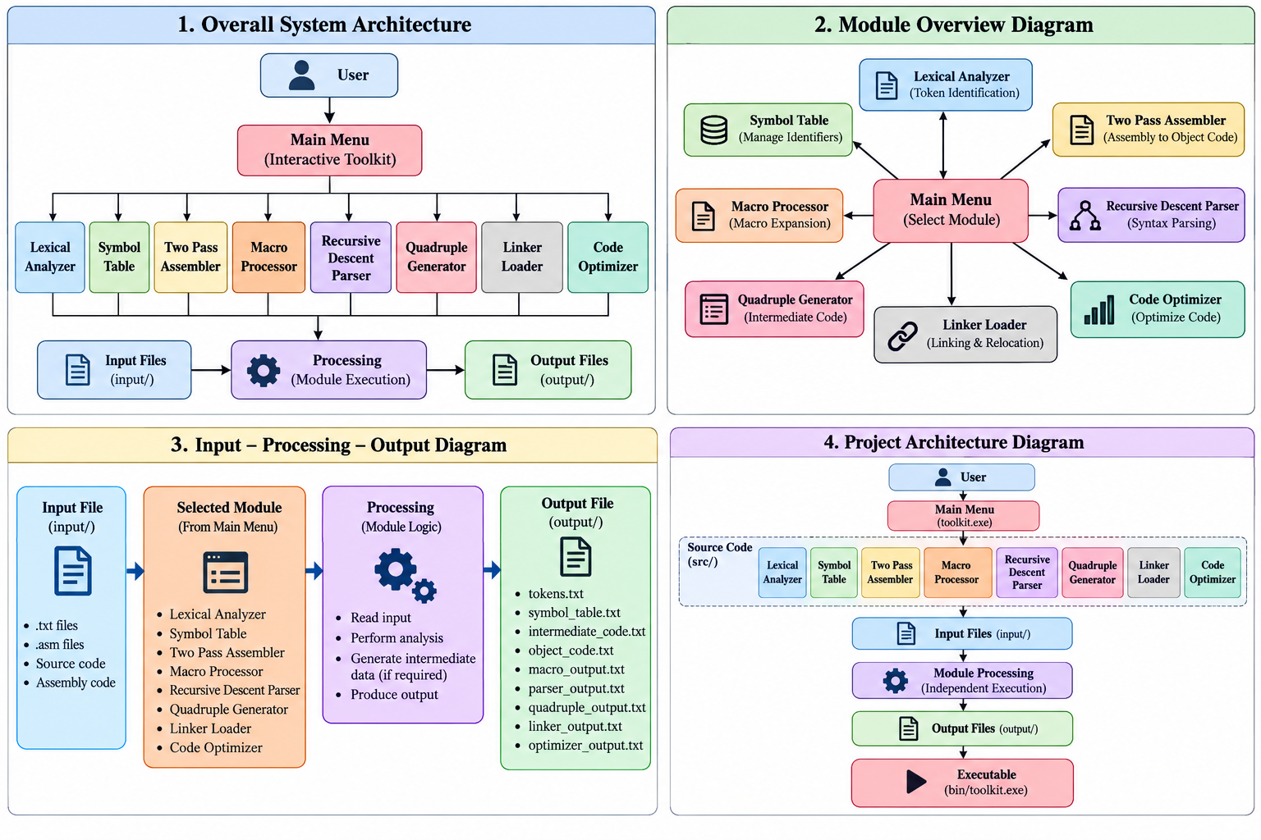
Figure 1: Overall System Architecture and Module Data Flow Diagram
Main.c Implementation
The main.c file serves as the central control unit of the Mini System Software Toolkit. It displays the main menu, accepts the user's choice, and invokes the corresponding function of the selected system software module. A switch-case structure is used to route execution to the eight modules, while the Exit option safely terminates the program.
Code Snippet 1: main.c
int main(void)
{
int choice;

do {
printf("\n===== MINI SYSTEM SOFTWARE TOOLKIT =====\n");
printf("1. Lexical Analyzer\n");
printf("2. Symbol Table\n");
printf("3. Two Pass Assembler\n");
printf("4. Macro Processor\n");
printf("5. Recursive Descent Parser\n");
printf("6. Quadruple Generator\n");
printf("7. Linker Loader\n");
printf("8. Code Optimizer\n");
printf("9. Exit\n");
printf("Enter your choice: ");
scanf("%d", &choice);

switch (choice) {
case 1: run_lexical_analyzer(); break;
case 2: run_symbol_table(); break;
case 3: run_assembler(); break;
case 4: run_macro_processor(); break;
case 5: run_parser(); break;
case 6: run_quadruple_generator(); break;
case 7: run_linker_loader(); break;
case 8: run_optimizer(); break;
case 9: printf("Exiting...\n"); break;
default: printf("Invalid choice!\n");
}
} while (choice != 9);

return 0;
}

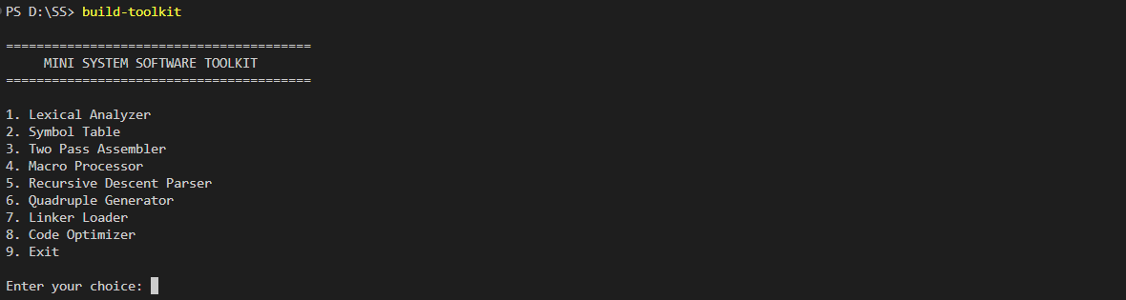Figure 2: Main Toolkit Menu Execution Output
The interactive console menu allows the user to select and execute any of the 8 system software modules .Each module provides a dedicated set of operations for processing its respective task.
The menu also includes a clear Exit option to terminate the application safely.
10. PROJECT FOLDER STRUCTURE
The workspace is organized into a clean directory layout that separates C source code, compiled binaries, documentation, input test files, and output generated artifacts.
Table 2: Complete Project Folder and Subdirectory Layout
Mini-System-Software-Toolkit/
├── bin/
│ └── toolkit.exe
├── docs/
│
├── input/
│
├── output/
│
├── src/
│ ├── code_optimizer/
│ │ ├── optimizer.c
│ │ └── optimizer.h
│ ├── common/
│ │ ├── common.c
│ │ └── common.h
│ ├── lexical_analyzer/
│ │ ├── lexical_analyzer.c
│ │ └── lexical_analyzer.h
│ ├── linker_loader/
│ │ ├── linker_loader.c
│ │ └── linker_loader.h
│ ├── macro_processor/
│ │ ├── macro_processor.c
│ │ └── macro_processor.h
│ ├── quadruple_generator/
│ │ ├── quadruple.c
│ │ └── quadruple.h
│ ├── recursive_descent_parser/
│ │ ├── parser.c
│ │ └── parser.h
│ ├── symbol_table/
│ │ ├── symbol_table.c
│ │ └── symbol_table.h
│ ├── two_pass_assembler/
│ │ ├── assembler.c
│ │ ├── assembler.h
│ │ ├── pass1.c
│ │ └── pass2.c
│ └── main.c
└── Makefile
11. SUMMARY MODULE OVERVIEW
The table below summarizes the primary functional role, input file source, and output artifact generated by each of the eight modules implemented in the Mini System Software Toolkit.
Table 1: Functional Summary Matrix of Toolkit Modules
Module | Primary Purpose | Primary Input File | Generated Output File(s)
Lexical Analyzer | Scans and categorizes source characters into different token types. | input/lexical_input.txt | output/tokens.txt
Symbol Table | Manages identifier attributes, data types, scopes, sizes, and memory addresses. | input/symbol_table_input.txt | output/symbol_table.txt
Two Pass Assembler | Translates assembly language into Intermediate Code and Object Code. | input/assembler_input.asm | output/intermediate_code.txt, output/object_code.txt
Macro Processor | Expands macro definitions, manages MNT/MDT, and performs parameter substitution. | input/macro_input.asm | output/macro_output.txt
Recursive Descent Parser | Validates arithmetic expressions using a top-down LL(1) grammar. | input/parser_input.txt | output/parser_output.txt
Quadruple Generator | Converts infix arithmetic expressions into three-address quadruple representation. | input/quadruple_input.txt | output/quadruple_output.txt
Linker Loader | Links object modules, resolves external symbols, and generates a linked memory map. | input/linker_input.txt | output/linker_output.txt
Code Optimizer | Performs constant folding, constant propagation, algebraic simplification, and dead code elimination. | input/optimizer_input.txt | output/optimizer_output.txt
12. MODULE 1: LEXICAL ANALYZER
The Lexical Analyzer represents the first phase of a compiler toolchain. Its primary role is to transform an unformatted stream of source code characters into a sequence of meaningful lexical tokens while discarding whitespace and comments.
12.1 Theoretical Concepts & Token Taxonomy
A token is a pair consisting of a token name and an optional attribute value. The Lexical Analyzer reads source code and categorizes tokens into keywords, identifiers, integer/float constants, string literals, character constants, operators, separators,parenthesis,comments, and preprocessor directives.
12.2 Implementation & C Code Snippet
The scanner reads ‘input/lexical_input.txt’ character-by-character using a deterministic finite-state scanner loop. Below is a representative C code snippet showing keyword lookup and lexeme classification:
Code Snippet 2: Keyword Scanning Logic in src/lexical_analyzer/lexical_analyzer.c
/* C17 Keyword Lookup & Lexeme Formatting in lexical_analyzer.c */
static const char *C17_KEYWORDS[] = {
"auto", "break", "case", "char", "const", "continue", "default", "do","double", "else", "enum", "extern", "float", "for", "goto", "if", "inline", "int", "long", "register", "restrict", "return", "short", "signed", "sizeof", "static", "struct", "switch", "typedef", "union","unsigned", "void", "volatile", "while"
};
#define NUM_KEYWORDS (sizeof(C17_KEYWORDS) / sizeof(C17_KEYWORDS[0]))
int is_keyword(const char *word) {
if (!word || *word == '\0') return 0;
for (size_t i = 0; i < NUM_KEYWORDS; i++) {
if (strcmp(word, C17_KEYWORDS[i]) == 0) return 1;
}
return 0;
}

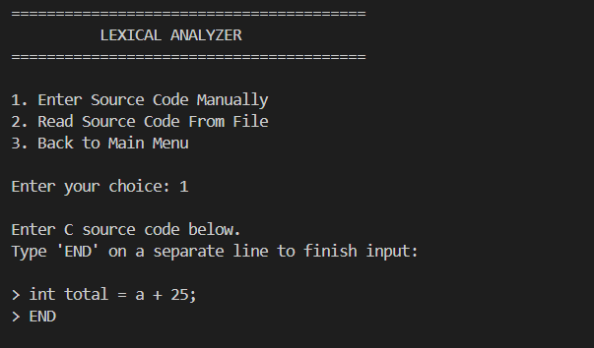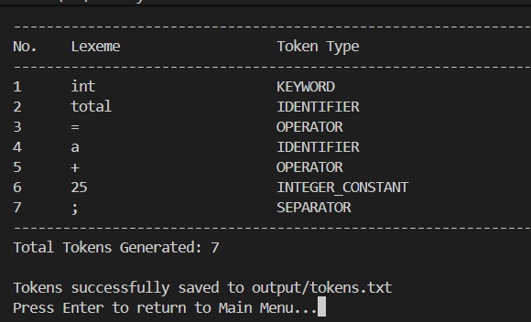
Figure 3: Lexical Analyzer Execution and Generated Token Output
The scanner reads input/lexical_input.txt and persists classified token entries to output/tokens.txt.
13. MODULE 2: SYMBOL TABLE MANAGER
The Symbol Table is a system data structure that stores information about identifiers declared in a program. It maintains memory locations, data types, variable sizes, and scope contexts.
13.1 Symbol Attribute Structure & Operations
Each symbol entry stores six essential attributes: Symbol Name, Data Type (int, float, char, etc.), Scope (global, local, function name), Memory Address, Storage Size in bytes, and Defined Flag. The module supports five operations:
1. Insert Symbol: Inserts a new symbol after checking for duplicate entries in the same scope.
2. Search Symbol: Performs a linear scan to locate an identifier index by name.
3. Update Symbol: Modifies the data type, scope, or address of an existing symbol.
4. Delete Symbol: Removes a symbol entry and compacts the array.
5. Display Table: Formats and displays the entire table to console and file.
13.2 Implementation & C Code Snippet
Code Snippet 3: Symbol Insertion & Automatic Address Calculation in src/symbol_table/symbol_table.c
/* Symbol Insertion and Address Allocation in symbol_table.c */
int insert_symbol(SymbolTable *st, const char *name, const char *data_type, const char *scope, int address, int size) {
if (!st || !name || *name == '\0') return 0;
if (st->count >= MAX_SYMBOLS) return 0;
if (search_symbol(st, name) != -1) {
printf("\nWarning: Symbol '%s' already exists in table.\n", name);
return 0;
}
Symbol *s = &st->symbols[st->count];
strncpy(s->name, name, MAX_NAME_LEN - 1);
strncpy(s->data_type, data_type ? data_type : "int", MAX_TYPE_LEN - 1);
strncpy(s->scope, scope ? scope : "global", MAX_SCOPE_LEN - 1);
s->size = (size > 0) ? size : get_datatype_size(s->data_type);
s->address = (address >= 0) ? address : st->next_address;
st->next_address = s->address + s->size;
st->count++;
return 1;
}
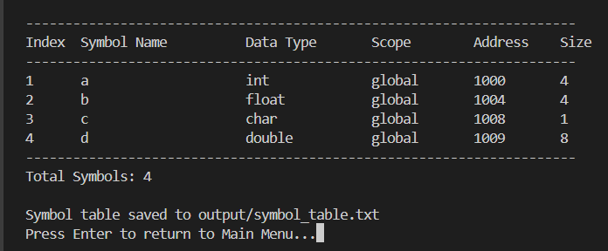
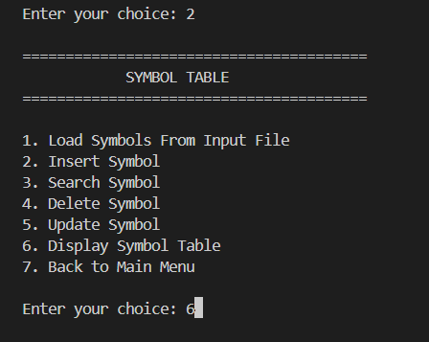Figure 4: Symbol Table Operations and Result Output
Displays active symbol attributes, data sizes, addresses, and scope offsets.
14. MODULE 3: TWO PASS ASSEMBLER
The Two-Pass Assembler translates assembly language programs into binary/hexadecimal machine code. A two-pass design is mandatory because forward references (referencing a label before its memory location is defined) cannot be resolved in a single pass.
14.1 Pass 1 vs Pass 2 Architecture
- Pass 1 (Address Allocation & Symbol Table Construction): Reads the assembly source line-by-line, tracks the Location Counter (LC), inserts label definitions into the Assembler Symbol Table, and emits an Intermediate Code (IC) stream consisting of Statement Types (IS=Imperative Statement, DL=Declaration Line, AD=Assembler Directive), Mnemonic Opcodes, Register Codes, and Symbol References.
- Pass 2 (Target Machine Code Generation): Reads the IC stream, looks up symbol addresses in the Symbol Table constructed during Pass 1, resolves all forward operand references, and emits final hexadecimal Object Code records.
14.2 Machine Opcode & Instruction Set Specification
The assembler implementation uses a target instruction set featuring 6 imperative statements, 2 declaration statements, 2 assembler directives, and 4 general-purpose registers:
Table 2: Assembler Instruction Set & Machine Opcode Table
Mnemonic | Class | Opcode | Description / Operation
STOP | IS | 00 | Halts execution
ADD | IS | 01 | Reg <- Reg + Memory Operand
SUB | IS | 02 | Reg <- Reg - Memory Operand
MULT | IS | 03 | Reg <- Reg * Memory Operand
MOVER | IS | 04 | Register <- Memory Operand
MOVEM | IS | 05 | Memory <- Register Operand
DS | DL | 01 | Declare Storage space (reserve words)
DC | DL | 02 | Declare Constant value
START | AD | 01 | Start assembly at specified address
END | AD | 02 | End of assembly program source
14.3 Implementation & C Code Snippet
Code Snippet 5: Pass 2 Machine Code Resolution in src/two_pass_assembler/pass2.c
/* Pass 2 Machine Code Resolution in src/two_pass_assembler/pass2.c */
int execute_pass2(void) {
if (!g_pass1_done) return 0;
for (int i = 0; i < g_inter_code.count; i++) {
const IntermediateEntry *ie = &g_inter_code.entries[i];
if (strcmp(ie->statement_type, "AD") == 0) continue; // Skip directives
ObjectCodeEntry *oe = &g_obj_code.entries[g_obj_code.count++];
oe->address = ie->address;
if (strcmp(ie->statement_type, "IS") == 0) { oe->opcode = ie->opcode; oe->reg_code = ie->reg_code;
int sym_idx = find_asm_symbol(&g_asm_symtab, ie->operand_name);
if (sym_idx != -1) oe->operand_address = g_asm_symtab.symbols[sym_idx].address;
}} return 1;
}

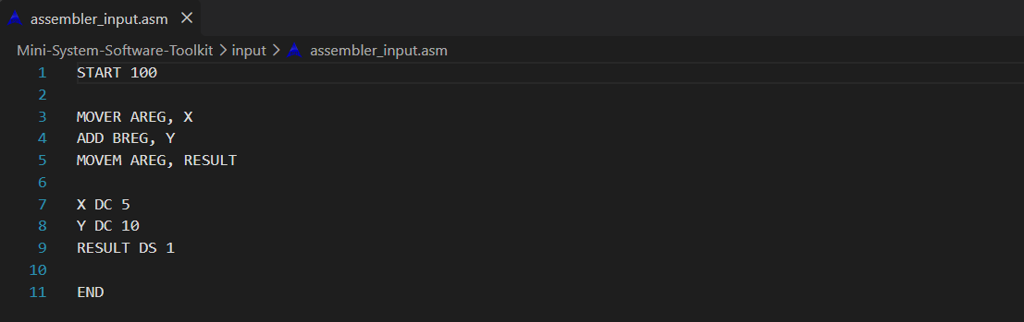Figure 5: Two Pass Assembler Assembly Source Input
Shows raw assembly source file containing instructions and directives.
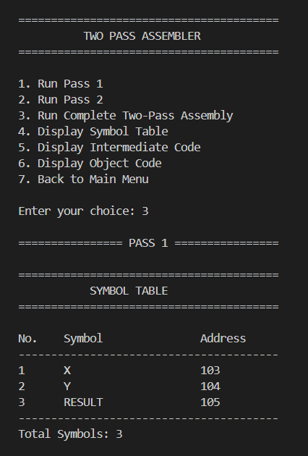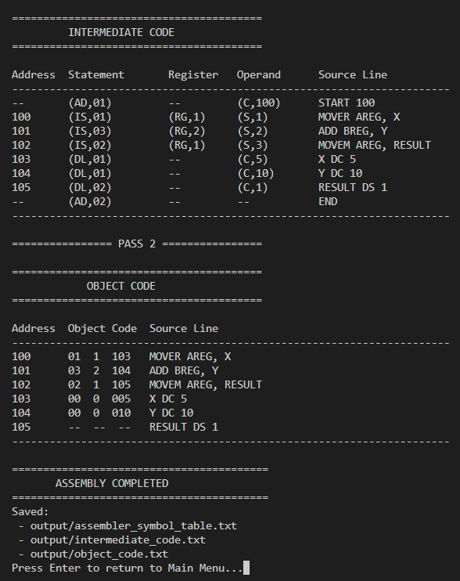
Figure 6: Two Pass Assembler Intermediate Code, Symbol Table, and Object Code Output
The module displays the generated Intermediate Code for the assembly program.
It also shows the Assembler Symbol Table with symbols and their addresses.
Finally, it generates and displays the Object Code produced during Pass 2.

15. MODULE 4: MACRO PROCESSOR
A Macro Processor is a pre-compiler component that allows software developers to define sequences of instructions under a single macro name and instantiate them repeatedly with arguments.
15.1 Macro Tables & Parameter Binding
The macro processor uses a two-pass table-driven design maintaining three primary data structures:
- Macro Name Table (MNT): Stores macro names, number of formal parameters, and index pointers into MDT.
- Macro Definition Table (MDT): Stores body lines of macro definitions with positional parameter placeholders (&ARG1, &ARG2).
- Argument List Array (ALA): Maps actual call arguments to formal parameters during expansion.
15.2 Implementation & C Code Snippet
Code Snippet 5: Macro Formal-to-Actual Argument Substitution in src/macro_processor/macro_processor.c
/* Parameter Substitution & Macro Expansion in src/macro_processor/macro_processor.c */
static void replace_parameter(const char *template_str, const char *formal, const char *actual, char *result, size_t result_size) {
result[0] = '\0';
const char *pos = template_str;
const char *found;
size_t formal_len = strlen(formal);
while ((found = strstr(pos, formal)) != NULL) {
strncat(result, pos, found - pos);
strcat(result, actual);
pos = found + formal_len;
}
strcat(result, pos);
}
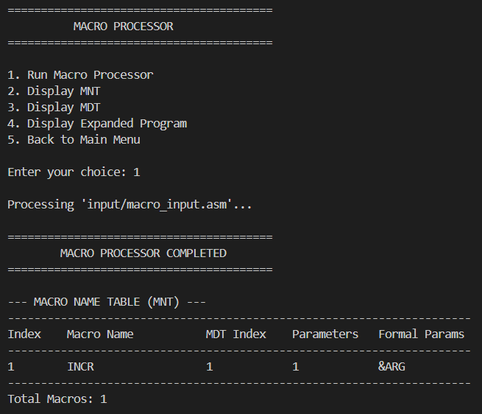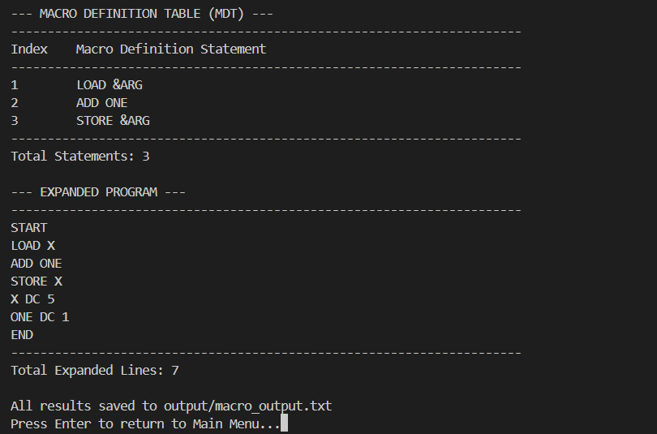
Figure 7: Macro Processor Definition and Expanded Output
Shows MNT/MDT records and final expanded assembly output.
16. MODULE 5: RECURSIVE DESCENT PARSER
The Recursive Descent Parser implements top-down predictive syntax analysis. It verifies whether an input arithmetic expression string conforms to a strict formal context-free grammar without backtracking.
16.1 Formal LL(1) Grammar Specification
The parser evaluates math expressions against the following non-ambiguous LL(1) grammar:
- Expression: E -> T E'
- Expression Prime: E' -> + T E' | - T E' | epsilon
- Term: T -> F T'
- Term Prime: T' -> * F T' | / F T' | epsilon
- Factor: F -> ( E ) | identifier | number
16.2 Implementation & C Code Snippet
Code Snippet 6: Recursive Parsing of Factors in src/recursive_descent_parser/parser.c
/* Recursive Descent Factor Parsing in src/recursive_descent_parser/parser.c */
static int parse_factor(void) {
skip_whitespace();char c = g_input[g_pos];
if (c == '(') {
g_pos++; // consume '('
if (!parse_expression()) return 0;
skip_whitespace();
if (g_input[g_pos] == ')') { g_pos++; return 1; }
else { set_error("Expected ')'"); return 0; }
}
if (isalpha((unsigned char)c) || c == '_') {
while (isalnum((unsigned char)g_input[g_pos]) || g_input[g_pos] == '_') g_pos++;
return 1;
}
if (isdigit((unsigned char)c)) {
while (isdigit((unsigned char)g_input[g_pos]) || g_input[g_pos] == '.') g_pos++;
return 1;
}
set_error("Unexpected token in factor");
return 0;
}
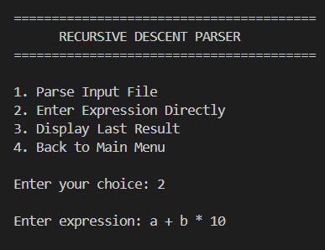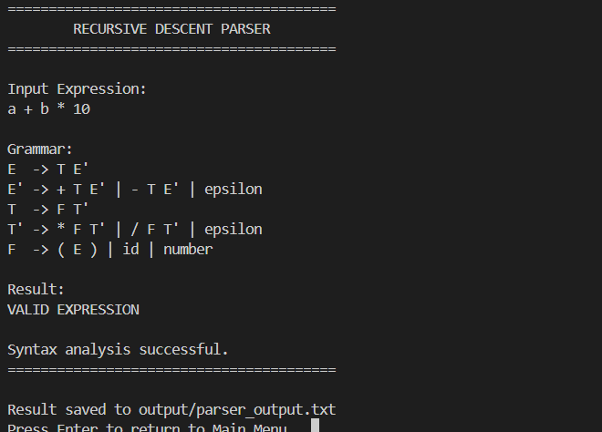
Figure 8: Recursive Descent Parser Valid and Invalid Expression Result
Displays syntax parsing results for valid expressions and error reporting for invalid strings.
17. MODULE 6: QUADRUPLE GENERATOR
The Quadruple Generator translates high-level arithmetic expressions into standardized 3-address intermediate code representations known as Quadruples.
17.1 Quadruple Format & Operator Precedence
A Quadruple is a 4-tuple record: ‘(Operator, Argument 1, Argument 2, Result Target)’. Complex expressions are broken down using temporary variables (‘T1’, ‘T2’, etc.) while respecting operator precedence (* and / before + and -).
17.2 Implementation & Example Execution
Input (‘input/quadruple_input.txt’): ‘a + b * c’ and Generated Quadruple Stream (‘output/quadruple_output.txt’):
- Quadruple 1: (*, b, c, T1)
- Quadruple 2: (+, a, T1, T2)
Code Snippet 7: Operator Precedence Evaluation in src/quadruple_generator/quadruple.c
/* Infix to Postfix Conversion in src/quadruple_generator/quadruple.c */
static int get_precedence(const char *op) {
if (strcmp(op, "*") == 0 || strcmp(op, "/") == 0) return 2;
if (strcmp(op, "+") == 0 || strcmp(op, "-") == 0) return 1;
return 0;
}

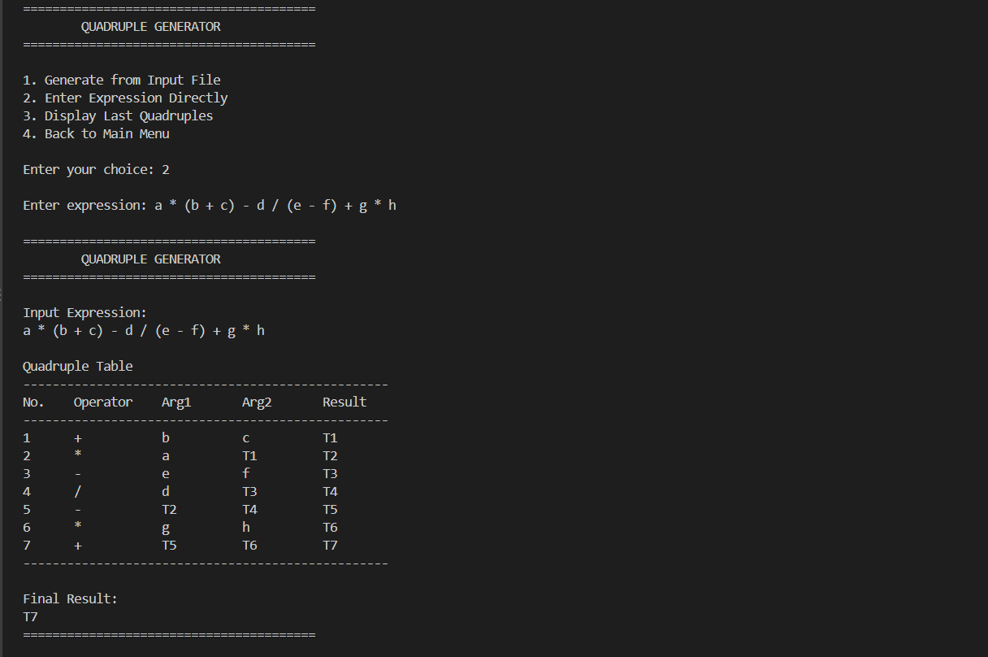
Figure 9: Quadruple Generator 3-Address Intermediate Code Output
Displays generated 4-tuple quadruple records for input arithmetic expressions.
18. MODULE 7: LINKER LOADER
The Linker Loader module simulates the linking and loading phases of executable generation. It links independently compiled object code modules, resolves external symbol references, and calculates relocated memory addresses.
18.1 File-Based Operation & Relocation Logic
Important Implementation Constraint: The Linker Loader is strictly FILE-BASED ONLY. It reads input module definitions from ‘input/linker_input.txt’ and emits a linked execution layout to ‘output/linker_output.txt’.
- External Symbol Table (EST): Constructs a unified table containing all global symbols exported by input modules.
- Address Relocation: Adds relocation constants (module load addresses) to internal module memory references.
- Symbol Resolution: Replaces external symbol references with absolute resolved memory addresses.
18.2 Implementation & C Code Snippet
Code Snippet 8: EST Construction & Relocation Offset Calculation in src/linker_loader/linker_loader.c
/* External Symbol Table Construction in src/linker_loader/linker_loader.c */
static int build_external_symbol_table(Module *modules, int mod_count, ESTEntry *est, int *est_count) {
*est_count = 0;
for (int i = 0; i < mod_count; i++) {
for (int j = 0; j < modules[i].def_count; j++) {
ESTEntry *entry = &est[*est_count];
strncpy(entry->symbol_name, modules[i].defs[j].symbol_name, MAX_NAME_LEN - 1);
entry->abs_address = modules[i].load_address + modules[i].defs[j].relative_address;
strncpy(entry->module_name, modules[i].name, MAX_NAME_LEN - 1);
(*est_count)++;
}
}
return 1;
}
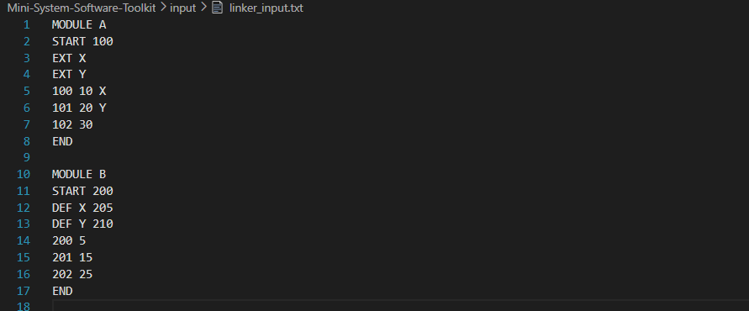
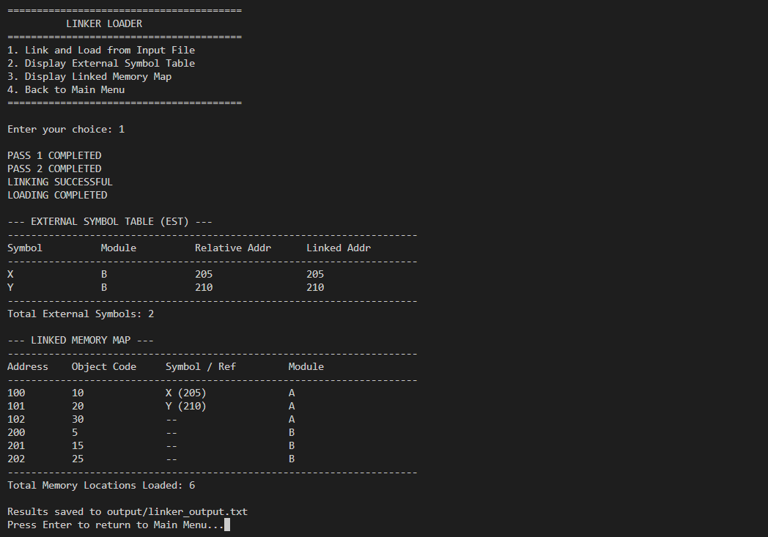
Figure 10: Linker Loader External Symbol Table and Linked Memory Map Output
Displays generated External Symbol Table (EST) and absolute relocated memory layout

19. MODULE 8: CODE OPTIMIZER
The Code Optimizer applies machine-independent transformation passes over intermediate code statements to improve execution performance and reduce memory consumption.
19.1 Optimization Techniques Implemented
- 1. Constant Folding: Evaluates constant arithmetic operations at compile-time (e.g., ‘a = 10 + 20’ -> ‘a = 30’).
- 2. Constant Propagation: Replaces variable references with known constant values assigned upstream.
- 3. Algebraic Simplification: Replaces identities with simpler equivalents (e.g., ‘x = y + 0’ -> ‘x = y’, ‘z = x * 1’ -> ‘z = x’).
- 4. Dead Code Elimination (DCE): Removes assignment statements whose target variables are never read downstream.
19.2 Implementation & C Code Snippet
Code Snippet 9: Algebraic Simplification Logic in src/code_optimizer/optimizer.c
/* Algebraic Simplification & Constant Folding in src/code_optimizer/optimizer.c */
static int optimize_algebraic(char *op, char *arg1, char *arg2, char *result_val) {
if (strcmp(op, "+") == 0 && strcmp(arg2, "0") == 0) { strcpy(result_val, arg1); return 1; }
if (strcmp(op, "*") == 0 && strcmp(arg2, "1") == 0) { strcpy(result_val, arg1); return 1; }
if (strcmp(op, "*") == 0 && strcmp(arg2, "0") == 0) { strcpy(result_val, "0"); return 1; }
return 0;
}

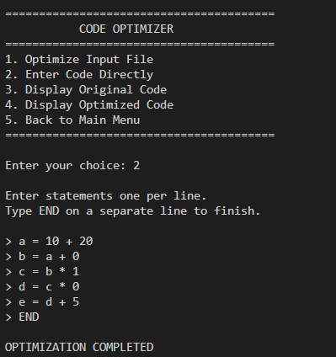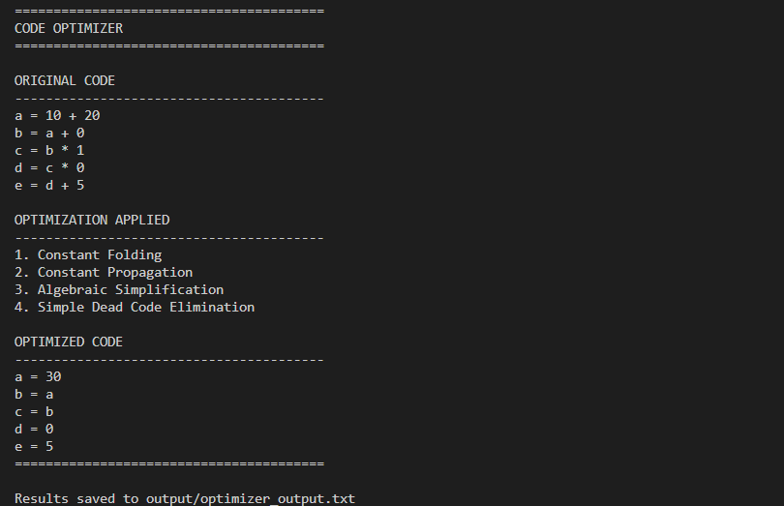
Figure 11: Code Optimizer Input and Optimized Code Output
Displays original intermediate statements alongside optimized output representations.
20. SYSTEM ARCHITECTURE & FLOWCHART VISUALIZATIONS
Visual flowcharts and system diagrams serve as essential documentation for understanding execution flow across system software toolchains. The project documentation includes high-resolution flowcharts for the main toolkit and all eight modules.
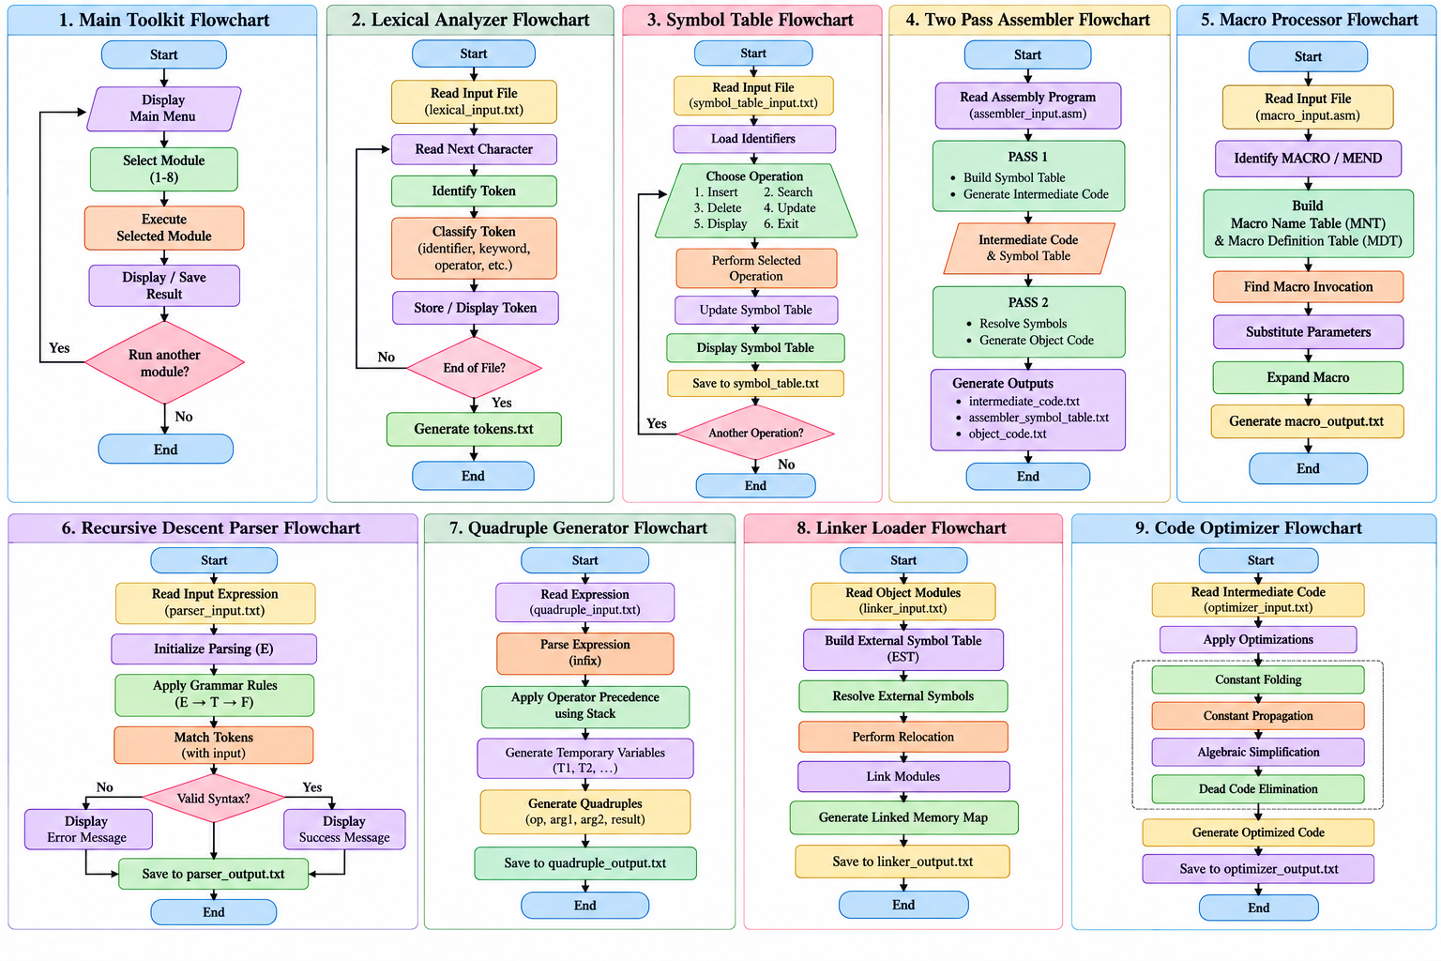Figure 12: Complete Set of Control Flowcharts for Main Toolkit and All 8 Modules
20.1 Summary Description of Module Control Flowcharts
- Toolkit Control Flow: Displays main menu loop, option selection, buffer clearing, sub-function invocation, and program termination.
- Lexical Analyzer Flowchart: Traces character reading, finite-state token identification, keyword matching, and output file writing.
- Symbol Table Flowchart: Details symbol lookup, insertion validation, scope resolution, address incrementing, and array management.
- Two-Pass Assembler Flowchart: Illustrates LC tracking and IC generation in Pass 1, followed by symbol resolution and Object Code emission in Pass 2.
- Macro Processor Flowchart:Traces MNT/MDT population during definition pass and formal argument substitution during expansion pass.
- Parser Flowchart: Depicts top-down grammar function calls (‘parse_expression’, ‘parse_term’, ‘parse_factor’) and error handling.
- Quadruple Flowchart: Shows Shunting-Yard token stack transformations and sequential 3-address quadruple generation.
- Linker Loader Flowchart: Illustrates EST construction, module base address relocation calculations, and final linked memory map generation.
- Optimizer Flowchart: Details sequential optimizer transformation passes (Constant Folding, Propagation, Simplification, DCE).
21. COMPREHENSIVE TESTING & RESULTS VERIFICATION
To ensure system stability and compliance with theoretical specs, the toolkit was subjected to a master verification test suite covering valid operations, edge cases, and syntax error conditions.
Table 3: Master Test Suite Results & System Validation Matrix
Test Case | Module | Input Specification | Expected Result | Actual Result | Status
TC-01 | Lexical Analyzer | int count = 10; | Categorize 5 tokens | Tokens logged to tokens.txt | PASS
TC-02 | Symbol Table | Insert duplicate 'x' | Emit duplicate warning | Warning printed, table preserved | PASS
TC-03 | Two Pass Assembler | Valid ASM program | Generate IC & Object Code | intermediate_code & object_code emitted | PASS
TC-04 | Two Pass Assembler | Undefined label 'L2' | Aborts Pass 2 with error | Error message displayed, Pass 2 stopped | PASS
TC-05 | Macro Processor | Macro with 2 args | Expand body & substitute args | macro_output.txt updated correctly | PASS
TC-06 | Parser | Expression: a + (b * c) | Valid expression result | Parse Successful printed | PASS
TC-07 | Parser | Invalid: a + * b | Detect syntax error | Syntax Error: Expected factor logged | PASS
TC-08 | Linker Loader | 2 Object Modules | Build EST & Linked Map | linker_output.txt generated | PASS
TC-09 | Code Optimizer | a = 10 + 20; x = y * 1 | Fold to 30; Simplify to x = y | optimizer_output.txt optimized | PASS

22. SYSTEM ADVANTAGES & ENGINEERING STRENGTHS
- 1. Unified Educational Platform: Combines 8 fundamental system software modules into a single menu-driven application.
- 2. Zero-Dependency Portability: Written in pure C11 without external third-party libraries; compiles cleanly with standard GCC.
- 3. Transparent Artifact Generation: All translation steps write persistent text artifacts to ‘output/’, providing full internal visibility.
- 4. Clean Decoupled Architecture: Modules are fully decoupled with clean header interfaces, allowing independent expansion.
- 5. Robust Error Reporting: Includes defensive buffer handling, array boundary checks, and syntax error reporters.
23. IMPLEMENTATION LIMITATIONS
1. Simplified Academic Simulation: Designed primarily as an academic educational simulation rather than a commercial toolchain.
2. Static Array Buffers: Uses fixed static arrays (e.g., MAX_SYMBOLS=100) rather than dynamic heap-allocated structures.
3. Restricted Instruction Set: Assembler targets a simplified 6-instruction model rather than full x86_64 or ARM ISA.
4. File-Based CLI Workflow: Operates via terminal command-line menus and file processing rather than a graphical IDE.
24. FUTURE ENHANCEMENT SCOPE
1. Interactive GUI / Web Dashboard: Develop a web-based visual dashboard using WebAssembly to animate translation steps in real time.
2. RISC-V / x86_64 Instruction Set Support: Expand assembler instruction sets to support real x86_64 or RISC-V machine opcodes.
3. Advanced Compiler Optimization: Implement control-flow graph (CFG) analysis, loop-invariant code motion, and register allocation.
4. Real ELF Binary Linker Support: Extend the linker loader to support standard ELF (Executable and Linkable Format) binary headers.
25. EDUCATIONAL & PRACTICAL LEARNING OUTCOMES
Through the development of the Mini System Software Toolkit, student engineers achieved four key competencies:
1. Front-End Lexical & Symbol Analysis: Mastered lexer tokenization mechanics, state transitions, and table-driven symbol table design.
2. Assembler & Macro Architecture: Gained deep insight into multi-pass translation, location counter tracking, and macro substitution.
3. Syntax Parsing & Intermediate Code: Implemented top-down predictive parsing and 3-address quadruple intermediate representation.
4. Linker, Loader & Code Optimization: Understood external symbol resolution, memory relocation, and compile-time optimization passes.
26. CONCLUSION
The Mini System Software Toolkit successfully bridges theoretical Computer Engineering concepts with practical software implementation using C11. It integrates eight core system software components—Lexical Analyzer, Symbol Table, Two-Pass Assembler, Macro Processor, Recursive Descent Parser, Quadruple Generator, Linker Loader, and Code Optimizer—into a single menu-driven application. Each module demonstrates an important stage of program translation and execution while providing clear file-based inputs and outputs for easy observation and analysis.
Overall, the project provides practical understanding of how different system software components work individually and together during program processing. It also strengthens skills in modular programming, file handling, data structures, algorithms, error handling, and software design. The toolkit can serve as a useful foundation for further learning in Compiler Design, Operating Systems, and Computer Architecture, while also providing scope for future enhancements such as advanced parsing, optimization techniques, and additional translation features.
27. REFERENCES & ACADEMIC CITATIONS
- D. M. Dhamdhere, "System Programming and Operating Systems", 2nd Revised Edition, Tata McGraw-Hill Education, 2011.
- A. V. Aho, M. S. Lam, R. Sethi, and J. D. Ullman, "Compilers: Principles, Techniques, and Tools" (Dragon Book), 2nd Edition, Pearson / Addison-Wesley, 2006.
- L. L. Beck, "System Software: An Introduction to Systems Programming", 3rd Edition, Pearson Education, 2002.
- ISO/IEC 9899:2011, "Information technology — Programming languages — C" (C11 Standard Specification).
- GNU Compiler Collection (GCC) Documentation, "GCC Command Options and C Standards Compliance", Free Software Foundation, 2024.
28. APPENDIX
Appendix A – Project Repository
Source Code Repository Placeholder: GitHub Repository:
https://github.com/dhruvi1124/Mini-System-Software-Toolkit
The GitHub repository contains the complete C11 source code (src/), input files (input/), output files (output/), Makefile, README.md, documentation (docs/), diagrams (docs/diagrams/), and flowcharts (`docs/flowcharts/).

