Dhruvi Naik

SYIT

ROLLNO-27

**Pet Santa**

Pet Santa is a ecommerce as well as a health app for all kind of animals from dogs and cats to reptiles and fishes. It consist of a login sign up page which then takes the user to an amazing interface consisting of various types of animals followed by the products and accessory for the same.

It is a ionic angular framework with a user friendly interface which is connected to our database which collects the data from the user. It was created in a visual studio and can be emulated anytime

1. Homepage

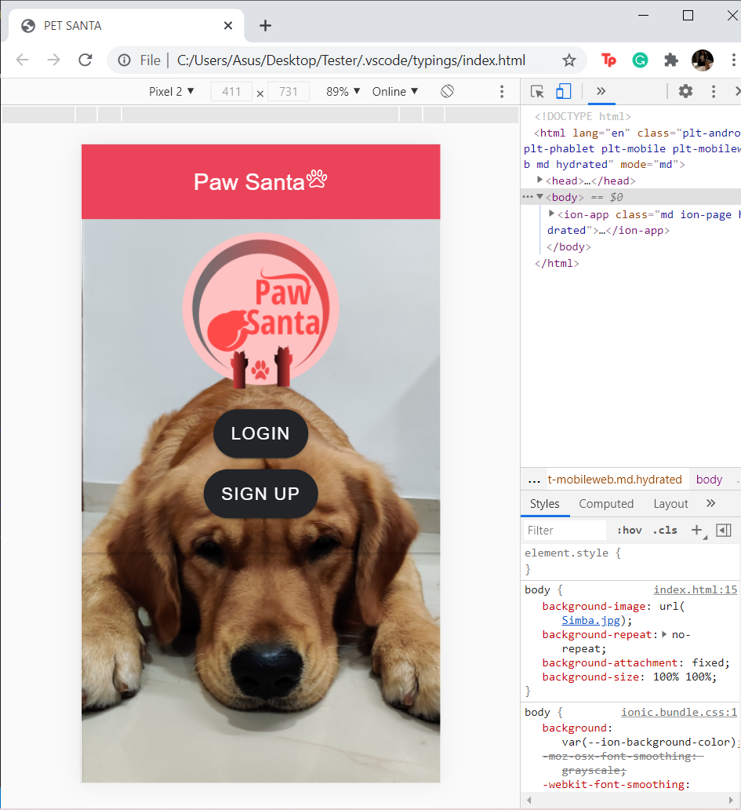

1. Login

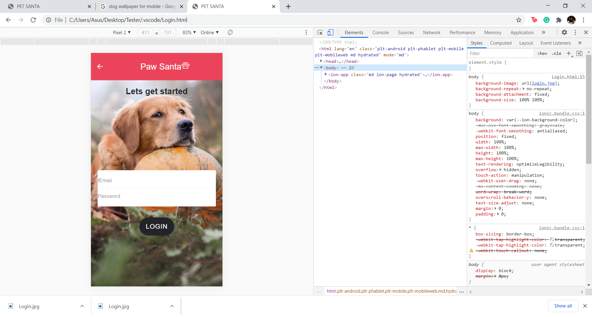

1. Sign up

