**Below is the design of the page :**

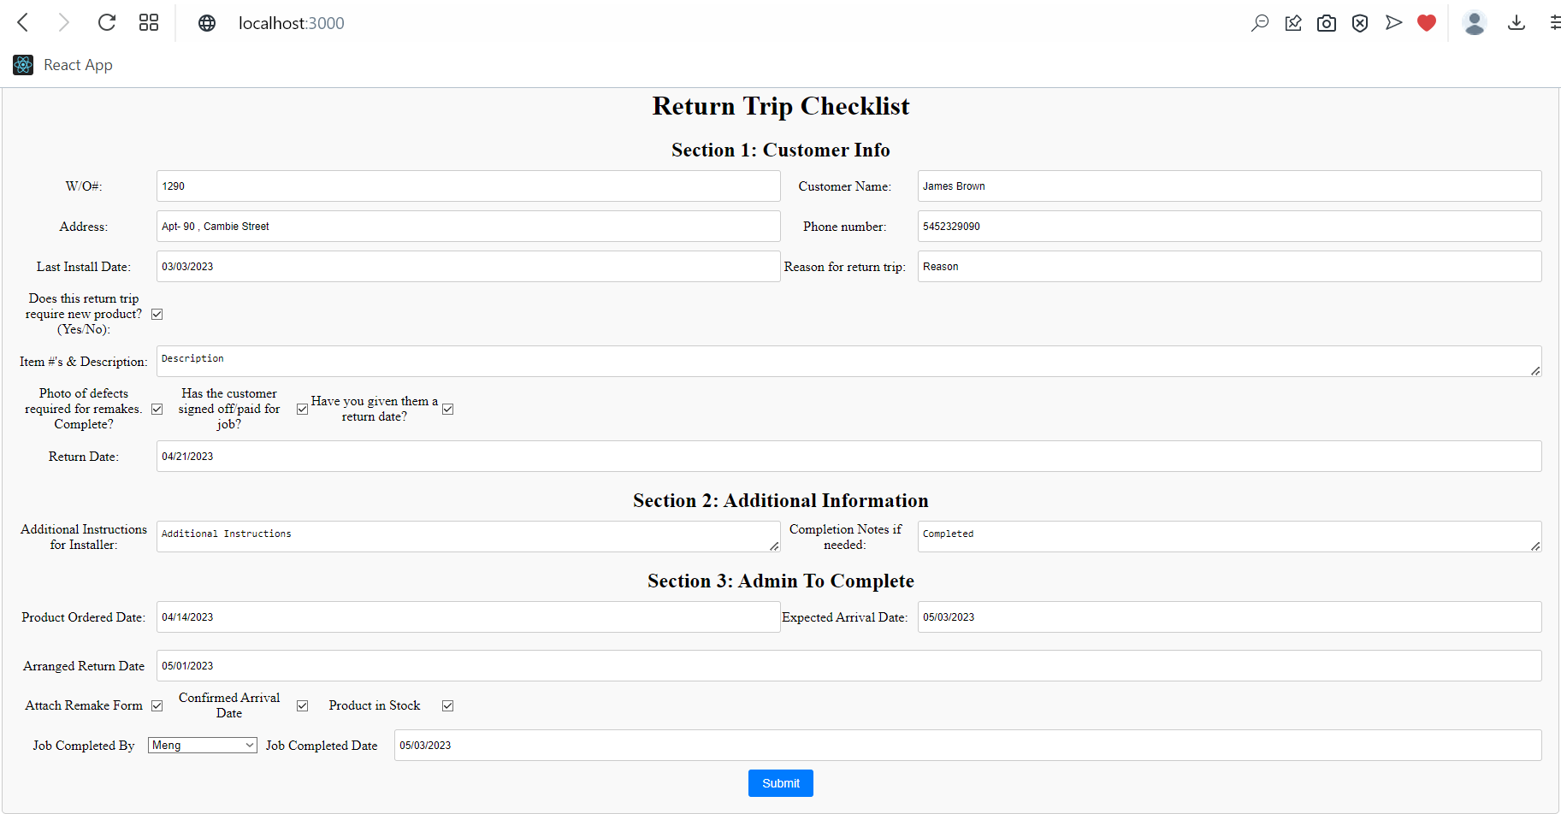

**Screen shot of the PDF file:**

**PDF attached :**

