MCA009
Lab-7 Introduction to Continuous Integration
Exercise:
1. Discuss Continuous Integration and Continuous Deployment.
[A]. Continuous Integration (CI)Definition:
Continuous Integration is the practice of frequently integrating code changes from multiple developers into a shared repository, usually multiple times per day.
"Integrate early, integrate often" → Catch integration issues as soon as possible instead of at the end of the sprint or release.
Benefits of CI:
- Early detection of bugs and integration issues
- Reduces "integration hell"
- Improves code quality
- Increases developer confidence
- Faster development velocity

Popular CI Tools:
- GitHub Actions
- GitLab CI/CD
- Jenkins
- CircleCI
- Azure DevOps Pipelines
- AWS CodeBuild
- Travis CI
[B]. Continuous Deployment (CD) is a DevOps practice in which every code change that successfully passes all automated tests is automatically deployed to the production environment without requiring manual approval. This approach ensures that software updates are delivered to users quickly and consistently.Continuous Deployment relies on a fully automated pipeline that manages the entire process from code integration to final deployment.
Difference Between Continuous Delivery and Continuous Deployment
- Continuous Delivery ensures that the application is always in a deployable state. The deployment to production is performed manually when required.
- Continuous Deployment goes one step further by automatically deploying every successful build to the production environment without human intervention.
Automated Deployment Pipeline
Continuous Deployment works through an automated pipeline that executes several stages to ensure software quality and stability.
Typical pipeline stages include:
- Build Stage – The application code is compiled and packaged.
- Unit Testing – Individual components of the software are tested.
- Integration Testing – Interactions between different components are verified.
- Security Scanning – The application is checked for vulnerabilities.
- Performance Testing – The system’s performance and scalability are validated.
- Staging Deployment – The application is deployed to a staging environment for final verification.
- Production Deployment – If all tests pass successfully, the application is automatically deployed to production.
Zero-Downtime Deployment Strategies
To ensure that applications remain available during updates, several deployment strategies are used:
- Blue-Green Deployment – Two identical environments are maintained, and traffic is switched from the old version to the new version.
- Canary Releases – The new version is released to a small group of users before full deployment.
- Rolling Updates – The application is updated gradually across servers to minimize downtime.
- Feature Flags (Feature Toggles) – Features can be enabled or disabled dynamically without redeploying the application.
Benefits of Continuous Deployment
Continuous Deployment provides several advantages for software development teams:
- Faster time-to-market, allowing features to reach users quickly.
- Smaller and less risky changes, making issues easier to identify and fix.
- Higher deployment frequency, enabling frequent software updates.
- Reduction of manual errors due to automation.
Encouragement of a strong automated testing culture.
2. Create a Simple Python application with below functionalities.
a. Create app.py with functions to add, subtract , multiply and divide.
b. Create test_app.py with test functions to test_add, test_substract, test_multiply and test_divide.
c. Test it using the PyTest module
Step1.Creating The App.py
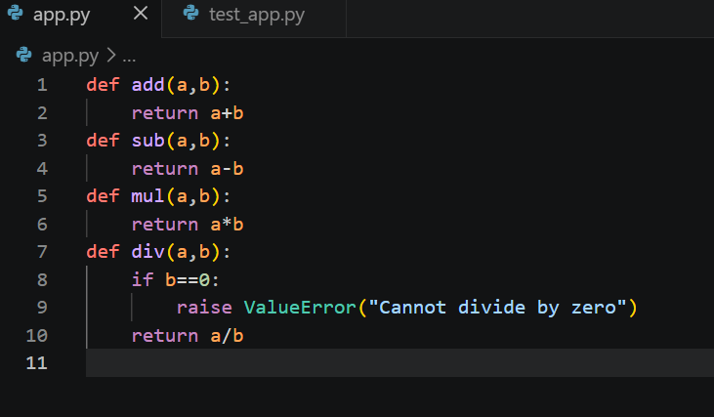
step.2 Create the Test File
test_app.py
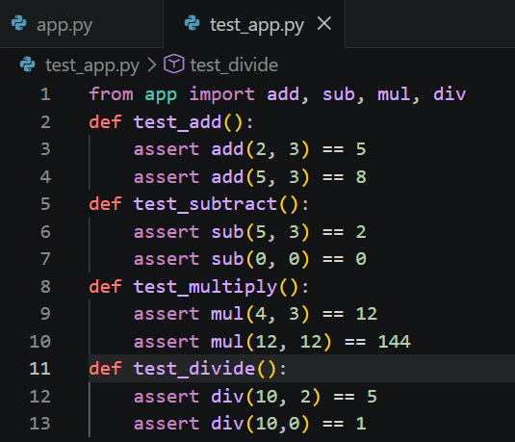
Step 3: Install PyTest
pip install pytest
Step 4:pytest
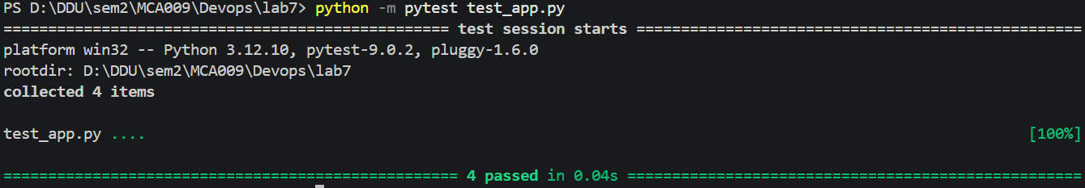

3.Use the above created app to practice a Continuous integration with GitLab.
Step1.Creating The Account Resource Group project In Gitlab
Step2.Push The Code To The Remote Repository
- git init
- git add .
- git commit -m "first commit"
- git branch -M main
- git remote add origin https://gitlab.com/devops_mca/Devops_Lab7.git
- git push -u origin main
Step3.Create .gitlab-ci.yml [for the automation of the ci]
image: python:3.11
stages:
- test
before_script:
- pip install pytest
test_job:
stage: test
script:
- pytest
Step4. Push the CI file To The Remote Repository
git add .gitlab-ci.yml
git commit -m "Add GitLab CI pipeline"
git push
Step5. Check pipeline
Project → Build → Pipelines
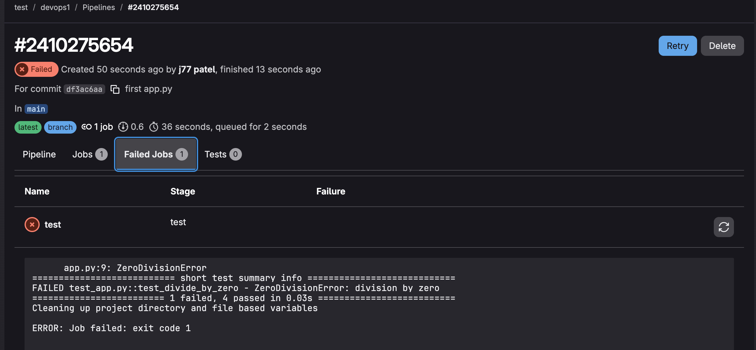
Pipeline Failed Because In App.py We Have Not Done The Proper Error Handling
Modify The Code And Write This
def divide(a, b):
if b == 0:
raise ValueError("Cannot divide by zero")
return a / b
Commit The Changes

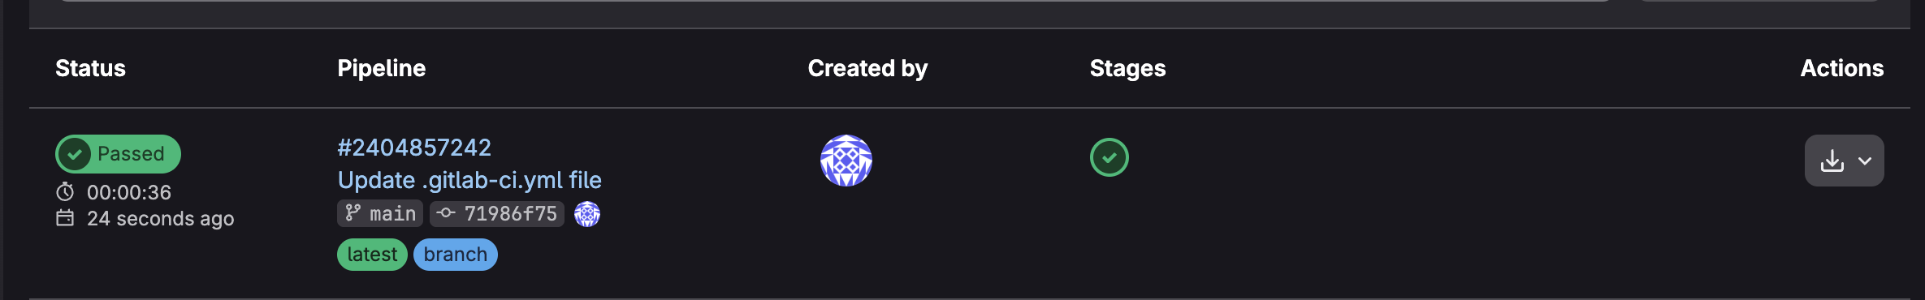
4.Use the above created app to practice a Continuous integration with Github Actions.
Step1.Create The Repository On Github
Step2.Remove The .gitlab-ci.yml From The Project Structure
Step3.Remove The First Remote Address From The Git
git remote -v
git remote remove origin
git remote -v
Step3.Push The Code To The Remote Repository
- git commit -m "Gitahub action"
- git branch -M main
- git remote add origin https://github.com/janakgadhiya/TestDevops.git
- git push -u origin main
Step4.Once The Code Is Uploaded On Github Go To Actions Tab
Step5.Select The Python Application
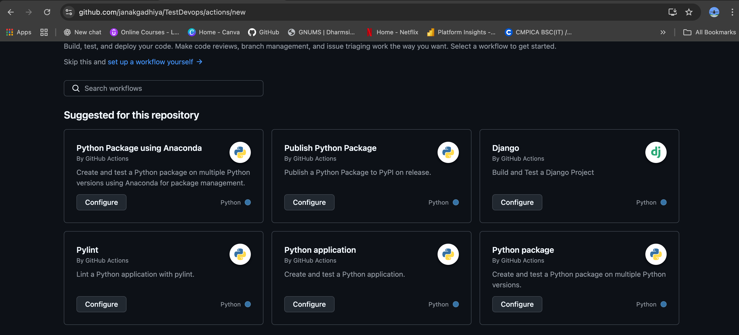
Step6.Commit The Changes our CI Pipeline Will Trigger Only When The Main Branch Changes

Step7.Create a new branch for this commit and start a pull request
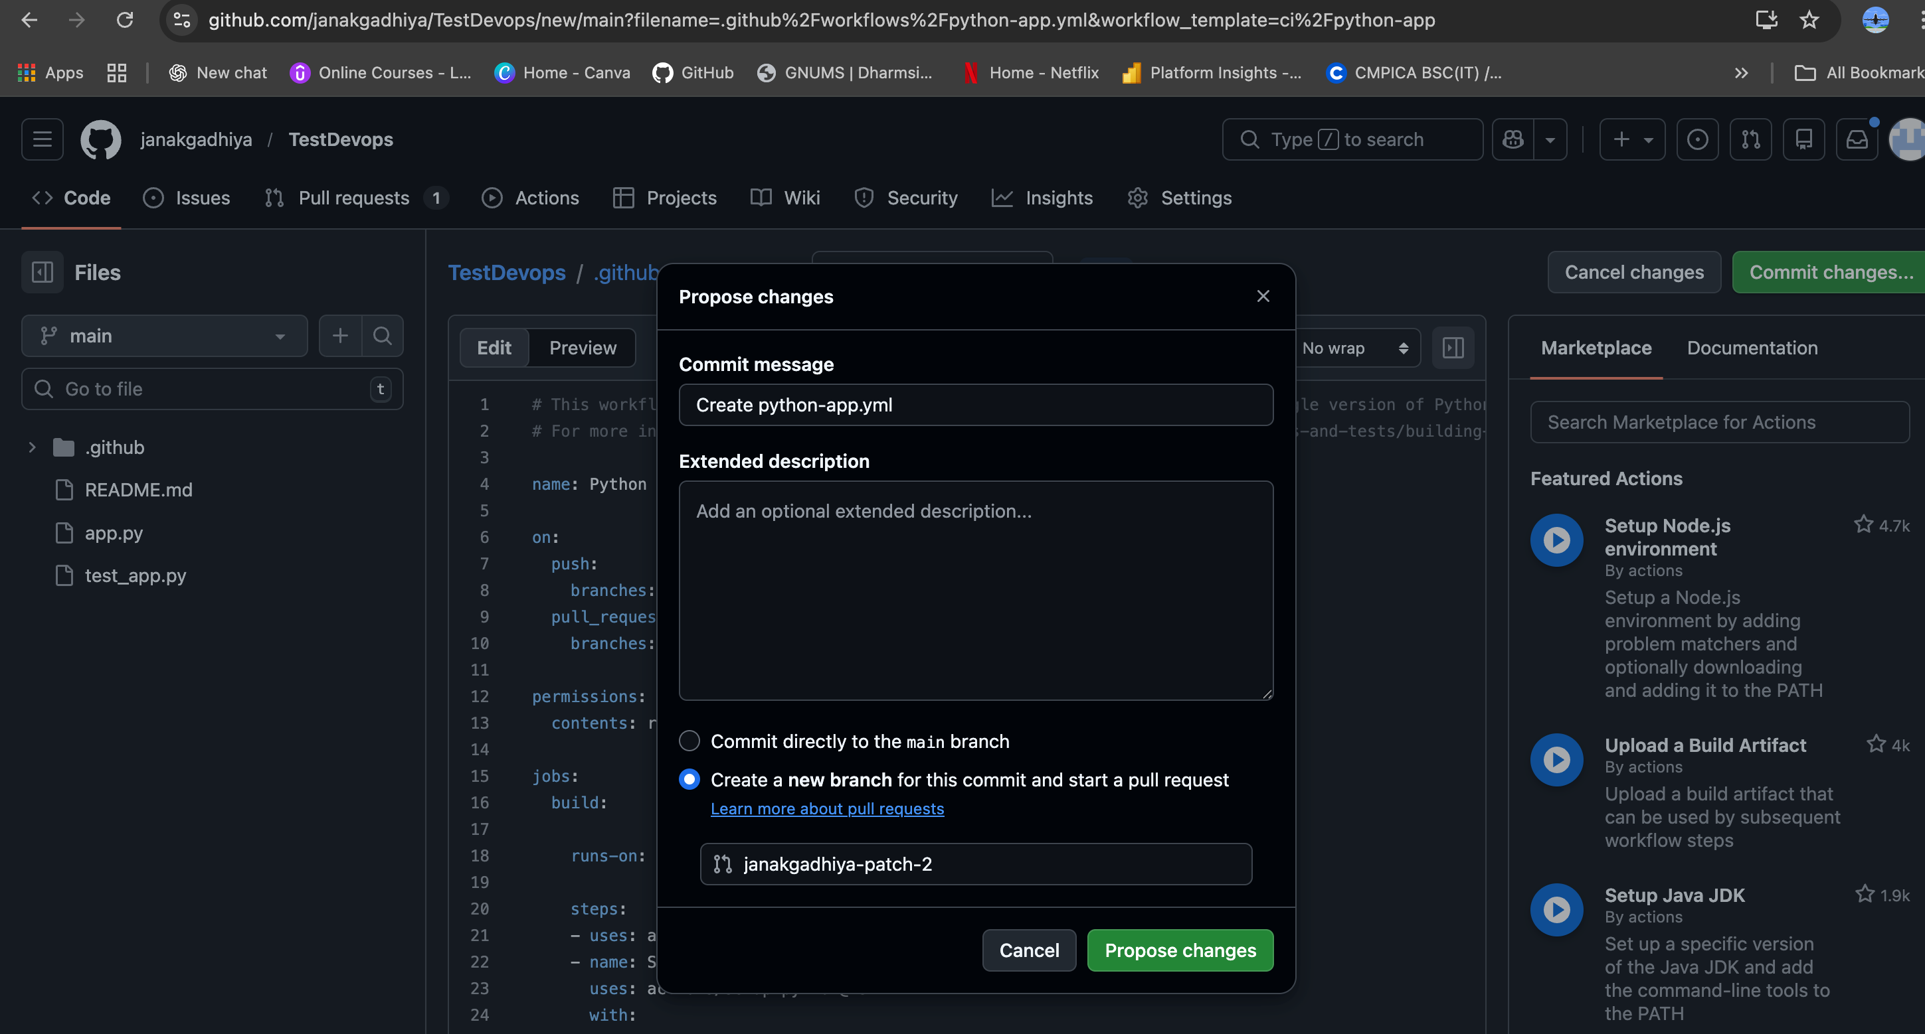
Step8.Create The Pull Request
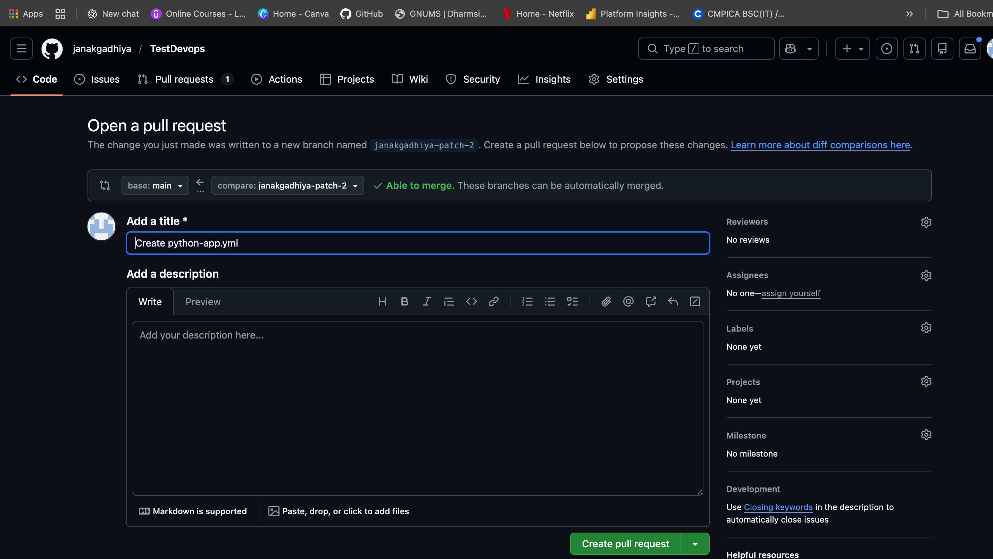
Step9.Merge The Pull Request So That It will Create The .github/workflows/python-app.yml
Step9.Go To Action Tab And See The Pipeline Is Running

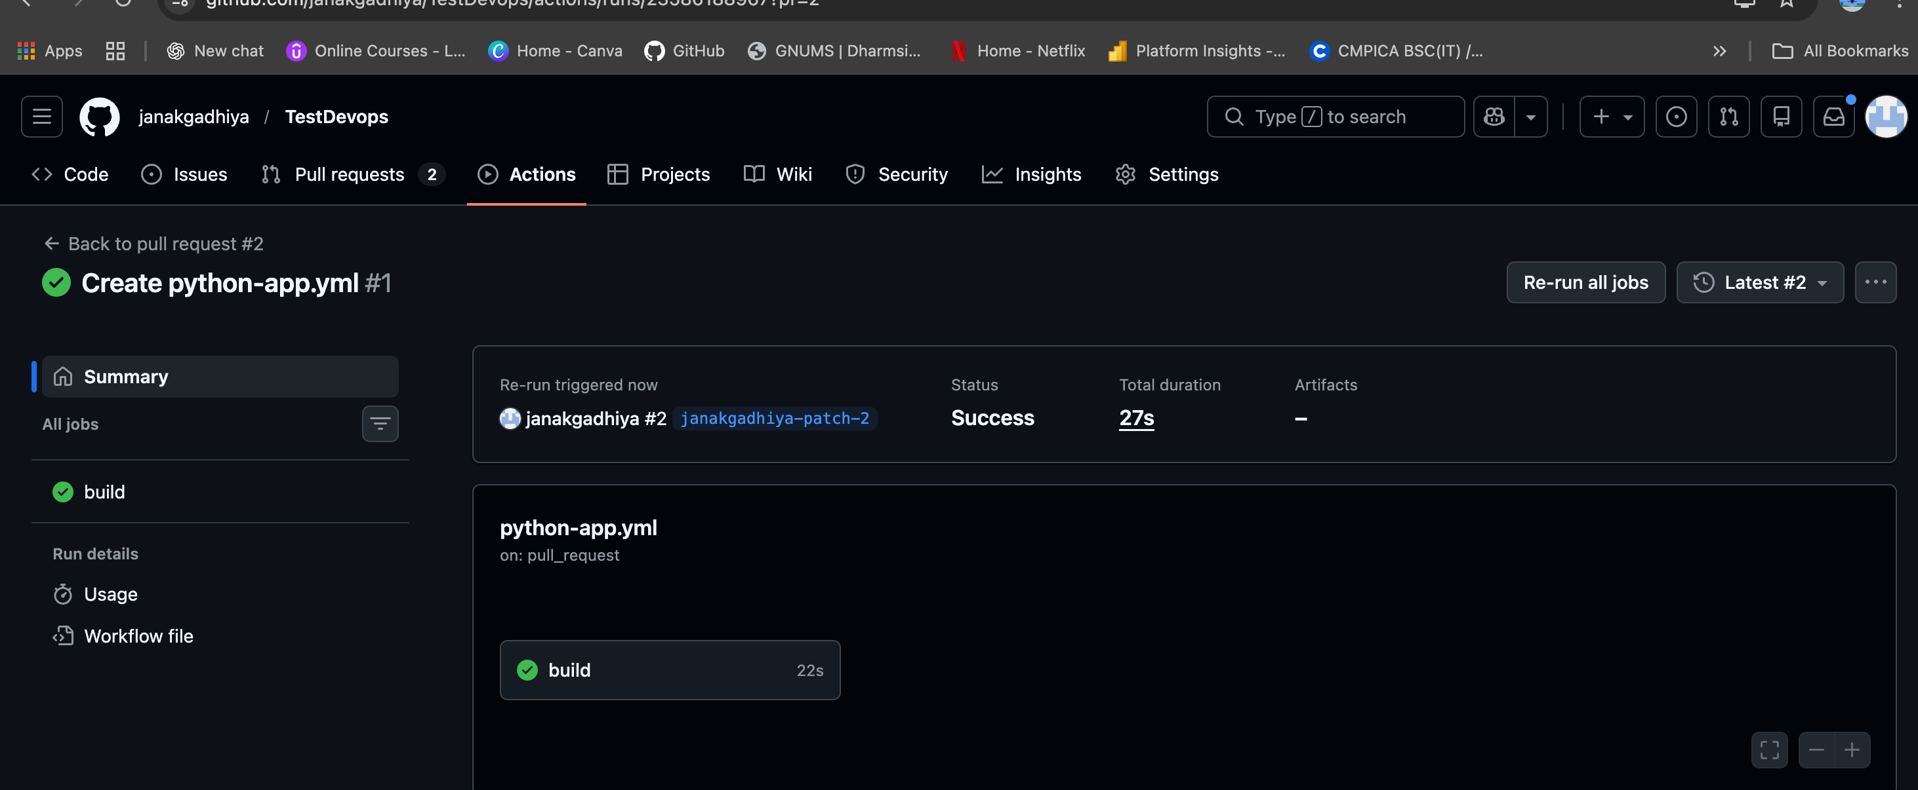
Step10.Make The Change To Test File And Check That Github Action Rebuild IT
