**Practical 2**

Date:- 07/08/21

Roll No:- 19BCE248

Course No:- 2CS502 Computer Networks

AIM: Explore Packet capture tool (Wireshark) to capture and analyse various

types of network packets.

* Capturing Data Packets

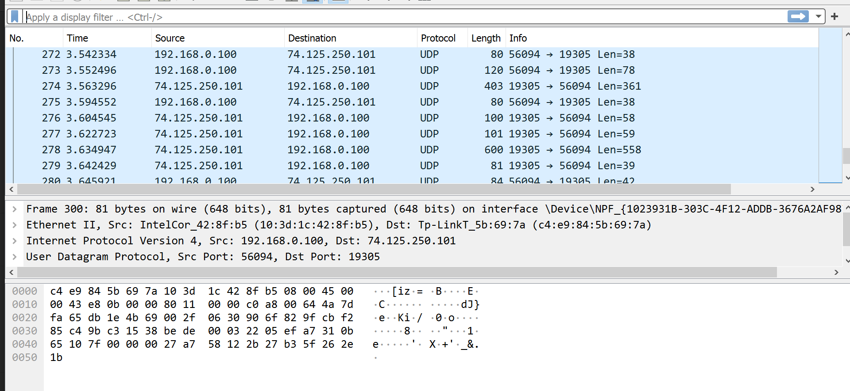

* Saving Data Packets

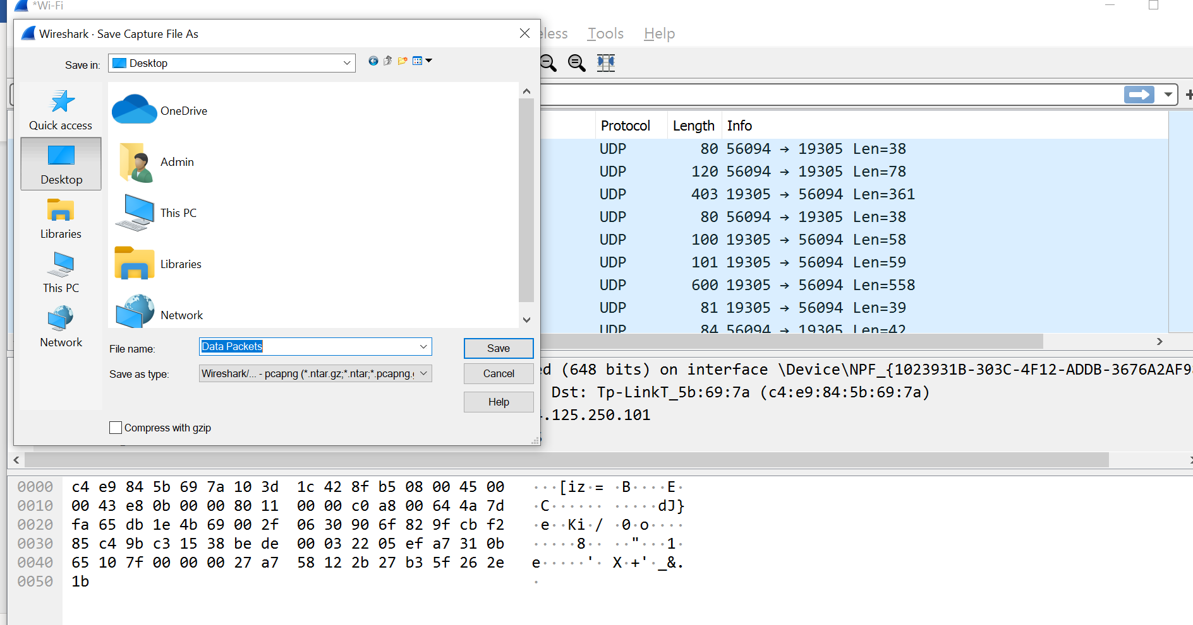

* Changing Date and Time Format

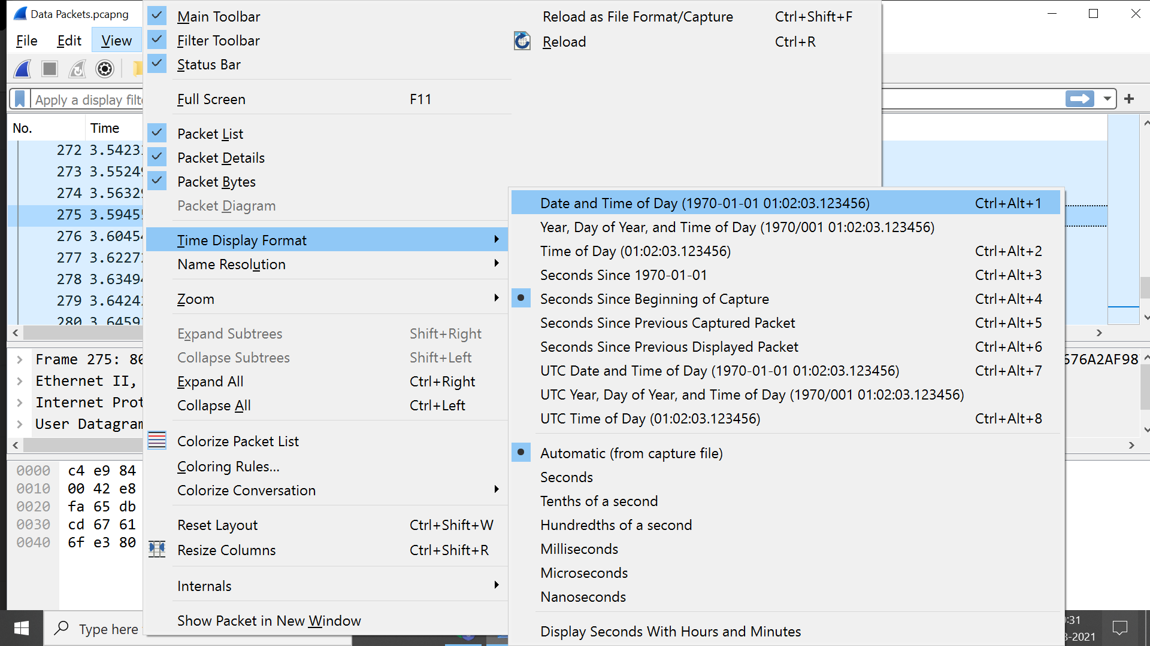

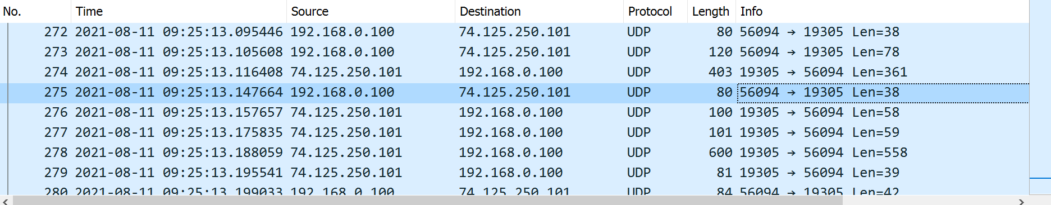

* Package Details

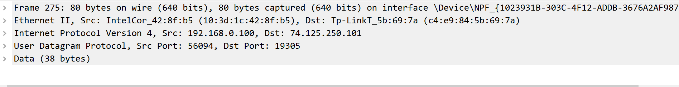

* Package Bytes

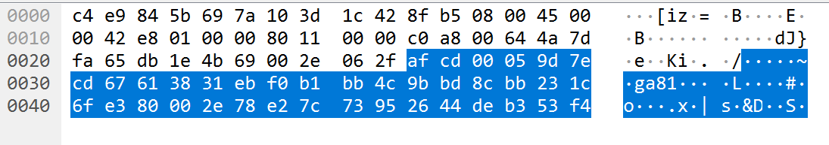

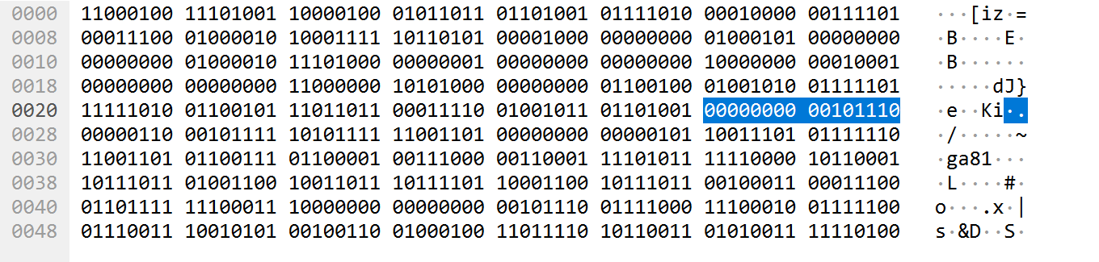

* Applying Filters

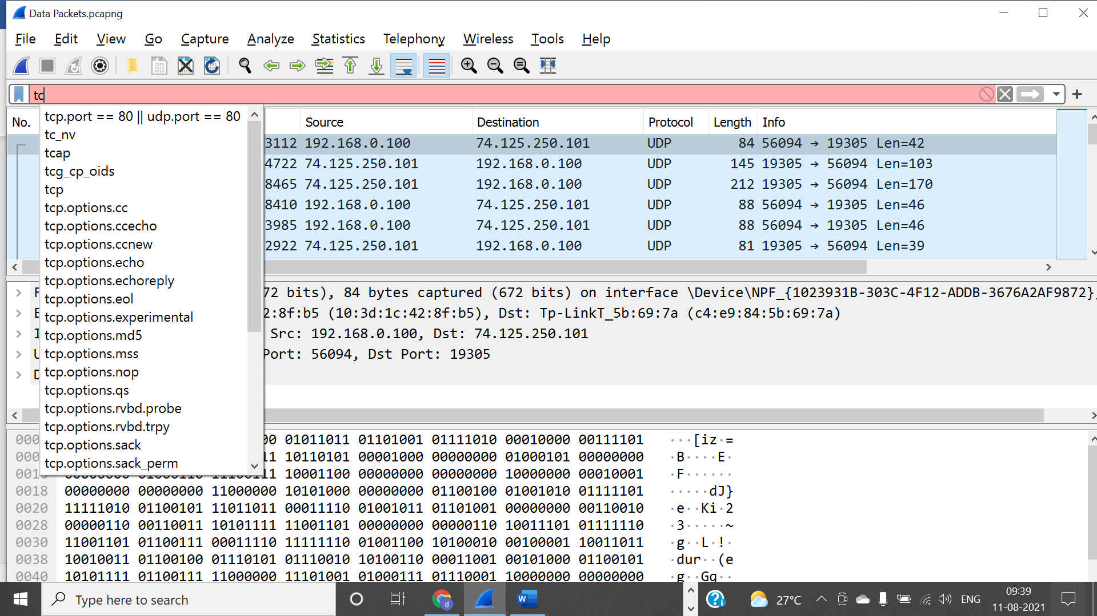

* Coloring Rules

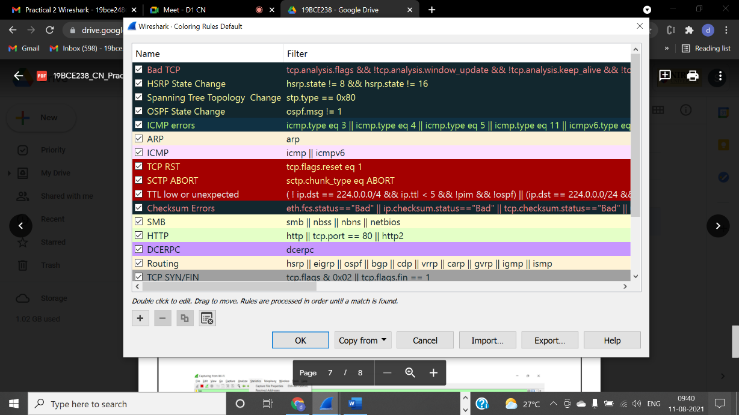

* Wireshark Statistics

