Practical 3

Date:- 11/08/21

Roll No:- 19BCE248

Course No:- 2CS502 Computer Networks

AIM: To implement Byte and Bit stuffing techniques.

*Byte Stuffing:*

import java.util.\*;

class ByteStuffing{

public static void main(String[] args) {

Scanner sc=new Scanner(System.in);

System.out.println("Enter Flag String");

String flag=sc.next();

System.out.println("Enter Esc String");

String esc=sc.next();

System.out.println("Enter no. of Frames");

int n=sc.nextInt();

String[] data=new String[n];

for (int i=0; i<n;i++ ) {

data[i]=sc.next();

}

List<String> send=new ArrayList<>();

send.add(flag);

for (String s:data) {

if (s.equals(flag) || s.equals(esc)) {

send.add(esc);

send.add(s);

}else {

send.add(s);

}

}

send.add(flag);

System.out.println("=========Data with byte stuffing=========");

for(String s:send)

System.out.print(s+" ");

System.out.println("");

StringBuffer received=new StringBuffer();

send.remove(0);

send.remove(send.size()-1);

for(int i=0;i<send.size();i++){

String s=send.get(i);

if (s.equals(esc)) {

received.append(send.get(i+1)+" ");

i++;

}else{

received.append(s+" ");

}

}

System.out.println("=========Data decoded at Reciever end=========");

System.out.println(received);

}

}

Output:

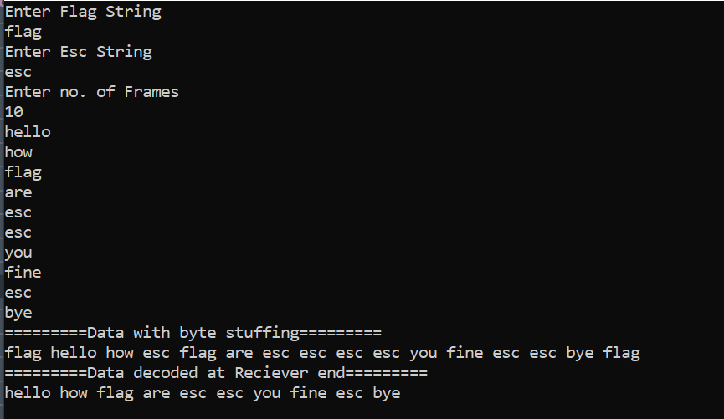

*BitStuffing:*

import java.util.\*;

class BitStuffing{

public static void main(String[] args) {

Scanner sc=new Scanner(System.in);

System.out.println("Enter Input Data:");

String input=sc.next();

char[] c=input.toCharArray();

int ct=0;

StringBuffer send=new StringBuffer();

for (char ch:c) {

if(ct==5){

send.append("0");

ct=0;

}

if (ch=='1') {

ct++;

send.append("1");

}else{

ct=0;

send.append("0");

}

}

System.out.println("=========Data with bit stuffing=========");

System.out.println(send);

ct=0;

StringBuffer recieved=new StringBuffer();

for (char ch:(new String(send)).toCharArray()) {

if(ct==5){

ct=0;

continue;

}

if (ch=='1') {

ct++;

recieved.append("1");

}else{

ct=0;

recieved.append("0");

}

}

System.out.println("=========Data decoded at Reciever end=========");

System.out.println(recieved);

}

}

Output:

