***OB Tutorial***

***19BCE248***

***Dhruvil Shah***

***2HSOE53***

Submitted to: Dr. Parul Bhati Maam

**Tutorial 1**

Tony Stark had just finished his first week at Reece Enterprises and decided to drive upstate to a small lakefront lodge for some fishing and relaxation. Tony had worked for the previous ten years for the O’Grady Company, but O’Grady had been through some hard times of late and had recently shut down several of its operating groups, including Tony’s, to cut costs. Fortunately, Tony’s experience and recommendations had made finding another position fairly easy. As he drove the interstate, he reflected on the past ten years and the apparent situation at Reece.

At O’Grady, things had been great. Tony had been part of the team from day one. The job had met his personal goals and expectations perfectly, and Tony believed he had grown greatly as a person. His work was appreciated and recognized; he had received three promotions and many more pay increases.

Tony had also liked the company itself. The firm was decentralized, allowing its managers considerable autonomy and freedom. The corporate Culture was easygoing. Communication was open. It seemed that everyone knew what was going on at all times, and if you didn’t know about something, it was easy to find out.

The people had been another plus. Tony and three other managers went to lunch often and played golf every Saturday. They got along well both personally and professionally and truly worked together as a team. Their boss had been very supportive, giving them the help they needed but also staying out of the way and letting them work.

When word about the shutdown came down, Tony was devastated. He was sure that nothing could replace O’Grady. After the final closing was announced, he spent only a few weeks looking around before he found a comparable position at Reece Enterprises.

As Tony drove, he reflected that "comparable" probably was the wrong word. Indeed, Reece and O’Grady were about as different as you could get. Top managers at Reece apparently didn’t worry too much about who did a good job and who didn’t. They seemed to promote and reward people based on how long they had been there and how well they played the never-ending political games.

Maybe this stemmed from the organization itself, Tony pondered. Reece was a bigger organization than O’Grady and was structured much more bureaucratically. It seemed that no one was allowed to make any sort of decision without getting three signatures from higher up. Those signatures, though, were hard to get. All the top managers usually were too busy to see anyone, and interoffice memos apparently had very low priority.

Tony also had had some problems fitting in. His peers treated him with polite indifference. He sensed that a couple of them resented that he, an outsider, had been brought right in at their level after they had had to work themselves up the ladder. On Tuesday he had asked two colleagues about playing golf. They had politely declined, saying that they did not play often. But later in the week, he had overheard them making arrangements to play that very Saturday.

It was at that point that Tony had decided to go fishing. As he steered his car off the interstate to get gas, he wondered if perhaps he had made a mistake in accepting the Reece offer without finding out more about what he was getting into.

**Questions**:

1. **Identify several concepts and characteristics from the field of organizational behavior that this case illustrates.**

In the context of this scenario, many of the concepts and features of the organization's behavior have been demonstrated. The organizational cultures of Reyes and O'Grady were vastly different.

When Tony Stark first started working at O'Grady, everything was going swimmingly. Let me begin with O'Grady, who appears to have very high human, conceptual, and technical abilities, but their human skill is the most visible value in the workplace, and the Leadership style that displays here the positive leadership this method concentrates on the "economic incentives." This can be seen in the text, which said that Tony had received three promotions and that he might obtain wage raises during his time with the firm.

1. **What advice can you give Tony? How would this advice be supported or tempered by behavioral concepts and processes?**

Tony Stark has the option of looking for a new job and then joining it, or he may make a difference in the company he previously worked for and create a change. It is difficult, but not impossible, to change corporate attitudes in such a large corporation. He's probably not the only one who's having trouble. There may be a few more persons who join him to assist him in making a decision. This change can be obtained by properly communicating with higher authorities. Let them know that employees are dissatisfied with their jobs and are unmotivated to work, which will lead to the company's demise and collapse. If decision-making is more efficient, this can be avoided.

1. **Is it possible to find an "ideal" place to work? Explain.**

No, There’s nothing like a perfect company, there’ll always be something going on and making things uncomfortable or annoying for you, so it’s a change that Looking for it makes these worries an opportunity for self-improvement and development, and in the end, there is a possibility to find a perfect workplace, but it’s up to you if you can make the negative turn into a positive thing.

**Tutorial 2**

Helen Bowers was stumped. Sitting in her office at the plant, she pondered the same questions she had been facing for months: how to get her company’s employees to work harder and produce more. No matter what she did, it didn’t seem to help much.

Helen had inherited the business three years ago when her father, Jake Bowers, passed away unexpectedly. Bowers Machine Parts was founded four decades ago by Jake and had grown into a moderate-size corporation. Bowers makes replacement parts for large-scale manufacturing machines such as lathes and mills. The firm is headquartered in Kansas City and has three plants scattered throughout Missouri.

Although Helen grew up in the family business, she never understood her father’s approach. Jake had treated his employees like part of his family. In Helen’s view, however, he paid them more than he had to, asked their advice far more often than he should have, and spent too much time listening to their ideas and complaints. When Helen took over, she vowed to change how things were done. In particular, she resolved to stop handling employees with kid gloves and to treat them like what they were: the hired help.

In addition to changing the way employees were treated, Helen had another goal for Bowers. She wanted to meet the challenge of international competition. Japanese firms had moved aggressively into the market for heavy industrial equipment. She saw this as both a threat and an opportunity. On the one hand, if she could get a toehold as a parts supplier to these firms, Bowers could grow rapidly. On the other, the lucrative parts market was also sure to attract more Japanese competitors. Helen had to make sure that Bowers could compete effectively with highly productive and profitable Japanese firms.

From the day Helen took over, she practiced an altogether different philosophy to achieve her goals. For one thing, she increased production quotas by 20 percent. She instructed her first-line supervisors to crack down on employees and eliminate all idle time. She also decided to shut down the company softball field her father had built. She thought the employees really didn’t use it much, and she wanted the space for future expansion.

Helen also announced that future contributions to the firm’s profit-sharing plan would be phased out. Employees were paid enough, she believed, and all profits were the rightful property of the owner—her. She also had private plans to cut future pay increases to bring average wages down to where she thought they belonged. Finally, Helen changed a number of operational procedures. In particular, she stopped asking other people for their advice. She reasoned that she was the boss and knew what was best. If she asked for advice and then didn’t take it, it would only stir up resentment.

All in all, Helen thought, things should be going much better. Output should be up and costs should be way down. Her strategy should be resulting in much higher levels of productivity and profits.

But that was not happening. Whenever Helen walked through one of the plants, she sensed that people weren’t doing their best. Performance reports indicated that output was only marginally higher than before but scrap rates had soared. Payroll costs were indeed lower, but other personnel costs were up. It seemed that turnover had increased substantially and training costs had gone up as a result.

In desperation, Helen finally had hired a consultant. After carefully researching the history of the organization and Helen’s recent changes, the consultant made some remarkable suggestions. The bottom line, Helen felt, was that the consultant thought she should go back to that "humanistic nonsense" her father had used. No matter how she turned it, though, she just couldn’t see the wisdom in this. People worked to make a buck and didn’t want all that participation stuff.

Suddenly, Helen knew just what to do: She would announce that all employees who failed to increase their productivity by 10 percent would suffer an equal pay cut. She sighed in relief, feeling confident that she had finally figured out the answer.

**Questions:**

1. **How successfully do you think Helen Bowers’s new plan will be?**

From the day Helen took over, she practiced a different philosophy together to achieve her goals. For one reason, their production increased by 20 percent. She instructed the first-line supervisors to take firm action against the staff and to stop all downtime. She also decided to close the company’s soft field established by her father. She thought the staff didn’t use it much, and she wanted the space for future expansion. The problems that came with the way she dealt with the workers, they are dissatisfied or not being involved in the process. They treat them like hired help or rather , Since the machines which paid for her work, paid her medium wages and expected her to work at full capacity and to produce as much what she can, she did not think of herself as a leader but as a manager, was interested in profit and did not share the profit among the workers who made her earn this profit.

1. **What challenges does Helen confront?**

Helen was a very straight person, and she knew what she was doing and knew what steps would help her grow the company, and never treated the people who worked for her. As human beings, where they were paid their average wage which I thought they would do more than enough for them, but they have to realize that in the end Today they also had desires to procreate and family at home, and they needed to be paid more than an average and to be treated more than just machines.

1. **If you were Helen’s consultant, what would you advise her to do?**

If I was given a role as Helen then I would select the areas I need to refine and prepare to process them. Once you’ve identified areas that need improvement, it’s time to work on my acceptance. Your daily tasks are my responsibility, so I must treat them as such. An inappropriate plan for each task by specifying your duties for the week in your chart. Whenever things appear, register them immediately. Make paperwork visible to the minimum, keeping only what is currently required on my desk. Maintenance of a computer-based paper system. Name All materials and place all linked content in the same folder. When my work schedule becomes overheated and faces constant interruptions, I tend to do so in order of priority.

**Tutorial 3**

Warren Oats was a highly successful executive for American Auto Suppliers, a Chicago-based company that makes original-equipment specialty parts for Ford, GM, and Chrysler. Rather than retreat before the onslaught of Japanese automakers, AAS decided to counterattack and use its reputation for quality and dependability to win over customers in Japan. Oats had started in the company as an engineer and worked his way up to become one of a handful of senior managers who had a shot at the next open vice-presidential position. He knew he needed to distinguish himself somehow, so when he was given a chance to lead the AAS attack on the Japanese market, he jumped at it.

Oats knew he did not have time to learn Japanese, but he had heard that many Japanese executives speak English, and the company would hire a translator anyway. The toughest part about leaving the United States was persuading his wife, Carol, to take an eighteen-month leave from her career as an attorney with a prestigious Chicago law firm. Carol finally persuaded herself that she did not want to miss an opportunity to learn a new culture. So, armed with all the information they could gather about Japan from their local library, the Oats headed for Tokyo.

Known as an energetic, aggressive salesperson back home, Warren Oats wasted little time getting started. As soon as his office had a telephone—and well before all his files had arrived from the States—Oats made an appointment to meet with executives of one of Japan’s leading automakers. Oats reasoned that if he was going to overcome the famous Japanese resistance to foreign companies, he should get started as soon as possible.

Oats felt very uncomfortable at that first meeting. He got the feeling that the Japanese executives were waiting for something. It seemed that everyone but Oats was in slow motion. The Japanese did not speak English well and appeared grateful for the presence of the interpreter, but even the interpreter seemed to take her time in translating each phrase. Frustrated by this seeming lethargy and beginning to doubt the much-touted Japanese efficiency, Oats got right to the point. He made an oral presentation of his proposal, waiting patiently for the translation of each sentence. Then he handed the leader of the Japanese delegation a packet containing the specifics of his proposal, got up, and left. The translator trailed behind him as if wanting to drag out the process even further.

By the end of their first week, both Oats and his wife were frustrated. Oats’s office phone had not rung once, which did not make him optimistic about his meeting with another top company the following week. Carol could scarcely contain her irritation with what she had perceived of the Japanese way of life. She had been sure that a well-respected U.S. lawyer would have little trouble securing a job with a Japanese multinational corporation, but the executives she had met with seemed insulted that she was asking them for a job. And the way they treated their secretaries! After only a week in Japan, both Carol and Warren Oats were ready to go home.

A month later, their perspective had changed radically, and both looked back on those first meetings with embarrassment. Within that month, they had learned a lot about the Japanese sense of protocol and attitudes toward women. Warren Oats believed he was beginning to get the knack of doing business with the Japanese in their manner: establishing a relationship slowly, almost ritualistically, waiting through a number of meetings before bringing up the real business at hand, and then doing so circumspectly. It was difficult for Oats to slow his pace, and it made him nervous to be so indirect, but he was beginning to see some value in the sometimes humbling learning process he was going through. Perhaps, he thought, he and Carol could become consultants for other executives who needed to learn the lessons he was beginning to understand.

**Question:**

1. **What specific errors did Warren and Carol Oats make during their first week in Japan?**

Oats should have done some research in Japanese ways of doing business. Particularly on their meeting etiquette and social interaction; they are well-known for their politeness and it is probably the defining factor whether Oats is able to secure the business.

First off, Oats should have presented his name card upon the first meeting even before he started to present his proposal. To Japanese, name cards represent an individual, Oats should have a cardholder specially catered to that. Introduction of himself and the company is also important, possibly this should be the only of the objective of the first meeting instead of on going straight to the point.

Secondly, Oats should have brought an assistant or more peers along with him on the first meeting. Seeing the Japanese attend the meeting in a group means they are prepared to ask specific questions per their expertise. Silence did occur during the meeting, it simply means that reflection is taking place; Oats should not have broken the silence.

1. **You were talking to a non-U.S. businessperson making first contact with an American company, what advice would you give?**

Business plan or proposal should be written as concise as possible, it should be presented straight to the point that it would not take more than 20 minutes. Americans can’t stand long meeting, just show all the numbers and figures that are proven and they are satisfied. Do persist and continue to convince them with strong words and promises that are sensible, it is alright to be aggressive.When in Rome, do as the Romans do. Don’t just wear like them, talk like one too. In case you are not familiar with how the Americans talk, watch some American shows like “How I met Your Mother”, there are a lot of ideas and humor which you can get from there. Learn their slang and their body language, or else you might miss out on some hidden message. On all occasions, be candid as much as they do; Americans believe that being direct is a virtue. Americans ask for what they want, say what they mean, and expect you to do the same.

**Tutorial 4**

Susan Harrington continued to drum her fingers on her desk. She had a real problem and wasn’t sure what to do next. She had a lot of confidence in Jack Reed, but she suspected she was about the last person in the office who did. Perhaps if she ran through the entire story again in her mind she would see the solution.

Susan had been distribution manager for Clarkston Industries for almost twenty years. An early brush with the law and a short stay in prison had made her realize the importance of honesty and hard work. Henry Clarkston had given her a chance despite her record, and Susan had made the most of it. She now was one of the most respected managers in the company. Few people knew her background.

Susan had hired Jack Reed fresh out of prison six months ago. Susan understood how Jack felt when Jack tried to explain his past and asked for another chance. Susan decided to give him that chance just as Henry Clarkston had given her one. Jack eagerly accepted a job on the loading docks and could soon load a truck as fast as anyone in the crew.

Things had gone well at first. Everyone seemed to like Jack, and he made several new friends. Susan had been vaguely disturbed about two months ago, however, when another dock worker reported his wallet missing. She confronted Jack about this and was reassured when Jack understood her concern and earnestly but calmly asserted his innocence. Susan was especially relieved when the wallet was found a few days later.

The events of last week, however, had caused serious trouble. First, a new personnel clerk had come across records about Jack’s past while updating employee files. Assuming that the information was common knowledge, the clerk had mentioned to several employees what a good thing it was to give ex-convicts like Jack a chance. The next day, someone in bookkeeping discovered some money missing from petty cash. Another worker claimed to have seen Jack in the area around the office strongbox, which was open during working hours, earlier that same day.

Most people assumed Jack was the thief. Even the worker whose wallet had been misplaced suggested that perhaps Jack had indeed stolen it but had returned it when questioned. Several employees had approached Susan and requested that Jack be fired. Meanwhile, when Susan had discussed the problem with Jack, Jack had been defensive and sullen and said little about the petty-cash situation other than to deny stealing the money.

To her dismay, Susan found that rethinking the story did little to solve his problem. Should she fire Jack? The evidence, of course, was purely circumstantial, yet everybody else seemed to see things quite clearly. Susan feared that if she did not fire Jack, she would lose everyone’s trust and that some people might even begin to question her own motives.

**Questions:**

1. **Explain the events in this case in terms of perception and attitudes. Does personality play a role?**

Henry Clarkston had given her a chance despite her record, and Susan had made the most of it. Susan also gave a chance to Jack perceiving the result from own story. In this case Susan attributed her attitude and situation to Jack and hoped that he too may come up in the organization in a similar way. This is referred to as attribution. Certainly personality plays a role day-to-day life. Individual perceptions, attitudes, behavior, habits etc form a personality of an individual, which influence the behavior at work place.

1. **What should Susan do? Should she fire Jack or give him another chance?**

Since the evidence is circumstantial Susan should counsel Jack and give him a last warning to change his attitude if he is guilty. Though there is no clear-cut proof, due his previous record he is being treated as a probable culprit. It is not fair to fire an employee, without established evidence. There should be strict monitoring on Jack so that he is caught red handed if he has not really given up the habit of stealing. A full-fledged enquiry has to be conducted about the recent happenings, to find out the culprit.

**Tutorial 5**

**Give your view on Impact of COVID19 on employee’s behavior and employee engagement in the organization.**

Organizations nowadays are constantly developing innovative and effective means to engage the employees during this tough time. This paper is a conceptual paper that is based on various research papers, articles, blogs, online newspapers, and reports of World Health Organization. During this pandemic situation, organizations are evolving many engagement activities like online family engagement practices, virtual learning and development, online team building activities, webinars with industry experts, online conduct weekly alignment sessions, team meet‐ups over video conference for lunch, short online game sessions, virtual challenges and competitions, online courses, appreciation sessions, communication exercises, live sessions for new‐skill training, online counseling sessions, recognition and acknowledgment session, webinars dealing with anxiety and stress, providing online guidance for exercise and meditation, social interactions in a virtual office, classrooms training modules digitally, e‐learning modules, and many more creative learning sessions. Work‐from‐home regime engagement activities are very fruitful for employees as well as for organizations. Those organizations doing these kinds of engagement activities for their employees are learning new skills and developing themselves. Employees are feeling committed to the organization and stay motivated during this tough time of COVID‐19 pandemic. Despite the ongoing outbreak of the novel COVID-19, few studies have been conducted on the stress arising from the pandemic. In this study, attributes of epidemic concerns perceived by hotel employees were examined, and their impact on work stress, employee well-being, self-rated mental health, organizational citizenship behavior, and employee-customer identification were verified. We found and verified four attributes based on qualitative and quantitative approaches.

**Tutorial 6**

**Leadership Qualities and Strategies of a Great Leader. (Select any great leader of your choice and prepare the document on it)**

1. Vision

Perhaps the greatest quality any leader can have is vision - the ability to see the big picture of where the organization or team they are working within is headed, what it's capable of, and what it will take to get there.

2. Inspiration

Equally as important as having a vision is the ability to convey that vision to others, and get them excited about it. This means maintaining a positive yet realistic presence within the organization helping team members stay motivated and engaged, and remember what it is that they are working for.

3. Strategic & Critical Thinking

A good leader will be able to think critically about the organization or team they work within and develop a clear understanding of its strengths, weaknesses, opportunities, and threats (and how they as an individual can work to support or overcome these). They'll be able to course-correct when necessary, and be able to assess the work they do to determine how it fits into overall organizational strategy and goals.

4. Interpersonal Communication

Good leaders must be able to interact with other people in a way that feels genuine. This does not mean you have to be an extrovert or a people-person to be a leader - there are many excellent leaders who self-identify as introverts! Rather, it means being able to demonstrate empathy, engaging in active listening, and building meaningful working relationships with those around you, whether they are a peer or a direct report.

5. Authenticity & Self-Awareness

One of the key ways to become a great leader is to be self-aware enough to understand your strengths and your flaws, and to build an authentic leadership style that's true to who you are and how you do your best work. You want to be the best possible leader you can be, not try to fit into a mold set by someone else. Try to embrace the things that make you who you are, and that will naturally translate into you developing an authentic leadership style.

6. Open-Mindedness & Creativity

Being a good leader means being open to new ideas, possibilities, and perspectives, and understanding that there's no "right" way to do things. Leadership involves the knowledge that success comes with a willingness to change how things are done and to bring in fresh eyes to inspire new ideas, in addition to trying to think outside the box as much as possible. Leaders must be able to listen, observe, and be willing to change course when necessary.

7. Flexibility

Leadership also means being adaptable and nimble when the situation calls for it. Nothing ever goes according to plan - whether you encounter minor roadblocks or large obstacles, you will need to be prepared to stop, reassess, and determine a new course of action. Good leaders will embrace the ever-changing nature of business and meet challenges with a flexible attitude - and be able to build inspire that same willingness to adapt in those around them.

8. Responsibility & Dependability

One of the most important qualities a leader can have is a sense of responsibility and dependability. This means displaying those traits in your individual work, but also demonstrating them in your interactions with others. Your team members need to know that they can depend on you to take on your fair share of work and follow through, support them through tough times, and help them meet both shared and individual goals.

9. Patience & Tenacity

A good leader knows how to take the long view, whether it's of a strategy, a situation, or a goal. Being able to take on any bumps in the road and persist on without getting frustrated or defeated is key—from small projects to corporate vision, patience is a trait that is essential to strong leadership.

10. Continuous Improvement

True leaders know that perfection is a myth - there is always room for improvement on all levels, from the personal to the team to the overall organization. They'll always be willing to help team members find ways to develop new skills or improve upon a weakness, be able to identify and implement strategies for helping the organization as a whole grow, and, perhaps most importantly, be able to look inward and identify the areas they would like to work on - and then act on them.

My favorite Leader is Narendra Modi and the above points were mentioned w.r.t to him.

**Tutorial 7**

1. **Define the term Motivation.**

Motivation is the word derived from the word ’motive’ which means needs, desires, wants or drives within the individuals. It is the process of stimulating people to actions to accomplish the goals. In the work goal context the psychological factors stimulating the people’s behaviour can be -

* desire for money
* success
* recognition
* job-satisfaction
* team work

1. **What is something that motivates you?**

My biggest motivation is family. They are my biggest source of inspiration and my strongest supporters as well. When I see my parents working, it gives me the drive to be like them. Their dedication to working is what motivates me to be like them. They are self-motivated individuals. Hence I try to imbibe their positivism into my life. I have learned from my father how to not give up on a tough client. The essence is to go through the grind to really know what the other person wants. This excites me to take up greater challenges and risks without the fear of failure or backing out. My mother is the source of calm confidence. Knowing exactly where to push hard and where to slow down is something I have imbibed from her. They remain, my go-to people, when I feel under the weather or less motivated.

1. **Draw a pyramid and explain each and every level of Maslow’s Hierarchy of needs.**

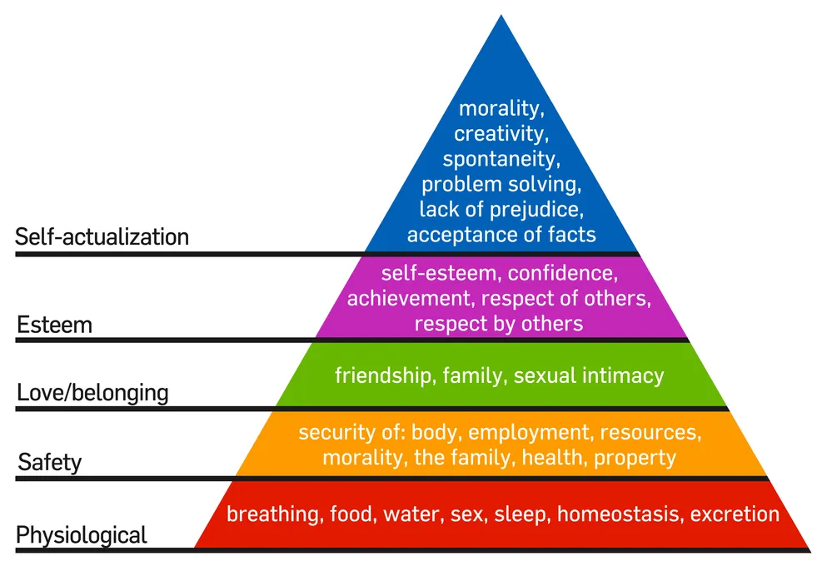

**Tutorial 8**

**Comparison of all these Theories of Motivation in tabular form:-**

**Maslow, Herzberg’s two-factor theory, ERG, McClelland, Equity and Vroom’s Expectancy Theory TH X and TH Y.**

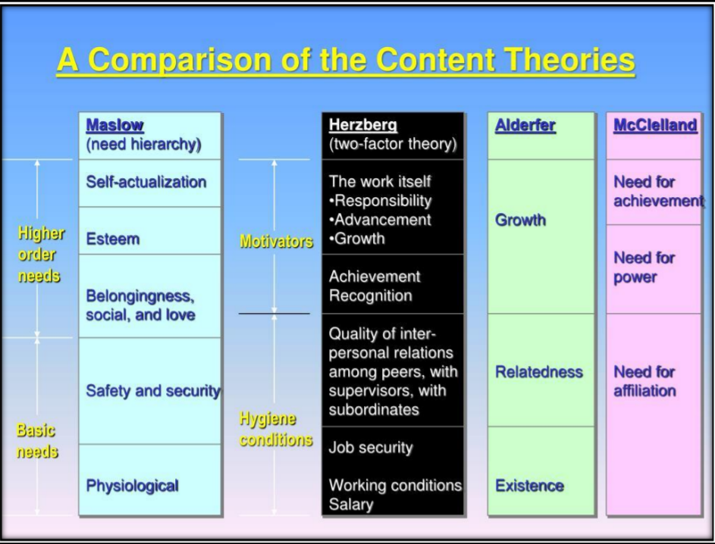

**Tutorial 9**

**Write a book review on “Who moved my cheese”.**

“Who Moved my Cheese?” is a simple story that reveals simple profound truths about change. It’s a fun story of 4 characters who live in a maze (world) and look for cheese (job, money, love et all) to keep themselves happy. The story revolves around how each character react when an unexpected “change” in circumstances deprives them of the cheese that they loved so dearly. Their reaction to the situation gives away valuable lessons that can help you discover for yourself how to deal with change so that you can enjoy less stress and more success (however you define it) in your life.

There have been several books and articles written on this evergreen topic of “Change”. Philosophers and thought-leaders have churned several anecdotes to convey their perspective of handling change. Corporates went on to create a whole new aspect called “Change Management”. All this sounds very serious. Doesn’t it? This book is an attempt to introduce how to deal with “Change” in a fun way, and that is exactly what kept me flipping through the pages.

**Tutorial 10**

**Define Organizational culture. Discuss difference between OC and corporate culture.**

An employer must begin with a thorough understanding of what culture is in a general sense and what their organization's specific culture is. At the deepest level, an organization's culture is based on values derived from basic assumptions about the following: • Human nature. Are people inherently good or bad, mutable or immutable, proactive or reactive? These basic assumptions lead to beliefs about how employees, customers and suppliers should interact and how they should be managed.

• The organization's relationship to its environment. How does the organization define its business and its constituencies?

• Appropriate emotions. Which emotions should people be encouraged to express, and which ones should be suppressed?

• Effectiveness. What metrics show whether the organization and its individual components are doing well?

An organization will be effective only when the culture is supported by an appropriate business strategy and a structure that is appropriate for both the business and the desired culture. Culture is a nebulous concept and is often an undefined aspect of an organization. Although extensive academic literature exists relating to the topic of organizational culture, there is no generally accepted definition of culture. Instead, the literature expresses many different views as to what organizational culture is. 29 Organizational culture can manifest itself in a variety of ways, including leadership behaviors, communication styles, internally distributed messages and corporate celebrations. Given that culture comprises so many elements, it is not surprising that terms for describing specific cultures vary widely. Some commonly used terms for describing cultures include aggressive, customer-focused, innovative, fun, ethical, researchdriven, technology-driven, process-oriented, hierarchical, family-friendly and risk-taking. Because culture is difficult to define, organizations may have trouble maintaining consistency in their messages about culture. Employees may also find it difficult to identify and communicate about perceived cultural inconsistencies. Organizational culture Organizational culture and corporate culture are usually used interchangeably. Both refer to the collective values, outlooks and approaches within an organization. Obviously, the term corporate culture focuses on for-profit corporations, while organizational culture extends to all forms of organizations including small business, privately held companies and nonprofit organizations. However, the meaning is essentially the same. You may notice some variation in how cultures manifest in different settings. Corporate Culture Corporate cultures tend to emphasize ways of operating and functioning that lead to optimum profit. Different businesses and industries embody different cultural bents to meet strategies that work for them. For example, companies in industries like information technology and creative marketing often have cultures that emphasize employee freedom 30 and creativity. This is because these industries compete for top talent and rely on employees' creativity and motivation to excel. Meanwhile, the banking industry tends toward more serious and structured cultures in part because financial institutions must keep strict controls and follow detailed protocols to comply with regulations, work in their customers' interests and safeguard financial assets.