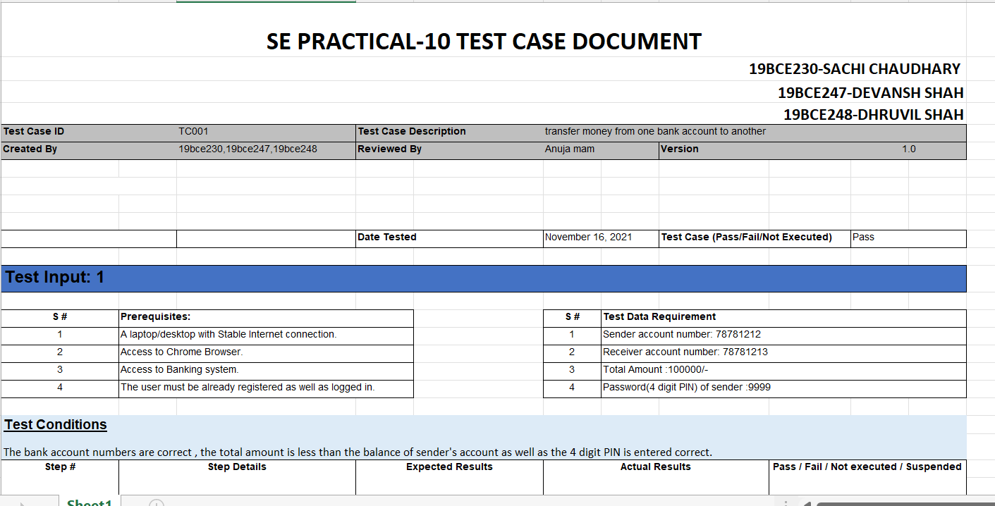

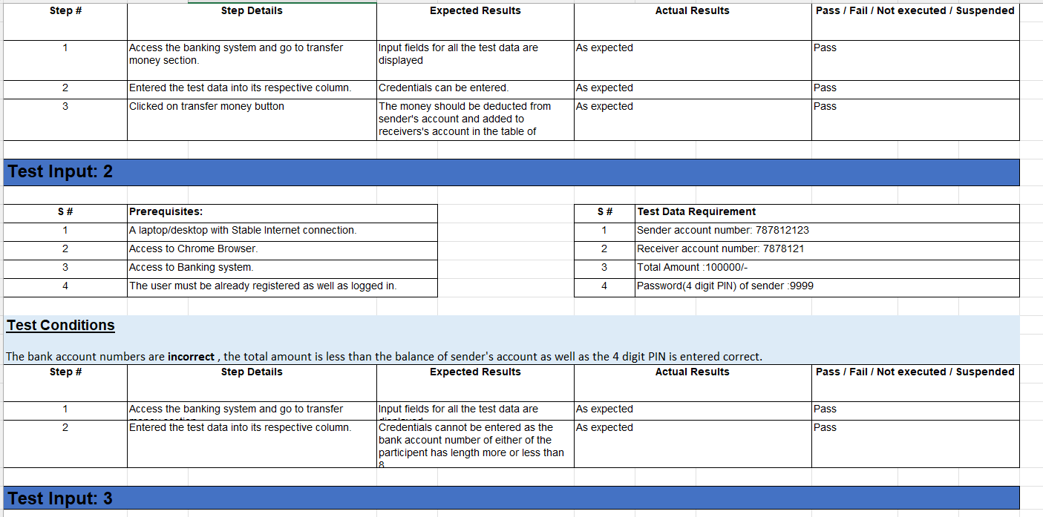

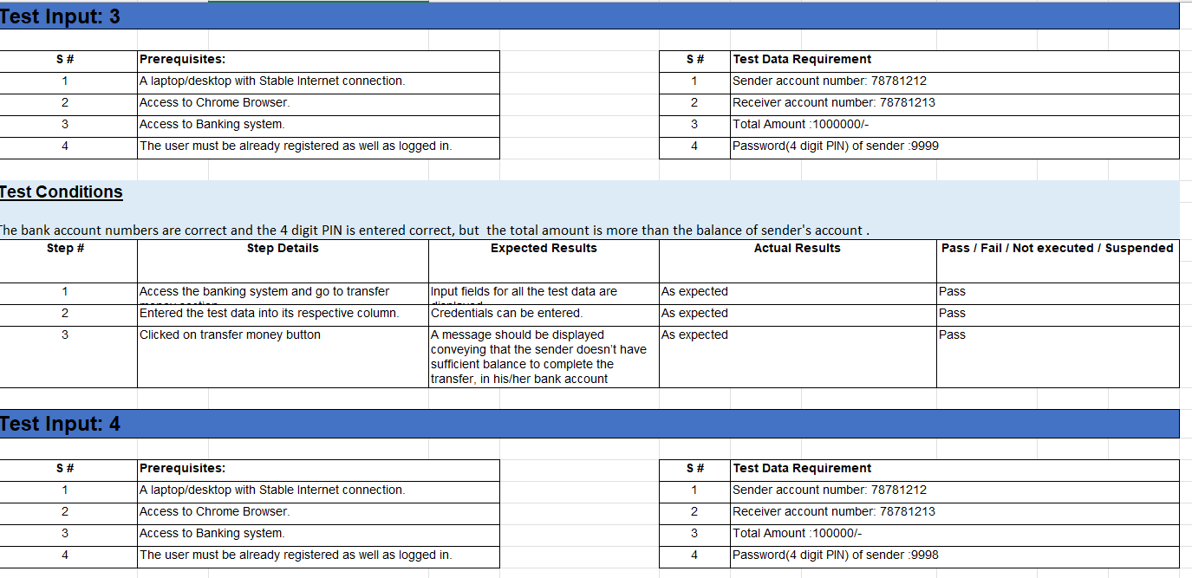

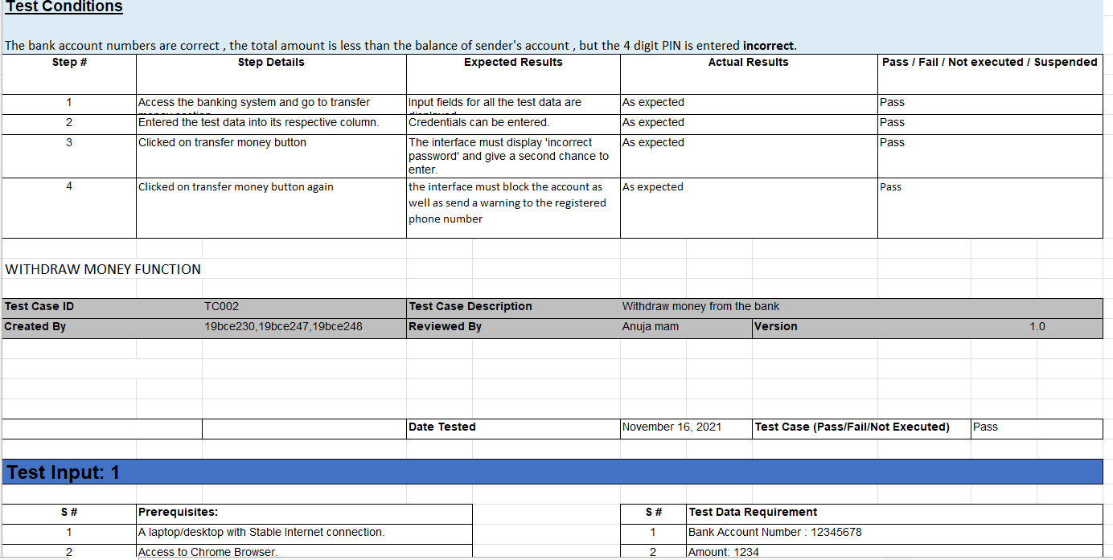

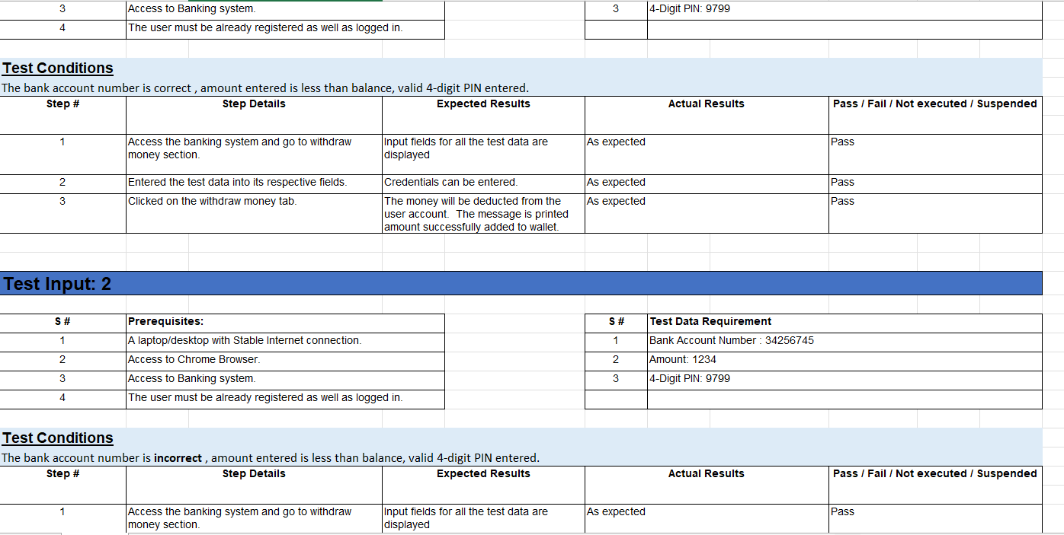

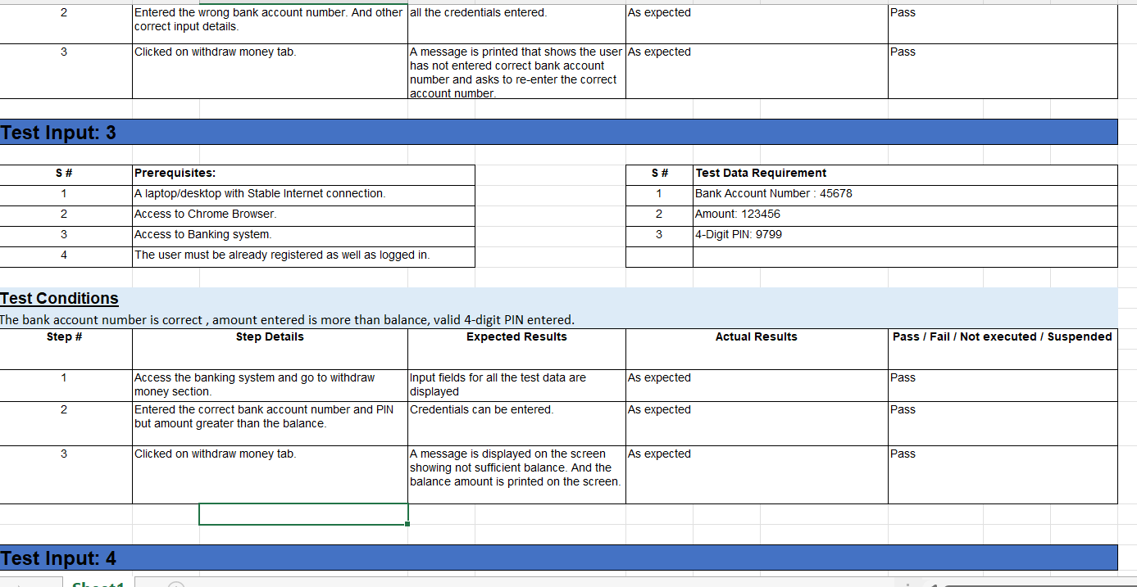

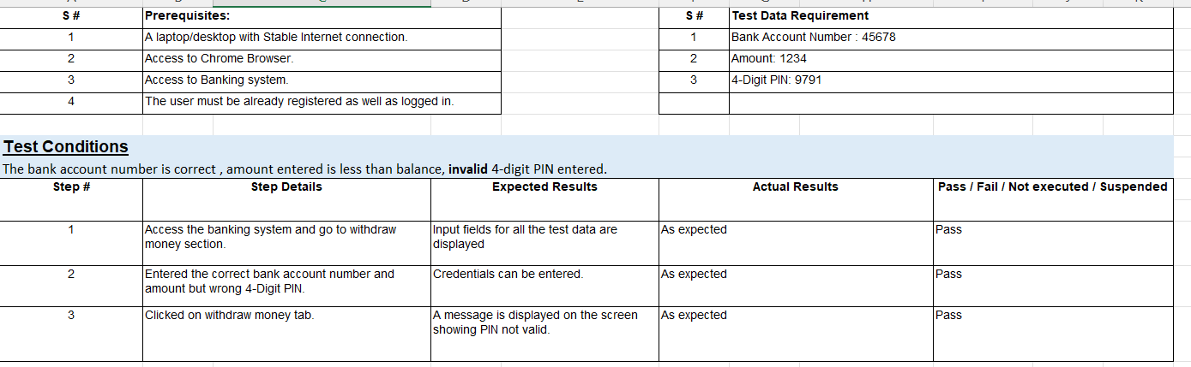

**Module Implementation:**

**Withdraw function:**

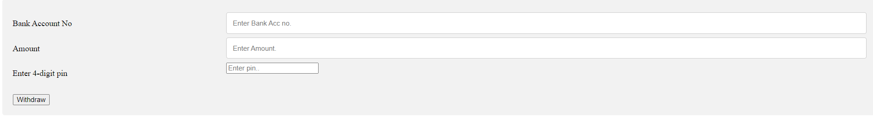

Invalid Details:

1. Account No:

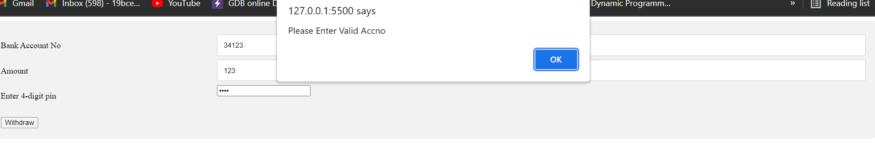

1. Amount > Balance

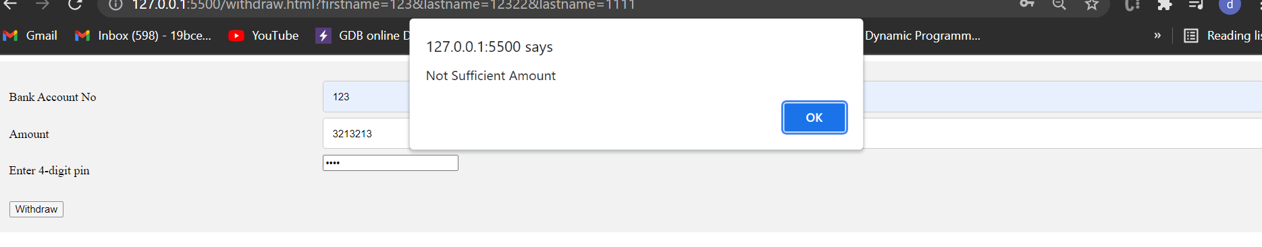

The balance available is 12321

1. Invalid Pin

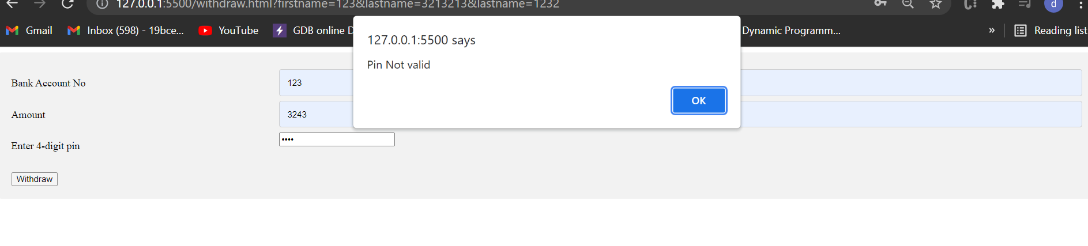

At last, all valid credentials entered

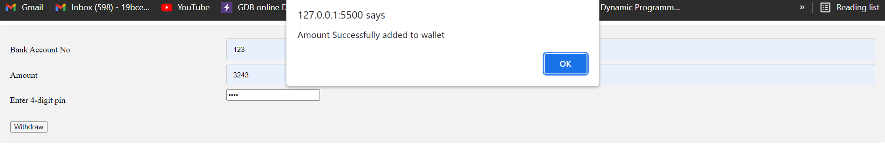

**Transaction Function:**

1. Both Sender and Receivers account entered wrong which is not present in the database.

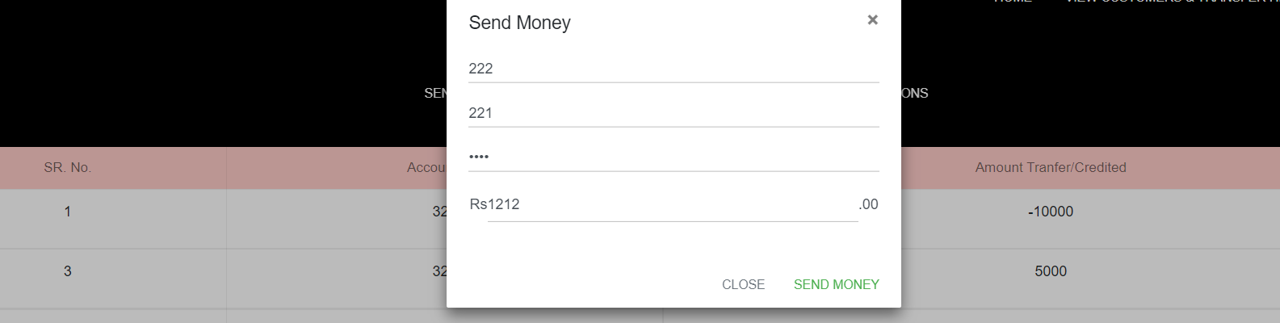

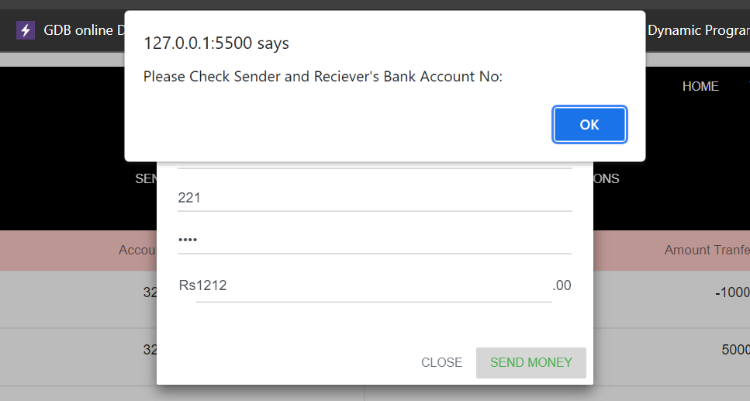

1. Invalid Pin:

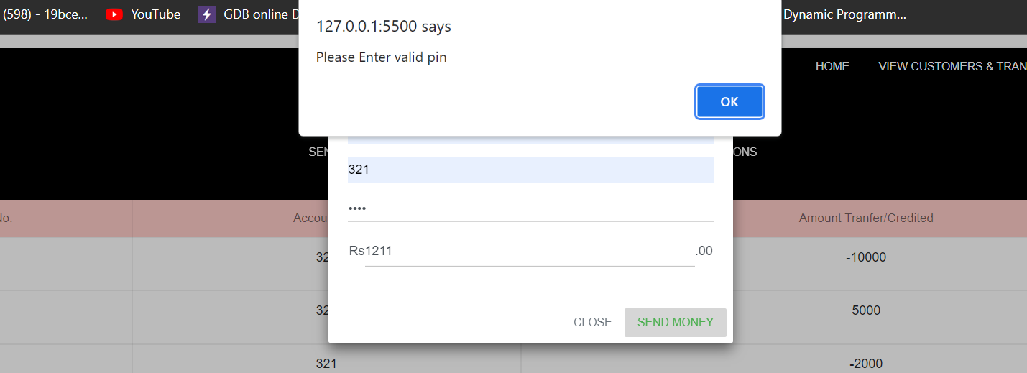

1. Amount Greater than balance

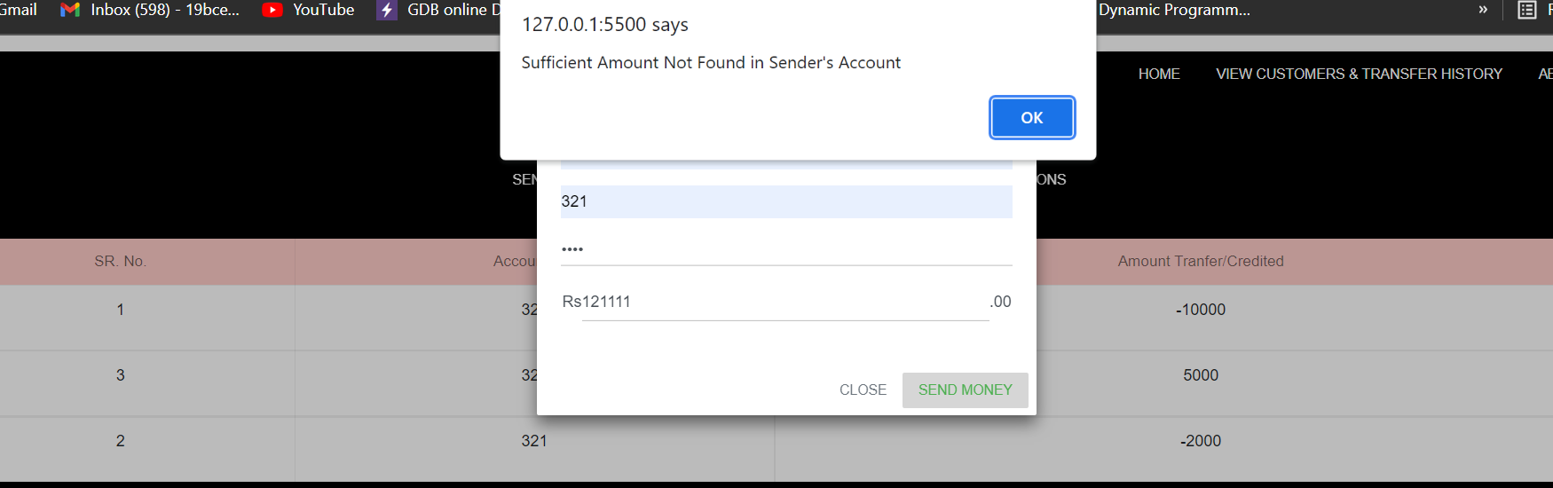

After adding a valid amount the transaction is shown in the history.

