Practical 6

Artificial Intelligence

EL3

19BCE248

AIM: Write a PROLOG program on lists.

1. To find whether given element is a member of list
2. ii Inserting an element at a) beginning b) end c) desired position

PROLOG CODE:

**Member of a list**

member(X,[X|_]).

member(X,[_|T]):-member(X,T).

**Output:**

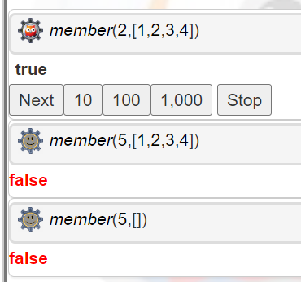

**Inserting at beginning:**

insertBegin(X,[H|T],[X|[H|T]]).

**Output:**

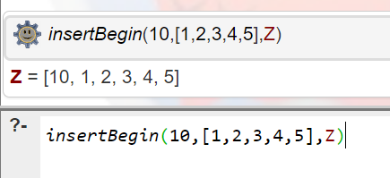

**Insert at end:**

insertAtEnd([], L,L).

insertAtEnd([H|T],L2,[H|L3]):-insertAtEnd(T,L2,L3).

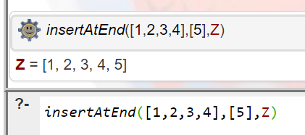

**Insert at Desired Position:**

insertAtPos(Item,List,1,[Item|List]).

insertAtPos(Item,[H|List],Pos,[H|Result]):-Pos1 is Pos-1,insertAtPos(Item,List,Pos1,Result).

