**Blockchain Technology**

**19BCE248**

**Practical 3**

**AIM:** To perform thorough study and installation of Anaconda 5.0.1 and Python 3.6 and perform proof of work (POW) consensus mechanism. Also, notice the changes in mining rewards and nonce requirement.

**Code:**

import hashlib

from select import select

import time

import json

import threading

import random

class Block:

    def __init__(self):

        self.chain=[]

        self.difficulty=4

    def addNewBlock(self,msg):

        data={}

        data["time"]=time.time()

        data["id"]=len(self.chain)

        data["message"]=msg

        if len(self.chain)==0:

            data["prevHash"]=0

        else:

            data["prevHash"]=self.chain[-1]["currHash"]

        str=json.dumps(data).encode()

        data["currHash"]=hashlib.sha256(str).hexdigest()

        data["nonce"]=0

        self.chain.append(data)

        self.getSHA()

    def validate_blocks(self):

        while True:

            ind=-1

            no_blocks=len(self.chain)

            for i in range(1,no_blocks):

                if(self.chain[i]["prevHash"]!=self.chain[i-1]["currHash"]):

                    print("Tampering Found!!")

                    ind=i

                    break

            if ind !=-1:

                for i in range(ind,no_blocks):

                    self.chain[i]["prevHash"]=self.chain[i-1]["currHash"]

    def getSHA(self):

        data=self.chain[-1]

        str=json.dumps(data).encode()

        hash=hashlib.sha256(str).hexdigest()

        while not self.isAchieved(hash):

            data["nonce"]=data["nonce"]+1

            str=json.dumps(data).encode()

            hash=hashlib.sha256(str).hexdigest()

        self.chain[-1]["currHash"]=hash

    def isAchieved(self,hash):

        str=hash[0:self.difficulty]

        count=str.count('0')

        return count==self.difficulty

def validate():

    validate_thread = threading.Thread(target=block.validate_blocks, name="Validate Blocks")

    validate_thread.start()

if __name__=="__main__":

    block=Block()

    for i in range(5):

        block.addNewBlock("My current count is"+str(i))

    # block.chain[2]["currHash"]='1'

    validate()

print(block.chain[2])

**Output:**

Here you can see that each of the hash value has difficulty 4 hash

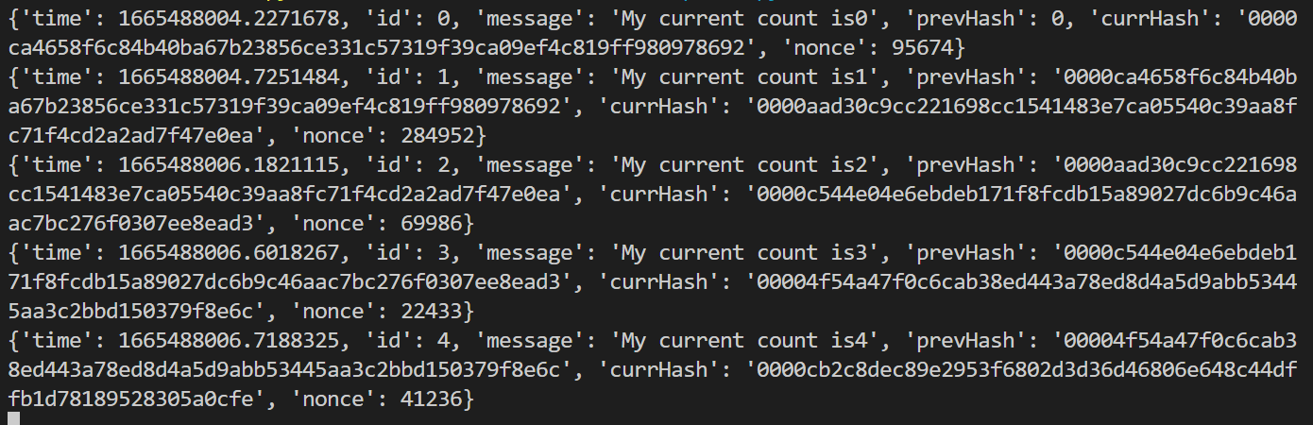

**Explanation of Implementation:**

* The basic implementation structure remains same as practical 2.
* The only change is addition of nonce in each block.
* It basically identifies the functionality of miners who competes during the addition of any transaction block in existing blockchain.
* Here it will continuously check whether first n bits are being 0 or not where n is given by user which represents the difficulty level.
* Once the goal is achieved it will just store the value.

**Learning:**

From these practical we learned about how we can implement the functionality of miners from scratch. Also we can understand how difficult it is for miners to achieve goal state.