**19BCE248**

**BCT**

**Practical 8**

AIM: To design and develop end-to-end decentralized applications (Dapps).

**Code:**

 pragma solidity ^0.6.0;

contract sample_dapp {

    uint value;

    function initialize (uint x) public {

        value = x;

    }

    function get() view public returns (uint){

        return value;

    }

}

**Mining Procedure:**

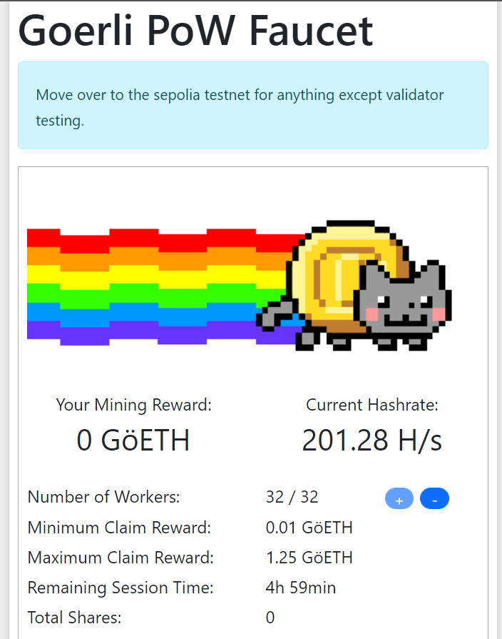

**Collecting rewards through mining:**

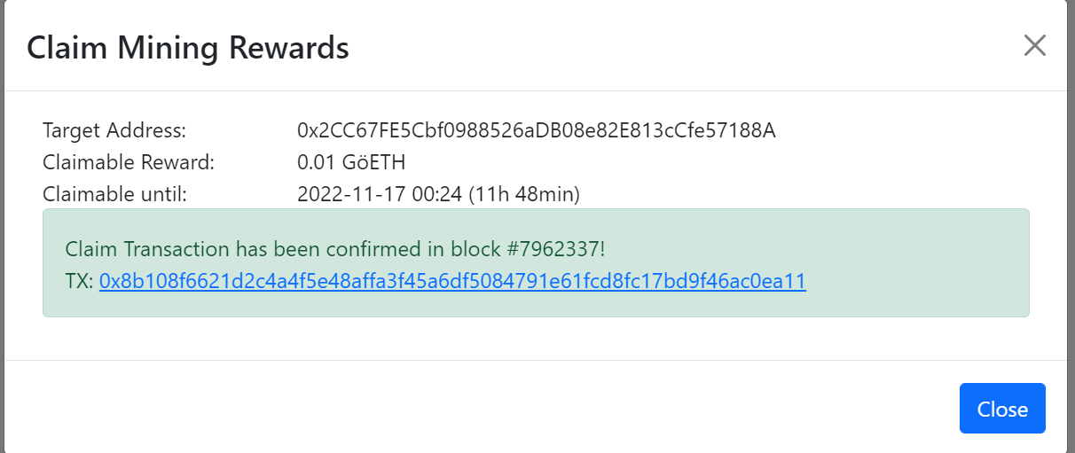

**Making first Dapp:**

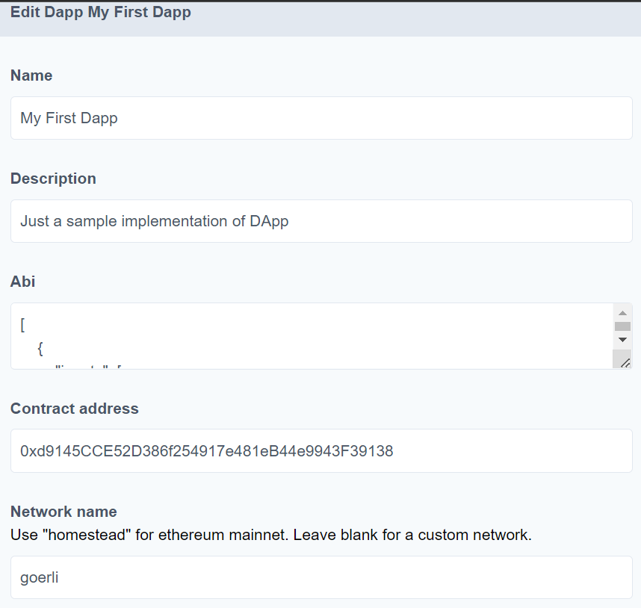

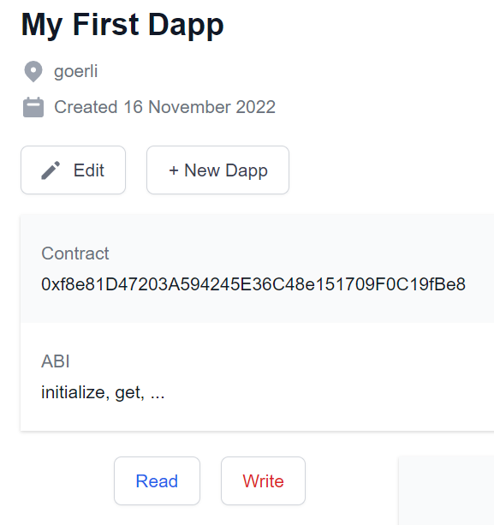

**Complete description of the transaction:**

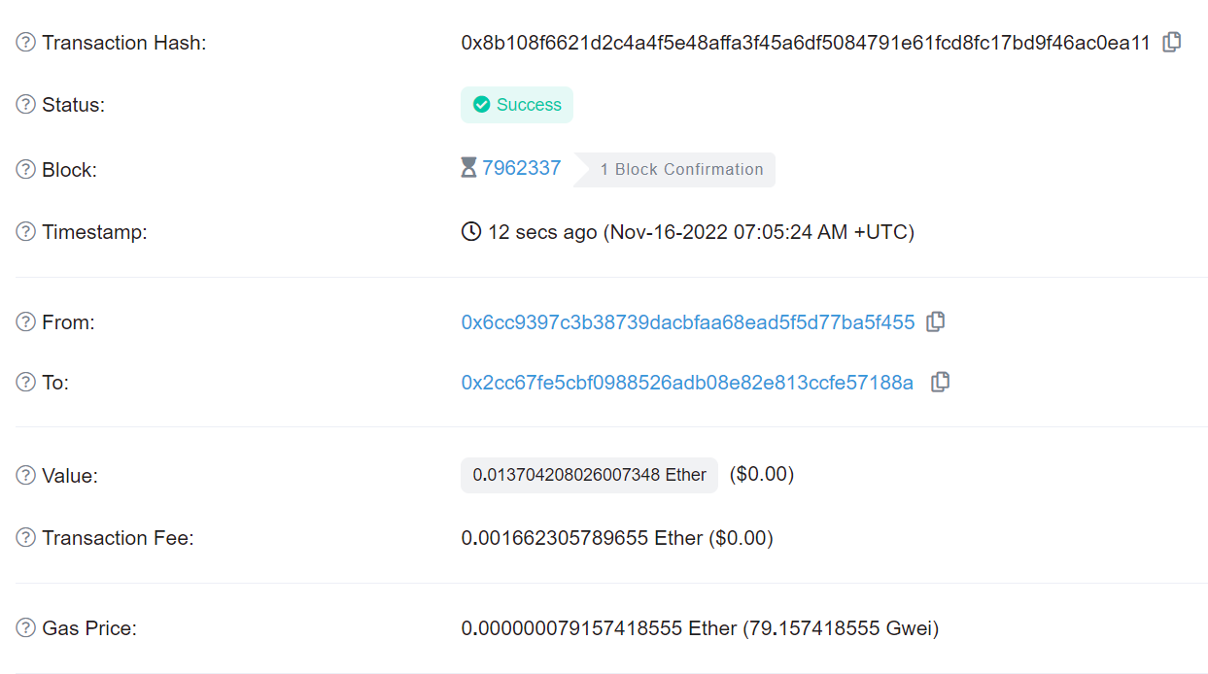

**Running of the program:**

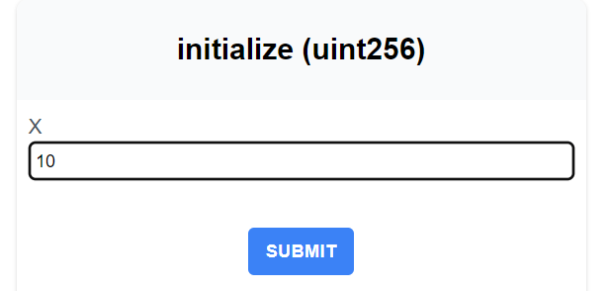

**To set the value we will use some reward amount:**

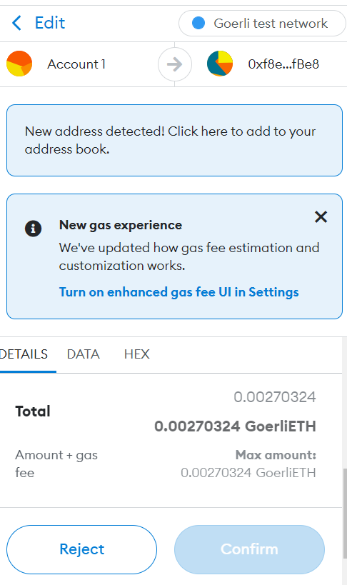

**Some links for ref:**

[**https://goerli-faucet.pk910.de/**](https://goerli-faucet.pk910.de/)

[**https://metamask.io/**](https://metamask.io/)

[**https://oneclickdapp.com/**](https://oneclickdapp.com/)