**19BCE248**

**Big Data Analytics**

**Lab 3**

**D2**

**AIM**: To run various commands of Hadoop

**mkdir:**





**rm:**

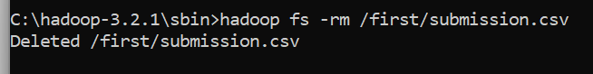

**rmdir:**



**put:**



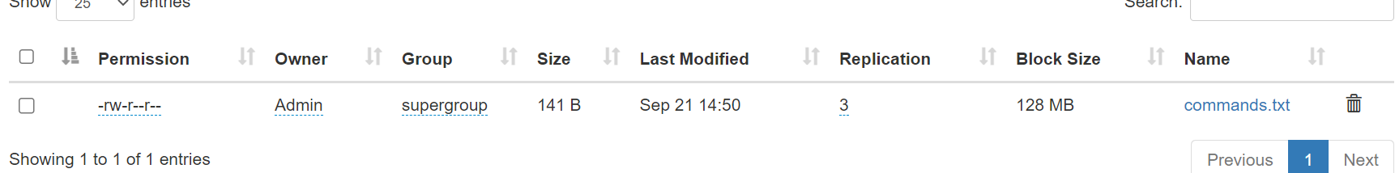

**cp:**

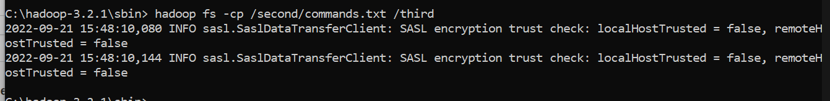



**Executing wordcount:**

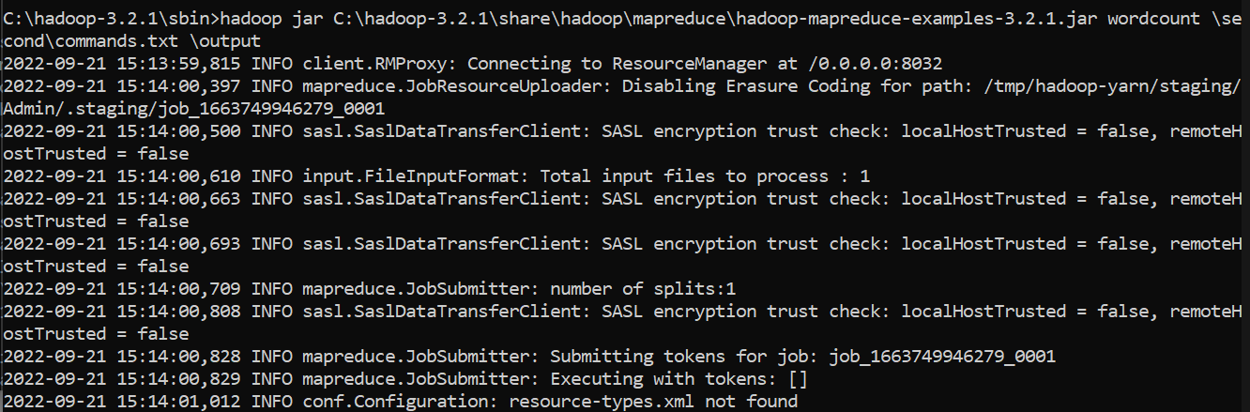

**File for counting :**

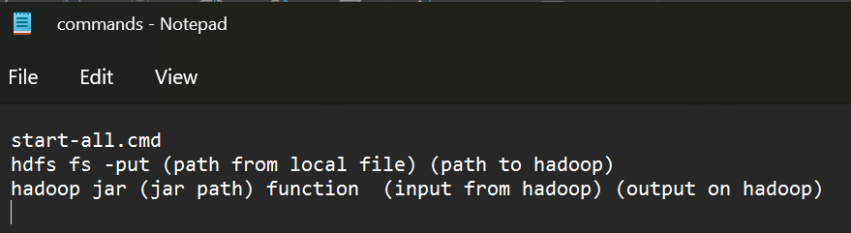

**Output:**

