BDA

Practical4

D2

19BCE248

AIM: To write MapReduce program for various operation on array.

Program for Word count using the pre-defined file provided by Apache

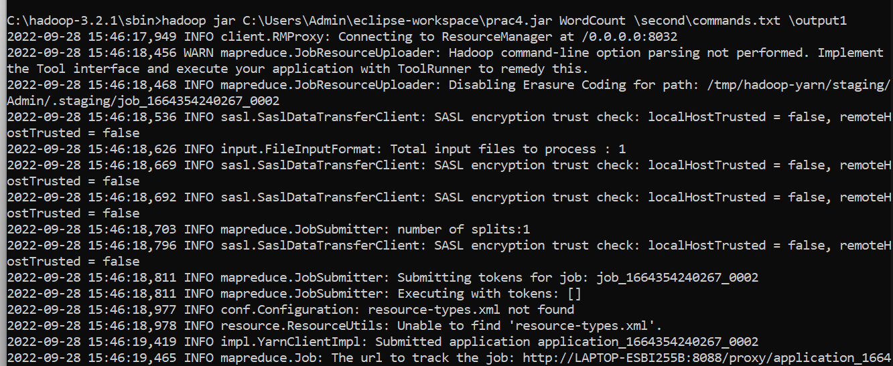



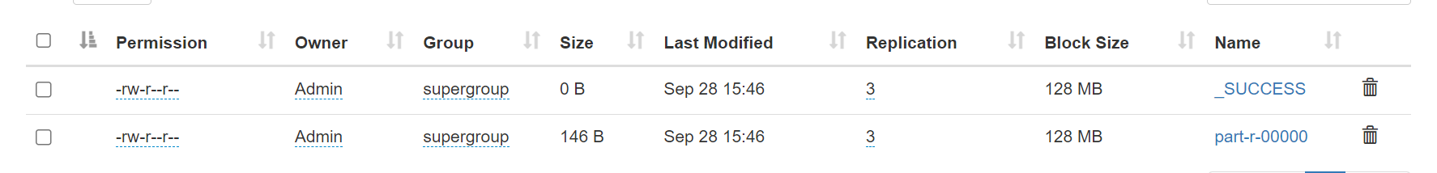

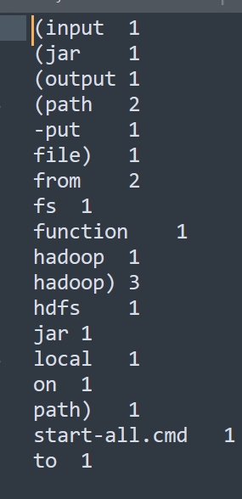

Sum of numbers in an array.

Code:

public void map(Object key, Text value, Context context) throws IOException,InterruptedException {

StringTokenizer itr = new StringTokenizer(value.toString());

int sum = 0;

int num;

while (itr.hasMoreTokens()) {

num = Integer.parseInt(itr.nextToken());

sum += num;

}

context.write(word, new IntWritable(sum));

}

 public void reduce(Text key, Iterable<IntWritable> values,

                       Context context

                       ) throws IOException, InterruptedException {

        int sum = 0;

        int num;

        for (IntWritable val : values) {

        num= val.get();

        sum += num;

        }

        result.set(sum);

        context.write(key, result);

    }

**Commands:**

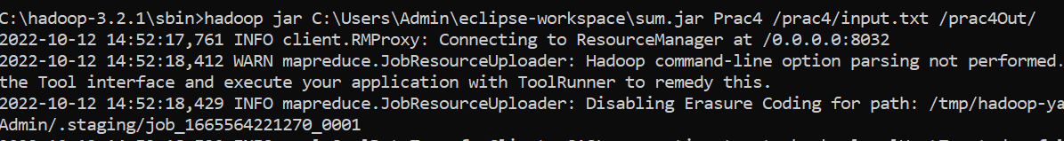

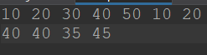

**Output:**

