BDA

Practical5

D2

19BCE248

AIM: To write MapReduce program for Phase frequency of given paragraph

Code:

public void map(Object key, Text value, Context context

                    ) throws IOException, InterruptedException {

      Text word=new Text();

      StringTokenizer itr = new StringTokenizer(value.toString());

      IntWritable num=new IntWritable(1);

      int len_string=0;

      while (itr.hasMoreTokens()) {

          len_string=itr.nextToken().length();

          word.set(Integer.toString(len_string));

          context.write(word,num);

      }

    }

  }

  public static class IntSumReducer

       extends Reducer<Text,IntWritable,Text,IntWritable> {

    private IntWritable result = new IntWritable();

    public void reduce(Text key, Iterable<IntWritable> values,

                       Context context

                       ) throws IOException, InterruptedException {

        int sum=0;

        for(IntWritable val: values) {

            sum+=val.get();

        }

        result.set(sum);

        context.write(key, result);

    }

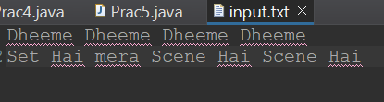

**Output:**

