BDA

Practical 8

19BCE248

**AIM: To perform MongoDB queries for Restaurant Dataset**

1. **Write a MongoDB query to display all the documents in the collection restaurants.**

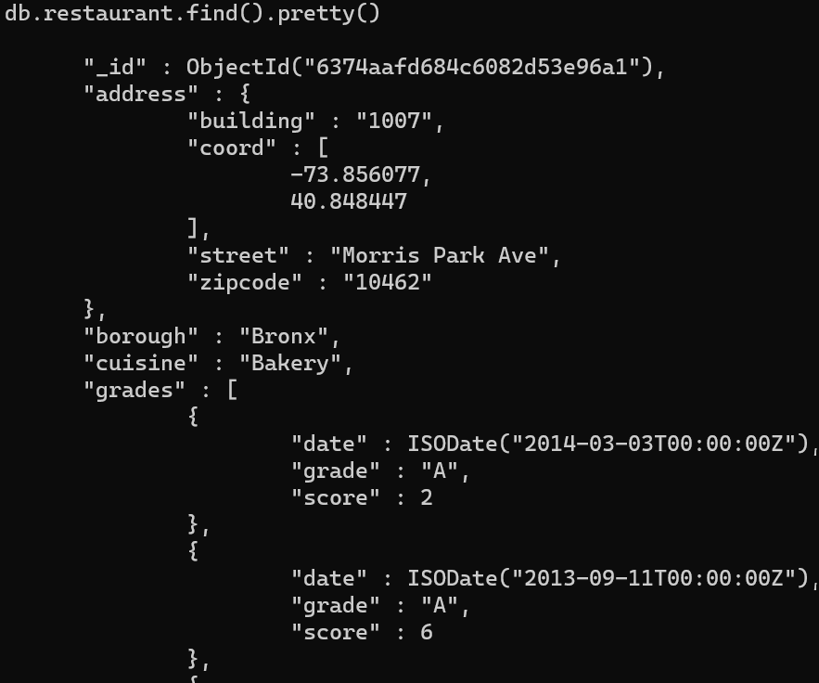

1. **Write a MongoDB query to display the fields restaurant_id, name, borough and cuisine, but exclude the field _id for all the documents in the collection restaurant.**

**db.restaurants.find({},{"restaurant_id" : 1,"name":1,"borough":1,"cuisine" :1,"_id":0});**

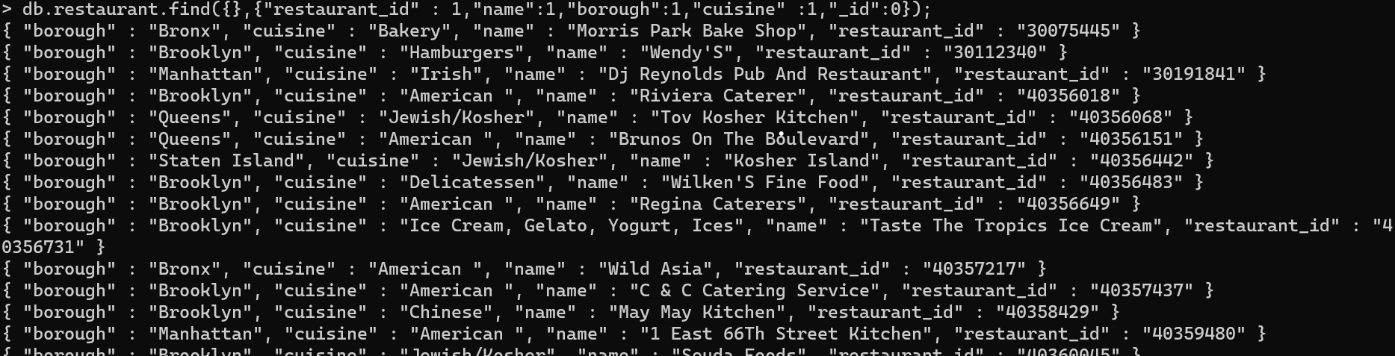

1. **Write a MongoDB query to display the first 5 restaurant which is in the borough Bronx**

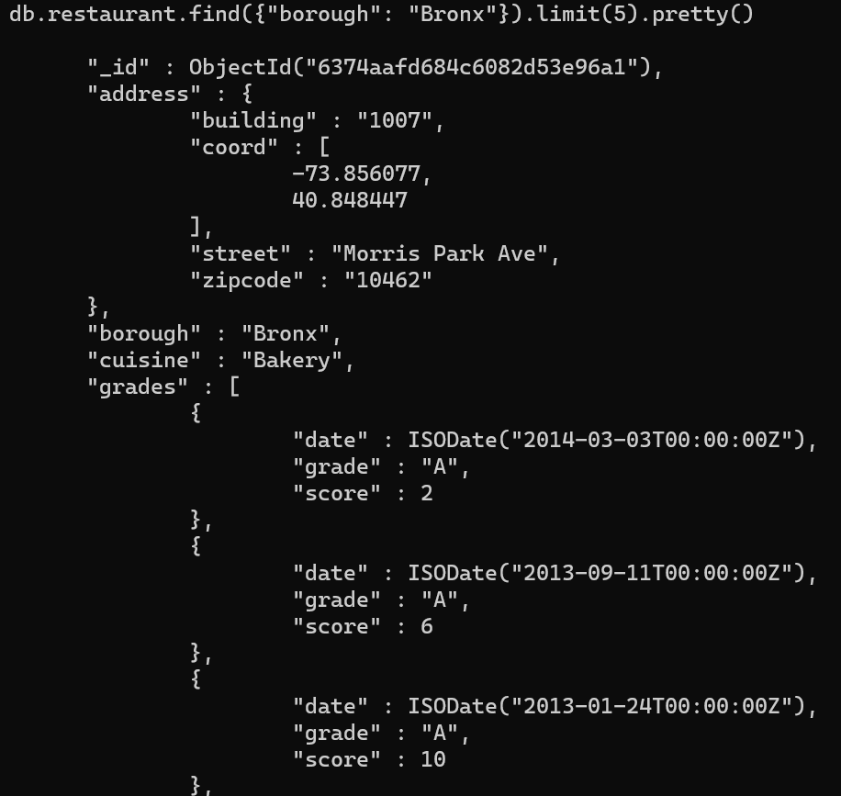

1. **Write a MongoDB query to find the restaurants who achieved a score more than 90.**

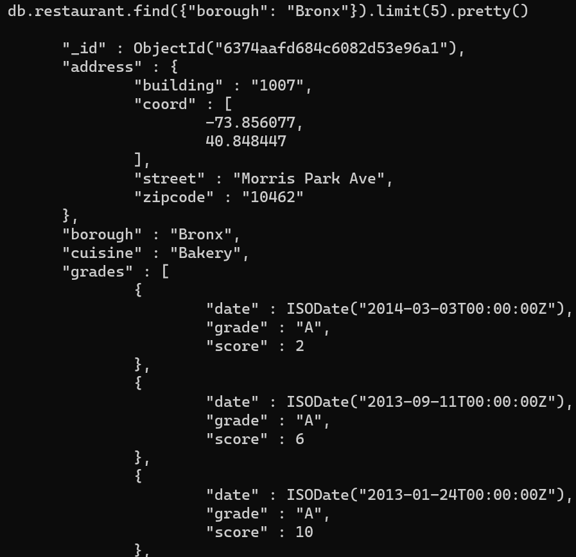

1. **Write a MongoDB query to find the restaurants which belong to the borough Bronx and prepared either American or Chinese dish**

**db.restaurants.find(**

**{**

**"borough": "Bronx" ,**

**$or : [**

**{ "cuisine" : "American " },**

**{ "cuisine" : "Chinese" }] } );**

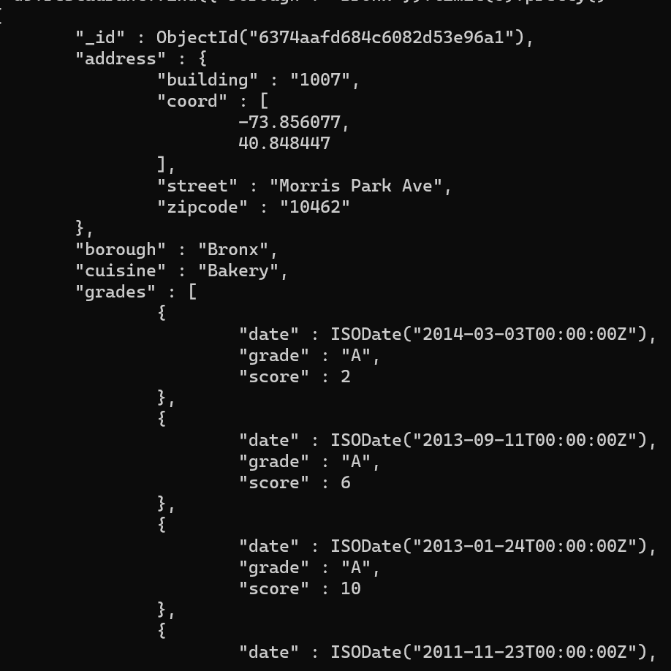

1. **Write a MongoDB query to know whether all the addresses contains the street or not.**

**db.restaurants.find(**

**{"address.street" :**

**{ $exists : true }**

**}**

**);**

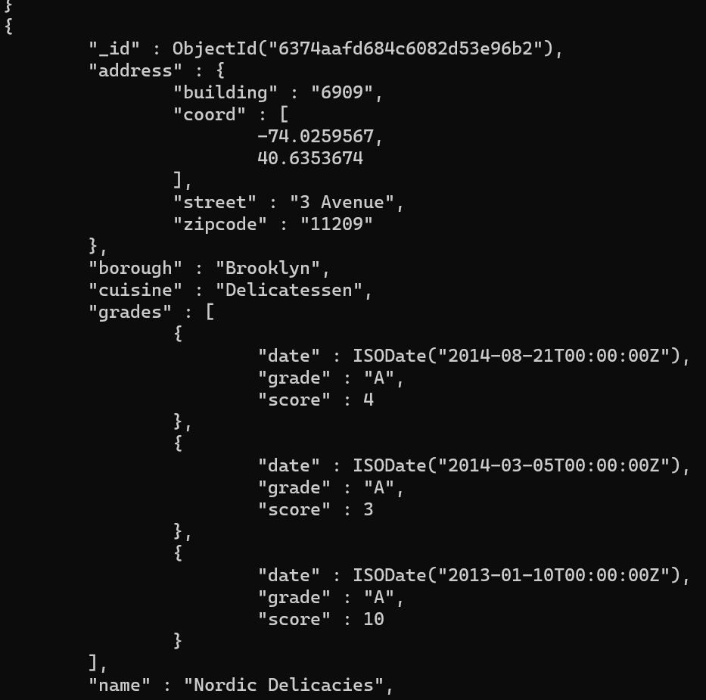

1. **Write a MongoDB query to find the restaurant Id, name, address and geographical location for those restaurants where 2nd element of coord array contains a value which is more than 42 and upto 52.**

**db.restaurants.find(**

**{**

**"address.coord.1": {$gt : 42, $lte : 52}**

**},**

**{"restaurant_id" : 1,"name":1,"address":1,"coord":1});**

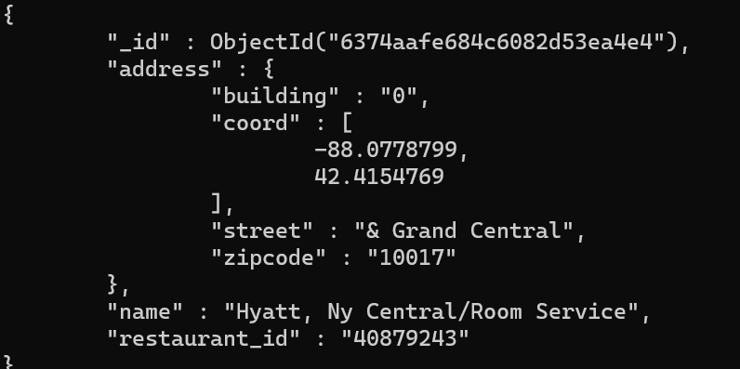

1. **Write a MongoDB query to display the fields restaurant_id, name, borough and cuisine for all the documents in the collection restaurant**

**db.restaurants.find({},{"restaurant_id" : 1,"name":1,"borough":1,"cuisine" :1});**

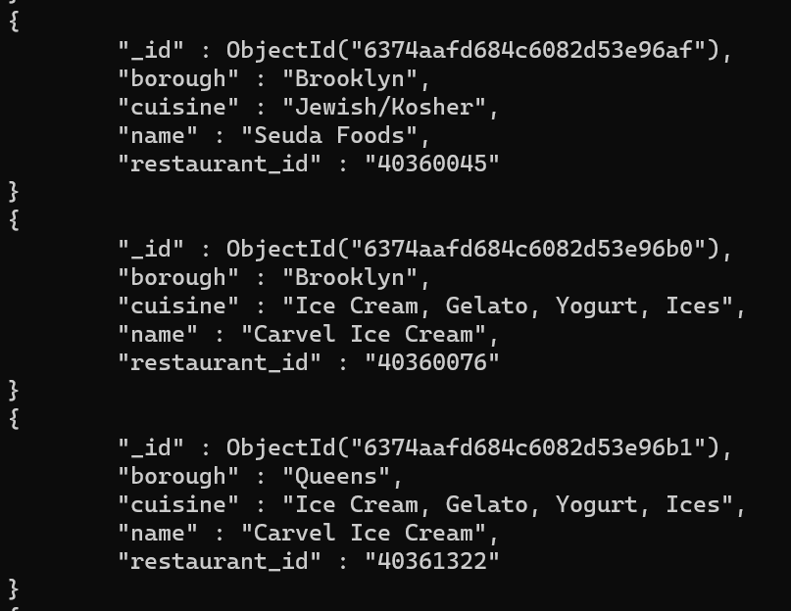

1. **Write a MongoDB query to display the next 5 restaurants after skipping first 5 which are in the borough Bronx**

**db.restaurants.find({"borough": "Bronx"}).skip(5).limit(5);**



1. **Write a MongoDB query which will select the restaurant Id, name and grades for those restaurants which returns 0 as a remainder after dividing the score by 7.**

