SKILLBRIDGE AI
PRODUCT REQUIREMENTS + TECHNOLOGY STACK
Black & white product direction · Development blueprint
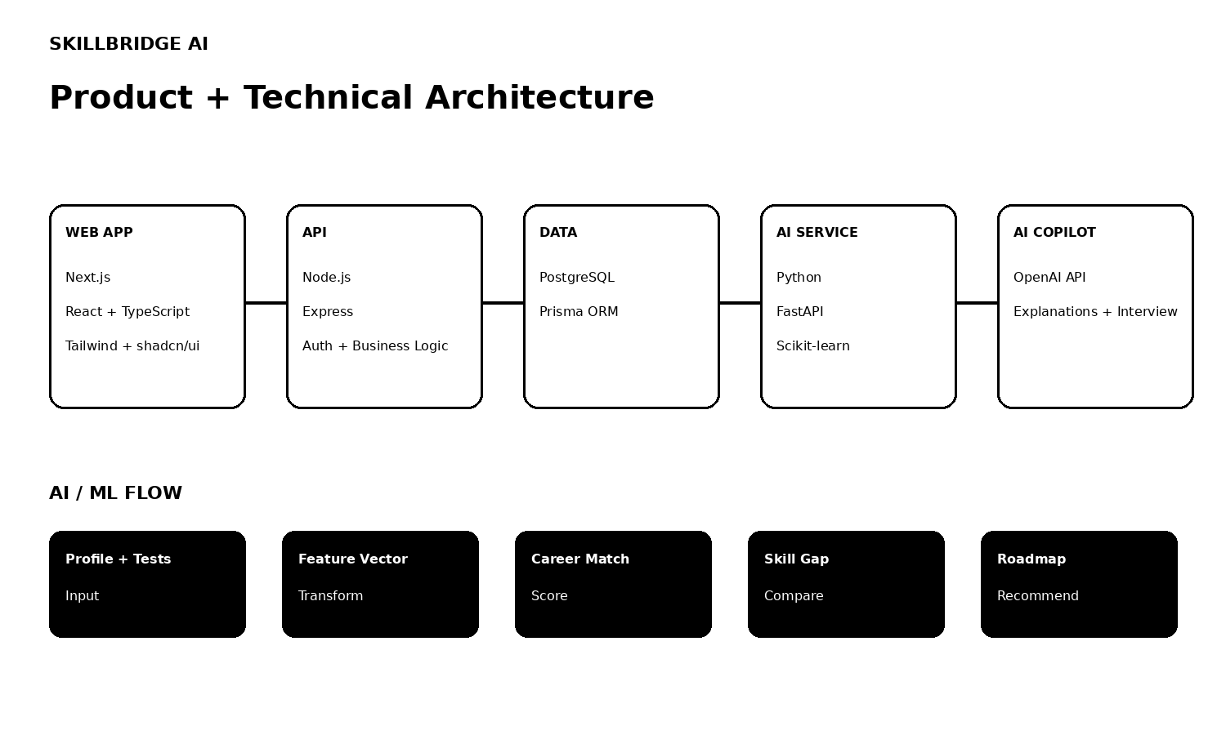
Core promise: discover strengths → verify skills → match careers → understand gaps → follow an adaptive roadmap → become job-ready.

1. Product Requirements
Problem: students often receive generic career advice, struggle to identify their real skills, face scattered course/career information, and lack a step-by-step plan. The platform addresses these issues with personalized guidance.
Target users: school and college students, graduates/career changers, and supporting counsellors/parents.
Goal | Product Response | Measure
Discover | Interest + aptitude + skill assessments | Assessment completion
Decide | Career match + explainable reasons | Match usefulness
Improve | Skill-gap analysis + adaptive roadmap | Roadmap progress
Prepare | Projects + resume + mock interview | Readiness score
2. Website Structure
- Home / Landing
- Authentication
- Student Dashboard
- Career Assessment
- Skill Assessment
- Career Explorer
- Career Recommendations
- Skill Gap Analysis
- Learning Roadmap
- Courses & Certifications
- Project Hub
- Resume Analyzer
- AI Mock Interview
- AI Career Copilot
- Profile / Settings
- Admin Panel
3. Core User Journey
Register → Profile → Assessment → AI Career Match → Explain Why → Skill Gap → Personalized Roadmap → Courses + Projects → Resume → Mock Interview → Career Ready
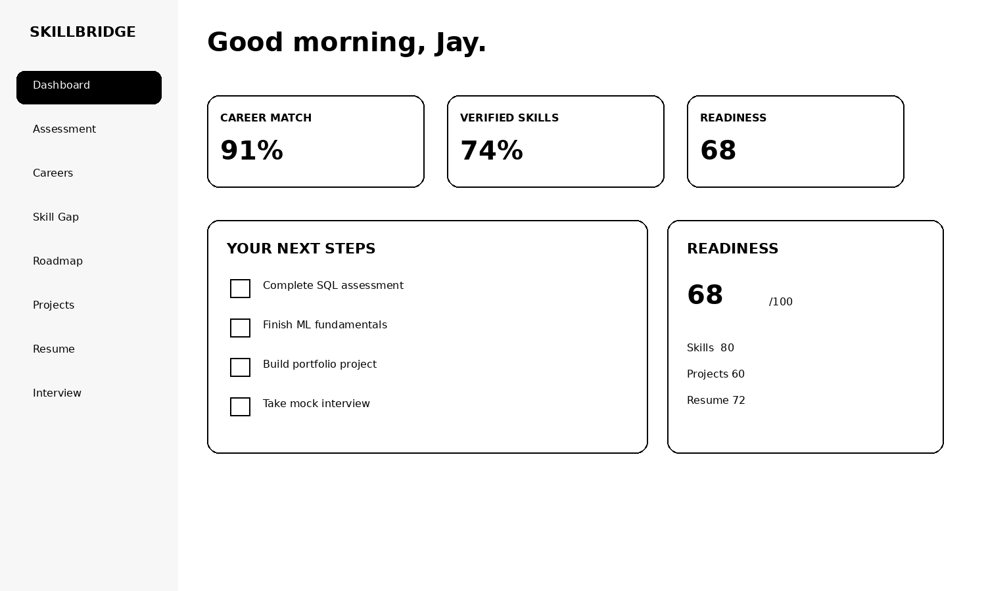

4. Feature Requirements
Feature | Description | Priority | MVP
Authentication | Email/Google login, session management | High | Yes
Assessment | Interest, aptitude and skills tests | High | Yes
Career Matching | Rank suitable careers with percentage | High | Yes
Explainable AI | Show reasons behind each match | High | Yes
Verified Skills | Compare self-rating with test score | High | Yes
Skill Gap | Current vs required skills | High | Yes
Adaptive Roadmap | Update learning path from progress | High | Yes
Projects | Career-aligned portfolio project suggestions | Medium | Yes
Resume Analyzer | Score + gaps + improvement tips | Medium | Later
Mock Interview | Role-specific questions + feedback | Medium | Later
Career Simulator | Compare two career paths | Medium | Later
Industry Gap | Compare student profile to target role demand | Medium | Later
5. Signature UX Patterns
- Career Match Card: percentage + 3 reasons + 2 gaps + 1 next action.
- Career Readiness: Skills + Projects + Resume + Interview combined into one 0–100 score.
- Verified Skill: self-rating versus objective assessment result.
- Adaptive Roadmap: completed tasks and new assessment results can change the next recommended step.

6. Technology Stack — Recommended
Layer | Technology | Purpose | Why
Design | Figma | Wireframes, prototype, design system | Best for visual product planning
Frontend | Next.js + React + TypeScript | Web app and dashboard | Fast, scalable, maintainable
Styling | Tailwind CSS + shadcn/ui | Black/white UI and reusable components | Clean, consistent implementation
Icons / Charts | Lucide + Recharts | Icons, progress, skill charts | Minimal visual language
Animation | Framer Motion | Micro-interactions | Premium feel without noise
Backend | Node.js + Express + TypeScript | REST APIs and business logic | Simple separation from ML service
Database | PostgreSQL + Prisma | Persistent application data | Strong relational model + ORM
AI/ML | Python + Scikit-learn | Career matching and scoring | Suitable for explainable ML MVP
ML API | FastAPI | Serve ML predictions | Fast Python API layer
GenAI | OpenAI API | Copilot, explanation, mock interview | Useful where natural language adds value
Auth | Auth.js / JWT | Authentication and sessions | Secure web auth approach
Files | Cloudinary / S3 | Resume and portfolio files | External object/file storage
Deploy | Vercel + Render/Railway | Frontend + backend/AI | Simple deployment split
Version control | Git + GitHub | Collaboration and CI | Standard development workflow
7. Technical Architecture

Recommended separation: Next.js handles the experience; Node.js handles authentication/business APIs; PostgreSQL stores product data; FastAPI hosts ML logic; OpenAI handles language-heavy assistant tasks.

8. AI / ML Modules
Module | Input | Output
Career Match | Interests, skills, education, preferences, goals | Ranked career matches
Skill Verification | Self-rating + skill test answers | Verified skill score
Skill Gap | Verified skills + target career requirements | Missing skills + priority
Roadmap | Skill gap + career + progress | Ordered learning steps
Career Explanation | Match features + gaps | Human-readable reasons
9. Database Modules
Core entities: users, student_profiles, education, skills, student_skills, assessments, questions, assessment_results, careers, career_skills, career_matches, skill_gaps, roadmaps, roadmap_tasks, courses, certifications, projects, student_projects, resumes, resume_analysis, interviews, interview_results, notifications, feedback.
10. API Groups
- /auth/* — signup, login, session, profile
- /students/* — profile and preferences
- /assessments/* — questions, attempts, results
- /careers/* — explorer, career detail, matches, compare
- /skills/* — verified skills and gap analysis
- /roadmaps/* — roadmap generation, tasks, progress
- /projects/* — recommendations and project tracking
- /resume/* — upload and analysis
- /interviews/* — sessions, answers, scoring
- /copilot/* — context-aware career assistant

11. Design System — Black & White
Token | Value | Usage
Canvas | #FFFFFF | Main background
Primary | #000000 | Headings, buttons, active states
Surface | #F4F4F4 | Grouped content
Border | #D9D9D9 | Inputs and dividers
Text | #111111 | Body text
Muted | #666666 | Secondary information
Radius | 16–24 px | Cards and panels
Spacing | 8 px grid | Consistent layout
Motion | 150–250 ms | Hover and transitions
12. Responsive Rules
- Desktop: sidebar + 12-column content; use 2–4 card grids.
- Tablet: collapsed navigation; prioritize primary score and next action.
- Mobile: single-column layout with drawer/bottom navigation; one decision per screen.
- Accessibility: do not depend on color alone; preserve keyboard focus and readable contrast.

13. Development Plan
Phase | Build | Deliverable | Target
1 | Figma + design system + Home + Auth | Visual foundation | Week 1
2 | Profile + assessments | Student data + scoring | Week 2
3 | Career matching + explanations | AI recommendation MVP | Week 3
4 | Skill gap + roadmap | Personalized action engine | Week 4
5 | Projects + readiness | Portfolio progress | Week 5
6 | Resume + mock interview + copilot | Career preparation | Week 6
7 | Admin + testing + deployment | Release candidate | Week 7
14. Success Metrics
- Assessment completion rate
- Percentage of users who reach a career recommendation
- Roadmap task completion rate
- Improvement in verified skill scores over time
- Resume / interview readiness improvement
- Student rating of recommendation usefulness
15. Security & Privacy
- Hash passwords and use secure sessions/tokens.
- Encrypt sensitive data in transit and at rest where applicable.
- Store resumes/files in private storage and issue controlled access URLs.
- Collect only data required for recommendations and clearly communicate consent.
- Keep AI recommendations advisory; provide explanations and allow users to review/change career goals.
Final Product Positioning
SkillBridge AI should feel like a calm, premium career product: minimal black-and-white interface, evidence-based recommendations, and a clear path from assessment to employability.
Recommended stack in one line: Next.js + TypeScript + Tailwind + shadcn/ui | Node.js + Express | PostgreSQL + Prisma | Python + FastAPI + Scikit-learn | OpenAI API | Vercel + Render/Railway.
Project basis: Student Skill & Career Advisor concept and original workflow from the supplied project presentation. The project describes inputs such as interests, academic history, skills and preferences, and outputs such as career recommendations, skill gaps, courses and projects.

