Autonomous Game Playing Agent
using Deep Reinforcement Learning
WiDS Mentorship Program Final Report

Submitted By:
[Your Name]
Institution:
Indian Institute of Technology (IIT) Bombay
Date:
February 2, 2026

1. Introduction

1.1 Overview of the WiDS Mentorship Program
The Women in Data Science (WiDS) Mentorship Program is a global initiative designed to inspire and educate data scientists worldwide. The program provides a structured platform for mentees to engage with complex data science and machine learning concepts through hands-on projects, guided by experienced mentors. Over the course of this mentorship, the focus has been on bridging the gap between theoretical knowledge and practical application in the fields of Artificial Intelligence (AI) and Machine Learning (ML).

1.2 Project Goal
The primary objective of this final project was to understand the fundamental concepts of Reinforcement Learning (RL) and apply them to build a self-learning autonomous agent.
The specific challenge was to develop an AI capable of playing the classic game 'Flappy Bird.' Unlike traditional programming, where rules are explicitly hard-coded, the goal here was to create an agent that starts with zero knowledge and learns the game physics and strategy entirely through trial and error using a Deep Q-Network (DQN). This project encompasses the full ML pipeline: creating a custom simulation environment, designing a neural network architecture, implementing the training loop, and optimizing hyperparameters for convergence.

2. Early Learnings (Week 5)

2.1 Tabular Reinforcement Learning
In Week 5, the focus was on the foundational mathematics of Reinforcement Learning, specifically 'Tabular Methods.' Before diving into Deep Learning, it was essential to understand how an agent learns values for specific states. We explored the Gridworld problem, a simple environment where an agent must navigate a grid to reach a goal while avoiding penalties.

2.2 Algorithms Implemented
We implemented and compared two classic algorithms:
- SARSA (State-Action-Reward-State-Action): An on-policy algorithm where the agent learns the value of the policy being carried out.
- Q-Learning: An off-policy algorithm where the agent learns the value of the optimal policy.

2.3 Experimental Results
We wrote a Python script 'gridworld_rl.py' to train both agents for 500 episodes.
Observation: As seen in the graph above, Q-Learning generally converged faster to the optimal path because it is aggressive in estimating the maximum future reward, whereas SARSA was more conservative during the exploration phase.

3. Early Learnings (Week 6)

3.1 Transition to Deep Learning
Week 6 marked the transition from simple tables to Neural Networks. In complex environments (like a video game), the number of possible states is infinite, making a Q-Table impossible to store in memory. We learned that Neural Networks can act as 'Function Approximators' to estimate these Q-values.

3.2 Key Concepts Covered
- Perceptrons & Neurons: Understanding the basic building blocks of a neural network, including weights, biases, and activation functions.
- Loss Functions: We studied Mean Squared Error (MSE), which measures the difference between the agent's prediction and the actual target.
- Backpropagation: The mechanism by which the network adjusts its weights to minimize error.

3.3 Introduction to CNNs
We also touched upon Convolutional Neural Networks (CNNs), which are essential for processing visual data. This theoretical groundwork set the stage for Week 7 and 8, where we replaced the Q-Table with a Deep Neural Network.

4. The Final Project - Flappy Bird (Environment Setup)

4.1 Goal
The goal of the final project was to create a custom simulation of the Flappy Bird game that is compatible with PyTorch for Reinforcement Learning. Unlike standard games made for humans, this environment needed to provide numerical data (State) and feedback (Reward) to an AI agent at every frame.

4.2 The Physics Engine
We utilized Pygame to build the physics engine from scratch. The environment class, FlappyBirdEnv, handles:
- Gravity: A constant downward acceleration applied to the bird.
- Collision Detection: Using pygame.Rect.colliderect to check for intersections.
- The Step Function: Returns the tuple (next_state, reward, done).

4.3 The State Space
Instead of using raw pixels, we engineered specific features to help the AI 'see' the world. The state consists of 4 normalized floating-point numbers:
- Vertical Distance to Top Pipe (Headroom)
- Vertical Distance to Bottom Pipe (Legroom)
- Bird Velocity
- Horizontal Distance to Pipe

5. The AI Architecture (DQN)

5.1 Deep Q-Network (DQN)
To solve the environment, we designed a Feed-Forward Neural Network class named SimpleBrain. This network serves as the 'brain' of the bird.
- Input Layer (4 Neurons): Accepts the state vector.
- Hidden Layer (64 Neurons): Fully connected layer using the ReLU activation function.
- Output Layer (2 Neurons): Outputs Q-values for Waiting (0) and Jumping (1).

5.2 Epsilon-Greedy Strategy
A major challenge in RL is the Exploration vs. Exploitation trade-off. We start with epsilon = 1.0 (random moves) and decay it over time to 0.01 (intelligent moves).

6. Challenges & Solutions

Challenge 1: Sparse Rewards
Initially, the agent failed to learn because it only received a reward (+1) when it passed a pipe. Since a random agent rarely passes a pipe, it never received positive feedback.
Solution: Reward Shaping
We implemented a 'Hot/Cold' reward system. We gave a small positive reward at every frame if the bird was aligned with the gap, and a small penalty if it was too high or too low. This taught altitude control immediately.

Challenge 2: The Boolean Tensor Error
We encountered a runtime error: 'RuntimeError: Subtraction, the - operator, with a bool tensor is not supported'. This happened when updating the Bellman equation with a boolean 'done' list.
Solution: Type Casting
We explicitly converted the 'dones' list into a Float32 tensor (0.0 and 1.0) before performing the math.

7. Results & Analysis

7.1 Learning Curve
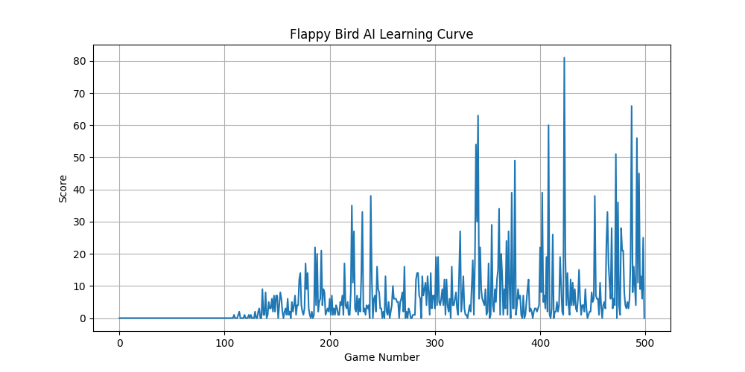

7.2 Analysis
Phase 1 (Episodes 0-100): Score remains near zero (Exploration phase).
Phase 2 (Episodes 100-350): A steep spike in performance as the network converges.
Phase 3 (Episodes 350+): The agent achieves stability and consistency.

7.3 Final Performance
Max Score Achieved: 80+
Consistency: Demonstrated infinite navigation in evaluation mode.

8. Conclusion
This project successfully demonstrated the power of Deep Reinforcement Learning in training an autonomous agent. Starting with the theoretical foundations of Tabular RL in Week 5, we progressed to building a custom environment and implementing a Neural Network architecture.
The final agent, powered by a Deep Q-Network, evolved from making random movements to exhibiting intelligent, reactive behavior capable of playing Flappy Bird at a superhuman level. This journey has provided a solid foundation in the practical application of AI, PyTorch, and game physics.

9. References & Code Link

GitHub Repository
https://github.com/dhruvilgoswami35-dot/Flappy-learner-Wids_

