1. What is software? What is software engineering

ANS: Software is more than program code. Software is a set of instructions, data or programs used to operate computers and execute specific tasks. It is the opposite of hardware, which describes the physical aspects of a computer. Software is a generic term used to refer to applications, and programs that run on a device. It can be thought of as the variable part of a computer, while hardware is the invariable part.

Software engineering:

software  **engineering** is the branch of computer science that deals with the **design, development, testing, and maintenance of software** . Software engineers apply engineering principles and knowledge of programming languages to build software solutions for end users.

1. Explain types of software

ANS. Types of software

* Application software
* System software
* Driver software
* Middleware
* Programming software

* Application software : The most common type of software, application software is a computer
* software package that performs a specific function for a user, or in some
* cases, for another application.
* - An application can be self-contained, or it can be a group of programs that
* run the application for the user.
* - Examples of Modern Applications include office suites, graphics software,
* databases and database management programs, web browsers, word
* processors, software development tools, image editors and communication
* platforms.
* Example:Microsoft Office, Paint, Powerpoint etc..
  + System software : These software programs are designed to run a computer's application
  + programs and hardware.
  + - - System software coordinates the activities and functions of the hardware
  + and software.
  + - It controls the operations of the computer hardware and provides an
  + environment or platform for all the other types of software to work in.
  + - The OS is the best example of system software; it manages all the other
  + computer programs.
  + - Other examples of system software include the firmware, computer
  + language translators and system utilities..
  + Example:Notepad ,Calculator etc..
    - Driver software : Also known as device drivers, this software is often considered a type of
    - system software.
    - - Device drivers control the devices and peripherals connected to a computer,
    - enabling them to perform their specific tasks.
    - - Every device that is connected to a computer needs at least one device
    - driver to function.
    - - Examples include software that comes with any nonstandard hardware,
    - including special game controllers, as well as the software that enables
    - standard hardware, such as USB storage devices, keyboards, headphones
    - and printers.
    - Example: Audio Driver,Video Driver etc..

* + - * Middleware : The term middleware describes software that mediates between application
      * and system software or between two different kinds of application software.
      * For example, middleware enables Microsoft Windows to talk to Excel and
      * Word.
      * - It is also used to send a remote work request from an application in a
      * computer that has one kind of OS, to an application in a computer with a
      * different OS. It also enables newer applications to work with legacy ones.
      * Example: database middleware,application server middleware

* + - * + programming software : Computer programmers use programming software to write code.
        + Programming software and programming tools enable developers to
        + develop, write, test and debug other software programs.
        + - Examples of programming software include assemblers, compilers,
        + debuggers and interpreters.
        + Examples : Turbo c,Eclipse,Sublime etc..

1. What is SDLC? Explain each phase of SDLC

ANS: The Software Development Life Cycle (SDLC) refers to a methodology

with clearly defined processes for creating high-quality software.

* + The Software Development Life Cycle (SDLC) refers to a methodology
  + with clearly defined processes for creating high-quality software. in
  + detail, the SDLC methodology focuses on the following phases of
  + software development:

1. Requirement Gathering

2. Analysis

3. Designing

4. Implementation

5. Testing

6. Maintenance

1. What is DFD? Create a DFD diagram on Flipkart

ANS : Also known as DFD, Data flow diagrams are used to graphically represent the flow of data in a business information system. DFD describes the processes that are involved in a system to transfer data from the input to the file storage and reports generation.

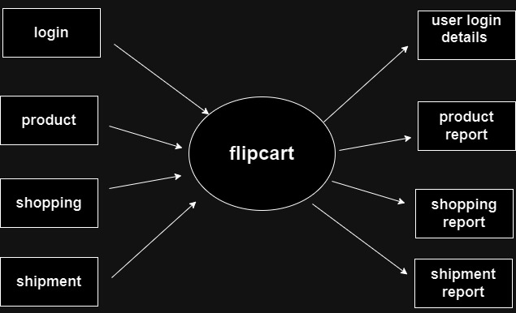

1. What is Flow chart? Create a flowchart to make addition of two numbers

ANS: A flow chart is a graphical or symbolic representation of a process. Each step in the process is represented by a different symbol and contains a short description of the process step. The flow chart symbols are linked together with arrows showing the process flow direction.

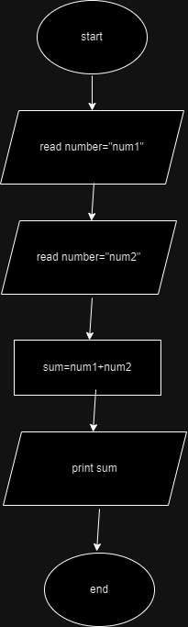

1. What is Use case Diagram? Create a use-case on bill payment on paytm.

ANS: A use case diagram is a way to summarize details of a system and the users within that system. It is generally shown as a graphic depiction of interactions among different elements in a system. Use case diagrams will specify the events in a system and how those events flow, however, use case diagram does not describe how those events are implemented

