Greenery
(Online Order Fruits and Vegetables)
A project submitted to
UKA TARSADIA UNIVERSITY

in partial fulfilment of the requirements
for the degree of

Integrated Masters of Science in Information Technology

for 8th Semester
2023-24

Submitted By:
Dhruvi Modiya (202006100110077)

Guided By:
Mr.Rakesh Savant
Assistant Professor


Babu Madhav Institute of Information Technology
Uka Tarsadia University
Bardoli – 394350
December 2023

CERTIFICATE

Date:
This is to certify that Ms. Dhruvi Modiya (202006100110077) has submitted project entitled “Greenery (Online Order fruits and vegetables)” as the partial fulfillment for the award of the degree of Bachelor of Science in Information Technology for 5 Years Integrated M.Sc. (IT) in 2023 – 2024.

_________________  Mr. Rakesh Savant  Project Guide |  | _________________  Dr. Jitendra Nasriwala  Programme Coordinator
External Examiner(s)



BABU MADHAV INSTITUTE OF
INFORMATION TECHNOLOGY

Table of Content
Chapters | Particulars |  |  | Page no.
1 | Introduction
1 | 1.1 | Problem Definition
1 | 1.2 | Project Objective
1 | 1.3 | Product Scope
2 | Overall Description
2 | 2.1 | Product Perspective/Environment Description
2 | 2.1 | 2.1.1 | Hardware Interface/ Hardware Specification
2 | 2.1 | 2.1.2 | Software Interface/ Software Specification
3 | System Specific Requirements
3 | 3.1 | Functional Requirement
3 | 3.2 | Non-functional Requirement
4 | UML Diagrams
4 | 4.1 | Use case Diagram
4 | 4.2 | Activity Diagram
5 | System Design
5 | 5.1 | Database Design
5 | 5.1 | 5.1.1 | Database Schema
5 | 5.1 | 5.1.2 | Data Dictionary
6 | System Implementation
6 | 6.1 | Screenshots
7 | Testing
7 | 7.1 | Test Cases
8 | Future Enhancement
 | Conclusion
 | Bibliography

List of Figures
Figure no. | Figure Description | Page no.
4.1.1 | Use Case Diagram for Admin
4.1.2
4.1.3
4.2.1 | Activity Diagram for Manage Product
4.2.2
4.2.3
4.2.4
4.2.5

List of Tables
Table no. | Table Description | Page no.
5.1.2 | Data Dictionary Tables | 50 - 60
7.1.1 | Test Cases for Login | 62
7.1.2 | Test Cases for Product

Company Profile

A TRUSTED WEB DEVELOPMENT COMPANY SINCE 2019
Our story started in 2019 with a web design firm established to help companies develop effective online presence. Over the years we develop a team of creative web designers and experienced developers who feel and behave like family and friends first.

We think our clients as a part of this family. We take the time to get to know you and your market by living your brand values and deeply understanding your customers; we develop design experiences, build web and mobile products, and help your businesses to grow.

A TEAM THAT ALWAYS DELIVER
We are a strong team of 10+ creative web designers, technically sound developers, project managers and analysts ready to help you to take your world-changing idea from concept to reality. While working with niche technology we always aim to deliver our best and always keep clients' reputation high. We approach our clients first to understand their goals and then craft custom solutions that best serve those needs.

SERVICES THEY PROVIDED:
- Mobile app development
- Web development
- NFT development
- UI/UX design
- Digital marketing

Acknowledgement

We would like to express our sincere gratitude to everyone who contributed to the completion of this project. Your support and encouragement have been invaluable throughout this journey.

We extend our deepest appreciation to our supervisor/advisor, Mr.Parthiv Vora
and Mr.Govind Savaliya, for their guidance, expertise, and unwavering support. Their mentorship has been instrumental in shaping the direction and quality of this work.

We are grateful to have this group for our research committee for insightful feedback and valuable suggestions. Their expertise has enriched the content and methodology of this project.

Secondly at this moment, I would like to express our deepest sense of gratitude to our professor as well as project guides Mr. Rakesh Savant who have contribute their precious time for the purpose of giving us the correct information with special interest &guidance throughout our project work.

Lastly, we want to express our gratitude to all the participants and individuals who contributed to the data collection process. Your willingness to participate and share valuable insights has greatly enhanced the depth and significance of this work.

This project would not have been possible without the collective efforts of all those mentioned above. Thank you for being an integral part of this journey.

Chapters 1 (Introduction)

  - Problem Definition

The Fruits and Vegetables Store Web App provides users with a convenient online platform to explore a diverse array of online products. Featuring an appealing and user-friendly interface, the application allows users to seamlessly view product details and conduct all their shopping activities online. The project's primary goal is to offer users a swift overview of online products, eliminating the need for physical store visits. This project is developed for users to have a brief look at the online products without actually visiting the store. The website displays different kinds of products of different variety so that user can easily get their expected online products.

  - Project Objective

- Provides the good user interface to ease of use and it also provides the security to the database.
- This system can view the details of any record.
- Locate any online product information wanted by the user.
- Reduced clerical work as most of the work done by computer.
- Provide greater speed & reduced time consumptions

  - Product Scope

The opportunity for the customer widens largely to the shop as the site can be accessed anywhere from the India through the internet. System is available for Indian users only. System is for only fruits and vegetables other product are not accepted.

1.4 Initial Requirement Document
Title of the project |  | Greenery (Order Online Fruits and Vegetables)
Stakeholders involved in capturing requirements |  | Dhruvi Modiya
Techniques used for requirement capturing |  | Brainstorming, Interview
Name of the person along with designation |  | Mr. Rakesh Savant(Associate Professor, Bmiit)
Date
Version
Consolidated list of initial requirement:
System Shall allow Customer to Register themselves by providing following information
- First Name
- Email-Id
- Password
- Contact No.
- Address
- AddressType
- UserImage

 | System shall allow customer to Update profile.
 | System shall allow authenticated user or Admin to login with Email-ID and Password.
 | System shall allow customer to change password.
 | System shall allow visitor to view Items and navigate through the portal.
 | System shall allow customer to add Items into cart and remove from cart.
 | System shall allow customer to place order by selecting payment mode and delivery address.
 | System shall allow customer to pay with card or cash on delivery.
 | System shall allow customer to cancel whole order or any particular item(s)
 | System shall allow customer to search Product with Product Category.
 | System shall only allow Authenticated User to place order.
 | System shall allow Admin to update Products rate.
 | System shall allow Admin to update Product States (Instock/Outofstock).
 | System shall allow Admin to update Item Images.
System shall allow Admin to add Item by providing following information.
- ProductName
- ProductBrand
- ProductPrice
- ProductMeasurement
- ProductWeight
- ProductStyle
- ProductProprties
- ProdustImage
- ProductTags
- ProductStatus
- CategoryId
- isDeleted
And also update/remove item.

Chapters 2 (Overall Description)

2.1 Product Perspective/Environment Description

2.1.1 Hardware Interface/ Hardware Specification
- Intel core Pentium
- 500 GB HDD
- 2 GB RAM
2.1.2 Software Interface/ Software Specification
- Operating system : windows 11
- Font end Tool : React
- Back end Tool : Node MondoDB

Chapters 3 (System Specific Requirements)

3.1 Functional Requirement
Functional requirements define the fundamental action that system must perform.

Module1 : Manage Registration

RN | Description | Comment
FR1 | Registration is compulsory for user to login into the system. | Registration form
FR2 | Enable new users to register themselves with following information:  - First Name  - Email-Id  - Password  - Contact No.  - Address  - AddressType  - UserImage | Registration form
FR3 | System shall not allow unsuccessful login. | Login form
FR4 | Enable a register user to change his password if she forgets his password.  - Send OTP through mail for user’s verification | Login form  Forgot password
FR5 | If user wants to purchase any fruites and vegetables then they must have to register in system. | Registration form  Login form

Module2 : Manage Product

RN | Description | Comment
FR1 | The system will assign an unique id(product id ) to each product | Product Form
FR2 | To manage this mondule,the admin will be able to perform following oprations like:  - Add new product  - Update an existing product  - View / Search / Update product  - Delete product | Product Form

Module3 : Manage Blog

RN | Description | Comment
FR1 | Admin can post the blog  - Title  - Description  - Date  - Image  - status | Blog Form
FR2 | Customer can view the blog | View Blog

Module4 : Manage Cart

RN | Description | Comment
FR1 | This module will be managed by customer.  • Add the product into cart.  • Update the cart.  • Removing product from cart. | Order Form
FR2 | After adding product into the cart user can checkout process and place his/her order | Order Form

Module5 : Manage Order

RN | Description | Comment
FR1 | Admin can view the customer order. | Order Form
FR2 | Customer can order the product. | Order Form
FR3 | Customer can cancel the order. | Order Form

Module6 : Payment

RN | Description | Comment
FR1 | After the generation of bill, the customer shall be able to make payment using one of the online payment gateways. | Payment Form

Module7 : Generate Bill

RN | Description | Comment
FR1 | After the confirmation of order placed by the customer the system shall be able to generate bill with all the necessary details . | Bill Form
FR2 | The system will assign a unique id(bill no) to each customer’s order bill. | Bill Form

Module8 : Manage Reports

RN | Description | Comment
FR1 | The system should be able to generate reports like:  - Day wise Order Report  - All Order Report  - Customer Report | Report Form

Module9 : Manage Feedback

RN | Description | Comment
FR1 | Admin can view customer feedback. | Feedback form
FR2 | Customer can give the feedback. | Feedback form

3.2 Non-functional Requirement
non-functional requirement define the needs in terms of performance, logic database requirement, design constraints, security, maintainability, and portability.

RN | Description | comments
NFR1 | Ensuring the website loads quickly and can handle a large number of concurrent users without slowing down. | Performance
NFR2 | The ability of the website to handle increased traffic and data as the business grows. | Scalability
NFR3 | Ensuring the website is available and operational 24/7 with minimal downtime. | Reliability
NFR4 | Ensuring the website works well on various browsers, operating systems, and devices. | Compatibility
NFR5 | The application will be user-friendly and easy to operate,and the functions will be easily understand. | usability
NFR6 | The system will be password protected.users will have to enter correct username and password to access the system. | security
NFR7 | The system will be designed in a maintainable manner. It will be easy to incorporate new requirements in the individual modules. | Maintainability
NFR8 | Software system safety optimizes system safety in the design, development, use, and maintenance of software system. | Safety

Chapter 4 (UML Diagram)

4.1 Use case Diagram

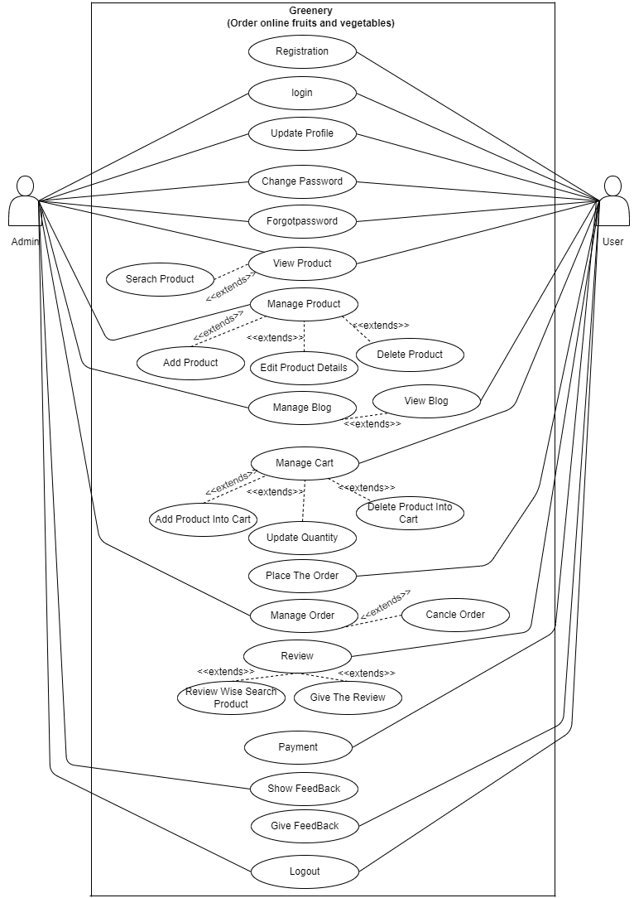

4.2 Activity Diagram

- Activity Diagram for Registration

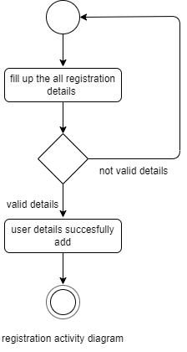

- Activity Diagram for Login
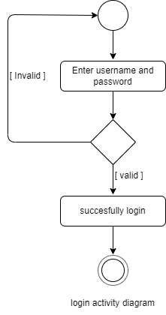
- Activity Diagram for Manage Product

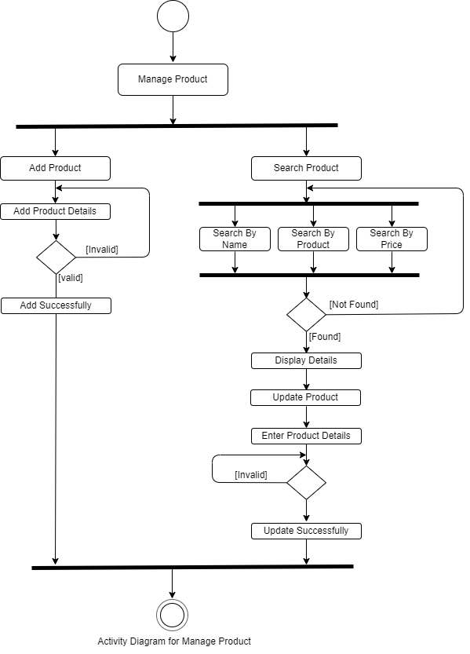

- Activity Diagram for Manage Cart

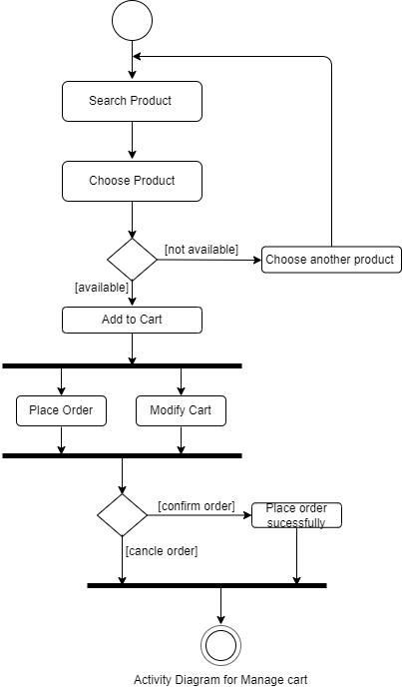

- Activity Diagram for Change Password

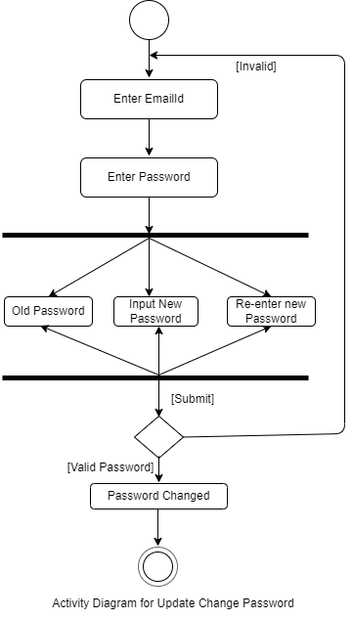

- Activity Diagram for Forgot Password

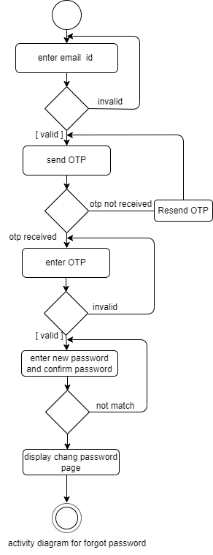

Chapters 5 (System Design)

5.1 Database Design
    - Database schema

- Manage Registration :

- Regitration(uid[pk],name,email,password,contact,address,addresstype,userimag)

2) Manage Product:

  - product(pid[pk],pname,pbrand,pprice,pmeasurement,pdescription,pweight,pstyle,properties,pimage,ptags,pstatus,categoryid[fk],pisdeleted)

3) Manage Blog:

- blogs(blogid[pk],btitle,bdescription,bdate,bimage,bstatus)

4) Manage Banner:

- banner(bnrid[pk],bnrdescription,bnrtitle,bimage)

5) Manage Brands:

- brands(brandid[pk],brandname,totalitem,brandimage,brandstatus)

6) Manage Category:

- category(catid[pk],categoryname,isdeleted)

7) Manage Cart:

  - cart(cid[pk],pid[fk],uid[fk],quantity,isdeleted)

8) Manage Contact:

  - contact(conid[pk],conname,conemail,conmsg)

9) Manage Subscribe:

  - subscribe(subid[pk],subemail)

10) Manage Wishlist:

  - wishlist(wishid[pk],uid[fk],pid[fk],isdlt)

11) Manage Order:

  - order(oid[pk],pid[fk],uid[fk],paymentid,totalamount,paymentmethod,paymentstatus,orderdate,deliverystatus,orderstatus,reason)

12) Manage Payment:

  - payment(paymentid[pk],oid[fk],totalprice,datet)

13) Manage Feedback:

  - feedback(fid[pk],uid[fk],name,email,blogid[fk],isdeleted)

5.1.2 Data Dictionary

Registration:
Field Name | Data Type | Constraint | Description
Uid | Int(default) | Primarykey | Unique
Name | Varchar (60) | Not null | First Name of user
Email | Varchar (254) | Not null | Unique
Password | Varchar (50) | Not null | Password for login
Contact | Char(10) | Not null | Primary Number
Address | Varchar (200) | Not null | Home address of user
AddressType | Varchar (200) | Not null | Home addresstypes of user
UserImage | Varchar(200) | Not null | User image

Product:
Field Name | Data Type | Constraint | Description
pid | Int(default) | Primarykey | Unique
pname | Varchar (60) | Not null | Name of the product
pbrand | Varchar (60) | Not null | Product brand
pprice | Varchar (10) | Not null | Price of product
pmeasurement | Varchar (60) | Not null | Measurement of product
pdescription | Varchar (60) | Not null | Description of product
pweight | Varchar (60) | Not null | Weight of product
pstyle | Varchar (60) | Not null | Style of product
properties | Varchar (60) | Not null | Properties of product
pimage | Varchar (60) | Not null | Image of product
ptags | Varchar (60) | Not null | Tags of product
pstatus | Varchar (60) | Not null | Status of product
categoryid | Int | Foreign key | Unique
pisdeleted | Varchar (60) | Not null | Product is deleted

Blog:
Field Name | Data Type | Constraint | Description
blogid | Int(default) | Primarykey | Unique
btitle | Varchar (60) | Not null | Title of blog
bdescription | Varchar (60) | Not null | Description of blog
bdate | Date | Not null | Date of blog
bimage | Varchar (254) | Not null | Image of blog
bstatus | Varchar (50) | Not null | Status of blog

Banner:
Field Name | Data Type | Constraint | Description
bnrid | Int(default) | Primarykey | Unique
bnrdescription | Varchar (60) | Not null | Description of banner
bnrtitle | Varchar (60) | Not null | Title of banner
bnrimage | Varchar (60) | Not null | Image of banner

Brands:
Field Name | Data Type | Constraint | Description
brandid | Int(default) | Primarykey | Unique
brandname | Varchar (60) | Not null | Name of brand
totalitems | int | Not null | Total items
brandimage | Varchar (60) | Not null | Image of brand
brandstatus | Varchar (60) | Not null | Status of brand

Category:
Field Name | Data Type | Constraint | Description
catid | Int(default) | Primarykey | Unique
categoryname | Varchar (60) | Not null | Name of category
isdeleted | Varchar (60) | Not null | Category is deleted

Cart:
Field Name | Data Type | Constraint | Description
cid | Int(default) | Primarykey | Unique
pid | Int(default) | Foreign key | Unique
uid | Int(default) | Foreign key | Unique
quantity | Int | Not null | Item quantity

Contact:

Field Name | Date Type | Constraint | Description
conid | Int(default) | Primary key | Unique
conname | Varchar (60) | Not null | Contact name
conemail | Varchar (60) | Not null | Contact email
conmsg | Varchar (50) | Not null | Contact message

Subscribe:

Field Name | Date Type | Constraint | Description
subid | Int(default) | Primary key | Unique
subemail | Varchar (60) | Not null | Subscriber email

Wishlist:

Field Name | Date Type | Constraint | Description
wishid | Int(default) | Primary key | Unique
uid | Int(default) | Foreign key | Unique
pid | Int(default) | Foreign key | Unique
isdlt | Varchar (50) | Not null | Wishlist is deleted

Order:
Field Name | Data Type | Constraint | Description
oid | Int(default) | Primarykey | Unique
pid | Int(default) | Foreign key | Unique
uid | Int(default) | Foreign key | Unique
paymentid | Int(default) | Not null | Payment id
totalamount | Int | Not null | Total amount
paymentmethod | Varchar (60) | Not null | Method of payment
paymentstatus | Varchar (60) | Not null | Status of payment
orderdate | Date | Not null | Order date
deliverystatus | Varchar (60) | Not null | Status of delivery
orderstatus | Varchar (60) | Not null | Status of order
reason | Varchar (60) | Not null

Payment:

Field Name | Date Type | Constraint | Description
paymentid | Int(default) | Primary key | Unique
oid | Int(default) | Foreign key | Unique
totalprice | Int(default) | Not null | Total price
date | Date | Not null | Date of payment

Feedback:
Field Name | Data Type | Constraint | Description
fid | Int(default) | Primarykey | Unique
uid | Int(default) | Foreign key | Unique
name | Varchar (60) | Not null | User name
email | Varchar (60) | Not null | User email
blogid | Intt(default) | Foreign key | Unique
isdeleted | Varchar (60) | Not null | Delete

Chapters 6 (Screenshorts)

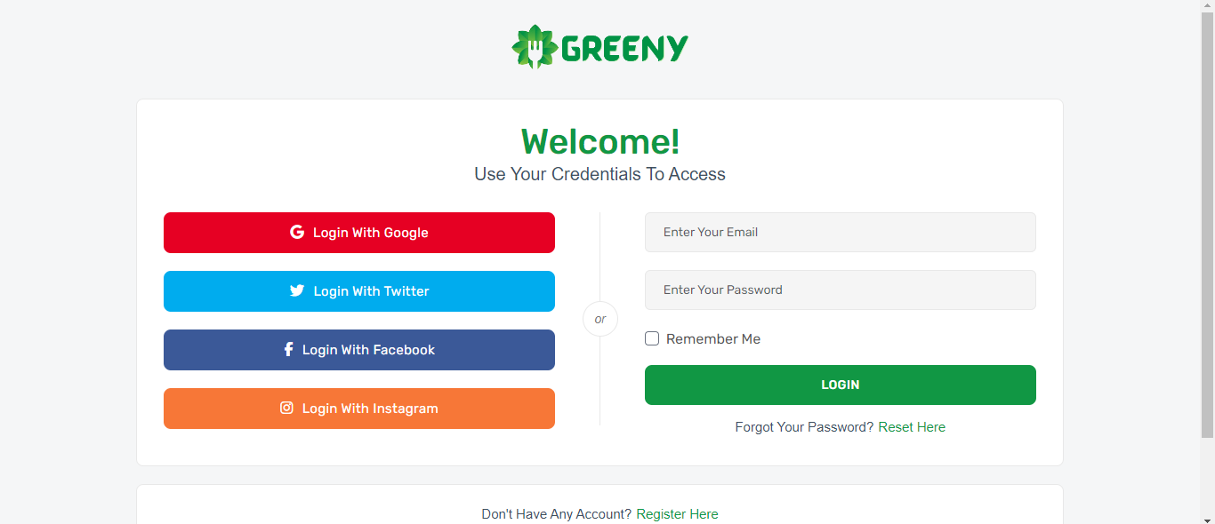

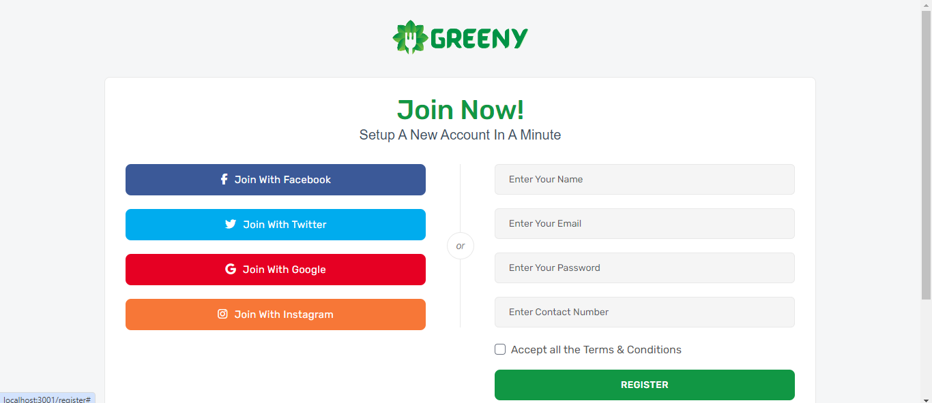

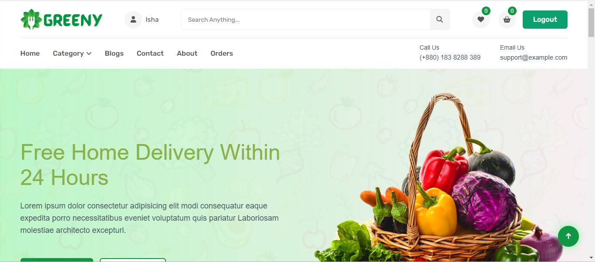

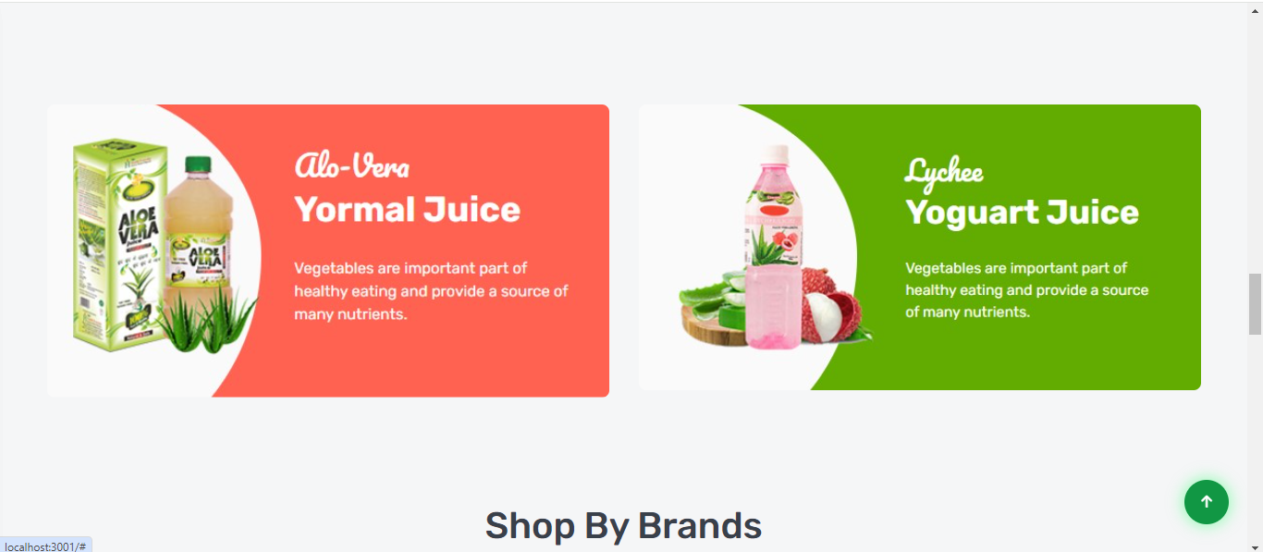

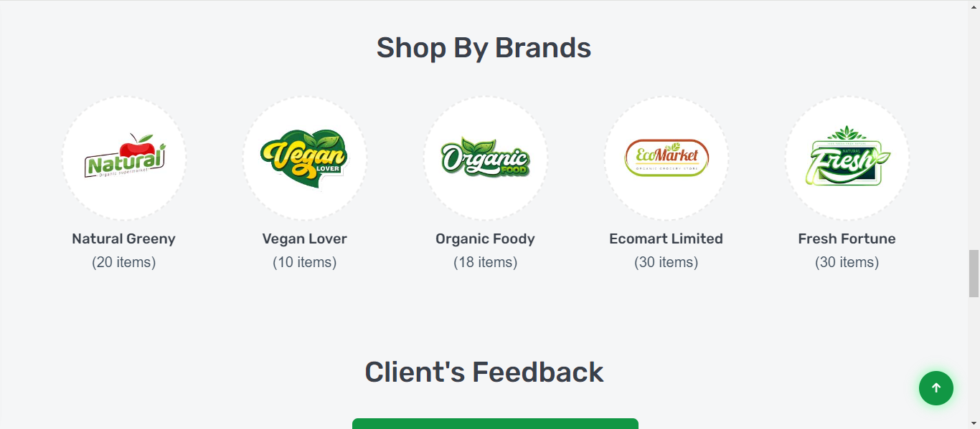

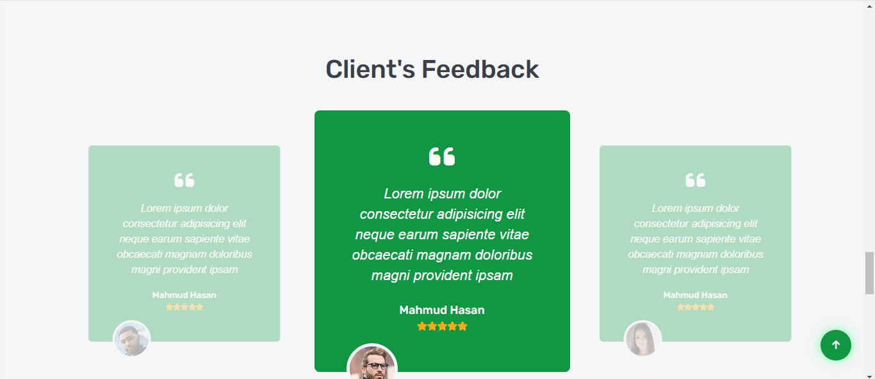

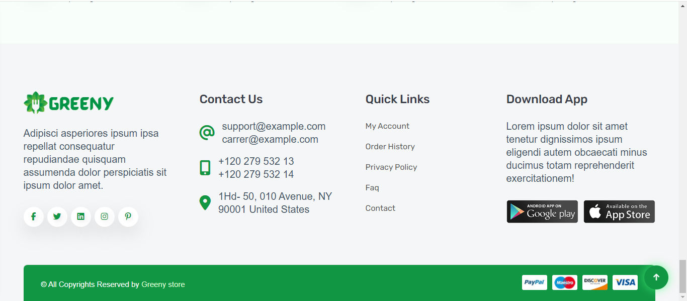

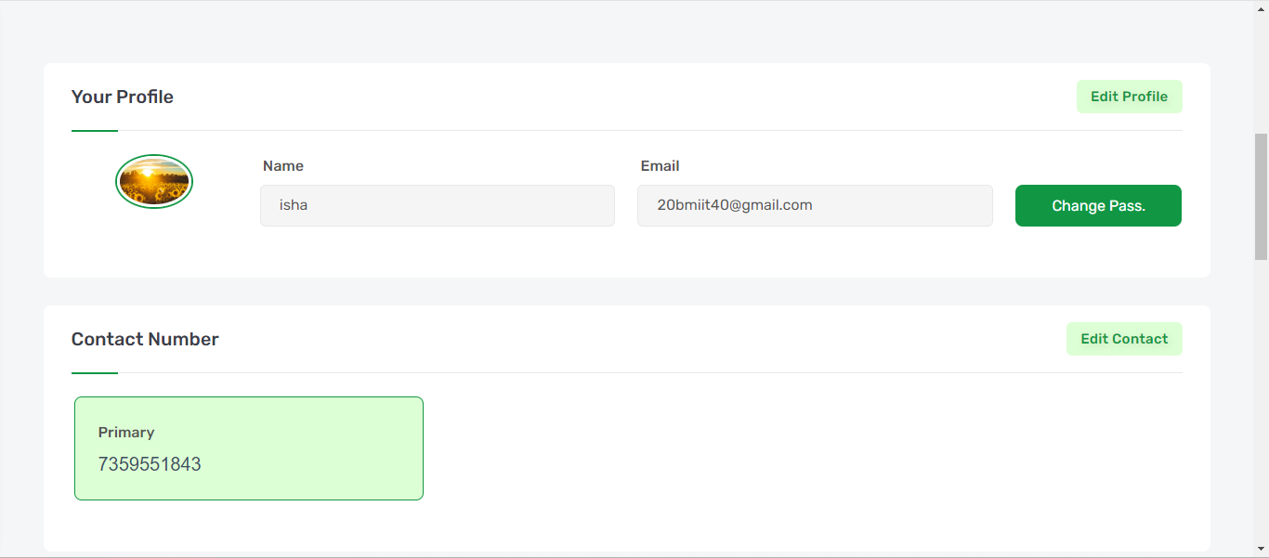

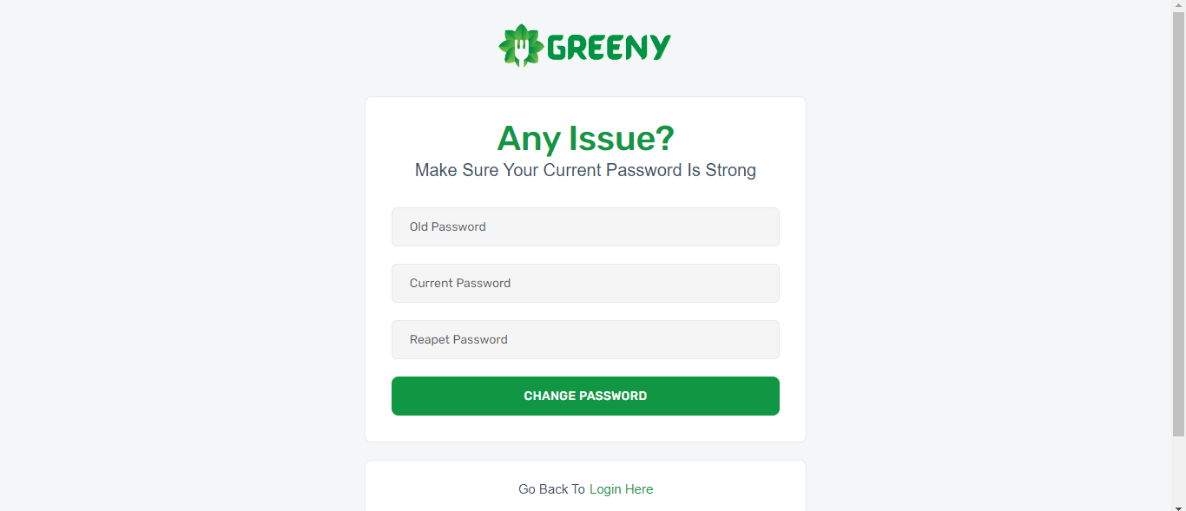

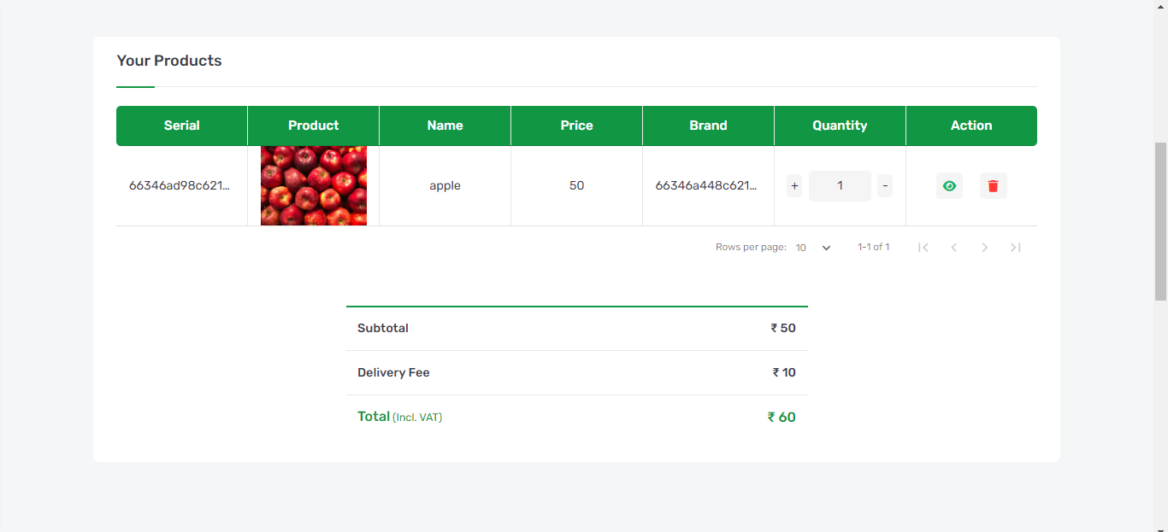

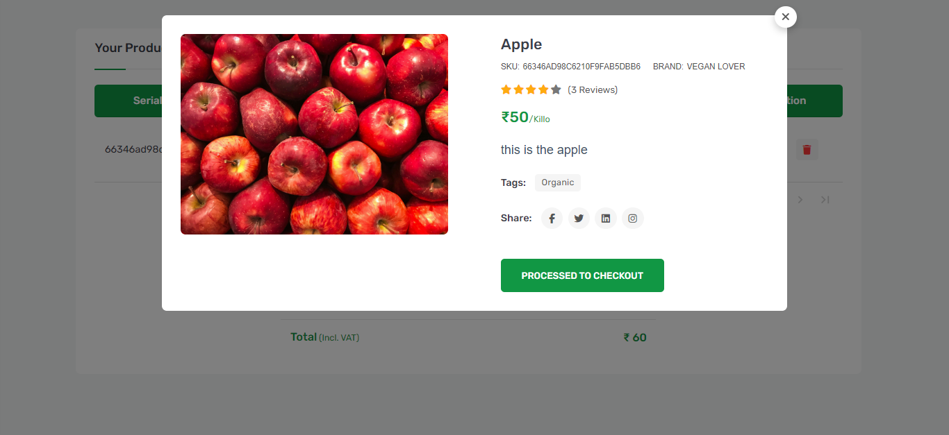

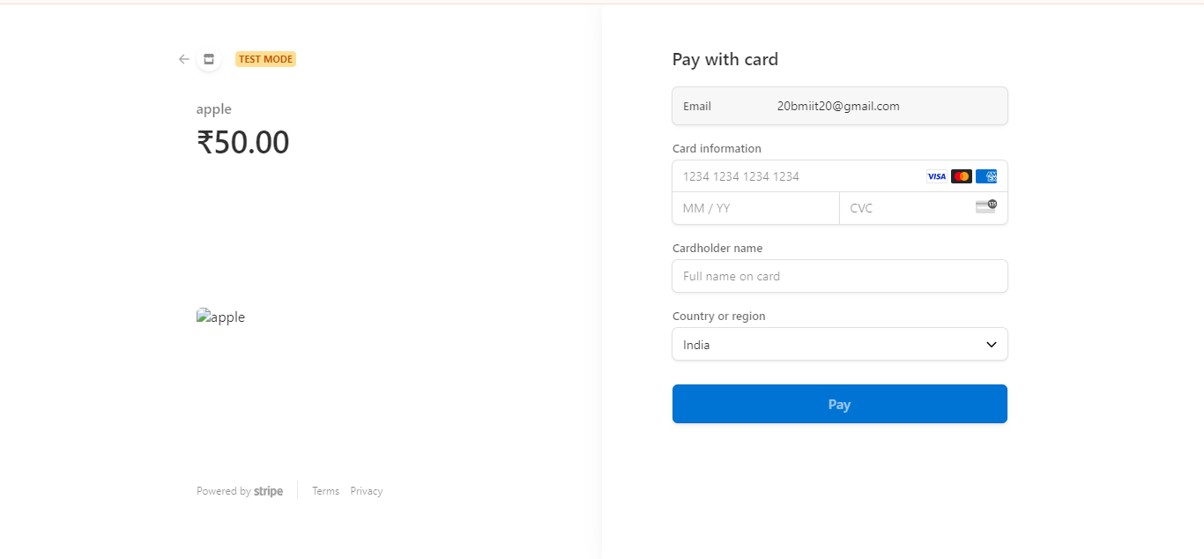

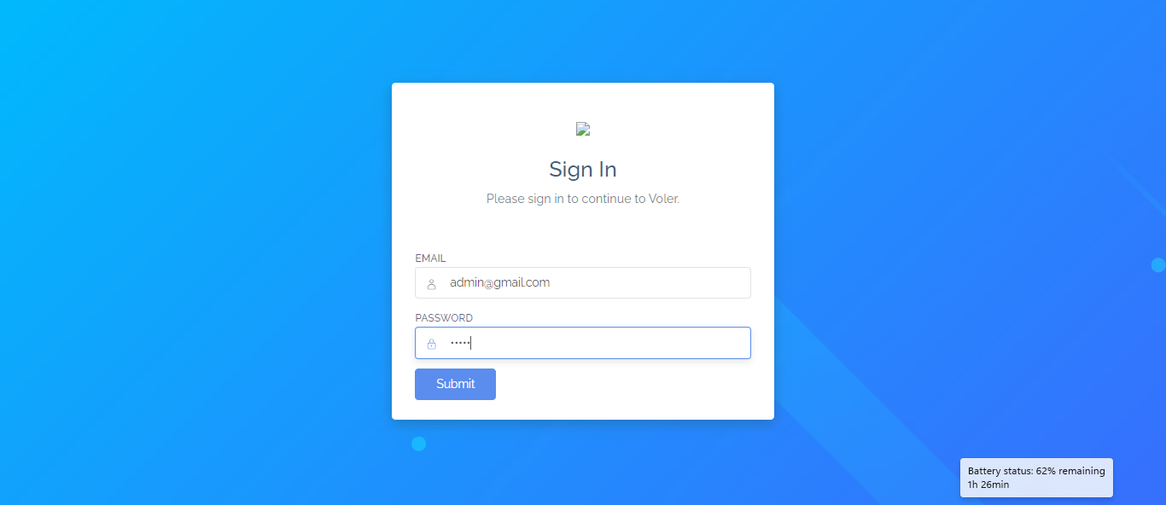

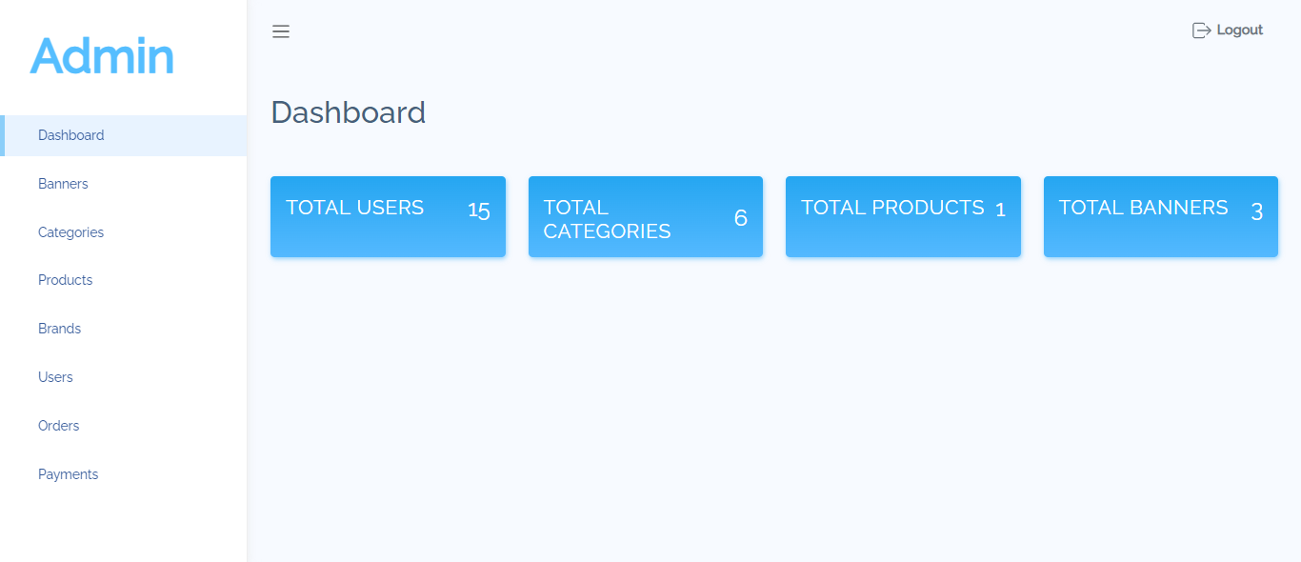

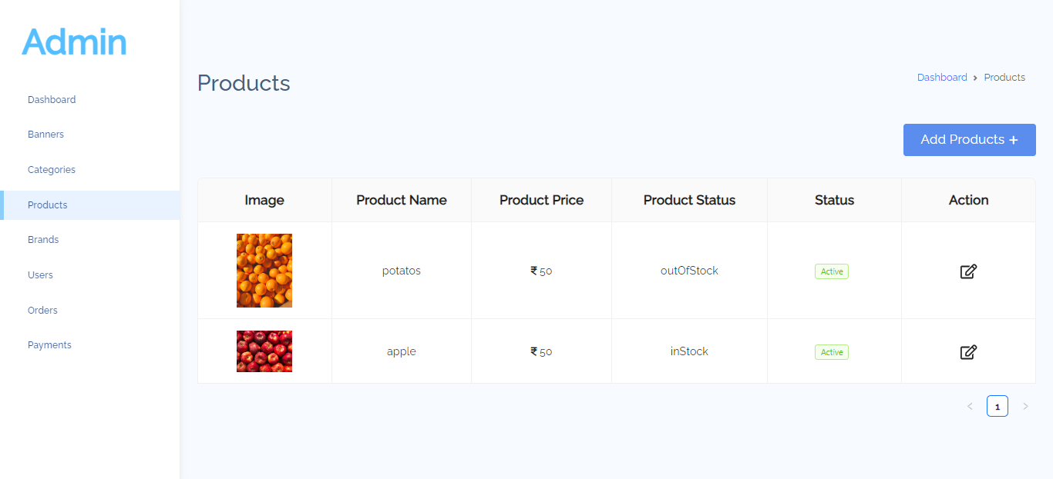

Chapters 7 (Testing)

1.Test Case : Login

Test Case no. | Component | Description | Input values | Expected output | Actual output | Remarks
1 | Email | Enter email id | Null | This field is required | This field is required | Fail
 | Email | Enter email id | [a-z,A-Z,0-9,@,_,.] | Accept | Accept | Pass
2 | Password | All input | null | This field is required | This field is required | Fail
 | Password | All input | Not null | Accept | Accept | Pass
3 | Login button | Perform event | Click while all or some field are invalid | Accept | Invalid  Credential | Fail
 | Login button | Perform event | All field are valid | Accept | Accept | Pass

2.Test Case : Registration

Test Case no. | Component | Description | Input values | Expected output | Actual output | Remarks
1 | Full name | Enter first name | null | This field is required | This field is required | Fail
 | Full name | Enter first name | Not null | Accept | Accept | Pass
2 | Email | Enter email | Null | This field is required | This field is required | Fail
 | Email | Enter email | Invalid | Invalid input | Invalid input | Fail
 | Email | Enter email | [a-z,A-Z,0-9,@,_,.] | Accept | Accept | Pass
3 | Address | Enter customer address | invalid | Not accept | Not accept | Fail
 | Address | Enter customer address | Valid | Accept | Accept | Pass
4 | Gender | Select gender | Null | This field is required | This field is required | Fail
 | Gender | Select gender | selected | Accept | Accept | Pass
5 | Contact number | Enter numeric value | Null | This field is required | This field is required | Fail
 | Contact number | Enter numeric value | invalid | Invalid input | Invalid input | Fail
 | Contact number | Enter numeric value | [0-9] | Accept | Accept | pass
6 | Pincode | Enter pincode number | Null | This field is required | This field is required | Fail
 | Pincode | Enter pincode number | invalid | Invalid input | Invalid input | Fail
 | Pincode | Enter pincode number | [0-9] | Accept | Accept | pass
7 | Register button | Perform event | Click while all or some field are invalid | Accept | Invalid credential | Fail
 | Register button | Perform event | All field are valid | Accept | Accept | Pass

3.Test Case : Change Password

Test Case no. | Component | Description | Input values | Expected output | Actual output | Remarks
1 | Current password | Enter current password | Null | This field is required | This field is required | Fail
 | Current password | Enter current password | Invalid | Enter valid password | Enter valid current password | Fail
 | Current password | Enter current password | Valid | Accept | Accept | Pass
2 | New password | Enter new password | Null | This field is required | This field is required | Fail
 | New password | Enter new password | Invalid | Enter valid password | Enter valid password | Fail
 | New password | Enter new password | Valid | Accept | Accept | pass
3 | Confirm password | Enter confirm password | Null | This field is required | This field is required | Fail
 | Confirm password | Enter confirm password | Invalid | Enter valid password | Enter valid password | Fail
 | Confirm password | Enter confirm password | valid | Accept | Accept | Pass

4.Test Case : Add Product

Test Case no. | Component | Description | Input values | Expected output | Actual output | Remarks
1 | Category name | Enter category name | Null | This field is required | This field is required | Fail
 | Category name | Enter category name | [A-Z,a-z] | Accept | Accept | Pass
2 | Category description | Enter category description | [a-z,A-Z,0-9,@,.,/] | Accept | Accept | Pass
 | Category description | Enter category description | Null | This field is required | This field is required | Fail
3 | Create button | Perform event | Click while all or some field are invalid | Accept | Invalid credential | Fail
 | Create button | Perform event | All field are valid | Accept | Accept | pass

5.Test Case : Customize order

Test  Case  Id | Components | Description | Input  Values | Expected  Output | Actual  Output | Remarks
1 | Material | Select  Material | Null | This field  Is required | This field is required | Fail
1 | Material | Select  Material | Valid | Accept | Accept | Pass
2 | Category | Select  Category | Null | This field  Is required | This field is required | Fail
2 | Category | Select  Category | Valid | Accept | Accept | Pass
3 | Purity | Select  Purity | Null | This field  Is required | This field is required | Fail
3 | Purity | Select  Purity | Valid | Accept | Accept | Pass
4 | Weight | Enter Weight | Null | This field  Is required | This field is required | Fail
4 | Weight | Enter Weight | Valid | Accept | Accept | Pass
5 | Price | Enter Price | Null | This field  Is required | This field is required | Fail
5 | Price | Enter Price | Valid | Accept | Accept | Pass
6 | Image | Upload Image | Null | This field  Is required | This field is required | Fail
6 | Image | Upload Image | Valid | Accept | Accept | Pass
6 | Image | Upload Image | Invalid | Enter Valid Image | Enter Valid Image | Fail
Chapters 8 (Future Enhancement)

The project has covered almost all the requirements. Further requirements and improvements can easily be done since the coding is mainly structured or modular in nature.

The project in developed new modules for live chatting to the customer and solve the customer query.

Developed SMS module for more interaction and easy communication.

