 | Practical:1
Aim: | In a bustling computer science department, a group of curious students gathered around their professor, eager to learn the ins and outs of programming. Dr. Techwise, their ever-inventive instructor, decided to give them a practical challenge that would bridge the gap between theory and application.  "Imagine," Dr. Techwise began, "that you are explorers venturing into the world of programming tools and environments. Your mission is to write a simple C program that displays your name on the screen. But here's the twist—you must do this using different text editors and Integrated Development Environments (IDEs) across Windows and Linux systems. Each environment is a unique terrain with its own set of tools and files. Ready to embark on this adventure?" Try to learn the backend files formed between the source code file and output .
Code: | 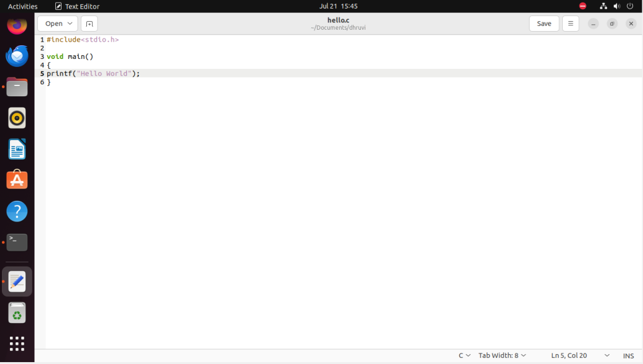
Output: | 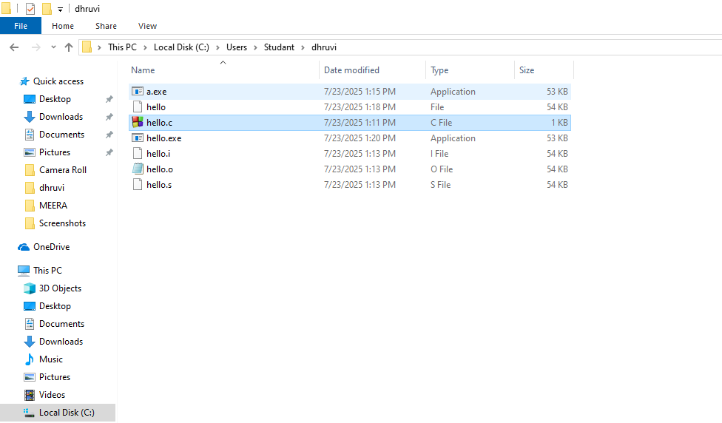  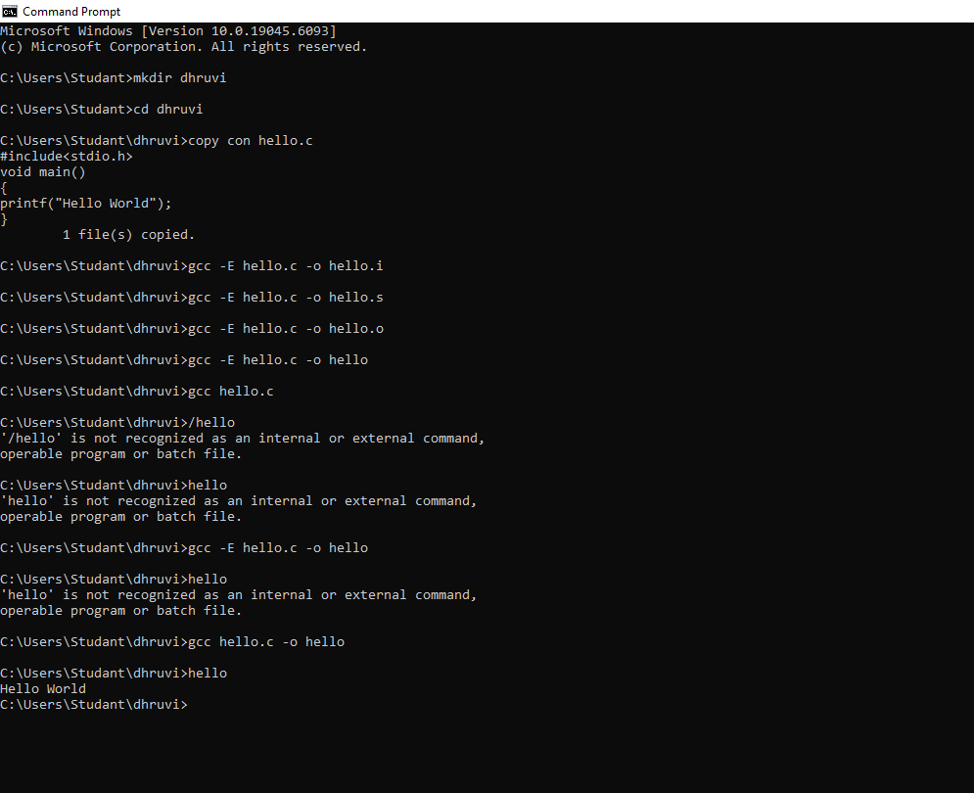  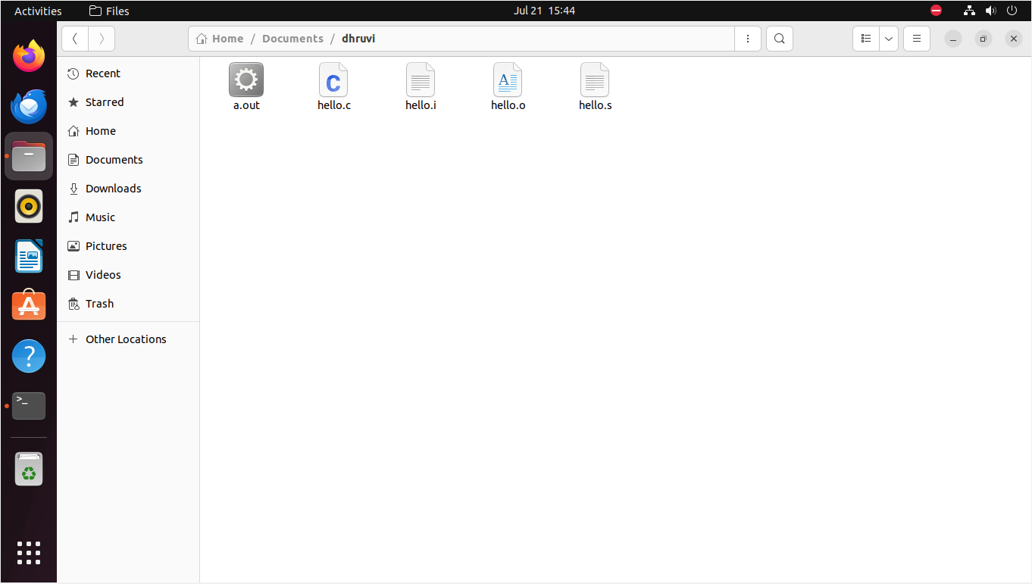  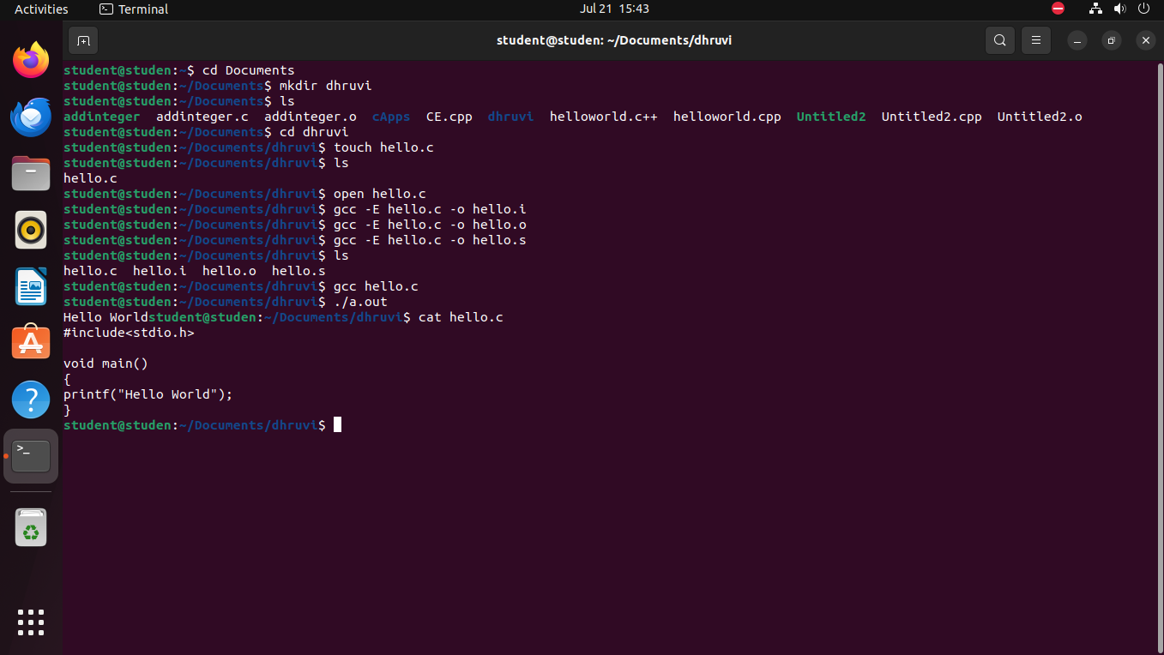

 | Practical:2
Aim: | Mr. Compute, the head of the planning department, gathered the team and laid out  a map of the proposed park. He pointed to the dimensions of the rectangular plot, elegantly sketched with labeled measurements:  Length: A grand 70 meters, stretching long enough to host a jogging track.  Breadth: A modest but substantial 90 meters, providing ample space for a variety of  activities.  "These dimensions," Mr. Compute explained, "make this park a perfect fit for our  community’s needs. But we must calculate the area and perimeter to finalize the  blueprint."
Code: | //Dhruvi Mokani  #include <stdio.h>  int main() {  int n, i;  float length, breadth, area, perimeter;  float fencingRate;  float grassRate;  printf("Enter number of parks: ");  scanf("%d", &n);  printf("Enter Grassrate per square meter:"); //input value of grassrate and fencingrate  scanf("%f",&grassRate);  printf("Enter value of Fencingrate per meter:");  scanf("%f",&fencingRate);  for (i = 1; i<= n; i++)  {  printf("\n--- Park %d ---\n", i);  printf("Enter length (in meters): "); // Input dimensions  scanf("%f", &length);  printf("Enter breadth (in meters): ");  scanf("%f", &breadth);  // Input validation  if (length <= 0 || breadth <= 0)  {  printf("Invalid dimensions! Length and breadth must be positive.\n");  continue;  }  area = length * breadth;  perimeter = 2 * (length + breadth);  // Costs  float fencingCost = perimeter * fencingRate;  float grassCost = area * grassRate;  // Output  printf("Area of Park = %.2f sq.m\n", area);  printf("Perimeter of Park = %.2f m\n", perimeter);  printf("Fencing Cost = Rs. %.2f\n", fencingCost);  printf("Grass Laying Cost = Rs. %.2f\n", grassCost);  }  return 0;  }
Output: | 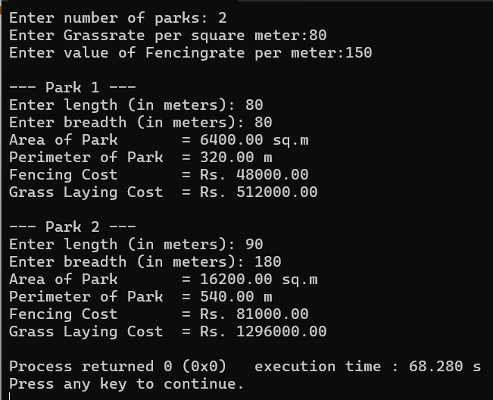

 | Practical:3
Aim: | In the heart of a bustling city, a popular fitness center, ActiveLife Studio, was  thriving with members who were determined to improve their health and well-  being. The studio’s manager, Priya, was passionate about helping people achieve  their fitness goals. One day, during a meeting with her trainers, Priya raised an  important point:  “Our members often ask if they’re making progress, but they don’t have an easy  way to track their overall health. What if we introduce a Body Mass Index (BMI)  calculator as part of our program? It’s simple, yet powerful for monitoring health.”  The team was excited about the idea, but there was a challenge: they needed a  reliable and efficient tool to calculate BMI for all members.  Priya turned to a tech-savvy friend, Arjun, for help. She explained the  requirements:  1. The program must accept a person’s weight in kilograms and height in  meters as inputs.  2. It should calculate the BMI using the formula:  BMI=Weight/Height2  3. Finally, the program should display the BMI in a clear, user-friendly  format, so members could easily understand their results.  “This will not only empower our members to monitor their health,” Priya added,  “but it will also encourage them to adopt healthier habits!”
Code: | //Dhruvi Mokani  #include <stdio.h>  int main() {  float weight, height, bmi;  printf("Enter weight in kilograms: "); // Input weight and height  scanf("%f", &weight);  printf("Enter height in meters: ");  scanf("%f", &height);  if (weight <= 0 || height <= 0) {  printf("Invalid input! Weight and height must be positive values.\n");  return 0;  }  // BMI Calculation  bmi = weight / (height * height);  printf("Your BMI is: %.2f\n", bmi);  // Display Catagory  if (bmi< 18.5)  printf("Category: Underweight\n");  else if (bmi>= 18.5 &&bmi< 24.9)  printf("Category: Normal weight\n");  else if (bmi>= 25 &&bmi< 29.9)  printf("Category: Overweight\n");  else  printf("Category: Obese\n");  return 0;  }
Output: | 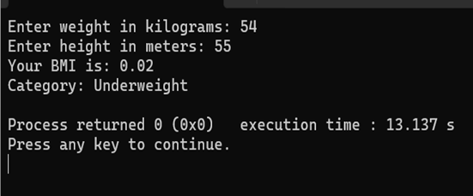

 | Practical:4
Aim: | At TechNest University, the programming club CodeMasters decided to up the  ante for their annual workshop. After the success of their data type demonstration  last year, they wanted to make this year’s event even more interactive and  insightful for new students.  During a brainstorming session, the club’s president, Anya, exclaimed,  “Let’s show them the magic of data types and their ranges! If students understand  not just the size but also the capabilities of each data type, they’ll be able to write  better programs with precision and confidence.”  The team cheered in agreement, and a new challenge was born.  Discover the Data Types: Write a program that displays the size (in  bytes) of commonly used data types (char, int, float, double, etc.) in C.  Explore the Ranges: Include a feature that outputs the minimum and  maximum values of each data type using appropriate constants from  <limits.h> and <float.h>.
Code: | //Dhruvi Mokani  #include <stdio.h>  #include <limits.h>  #include <float.h>  int main() {  printf("===== Data Types in C =====\n\n");  printf("char:\n");  printf(" Size : %zu byte(s)\n", sizeof(char));  printf(" MinValue : %d\n", CHAR_MIN);  printf(" MaxValue : %d\n\n", CHAR_MAX);  printf("int:\n");  printf(" Size : %zu byte(s)\n", sizeof(int));  printf(" MinValue : %d\n", INT_MIN);  printf(" MaxValue : %d\n\n", INT_MAX);  printf("short:\n");  printf(" Size : %zu byte(s)\n", sizeof(short));  printf(" MinValue : %d\n", SHRT_MIN);  printf(" MaxValue : %d\n\n", SHRT_MAX);  printf("long:\n");  printf(" Size : %zu byte(s)\n", sizeof(long));  printf(" MinValue : %ld\n", LONG_MIN);  printf(" MaxValue : %ld\n\n", LONG_MAX);  printf("long long:\n");  printf(" Size : %zu byte(s)\n", sizeof(long long));  printf(" MinValue : %lld\n", LLONG_MIN);  printf(" MaxValue : %lld\n\n", LLONG_MAX);  printf("unsigned int:\n");  printf(" Size : %zu byte(s)\n", sizeof(unsigned int));  printf(" MinValue : %u\n", 0);  printf(" MaxValue : %u\n\n", UINT_MAX);  printf("float:\n");  printf(" Size : %zu byte(s)\n", sizeof(float));  printf(" MinValue : %.10e\n", FLT_MIN);  printf(" MaxValue : %.10e\n", FLT_MAX);  printf(" Precision : %d decimal digits\n\n", FLT_DIG);  printf("double:\n");  printf(" Size : %zu byte(s)\n", sizeof(double));  printf(" MinValue : %.10e\n", DBL_MIN);  printf(" MaxValue : %.10e\n", DBL_MAX);  printf(" Precision : %d decimal digits\n\n", DBL_DIG);  printf("long double:\n");  printf(" Size : %zu byte(s)\n", sizeof(long double));  printf(" MinValue : %.10Le\n", LDBL_MIN);  printf(" MaxValue : %.10Le\n", LDBL_MAX);  printf(" Precision : %d decimal digits\n\n", LDBL_DIG);  return 0;  }
Output: | 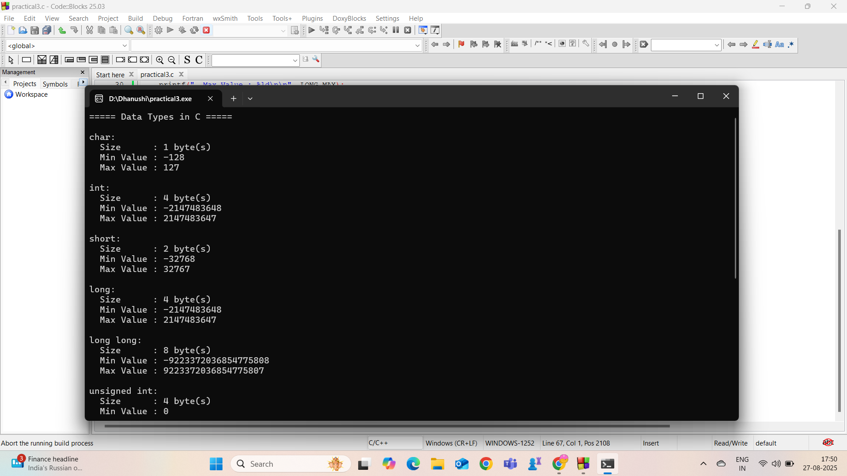  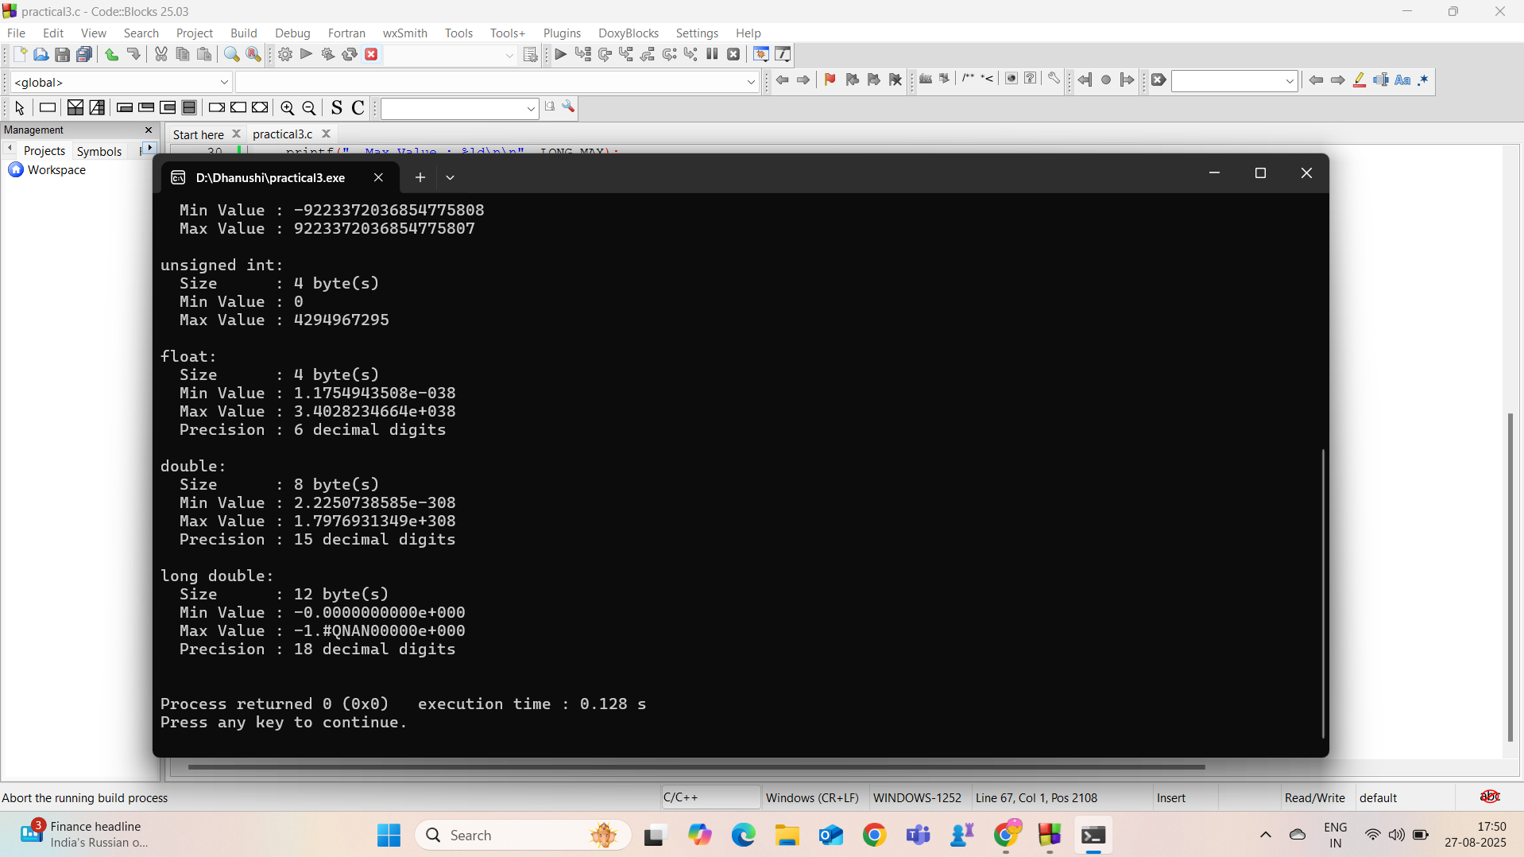

 | Practical:5
Aim: | In the bustling offices of Bharat's Home Ministry, a team of data analysts sat in a  meeting room, surrounded by charts, reports, and coffee cups. The year was 2024,  and the Ministry had embarked on a critical mission: to better understand the state  of education in Bharat.  Minister Rajan, known for his forward-thinking strategies, addressed the room:  “We are on a journey to improve literacy in Bharat. To make informed decisions,  we need accurate data on the number of literate and illiterate men and women in our  population. Let’s turn these numbers into actionable insights.”  The analysts were given the following statistics:  1. Population of Bharat in 2024: 1,441,981,744  2. Percentage of Women: 48.4%  3. Literacy Rates:  o Overall: 85.95%  o Men: 80.95%  o Women: 62.84%  The team’s challenge was to compute the count of illiterate men and women  using these statistics. To streamline this process, they turned to their tech-savvy  intern, Arya.
Code: | //Dhruvi Mokani  #include <stdio.h>  int main() {  //Declare Variables  long longtotalPopulation;  double percentWomen,percentmen, literacyOverall, literacyMen, literacyWomen;  long longnumWomen, numMen;  long longliterateMen, literateWomen, illiterateMen, illiterateWomen;  // take Input from user  printf("Enter total population: ");  scanf("%lld", &totalPopulation);  printf("Enter percentage of women: ");  scanf("%lf", &percentWomen);  printf("Enter overall literacy rate: ");  scanf("%lf", &literacyOverall);  printf("Enter literacy rate of men: ");  scanf("%lf", &literacyMen);  printf("Enter literacy rate of women: ");  scanf("%lf", &literacyWomen);  percentmen=(100-percentWomen);  printf("percentage of Men is %lf",percentmen);  numWomen = (long long)(totalPopulation * (percentWomen / 100.0));  numMen = totalPopulation - numWomen;  // Calculatlitrate Men and Women  literateWomen = (long long)(numWomen * (literacyWomen / 100.0));  literateMen = (long long)(numMen * (literacyMen / 100.0));  // Calculatillitrate Men and Women  illiterateWomen = numWomen - literateWomen;  illiterateMen = numMen - literateMen;  // Output  printf("\n------------------- Literacy Report -------------------\n");  printf("%20s %15s %15s\n", "Category", "Literate", "Illiterate");  printf("-------------------------------------------------------\n");  printf("%20s %15lld %15lld\n", "Men", literateMen, illiterateMen);  printf("%20s %15lld %15lld\n", "Women", literateWomen, illiterateWomen);  printf("-------------------------------------------------------\n");  printf("%20s %15lld %15lld\n", "Total", literateMen + literateWomen, illiterateMen + illiterateWomen);  printf("\nLiteracy gap between men and women: %.2f%%\n", literacyMen - literacyWomen);  double newLiteracyWomen = literacyWomen + 5.0;  if (newLiteracyWomen> 100.0) newLiteracyWomen = 100.0;  long longnewLiterateWomen = (long long)(numWomen * (newLiteracyWomen / 100.0));  long longnewIlliterateWomen = numWomen - newLiterateWomen;  printf("\nIf women's literacy improves by 5%%:\n");  printf("New Literate Women: %lld\n", newLiterateWomen);  printf("New Illiterate Women: %lld\n", newIlliterateWomen);  return 0;  }
Output: | 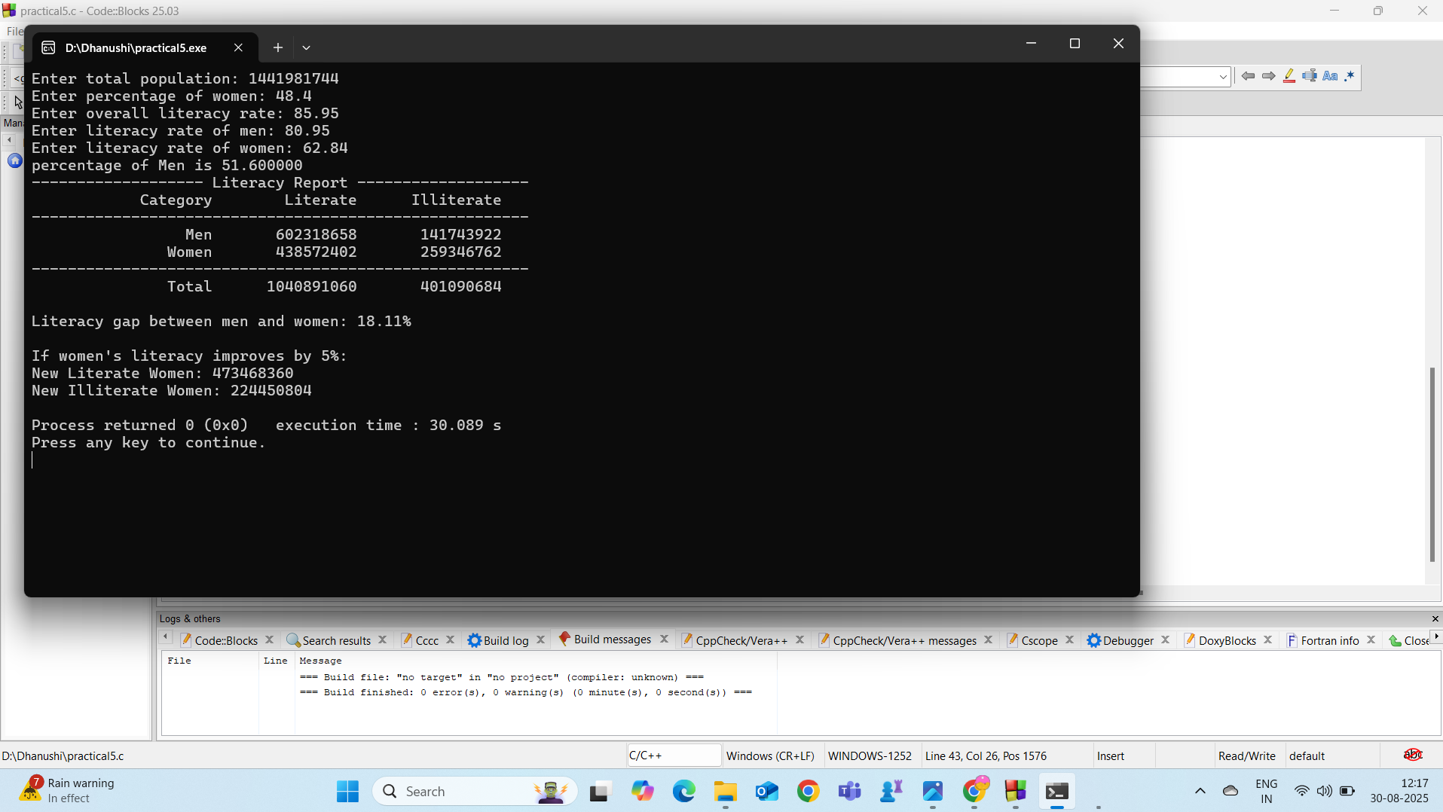

 | Practical:6
Aim: | In the heart of India’s bustling Meteorological Department, meteorologist Riya stared at the glowing screen filled with weather data. It was a critical day – the team was preparing a comprehensive weather report for an upcoming international climate summit.  Suddenly, her colleague Arjun exclaimed,  “Riya, we need the temperature readings in Fahrenheit for our global audience. Most countries use Fahrenheit for their weather updates!”  Riya nodded. While the team’s sensors recorded temperatures in Celsius, the global report required conversions to Fahrenheit.  “Let’s automate this,” Riya suggested. “We need a program to do the conversion accurately and quickly.”  **Fahrenheit = (Celsius × 9/5) + 32.**  Analyze the value of Fahrenheit while temperature is 0, 100, or –40 Celsius.
Code: | //Dhruvi Mokani  #include<stdio.h>  void main()  {  float cel, far;  int ch;  // Asking user to choose  printf("Enter choice 1 for Fahrenheit to Celsius and choice 2 for Celsius to Fahrenheit");  printf("\nEnter your choice: ");  scanf("%d", &ch);  switch(ch)  {  case 1:  // Taking temperature in Celsius  printf("\nEnter Celsius: ");  scanf("%f", &cel);  // Converting Celsius to Fahrenheit  far = (cel * 9/5) + 32;  printf("\nFahrenheit: %f", far);  break;  case 2:  // Taking temperature in Fahrenheit  printf("\nEnter Fahrenheit: ");  scanf("%f", &far);  // Converting Fahrenheit to Celsius  cel = (far - 32) * (5/9.0);  printf("\nCelsius: %f", cel);  break;  }  //Analysing the value of Fahrenheit while temperature is 0, 100, or –40 Celsius.  cel = 0;  printf("\nTemperature in Celcius:%f", cel);  far = (cel * 9/5) + 32;  printf("\t\tTemperature in farenhite:%f", far);  cel = -40;  printf("\nTemperature in Celcius:%f", cel);  far = (cel * 9/5) + 32;  printf("\t\tTemperature in farenhite:%f", far);\  cel = 100;  printf("\nTemperature in Celcius:%f", cel);  far = (cel * 9/5) + 32;  printf("\t\tTemperature in farenhite:%f", far);  }
Output: | 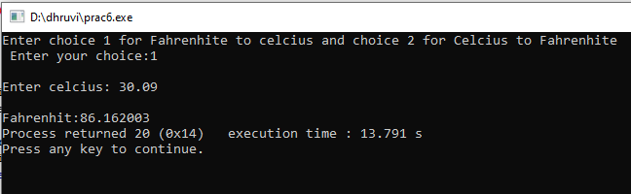  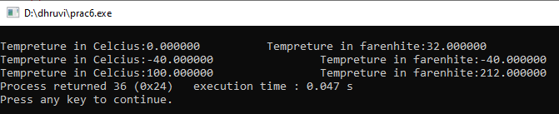

 | Practical:7
Aim: | At the Sunrise Amusement Park, the management is introducing an automated  ticketing system to reduce wait times at entry gates.  The system needs to decide whether a visitor should be charged for entry or  allowed in for free. The park allows free entry to children but charges a fixed  ticket price for adults.  The management has provided some basic guidelines for implementing this  system:  • Visitors will provide their age at the entry gate.  • Depending on their age, the system will decide whether the visitor is  eligible for free entry or must pay for a ticket.
Code: | //Dhruvi Mokani  #include <stdio.h>  int main() {  int numVisitors, age;  float ticketPrice = 100.0, totalCost = 0.0;  int adultCount = 0;  // number of visitors  printf("Enter the number of visitors: ");  scanf("%d", &numVisitors);  if (numVisitors<= 0) {  printf("Invalid number of visitors!\n");  return 0;  }  //Enter age  for (int i = 1; i<= numVisitors; i++) {  printf("Enter age of visitor %d: ", i);  scanf("%d", &age);  if (age < 0 || age > 120) {  printf("Error: Invalid age entered! Please enter age between 0 and 120.\n");  }  if (age < 12) {  printf("Visitor %d: Free entry (Child)\n", i);  }  else if (age >= 60) {  printf("Visitor %d: Free entry (Senior Citizen)\n", i);  }  else {  totalCost += ticketPrice;  adultCount++;  printf("Visitor %d: Ticket price = %.2f\n", i, ticketPrice);  }  }  // Apply discount if more than 5 adults  if (adultCount> 5) {  float discount = totalCost * 0.10;  totalCost -= discount;  printf("Group discount applied (10%%): %.2f\n", discount);  }  //Final price  printf("\nTotal ticket cost for the group: %.2f\n", totalCost);  return 0;  }
Output: | 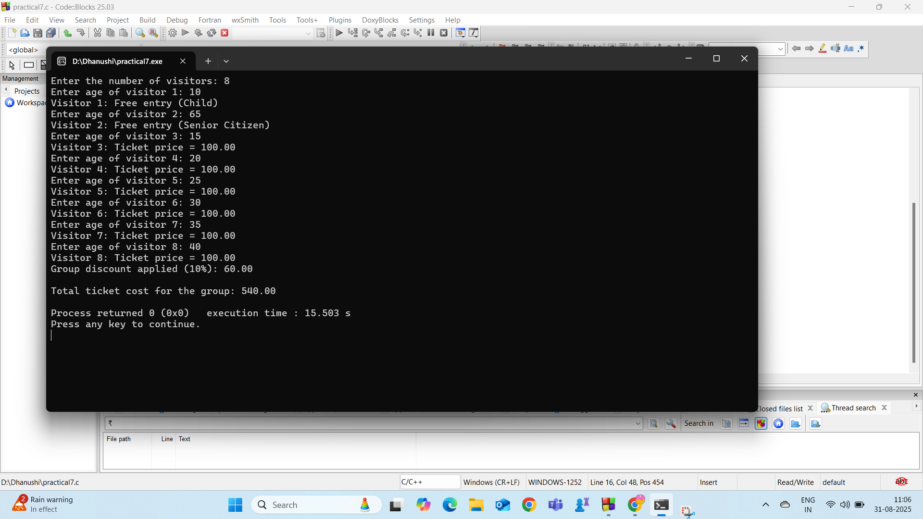

 | Practical:8
Aim: | Spark Savings Bank is launching a new campaign to attract young adults to open  savings accounts. To ensure only eligible individuals apply, the bank wants to  introduce an eligibility checker at their branches.  Here’s the scenario:  1. Customers walk into the branch and provide their age.  2. Depending on their age, they are either deemed eligible to open a savings  account or politely informed that they are not eligible yet.  The eligibility criteria and how the system should behave are left for you to  deduce and implement.
Code: | //Dhruvi Mokani  #include <stdio.h>  int main() {  int choice;  int age;  //Check eligibility  do {  printf("\n====== Spark Savings Bank Eligibility Checker ======\n");  printf("1. Check Eligibility\n");  printf("2. Exit\n");  printf("Enter your choice: ");  scanf("%d", &choice);  switch(choice) {  case 1:  printf("\nEnter customer's age: ");  scanf("%d", &age);  // Validate age  if (age < 0 || age > 120) {  printf("Invalid input! Please enter a valid age between 0 and 120.\n");  }  else if (age < 18) {  printf("Customer is NOT eligible for a savings account.\n");  }  else if (age >= 18 && age < 60) {  printf("Customer is eligible for a REGULAR savings account.\n");  }  else {  printf("Customer is eligible for a SENIOR CITIZEN savings account.\n");  }  break;  case 2:  printf("\nThank you for using the eligibility checker.\n");  break;  default:  printf("\nInvalid choice! Please try again.\n");  }  } while(choice != 2);  return 0;  }
Output: | 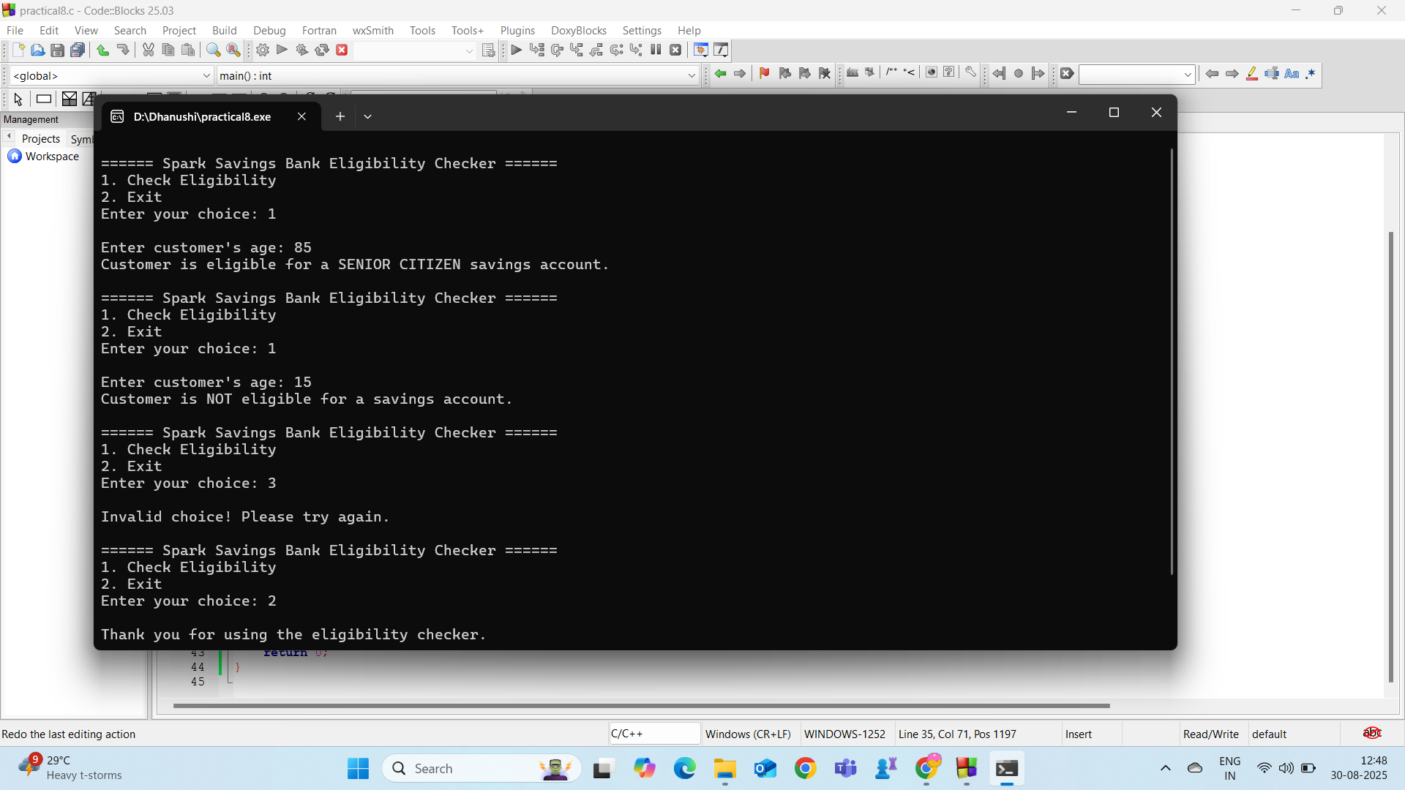

 | Practical:9
Aim: | Every year during the festive season, ShopEase Online introduces special  discounts to attract customers and boost sales. This year, the store’s marketing team  has come up with a tiered discount policy to reward loyal shoppers based on their  spending.  As part of their customer engagement drive, they’ve tasked you, a budding  developer, with designing the logic for the discount system.  Here’s the scenario:  1. Customers shop for their favorite items and proceed to the checkout page.  2. The system calculates the total shopping amount and applies a discount  based on their spending:  o For total amounts below ₹1000, no discount is applied.  o For totals between ₹1000 and ₹5000, the customer enjoys a 10%  discount.  o For totals exceeding ₹5000, they receive a generous 20% discount.  3. The system must display the total amount, the discount applied, and the final  amount the customer needs to pay.  The store manager is eager to see how this system can enhance customer satisfaction  and drive sales. How will you design a program that ensures every customer  experiences a seamless checkout process with accurate discounts?
Code: | //Dhruvi Mokani  #include<stdio.h>  void main()  {  int totalamount, discount, discountvalue, finalamount, gst, gstvalue;  for(int i=0;i<10;i++) // loop for multiple customers  {  printf("\nCustomer's Total Amount:");  scanf("%d", &totalamount);  gst = 5;  gstvalue = totalamount * gst / 100; //calculate gstvalue  if(totalamount < 1000) //different conditions for different amounts  {  discount = 0;  printf("Sorry!! No discount Applied");  discountvalue = totalamount * discount / 100;  finalamount = totalamount - discountvalue - gstvalue;  printf("\nDiscount Value=%d ", discountvalue);  printf("\n5%% GST Applied");  printf("\nFinal amount=%d ", finalamount);  }  else if(totalamount > 1000 && totalamount <= 5000)  {  discount = 10;  discountvalue = totalamount * discount / 100;  finalamount = totalamount - discountvalue - gstvalue;  printf("\n10%% discount Applied");  printf("\nDiscount Value=%d ", discountvalue);  printf("\n5%% GST Applied");  printf("\nFinal amount=%d ", finalamount);  }  else if(totalamount > 5000)  {  discount=20;  discountvalue=totalamount*discount/100;  finalamount=totalamount-discountvalue-gstvalue;  printf("20%% discount Applied");  printf("\nDiscount Value=%d", discountvalue);  printf("\n%s%% GST Applied");  printf("\nFinal amount=%d ", finalamount);  }  int rm,pc;  printf("\nAre you a registered Member(1 for yes/2 for no):"); //Asking for registration  scanf("%d", &rm);  switch(rm) { //using switch case for asking registration details  case 1 :  printf("Enter Your Promo code:");  scanf("%d", &pc);  printf("Extra 5%% Discount applied");  int dv=finalamount*5/100;  int fa=finalamount-dv;  printf("\nFinal Amount after special discount=%d", fa);  printf("\nThank You Visit again");  break;  case 2 :  printf("Thank You Visit again");  }  }  }
Output: | 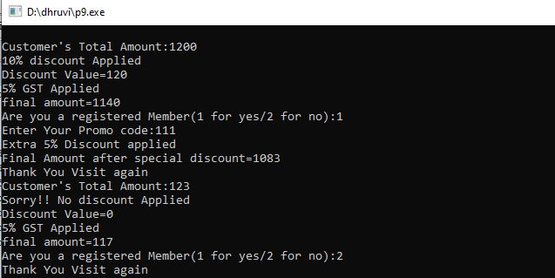

 | Practical:10
Aim: | Foodies is a restaurant established in 2020. Due to rush of customers, the waiters  are not able to manage the food supply appropriately. To help them, create a menu  ordering system, which allows customers to select the items from the menu and  1 CO2  By: Dr. Aayushi Chaudhari, Dr. Khushi Patel  compute the total cost of their order. Use switch case for menu ordering and item  selection.  Menu includes the following:  • Burger - ₹150  • Pizza - ₹200  • Pasta - ₹120  • Sandwich - ₹100  • French Fries - ₹80  Display the menu to user and allow them to enter the number they wish to order.  Calculate the total amount after selection of all items. Ask user to enter ‘0’ after  finishing the ordering of items.
Code: | #include <stdio.h>  int main() {  char *items[] = {"Burger", "Pizza", "Pasta", "Sandwich", "French Fries"};  int prices[] = {150, 200, 120, 100, 80};  int qty[5] = {0};  int choice, q;  float total = 0;  do {  printf("\n----- MENU -----\n");  for (int i = 0; i< 5; i++) {  printf("%d. %s - Rs.%d\n", i+1, items[i], prices[i]);  }  printf("0. Finish Order\n");  printf("Enter your choice: ");  scanf("%d", &choice);  if (choice >= 1 && choice <= 5) {  printf("Enter quantity: ");  scanf("%d", &q);  qty[choice-1] += q;  total += prices[choice-1] * q;  }  else if (choice != 0) {  printf("Invalid choice! Try again.\n");  }  } while (choice != 0);  // Discount  if (total > 500) {  printf("\n10%% Discount Applied!\n");  total = total * 0.90;  }  // summary  printf("\n----- ORDER SUMMARY -----\n");  for (int i = 0; i< 5; i++) {  if (qty[i] > 0) {  printf("%s x%d = Rs.%d\n", items[i], qty[i], qty[i]*prices[i]);  }  }  printf("Total: Rs%.2f\n", total);  return 0;  }
Output: | 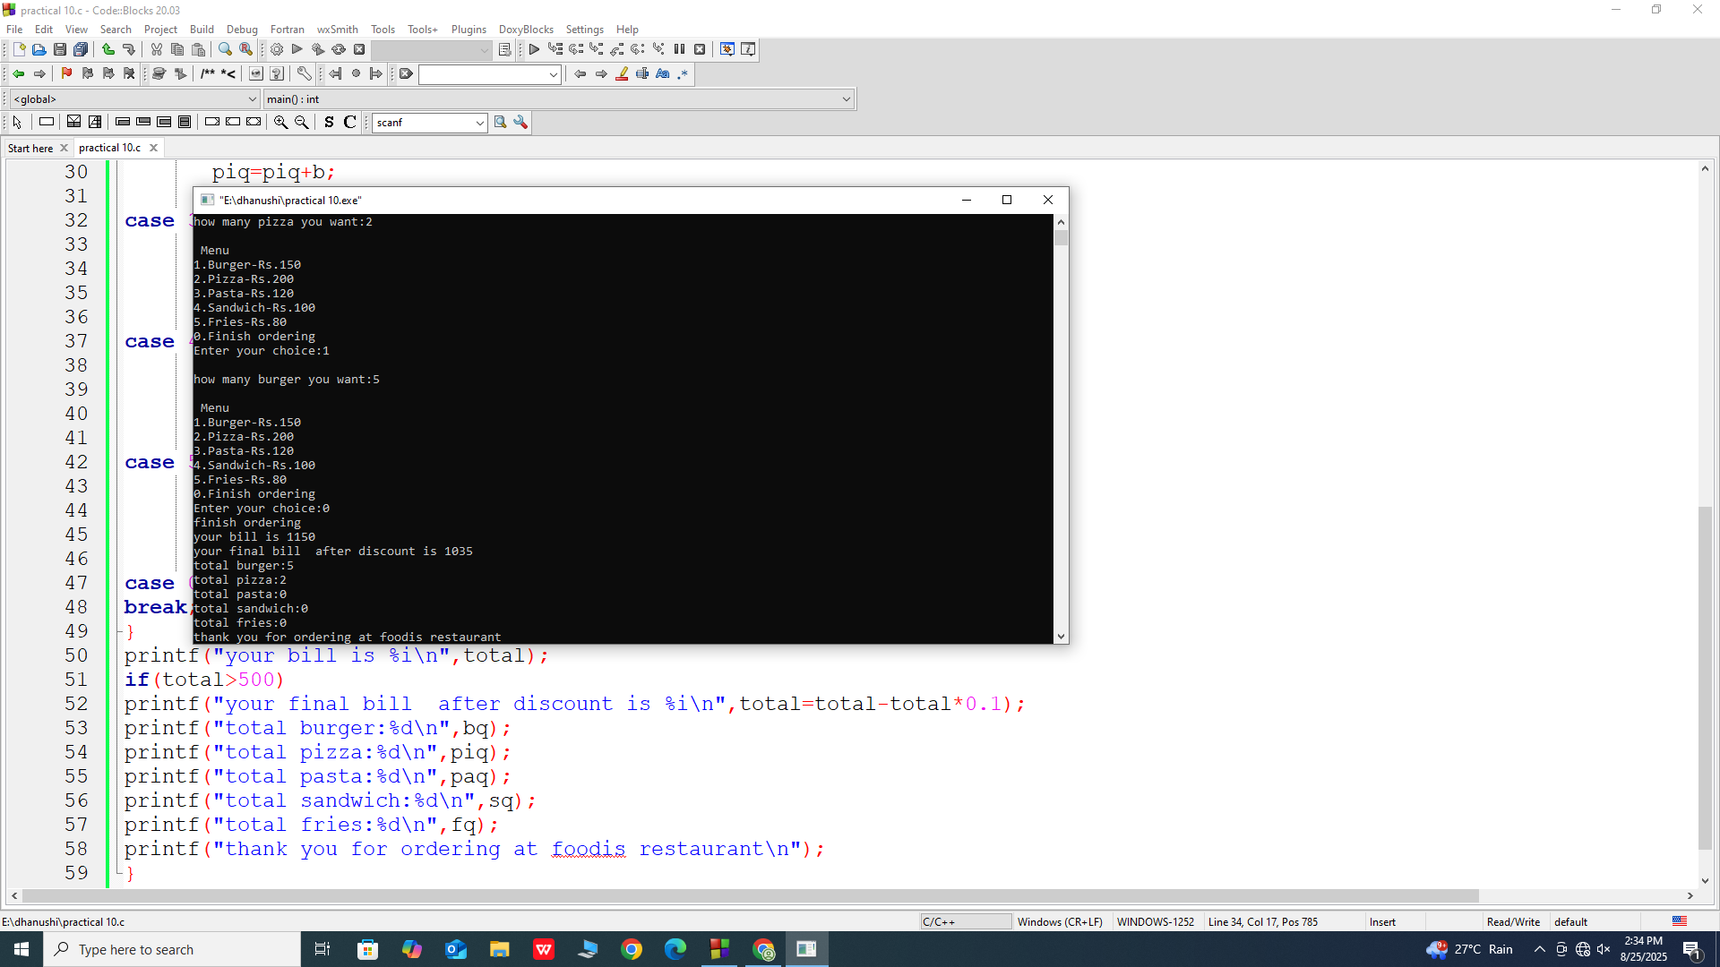

 | Practical:11
Aim: | Determine the grade of a student based on their marks using the conditional (ternary) operator. Take student’s marks as input and display the corresponding grade as output according to the following criteria: Marks >= 90: Grade A Marks >= 80 and < 90: Grade B Marks >= 70 and < 80: Grade C Marks >= 60 and < 70: Grade D Marks < 60: Grade F Validate the input by ensuring user is entering marks between 0-100, else declare that the entered input is invalid.
Code: | //Dhruvi Mokani 25cs047  #include<stdio.h>  void main()  {  int s,i,marks,gpa;  printf("Enter no. of students: ");  scanf("%d",&s);  for(i=1;i<=s;i++)  {  printf("\nEnter ur marks:");  scanf("%d",&marks);  if(marks<0||marks>100)  printf("Invalid input");  else  (marks>=90)?printf("Grade:A Congrats!!"):(marks>=80&&marks<90)?printf("Grade:B Good!!"):(marks>=70&&marks<80)?printf("Grade:C Can do better"):(marks>=60&&marks<70)?printf("Grade:D Can do better"):(marks<60)?printf("Grade:F Need more improvement"):printf("invalid");  }  }
Output: | 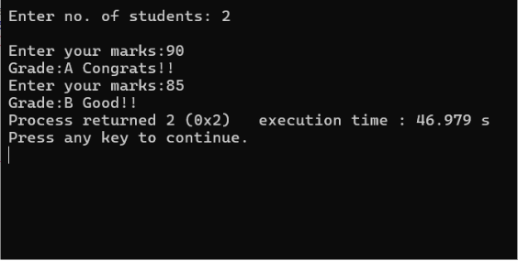

 | Practical:12
Aim: | The librarian at City High School has implemented a barcode system for all  library books. Each book is assigned a unique ID number from 1 to 50. The  librarian wants to generate a catalog to:  Display all the book IDs sequentially.  Mark every 5th book as a "Special Edition".  Write a program to generate this catalog, ensuring it displays each book ID on a  new line and highlights special editions with a clear note next to their ID.  Expected sample outcome:  Book ID: 1  Book ID: 2  Book ID: 3  Book ID: 4  Book ID: 5 (Special Edition)
Code: | //Dhruvi Mokani 25cs047  #include <stdio.h>  void main()  {  FILE *p12;  int i, s, e, spe, rare, BookID;  // Open file for writing  p12 = fopen("p12.txt", "w");  // Input start of range  printf("Enter starting number of books: ");  scanf("%d", &s);  // Input end of range  printf("Enter ending number of books: ");  scanf("%d", &e);  // Input special edition number  printf("Enter number for Special Edition of book: ");  scanf("%d", &spe);  // Input rare edition number  printf("Enter number for Rare Edition of book: ");  scanf("%d", &rare);  // Loop through given book ID range  for (i = s; i <= e; i++)  {  BookID = i;  // Check for special edition (divisible by spe & odd)  if (BookID % spe == 0 && BookID % 2 != 0)  {  printf("Book ID %d 'SPECIAL EDITION'\n", BookID);  fprintf(p12, "BOOK ID %d 'SPECIAL EDITION'\n", BookID);  }  // Check for rare edition (divisible by rare & even)  else if (BookID % rare == 0 && BookID % 2 == 0)  {  printf("Book ID %d 'RARE EDITION'\n", BookID);  fprintf(p12, "BOOK ID %d 'RARE EDITION'\n", BookID);  }  // Normal book ID  else  {  printf("Book ID %d\n", BookID);  fprintf(p12, "Book ID %d\n", BookID);  }  }  // Close file  fclose(p12);  }
Output: | 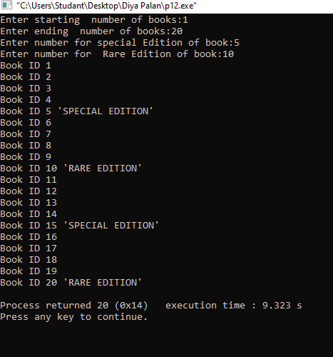  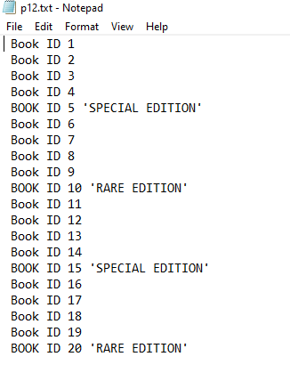

 | Practical:13
Aim: | The Smart Water System Company has developed an automatic tank refill  system. This system starts refilling an empty tank (initially at 0 liters) until it  reaches its maximum capacity of 100 liters.  • The system refills the tank at a fixed rate of 10 liters per minute.  • It displays the current water level after each refill.  Write a program to simulate this process. Ensure the program stops automatically  when the tank is full, displaying a message: "Tank is full."  Expected sample outcome:  Current water level: 10 liters  Current water level: 20 liters  ...  Tank is full.
Code: | //Dhruvi Mokani 25cs047  #include<stdio.h>  void main()  {  int i, cap, fill, Tank;  printf("Enter capacity of your tank : ");  scanf("%d", &cap); // take tank capacity  printf("Enter filling rate for your tank : ");  scanf("%d", &fill); // take filling rate  // loop starts from first fill value and goes till tank capacity  for(i = fill; i <= cap; i++)  {  Tank = i; // update current tank level  // print only when tank level hits multiples of filling rate  if(Tank % fill == 0)  {  printf("Current Tank Level: %d Liter Full\n", Tank);  printf("Tank Level: %d%% Full\n", Tank);  sleep(1); // delay for 1 second  }  // when tank reaches full capacity  if(Tank == cap)  {  printf("Tank is FULL!!\n");  sleep(1);  }  }  }
Output: | 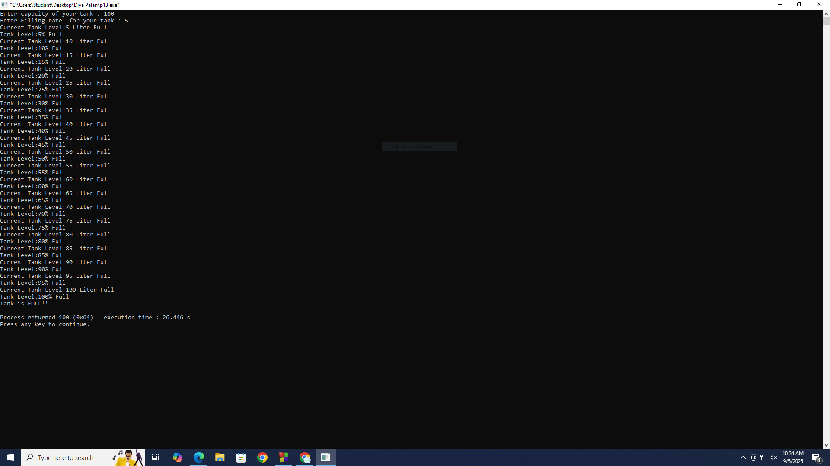

 | Practical:14
Aim: | The National Bank of Bharat wants to simulate an ATM machine.  Assume the user has a starting balance of ₹5000.  The ATM should allow the user to withdraw cash as long as their balance is  sufficient.  For every transaction:  • Prompt the user to enter the amount they wish to withdraw.  • Deduct the amount from the balance and display the remaining balance.  • If the user attempts to withdraw more than the available balance, display a  warning message: "Insufficient balance."  The program should continue until the user chooses to stop.
Code: | //Dhruvi Mokani 25cs047  #include <stdio.h>  void main()  {  int amount = 10000, wd, dp, pin = 2552; //wd for withdraw money  int p, i, ch; //dp for deposit money  printf("*********** ATM MACHINE ***********\n");  printf("Practical 14 - ATM Program\n\n");  // taking PIN from user  printf("Enter your PIN: ");  scanf("%d", &p);  // allow 3 attempts  for(i = 0; i < 3; i++)  {  if(p == pin)  {  // display menu  printf("\n1. Withdraw Money");  printf("\n2. Deposit Money");  printf("\n3. Exit");  printf("\n\nEnter your choice: ");  scanf("%d", &ch);  switch(ch)  {  // ---------------- WITHDRAW ----------------  case 1:  printf("\nYour Current Balance: %d\n", amount);  printf("Enter amount to withdraw: ");  scanf("%d", &wd);  // check for invalid input  if(wd <= 0)  printf("Enter a valid amount!\n");  // check for sufficient balance  else if(wd > amount)  printf("Insufficient Balance!\n");  else  {  amount -= wd;  printf("\nWithdrawal Successful!\n");  printf("Remaining Balance: %d\n", amount);  }  break;  // ---------------- DEPOSIT ----------------  case 2:  printf("\nYour Current Balance: %d\n", amount);  printf("Enter amount to deposit: ");  scanf("%d", &dp);  // check for invalid input  if(dp <= 0)  printf("Enter a valid amount!\n");  else  {  amount += dp;  printf("\nDeposit Successful!\n");  printf("Updated Balance: %d\n", amount);  }  break;  // ---------------- EXIT ----------------  case 3:  exit(0);  default:  printf("Invalid Choice!\n");  }  break; // exit loop after successful PIN  }  else  {  // incorrect pin message  printf("\nIncorrect PIN! Try again: ");  scanf("%d", &p);  }  }  // after 3 wrong attempts  if(i == 3)  {  printf("\nYour card is blocked due to multiple incorrect attempts.\n");  }  }
Output: | 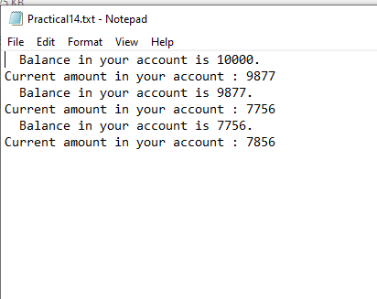  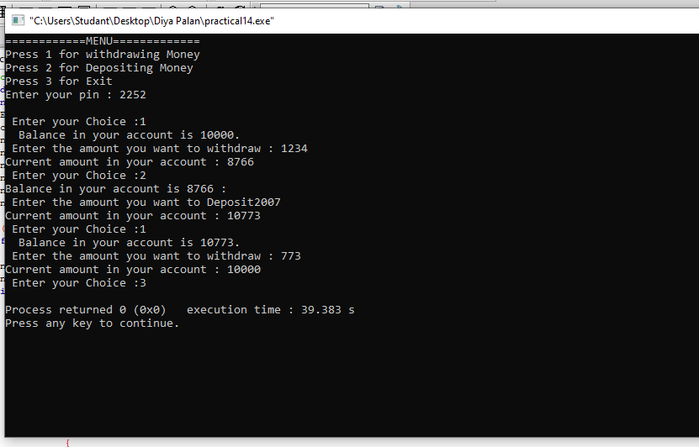

 | Practical:15
Aim: | Develop a countdown timer, that allows user to set a starting number of seconds and  then count down to zero, displaying each second as it decrements. After the  countdown completes write ‘Countdown completed!
Code: | //Dhruvi Mokani 25cs047  #include <stdio.h>  #include <unistd.h> // for sleep()  void main()  {  int time, ch;  x: // label for restarting the program  printf("Enter the Countdown time in seconds: ");  scanf("%d", &time); // input time from user  // validate time  if(time <= 0)  {  printf("Enter valid value\n");  goto x; // restart if invalid  }  else  {  // countdown loop from time to 0  for(int i = time; i >= 0; i--)  {  // print minutes : seconds format  printf("\n %d:%d", i/60, i%60);  sleep(1); // delay of 1 second  // when counter hits zero  if(i == 0)  {  printf("\n==== COUNTDOWN COMPLETED ====\n");  }  }  }  // menu after completion  printf("\nPress 1 to Start Again\n");  printf("Press 2 to Exit\n");  scanf("%d", &ch);  switch(ch)  {  case 1: goto x; // restart  case 2: exit(0); // exit program  default:  printf("Invalid choice\n");  goto x;  }  }
Output: | 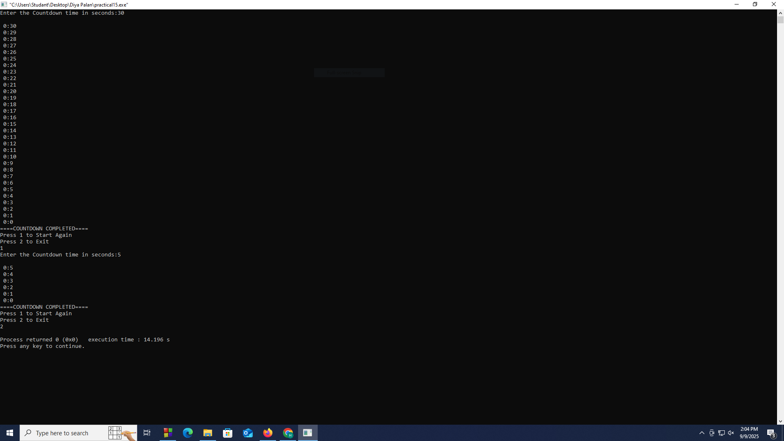

 | Practical:16
Aim: | Develop a C program that simulates a matchstick game between the user and the  computer. The objective of the game is to avoid picking the last matchstick. The  program should ensure that the computer always wins by strategically picking  matchsticks. The game starts with 21 matchsticks. The user and the computer take  turns to pick 1, 2, 3, or 4 matchsticks. The player forced to pick the last matchstick  loses the game.  Rules:  1. The game starts with 21 matchsticks.  2. The user is asked to pick 1, 2, 3, or 4 matchsticks.  3. After the user picks, the computer makes its pick.  4. The player who is forced to pick the last matchstick loses the game
Code: | //Dhruvi Mokani 25cs047  #include<stdio.h>  #include<time.h>  void main()  {  int matchstick,user,com,ch,comcount,usercount;  comcount=0;usercount=0;  char start;  x: // Label for restarting the game  matchstick=21; //Total Matchsticks  printf("Total Matchsticks=%d",matchstick);  printf("\nYou want to start first??:(y/n):"); //Asking if user wants to start first  scanf(" %c",&start);  for(int i=0;i<21;i++)  {  if(start=='y')  {  if(matchstick==1)  {  printf("\nUser loose the game\nComputer Wins!!");  comcount++;  break;  }else{  printf("\nEnter No. of Matchsticks you want to pick(1-4):");  scanf("%d",&user);  if(user>4)  {  printf("Choose Between 1 to 4");  exit(0);  }  else  {  matchstick=matchstick-user; //Subtract user's pick from total  printf("\nRemaining Matchstick:%d",matchstick);  }  com=rand()%4+1;  printf("\nComputer Picks %d Matchstick",com);  if(matchstick==com)  {  printf("\nComputer loose the game\nUser Wins.");  usercount++;  break;  }  else  {  matchstick=matchstick-com; //Subtract com's pick from total  printf("\nRemaining Matchstick:%d",matchstick);  }  else if(start=='n')  {  com=rand()%4+1;  printf("\nComputer Picks %d Matchstick",com);  if(matchstick==com)  {  printf("\nComputer loose the game\nUser Wins.");  usercount++;  break;  }  matchstick=matchstick-com;  printf("\nRemaining Matchstick:%d",matchstick);  if(matchstick==1)  {  printf("\nUser loose the game\nComputer Wins!!");  comcount++;  break;  }  else{  printf("\nEnter No. of Matchsticks you want to pick(1-4):");  scanf("%d",&user);  if(user>4)  {  printf("Choose Between 1 to 4");  exit(0);  }  else  matchstick=matchstick-user;  printf("\nRemaining Matchstick:%d",matchstick);  }  }  printf("\nDo you want to play again(1 for yes/2 for no):");  scanf("%d",&ch);  if(ch==1)  {  goto x;  }  else if(ch==2)  {  Printf(“User Wins=%d”usercount);  Printf(“computer Wins=%d”comcount);  Exit(0);  }  Else  {  Exit(0);  }  }
Output: | 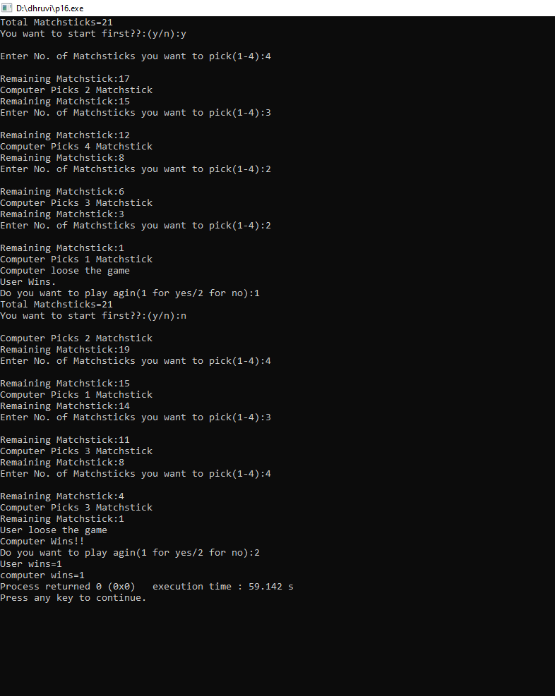

 | Practical:17
Aim: | The National Sports Federation has developed an app to track a runner’s distance  during a marathon.  The runner starts from 0 km and covers 0.5 km every minute.  The app needs to display the distance covered at each minute until the runner  completes a total distance of 10 km.  Write a program to simulate the distance tracking.  Note: Use an infinite while loop with a break statement to stop tracking after the  runner has completed the marathon.  Expected sample outcome:  Minute 1: Distance covered = 0.5 km  Minute 2: Distance covered = 1.0 km  ...  Minute 20: Distance covered = 10.0 km  Marathon complete!
Code: | //Dhruvi Mokani 25cs047  #include<stdio.h>  void main()  {  float run, per, i, km;  printf("Enter the distance u want to run (in km) :");  scanf("%f", &run); // take total distance to run  printf("Enter the km u want run in one min :");  scanf("%f", &per); // take speed per minute  for(i = 1; i <= run/per; i++) // loop for each minute  {  km = km + per; // update distance covered  printf("Minute : %.2f", i); // print minute number  printf("\tDistance covered is %.2f", km); // print distance  printf("\n");  if(km == run) // check if marathon completed  {  printf("===========MARATHON COMPLETED===========");  }  else  continue; // continue loop if not completed  }  }
Output: | 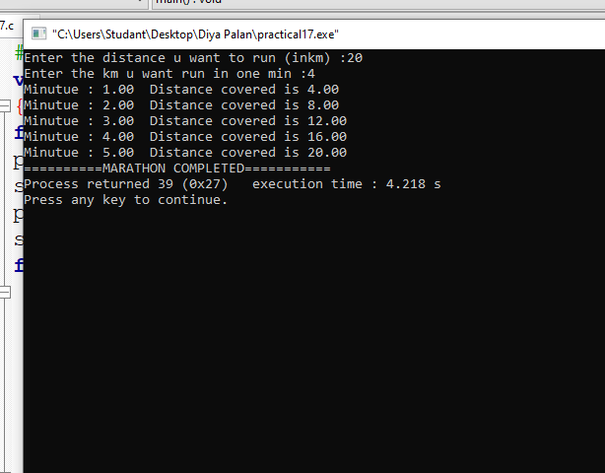

 | Practical:18
Aim: | Write a C program to generate and display a multiplication table based on user input  in the following form:  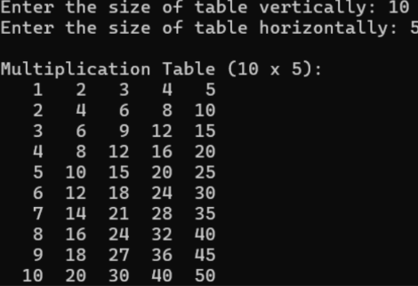
Code: | //Dhruvi Mokani 25cs047  #include<stdio.h>  void main()  {  int v, h, i, j;  x: printf("Enter the size of table vertically :");  scanf("%d", &v); // take vertical size  printf("Enter the size of table horizontally :");  scanf("%d", &h); // take horizontal size  if (v < 0 || h < 0) // check for invalid input  {  printf("Enter valid input");  goto x; // go back to re-enter  }  else  {  for(i = 1; i <= v; i++) // loop for vertical rows  {  for(j = 1; j <= h; j++) // loop for horizontal columns  {  printf("%d\t", i * j); // print table value  }  printf("\n"); // new row  }  printf("========REVERSE TABLE========\n");  for(i = v; i >= 1; i--) // reverse vertical loop  {  for(j = h; j >= 1; j--) // reverse horizontal loop  {  printf("%d\t", i * j); // print reverse table value  }  printf("\n");  }  }  }
Output: | 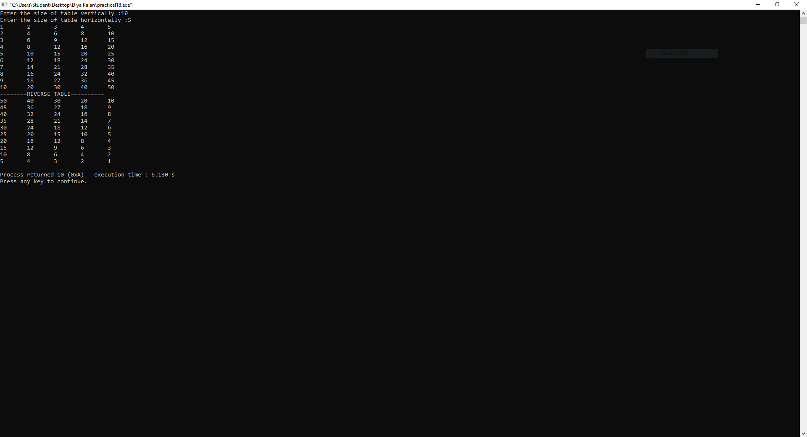

 | Practical:19
Aim: | 19. Use appropriate nested loops to draw the following patterns: 4 CO2  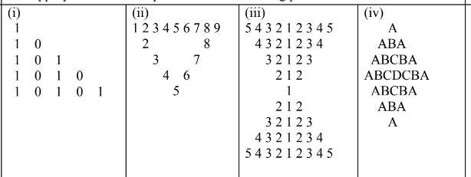
Code: | //Dhruvi Mokani 25cs047  //Code for (i)  #include<stdio.h>  void main()  {  int i, j, rows = 4; // variable & row size  for(i = 0; i <= rows; i++) // loop for each row  {  for(j = 0; j < rows - i; j++) // print leading spaces  {  printf(" ");  }  for(j = rows - i; j <= rows; j++) // print pattern values  {  if(j % 2 == 0) // check even position  {  printf("1 "); // print 1 for even  }  else  {  printf("0 "); // print 0 for odd  }  }  printf("\n"); // move to next line  }  }  // Code for (ii)  #include<stdio.h>  void main()  {  int i, j; // loop variables  for(i = 1; i <= 6; i++) // outer loop for rows  {  for(j = 1; j < 10; j++) // inner loop for columns  {  if(i == 1) // first row (print all numbers)  {  printf("%d\t", j);  }  else if((i == j) || j == 10 - i) // diagonal conditions  {  printf("%d\t", j); // print number at diagonal  }  else  {  printf("\t"); // print empty space  }  }  printf("\n"); // move to next line  }  }  // Code for (iii)  #include<stdio.h>  void main()  {  int i, j, n = 5; // n is the highest number  // upper part  for(i = n; i >= 1; i--) // loop from 5 to 1  {  for(j = i; j >= 1; j--) // left decreasing part  {  printf("%d ", j);  }  for(j = 2; j <= i; j++) // right increasing part  {  printf("%d ", j);  }  printf("\n"); // next line  }  // lower part  for(i = 2; i <= n; i++) // loop from 2 to 5  {  for(j = i; j >= 1; j--) // left decreasing part  {  printf("%d ", j);  }  for(j = 2; j <= i; j++) // right increasing part  {  printf("%d ", j);  }  printf("\n"); // next line  }  }  //Code for (iv)  #include <stdio.h>  int main() {  int n = 4; // height  // upper part  for(int i = 1; i <= n; i++) {  char ch = 'A';  // left side  for(int j = 1; j <= i; j++) {  printf("%c", ch);  ch++;  }  ch -= 2; // step back  // right side  for(int j = 1; j < i; j++) {  printf("%c", ch);  ch--;  }  printf("\n");  }  // lower part  for(int i = n-1; i >= 1; i--) {  char ch = 'A';  // left  for(int j = 1; j <= i; j++) {  printf("%c", ch);  ch++;  }  ch -= 2;  // right  for(int j = 1; j < i; j++) {  printf("%c", ch);  ch--;  }  printf("\n");  }  return 0;  }
Output: | (i)  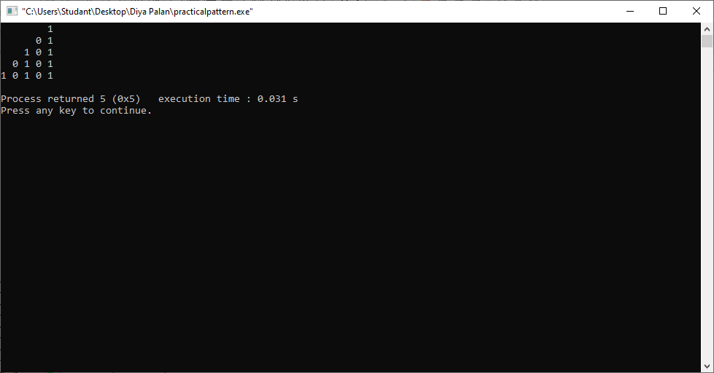  (ii)  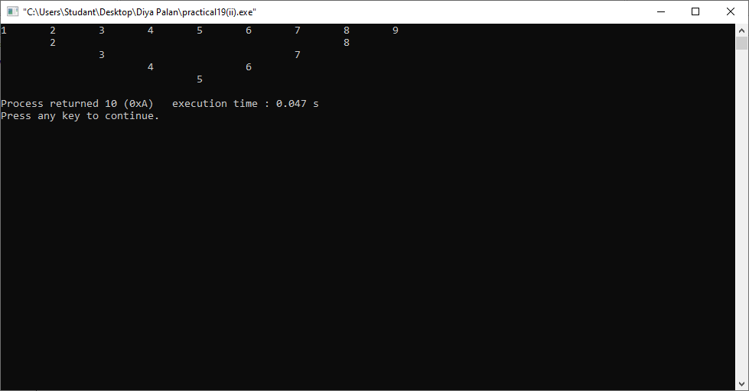  (iii)  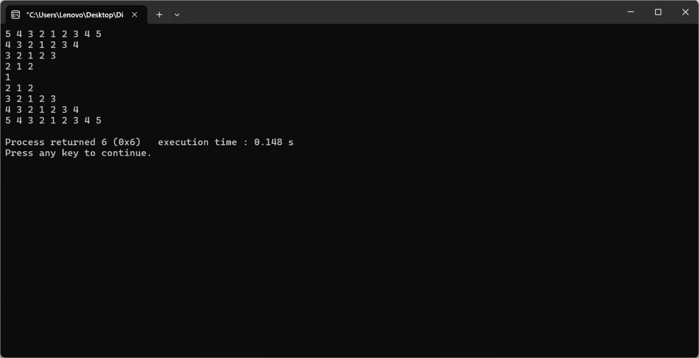  (iv)  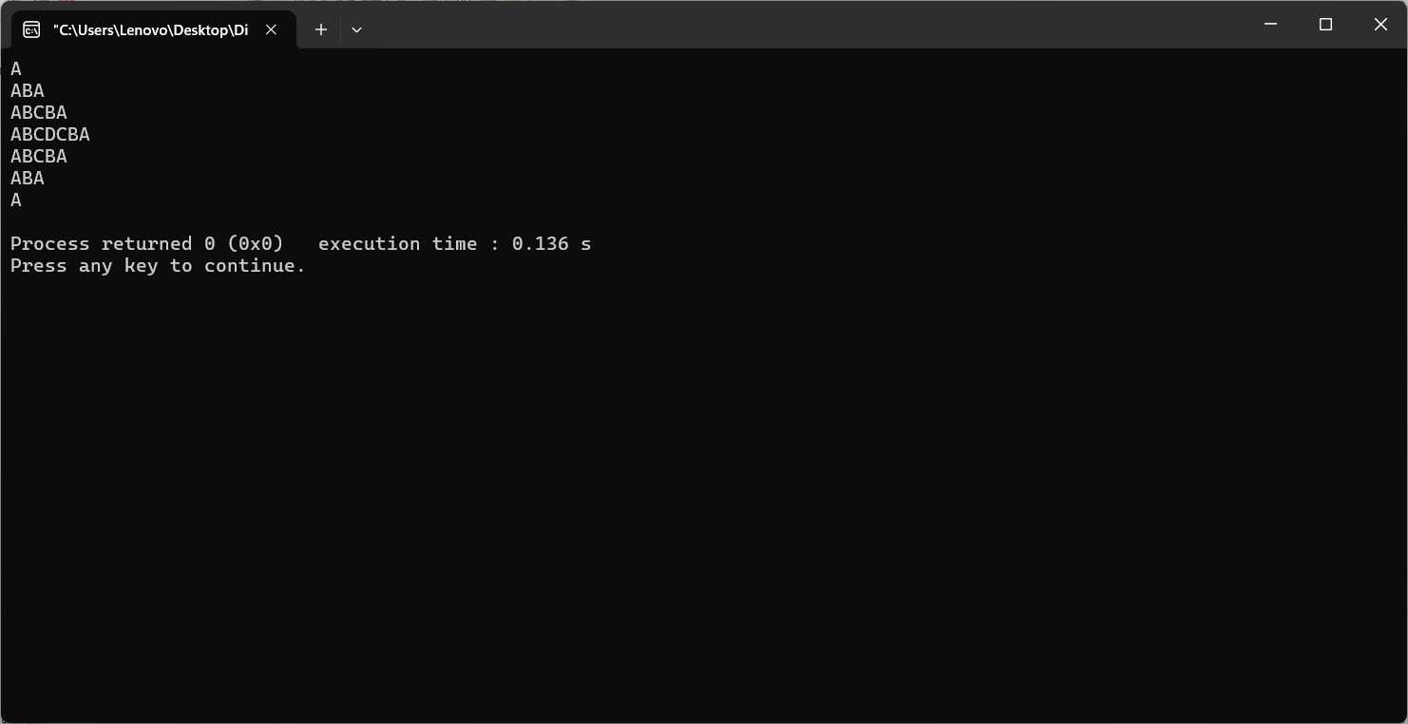

 | Practical:20
Aim: | You are a security officer responsible for tracking attendance at an exclusive  workshop with N participants. At the end of the event, you have a list of N-1 unique  participant IDs representing those who attended. However, one participant ID is  missing from the list.  Your task is to identify the missing participant ID from the range of IDs, which goes  sequentially from 1 to N, to ensure accurate records.
Code: | //Dhruvi Mokani 25cs047  #include <stdio.h>  void main()  {  int i, j, n;  // Input size of array  printf("Enter size of array: ");  scanf("%d", &n);  int a[n];  // Input n IDs  printf("Enter %d IDs:\n", n);  for(i = 0; i < n; i++)  {  printf("ID at index %d: ", i);  scanf("%d", &a[i]);  }  // Find missing ID (checks if consecutive numbers are not 1 apart)  for(i = 0; i < n - 1; i++)  {  if(a[i+1] - a[i] != 1 && a[i+1] - a[i] != 0)  {  printf("Missing ID is %d\n", a[i] + 1);  }  }  // Find repeated IDs  for(i = 0; i < n; i++)  {  for(j = i + 1; j < n; j++)  {  if(a[i] == a[j])  {  printf("%d is a repeated ID\n", a[i]);  }  }  }  }
Output: | 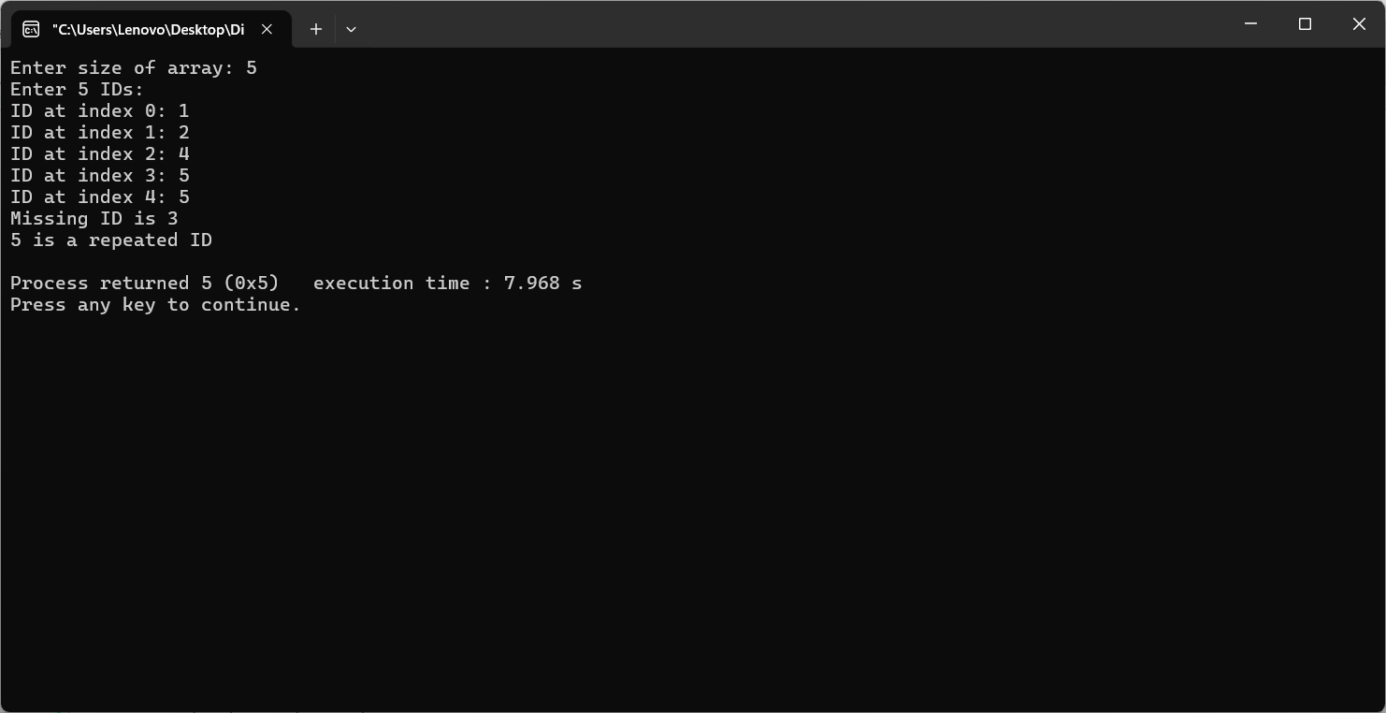

 | Practical:21
Aim: | In many real-world settings, such as government offices, banks, or survey agencies, data entry operators often input numerical data into systems manually. To aid in quick analysis and validation of input data, you are tasked with developing a C-based console application that assists operators in understanding the nature of the numbers they enter.  The system should allow the operator to input exactly 25 integers through the keyboard. Once all the numbers are entered, the program should process the data and display the following statistics:  - Total number of positive numbers  - Total number of negative numbers  - Total number of even numbers  - Total number of odd numbers  This program will help data entry staff and analysts to quickly interpret trends, check for errors (e.g., unexpected negative values), and prepare data for further processing or reporting
Code: | #include <stdio.h>  void main()  {  printf("Dhruvi Mokani\t25CS047\n");  int n;  printf("Enter Array Size:");  scanf("%d", &n);  int arr[n], positive, negative, odd, even, zero;  int positiveno[n], negativeno[n], oddno[n], evenno[n];  //all these variable is for count which will use as counter  zero = 0;  positive = 0;  negative = 0;  odd = 0;  even = 0;  //Enter Array Elements  printf("Enter array Elements:\n");  for (int i = 0; i < n; i++)  {  scanf("%d", &arr[i]);  }  //Using for loop for n array elements  for (int i = 0; i < n; i++)  {  if (arr[i] == 0)  {  zero++;  }  else if (arr[i] > 0)  {  positiveno[positive++] = arr[i];  }  else if (arr[i] < 0)  {  negativeno[negative++] = arr[i];  }  if (arr[i] % 2 == 0)  {  evenno[even++] = arr[i];  }  else  {  oddno[odd++] = arr[i];  }  }  //to print total output  printf("\nTotal Zeros: %d", zero);  printf("\nTotal Positive Numbers: %d", positive);  printf("\nTotal Negative Numbers: %d", negative);  printf("\nTotal Odd Numbers: %d", odd);  printf("\nTotal Even Numbers: %d\n", even);  //to print all the elements in output  printf("\nPositive Numbers:");  for (int i = 0; i < positive; i++)  {  printf("%d\n", positiveno[i]);  }  printf("\nNegative Numbers:");  for (int i = 0; i < negative; i++)  {  printf("%d\n", negativeno[i]);  }  printf("\nOdd Numbers:");  for (int i = 0; i < odd; i++)  {  printf("%d\n", oddno[i]);  }  printf("\nEven Numbers:");  for (int i = 0; i < even; i++)  {  printf("%d\n", evenno[i]);  }  }
Output: | 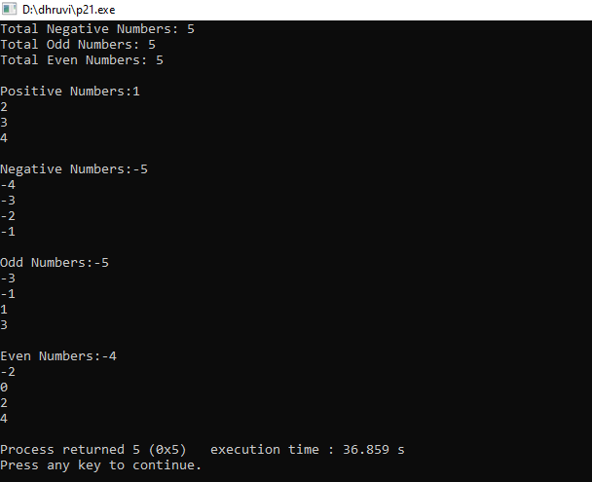

 | Practical:22
Aim: | Display the seating arrangement in theatre using C program. The theater has a fixed number of rows and seats per row. Create a seating chart where each seat is identified by its row and seat number. Additionally, the program should allow the user to mark certain seats as reserved. The seating chart should be displayed with indicators showing which seats are reserved and which are available.  Expected Outcome:  Enter the number of reserved seats: 3  Enter row and seat number for reserved seat 1 (e.g., 2 5): 1 3  Enter row and seat number for reserved seat 2 (e.g., 2 5): 2 5  Enter row and seat number for reserved seat 3 (e.g., 2 5): 3 7  Seating Chart:  Row 1: 0 X 0 0 0 0 0 0  Row 2: 0 0 0 0 X 0 0 0  Row 3: 0 0 0 0 0 0 X 0  Row 4: 0 0 0 0 0 0 0 0  Row 5: 0 0 0 0 0 0 0 0
Code: | //Dhruvi Mokani 25CS047  #include<stdio.h>  void main()  {  int rows, cols, resseats;  //Enter Cols and Rows  printf("Enter Rows:\n");  scanf("%d", &rows);  printf("\nEnter Cols:\n");  scanf("%d", &cols);  //declaring an array named theater  int theater[rows][cols];  //taking thearter array as 0  for (int i = 0; i < rows; i++)  {  for (int j = 0; j < cols; j++)  {  theater[i][j] = 0;  }  }  //to print theatre array  for (int i = 0; i < rows; i++)  {  for (int j = 0; j < cols; j++)  {  printf("%d\t", theater[i][j]);  }  printf("\n");  }  printf("\nEnter the number of reserved seats:");  scanf("%d", &resseats);  int x, c;  //to enter reserved seats  for (int i = 0; i < resseats; i++)  {  printf("Enter Row and Seat No for Reserved Seat %d\n", i + 1);  scanf("%d", &x);  scanf("%d", &c);  theater[x - 1][c - 1] = 1;  }  //putting reserve seat numbers as reserved  for (int i = 0; i < rows; i++)  {  for (int j = 0; j < cols; j++)  {  if (theater[i][j] == theater[x - 1][c - 1])  {  printf("R\t");  }  else  {  printf("%d\t", theater[i][j]);  }  }  printf("\n");  }  }
Output: | 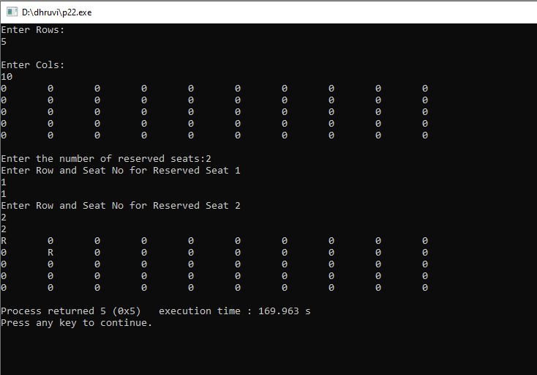

 | Practical:23
Aim: | You are managing a fruit stand at a local market. The market operates for several days, and you record the price of a specific fruit every day in an array, where prices[i] is the price of the fruit on the i-th day.  As a vendor, your goal is to maximize your profit by buying the fruit on one day and selling it on a later day when the price is higher. You can make only one transaction (buy one day, sell one day).  Write a program in C to determine the maximum profit you can achieve from this transaction. If no profit is possible (i.e., the fruit price only decreases or stays the same), return 0.
Code: | #include<stdio.h>  int main()  {  int n,i;  int minprofit=0, maxprofit=0, buyday=0, sellday=0;  int totalprofit=0;  int buyprice=0, sellprice=0;  // Asking number of days  printf("Enter days:\n");  scanf("%d",&n);  int a[n]; // array to store prices  // Taking price input  Printf(“Input Price:”);  for(i=0;i<n;i++)  {  scanf("%d",&a[i]);  }  minprofit=a[0]; // assume first day is minimum price  // Finding maximum single-transaction profit  for(i=1;i<n;i++)  {  // If selling today gives more profit  if(a[i]-minprofit > maxprofit)  {  maxprofit = a[i]-minprofit;  sellday = i; // record selling day  sellprice = a[i]; // selling price  }  // If today’s price is new minimum  else if(a[i] < minprofit)  {  minprofit = a[i];  buyday = i; // record buying day  buyprice = a[i]; // buying price  }  }  // Printing max profit result  if(maxprofit > 0)  {  printf("Buy on day %d (price=%d) sell on day %d(price=%d)",  buyday+1,buyprice, sellday+1, sellprice);  printf("\nMaximum profit = %d\n", maxprofit);  }  else  {  printf("No transaction is possible as the price keeps decreasing.");  printf(" Maximum profit = 0.");  }  // Detailed transaction (all profits)  printf("\nDetailed transaction:\n");  for(i=0;i<n-1;i++)  {  // If next day price is higher make profit  if(a[i+1] > a[i])  {  totalprofit += a[i+1] - a[i];  printf("Buy on day %d(price=%d) sell on day %d(price=%d)\n",  i+1, a[i], i+2, a[i+1]);  }  }  printf("Total profit after all transactions is %d", totalprofit);  return 0;  }
Output: | 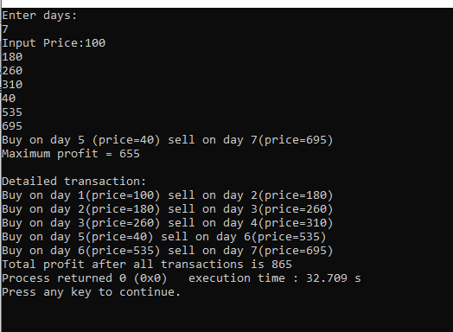

 | Practical:24
Aim: | Alex is a budding writer who loves jotting down creative ideas and thoughts. However, Alex prefers using simple, lightweight tools over complex software. Frustrated by the clutter of unnecessary features in modern note-taking apps, Alex decides to create a custom text-based note-taking program tailored to their needs. As a developer, you are tasked with helping Alex design this application. The program should allow Alex to manage notes and perform the following operations manually (without using built-in string manipulation functions from <string.h>):  - Calculate the Length: Alex wants to know the length of a specific note to meet character count requirements.  - Reverse a Note: Alex often enjoys viewing their notes in reverse order as a creative exercise.  - Compare Two Notes: Sometimes, Alex drafts multiple versions of the same idea and needs to compare them to identify similarities or differences.  - Copy a Note: Alex frequently copies notes to create variations or backup content.  - Concatenate Notes: When merging ideas, Alex needs to combine two notes into one seamlessly.  - Upper Case Converter: Often tries to convert whole note into upper case.  - Lower Case Converter: Often tries to convert whole note into lower case.  Capitalize each word: In whole note, tries to capitalize 1st character of each word.
Code: | #include<stdio.h>  void main()  {  printf("Dhruvi Mokani\t25CS047\n");  int i,length=0,count=0;  char str1[50];  char str2[50];  char revstr[50];  char copy[50];  //Enter two strings  printf("String 1:");  gets(str1);  printf("String 2:");  gets(str2);  printf("\n");  //for length  printf("Length : \n");  for(i=0;str1[i]!='\0';i++)  {  length++;  }  printf("The length of str1 : %d\n",length);  printf("\n");  //for reverse the string  printf("Reverse : \n");  for (i=length;i>=0;i--)  {  printf("%c",str1[i]);  }  printf("\n\n");  //for compare two strings  printf("Comparision : \n");  for(i=0;str1[i]!=0 && str2[i]!=0;i++)  {  if(str1[i]!=str2[i] || str1[i]=='\0' || str2[i]=='\0')  {  count++;  break;  }  }  if(count==0)  {  printf("str1 and str2 is same\n");  }  else  {  printf("str1 and str2 is not same\n");  }  printf("\n");  //for copy the string to another array  printf("Copy string : \n");  for(i=0;str1[i]!='\0';i++)  {  copy[i]=str1[i];  }  copy[i]='\0';  puts(copy);  printf("\n");  //for capitalize first alphatabet of string  printf("Capitalize : \n");  for(i=0;str1[i]!='\0';i++)  {  if(i==0)  {  if(str1[i]>='a' && str1[i]<='z')  {  str1[i]=str1[i]-32;  }  }  else if(str1[i-1]==' ')  {  if(str1[i]>='a' && str1[i]<='z')  {  str1[i]=str1[i]-32;  }  }  }  puts(str1);  printf("\n");  //to convert string in uppercase  printf("Upper Case : \n");  for(i=0;str1[i]!='\0';i++)  {  if(str1[i]>='a' && str1[i]<='z')  {  str1[i]=str1[i]-32;  }  }  puts(str1);  printf("\n");  //to convert string in lower case  printf("Lower Case :\n");  for(i=0;str2[i]!='\0';i++)  {  if(str2[i]>='A' && str2[i]<='Z')  {  str2[i]=str2[i]+32;  }  }  puts(str2);  printf("\n");  //to concatenate two strings  printf("concatenate : \n");  for(i=0;str1[i]!=0 && str2[i]!=0;i++)  {  str1[length+i]=str2[i];  }  puts(str1);  printf("\n");  }
Output: | 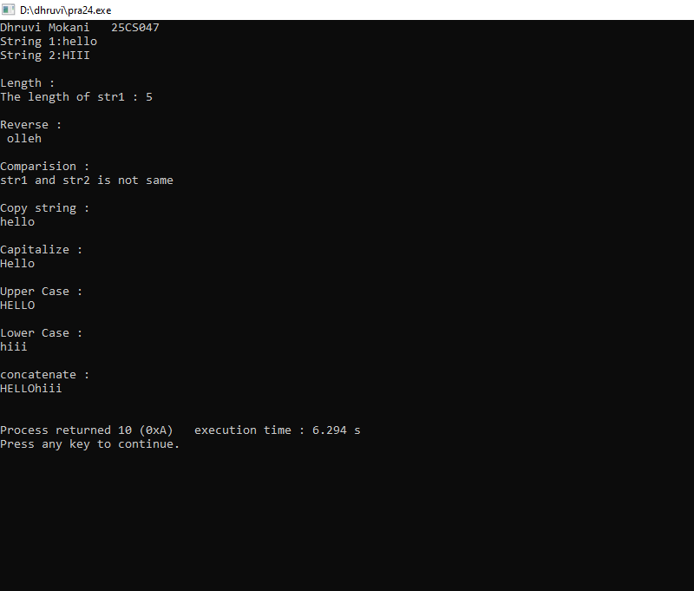

 | Practical:25
Aim: | A library manager wants to built a simple system to manage and track book related tasks as checking book avability updating inventory and calculate fines for overdue books. Different methods are required to address these operations.  Expected Output:  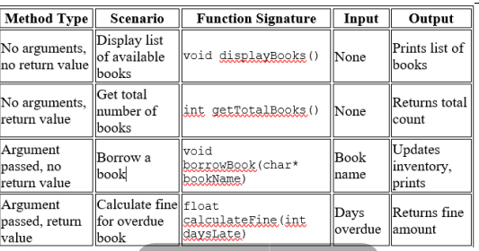
Code: | #include <stdio.h>  #include <string.h>  #define MAX_BOOKS 5  //Dhruvi Mokani 25cs047  // Global inventory  char books[MAX_BOOKS] [50]= {"Harry Potter", "C Programming","Data Structures","Ansi C”,“Too Good to be True”};  int bookAvailable[MAX_BOOKS] = {1, 1, 1, 1, 1}; // 1 = available, 0 = borrowed  // No arguments, no return value  void displayBooks() {  printf("\nAvailable Books:\n");  for (int i = 0; i < MAX_BOOKS; i++) {  if (bookAvailable[i] == 1)  printf("%d. %s\n", i + 1, books[i]);  }  }  // No arguments, returns value  int getTotalBooks() {  int count = 0;  for (int i = 0; i < MAX_BOOKS; i++) {  if (bookAvailable[i] == 1)  count++;  }  return count;  }  // Argument passed, no return value  void borrowBook(char* bookName) {  for (int i = 0; i < MAX_BOOKS; i++)  {  if (strcmp(books[i], bookName) == 0)  {  if (bookAvailable[i] == 1)  {  bookAvailable[i] = 0;  printf("\nYou borrowed: %s\n", bookName);  return;  } else {  printf("\nBook already borrowed.\n");  return;  }  }  }  printf("\nBook not found in library.\n");  }  // Argument passed, return value  float calculateFine(int daysLate) {  float finePerDay = 10; // ₹2 per day  return daysLate * finePerDay;  }  int main() {  printf("Library Management System\n");  displayBooks();  printf("\nTotal available books: %d\n", getTotalBooks());  borrowBook("Harry Potter");  printf("\nAfter borrowing:\n");  displayBooks();  int lateDays = 2;  printf("\nFine for %d days late: %.2f\n", lateDays, calculateFine(lateDays));  return 0;  }
Output: | 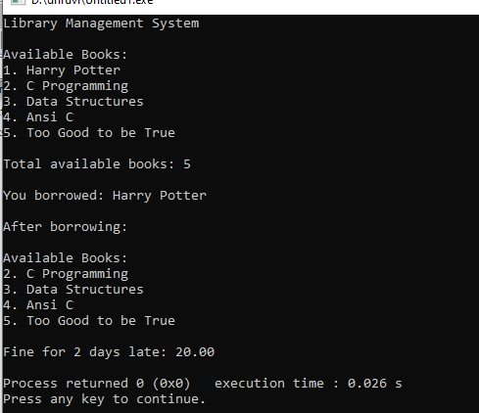

 | Practical:26
Aim: | An architect is designing a triangular garden for a residential project. To ensure the design is feasible and meets the space constraints, the architect needs to verify if the given lengths for the sides of the triangle can form a valid shape. If the sides form a valid triangle, the architect also wants to calculate its area to estimate the amount of turf or plants required.  You are tasked with creating a program to assist the architect. The program should use nested functions to:  - Input the side lengths: Allow the architect to input the lengths of the three sides of the proposed triangular garden.  - Validate the triangle: Check if the given lengths satisfy the triangle inequality theorem (sum of any two sides must be greater than the third side).  - Calculate the area using Heron's formula: If the sides form a valid triangle, compute its area using  - Heron's formula: Display the results: Inform the architect whether the sides form a valid triangle and, if valid, show the area of the triangle.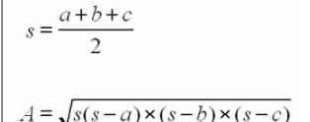
Code: | #include<stdio.h>  #include<math.h>  //Dhruvi Mokani 25CS047  int validity(int a,int b,int c);  float area(int a,int b,int c);  int main()  {  int a,b,c;  float result;  printf("\n Enter 1st side length of triangle : ");  scanf("%d",&a);  printf("\n Enter 2nd side length of triangle : ");  scanf("%d",&b);  printf("\n Enter 3rd side length of triangle : ");  scanf("%d",&c);  result=validity(a,b,c);  printf("\nThe area of triangle %.2f",result);  return 0;  }  int validity(int a,int b,int c)  {  if(a>=0 && b>=0 && c>=0)  {  if(a+b>c && b+c>a && c+a>b)  {  printf("\nValid Triangle : yes");  return area(a,b,c);  }  else  {  printf("Not valid triangle : The given lengths do not from a valid triangle.");  return 0;  }  }  else  {  printf("Not valid Triangle : Side lengths must be positive numbers");  return 0;  }  printf("\nName : Patel Pal ");  printf("\nID NO : 25CE084");  }  float area(int a,int b,int c)  {  float s,A;  s=(a+b+c)/2.0;  A=sqrt(s*(s-a)*(s-b)*(s-c));  return A;  }
Output: | 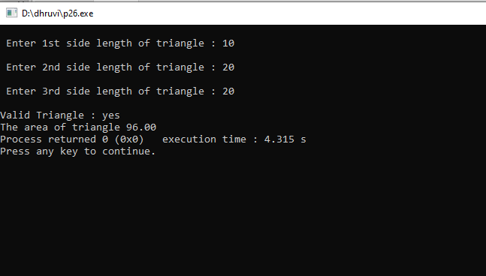

 | Practical:27
Aim: | A financial advisor is creating a tool to help clients plan their savings over a period of months. The advisor notices a common savings pattern where the amount saved in a given month is often influenced by the sum of the savings from the two previous months. This growth pattern is similar to the Fibonacci series.  The advisor wants a program that:  - Takes the number of months (n) as input from the user.  - Generates a series showing the savings amount for each month based on this pattern.  - Displays the series to help clients visualize how their savings might grow over time.  For simplicity, assume the savings for the first two months are fixed at ₹1 each.
Code: | #include <stdio.h>  // Recursive function to calculate savings (Fibonacci)  int saving(int month) {  // Base cases:Month 0=0 Month 1 and Month 2 savings = ₹1  if(month==0)  {  return 0;  }  if (month == 1 || month == 2) {  return 1;  }  // Recursive step: previous month + month before that  return saving(month - 1) + saving(month - 2);  }  void main() {  int n;  // Take number of months  printf("Enter number of months: ");  scanf("%d", &n);  // Validate input  if (n < 1) {  printf("Invalid input! n must be >= 1.\n");  }  printf("\nSavings Growth Series :\n");  // Display month-wise savings  for (int i = 0; i <= n; i++) {  printf("Month %d: %d\n", i, saving(i));  }  }
Output: | 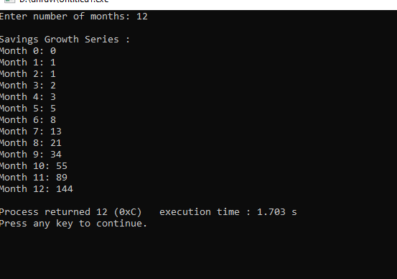

 | Practical:28
Aim: | A librarian at CHARUSAT wants a simple digital system to manage the details of individual books in the library. The librarian frequently needs to check and update information such as the book’s title, author, price, and whether it is currently issued or available.  To make this process efficient, you are tasked with creating a program that uses a union to represent the details of a book. The union will optimize memory usage by storing only the necessary details of a single book at a time.  The program should:  - Allow the librarian to enter details for a book, including its accession number, title, author name, price, and whether the book is currently issued (use a flag: 1 for issued, 0 for available).  - Display the entered book details in a readable format for verification.  This program will help the librarian quickly log and review book data, ensuring smooth library operations while conserving memory.
Code: | #include<stdio.h>  #include<string.h>  //Dhruvi Mokani 25cs047  //we can use structure behalf of union here by just using struct keyword  //difference between structure and union is given in the output.  // Union to store book details  union library  {  char title[50];  char author[50];  float price;  int issue;  }a[50];  void main()  {  int i;  // Loop to take input for 2 books  for(int i = 1; i < 3; i++)  {  // Taking book title  printf("\nEnter Book %d Title: ", i);  fgets(a[i].title, sizeof(a[i].title), stdin);  // Taking author name  printf("\nEnter Book %d Author: ", i);  fgets(a[i].author, sizeof(a[i].author), stdin);  // Taking price of the book  printf("\nEnter Book %d Price: ", i);  scanf("%f", &a[i].price);  // Taking issue status: 1 = issued, 0 = not issued  printf("\nEnter Book %d is issued (1 for yes / 0 for no): ", i);  scanf("%d", &a[i].issue);  fflush(stdin);  }  // Loop to display stored book details  for(int i = 1; i < 3; i++)  {  printf("\nName of the book: %s", a[i].title);  printf("Author of the book: %s", a[i].author);  printf("Price of the book: %.2f\n", a[i].price);  // Checking issue status  if(a[i].issue == 1)  {  printf("Book is issued\n");  }  else  {  printf("Book is not issued\n");  }  }  }
Output: | Structure Output:  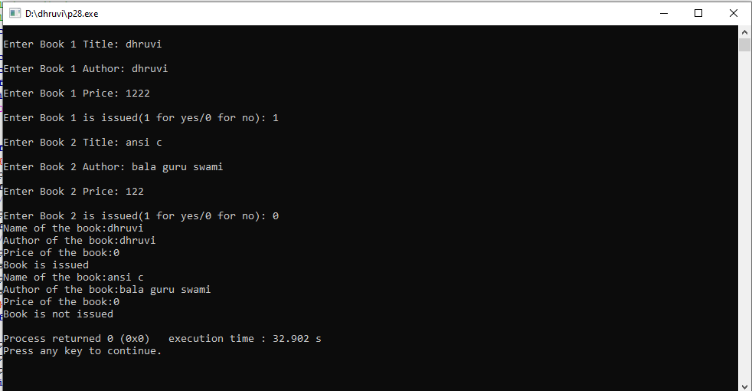  Differnce between structure and union is that Structure stores all members at the same time, whereas Union stores only one member at a time using shared memory.  Union Output:  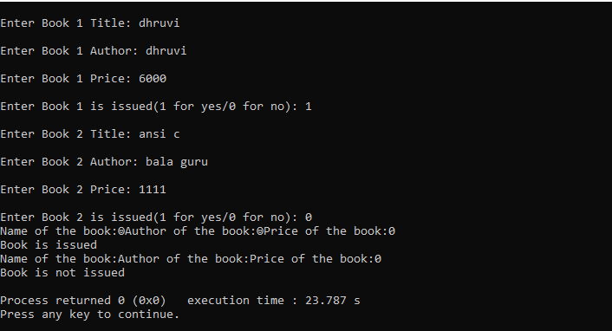

 | Practical:29
Aim: | At CHARUSAT, the university is organizing an inter-college sports competition and needs an efficient system to manage its sports teams. Each team represents a specific sport (e.g., basketball, football) and is led by a dedicated coach. The sports coordinator wants a program that will help maintain team and coach information in an organized manner.  The system should:  ● Store Details: Keep a record of multiple sports teams, including the team’s name, sport type, and coach information.  ● Manage Coach Data: Maintain detailed information about each coach, such as their name, age, and years of experience.  ● Allow Operations: Provide options to add new teams, search for a specific team, and display all stored teams and coach details.  To achieve this, use a nested structure in C programming, where the team structure includes a sub-structure for coach information.
Code: | #include <stdio.h>  #include <string.h>  struct Coach {  char name[50];  int age;  int experience;  };  struct Team {  char team_name[50];  char sport_type[30];  struct Coach coach;  };  struct Team teams[10];  int team_count = 0;  void addTeam() {  printf("Enter Team Name: ");  scanf(" %[^\n]", teams[team_count].team_name);  printf("Enter Sport: ");  scanf(" %[^\n]", teams[team_count].sport_type);  printf("Enter Coach Name: ");  scanf(" %[^\n]", teams[team_count].coach.name);  printf("Enter Coach Age: ");  scanf("%d", &teams[team_count].coach.age);  printf("Enter Coach Experience: ");  scanf("%d", &teams[team_count].coach.experience);  team_count++;  printf("Team added!\n");  }  void searchTeam() {  char name[50];  printf("Enter team name: ");  scanf(" %[^\n]", name);  for(int i=0; i<team_count; i++) {  if(strcmp(teams[i].team_name, name) == 0) {  printf("Team: %s\nSport: %s\nCoach: %s, Age: %d, Exp: %d years\n",  teams[i].team_name, teams[i].sport_type,  teams[i].coach.name, teams[i].coach.age, teams[i].coach.experience);  return;  }  }  printf("Team not found!\n");  }  void displayAll() {  for(int i=0; i<team_count; i++) {  printf("\nTeam %d: %s (%s)\nCoach: %s, %d years, %d years exp\n",  i+1, teams[i].team_name, teams[i].sport_type,  teams[i].coach.name, teams[i].coach.age, teams[i].coach.experience);  }  }  int main() {  int choice;  while(1) {  printf("\n1.Add Team\n2.Search Team\n3.Show All\n4.Exit\nChoice: ");  scanf("%d", &choice);  switch(choice) {  case 1: addTeam(); break;  case 2: searchTeam(); break;  case 3: displayAll(); break;  case 4: return 0;  default: printf("Invalid choice!\n");  }  }  }
Output: | 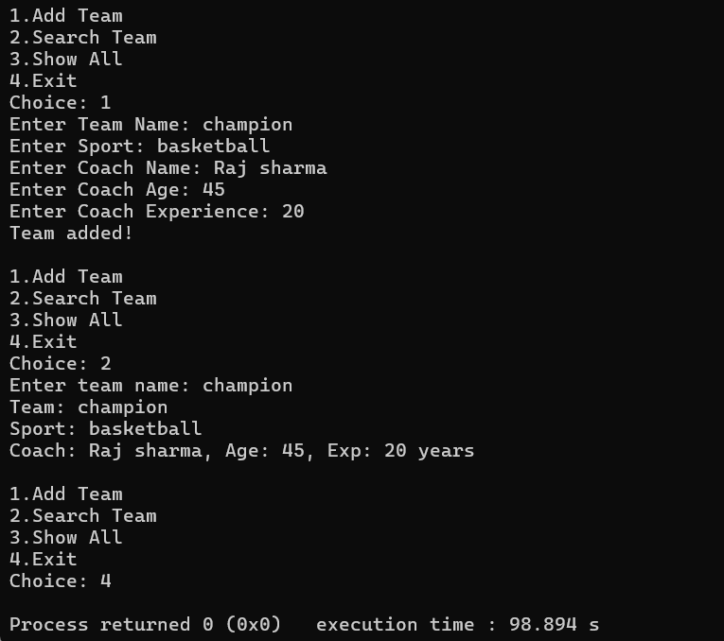

 | Practical:30
Aim: | A grocery store manager wants to analyze pricing trends in the inventory. You are tasked with developing a C program to assist with this task using pointers. The program should allow the manager to:  - Input the number of items in the inventory.  - Provide the prices of these items in an unordered manner.  - Sort the prices in ascending order using pointer arithmetic.  - Display the sorted prices for review.  Test the created system by applying the following test cases: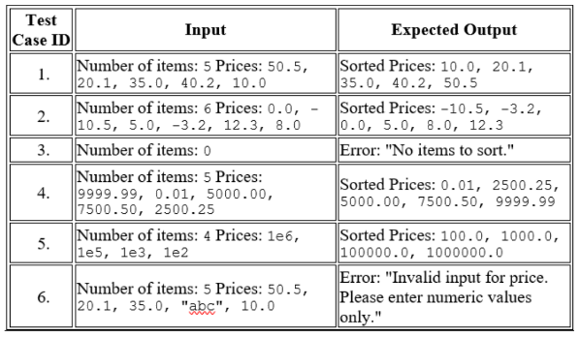
Code: | #include<stdio.h>  //Dhruvi Mokani 25cs047  int main()  {  float a[20],*p,tem;  int i,n,j,flag=0;  p=a;  printf("\nEnter the number of iteams in an unordered manner : ");  scanf("%d",&n);  for(i=0;i<n;i++)  {  printf("Price of iteam %d is ",i+1);  scanf("%f",(p+i));  }  for(i=0;i<n;i++)  {  if(*(p+i)>=0)  {  for(j=i+1;j<n;j++)  {  if(*(p+j)>=0)  {  if(*(p+i)>*(p+j))  {  tem=*(p+i);  *(p+i)=*(p+j);  *(p+j)=tem;  flag=1;  }  }  }  }  else  {  printf("Please Enter Positive Number");  }  }  if(flag==1)  {  printf("\nsorting order : ");  for(i=0;i<n;i++)  {  printf("\n%.2f",*(p+i));  }  }  return 0;  }
Output: | 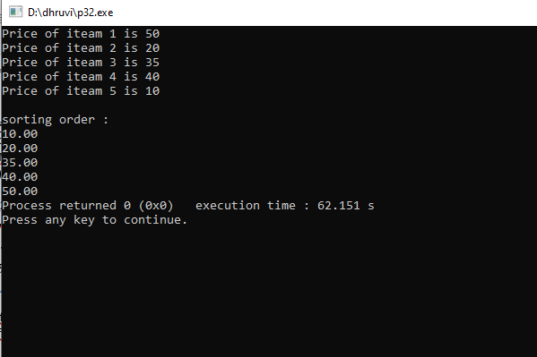

 | Practical:31
Aim: | A content manager at a digital publishing platform is tasked with creating and editing article summaries. Initially, they allocate memory to store a short summary of the article. However, as they expand the article description, the system must dynamically adjust the memory allocation to accommodate the longer text.  - Use calloc() to allocate memory for an initial short string (e.g., a brief article summary).  - Allow the user to input and store the initial string.  - Use realloc() to dynamically expand the memory allocation when the user wants to modify the string and store a larger summary.  - Display the updated string after reallocation.  This program ensures efficient memory usage while allowing flexibility for dynamic text editing.
Code: | #include <stdio.h>  #include <stdlib.h>  int main() {  char *summary;  printf(“25CS047\n”);  // Allocate memory for short summary  summary = (char*)calloc(50, sizeof(char));  printf("Enter short summary: ");  fgets(summary, 50, stdin);  printf("\nYour short summary: %s", summary);  // Expand memory for longer summary  printf("\nNow enter longer summary: ");  // Reallocate more memory  summary = (char*)realloc(summary, 200);  // Clear input and get new summary  fgets(summary, 200, stdin);  // Show final result  printf("\nYour final summary: %s", summary);  // Free memory  free(summary);  return 0;  }
Output: | 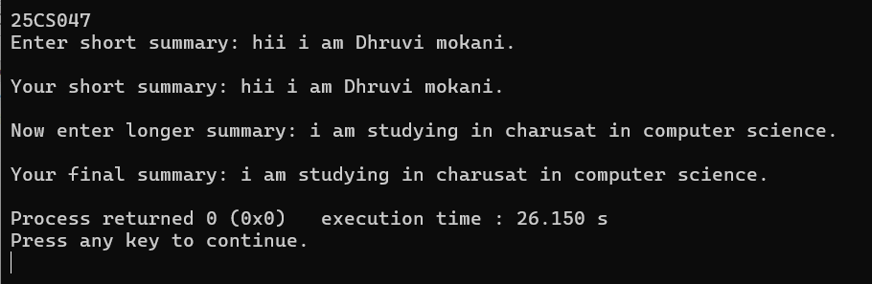

 | Practical:32
Aim: | A student at CHARUSAT is working on a creative writing project and needs a tool to analyze their text by reversing every word in a document. This process can help them explore unique word patterns and enhance their understanding of text structure.  You are tasked with creating a program that:  ● Reads the content of a file named Demo.txt, which contains text input from the student.  ● Reverses each word in the file while maintaining the original sequence of the words.  ● Displays the reversed words to the user for review.
Code: | #include<stdio.h>  //Dhruvi Mokani 25cs047  int main()  {  FILE *f1;  char p[100],c;  int size;  f1=fopen("dhruvi.txt","w"); //open file  fprintf(f1,"Hello");  fclose(f1); //close file  f1=fopen("dhruvi.txt","r");  fseek(f1,-1,2); //move the file pointer to a specific location in a file.  size=ftell(f1); //know the current position of the file pointer.  while(size>=0)  {  c=getc(f1);  printf("%c",c);  fseek(f1,-2,1);  size--;  }  fclose(f1);  printf("\n");  return 0;  }
Output: | 