COMPARISON OF FLSM AND VLSM
Cisco Packet Tracer Networking Assignment

1. Aim
To design and compare Fixed Length Subnet Masking (FLSM) and Variable Length Subnet Masking (VLSM) for five departments requiring 70, 35, 18, 9 and 5 hosts, and to compare address utilisation and observed ping performance.

2. Network Requirements
Department | Required hosts
Department 1 | 70
Department 2 | 35
Department 3 | 18
Department 4 | 9
Department 5 | 5

3. FLSM Address Allocation
In FLSM, every department receives the same subnet size. The largest department requires 70 hosts, so a /25 subnet (255.255.255.128) is used for every department. Each /25 contains 128 total addresses and 126 usable host addresses.
Department | Network / Prefix | Usable host range | Broadcast | Usable hosts
1 | 192.168.0.0/25 | 192.168.0.1–126 | 192.168.0.127 | 126
2 | 192.168.0.128/25 | 192.168.0.129–254 | 192.168.0.255 | 126
3 | 192.168.1.0/25 | 192.168.1.1–126 | 192.168.1.127 | 126
4 | 192.168.1.128/25 | 192.168.1.129–254 | 192.168.1.255 | 126
5 | 192.168.2.0/25 | 192.168.2.1–126 | 192.168.2.127 | 126
Theoretical parent block for this table: 192.168.0.0/22. The Packet Tracer FLSM ping screenshot shows PC1 testing 192.168.2.2.

4. VLSM Address Allocation
In VLSM, each department receives the smallest subnet that supports its host requirement. The following is a compact example allocation within 192.168.0.0/24.
Department | Network / Prefix | Usable host range | Broadcast | Usable hosts
1 (70 hosts) | 192.168.0.0/25 | 192.168.0.1–126 | 192.168.0.127 | 126
2 (35 hosts) | 192.168.0.128/26 | 192.168.0.129–190 | 192.168.0.191 | 62
3 (18 hosts) | 192.168.0.192/27 | 192.168.0.193–222 | 192.168.0.223 | 30
4 (9 hosts) | 192.168.0.224/28 | 192.168.0.225–238 | 192.168.0.239 | 14
5 (5 hosts) | 192.168.0.240/29 | 192.168.0.241–246 | 192.168.0.247 | 6
Important: the VLSM Packet Tracer screenshot provided shows a ping to 10.0.1.242. Therefore, use the network addresses from your saved Packet Tracer VLSM file if they differ from the example allocation table above. The prefix sizes and address utilisation calculations remain the same.

5. Address Utilisation Comparison
Metric | FLSM | VLSM | Comparison
Subnet prefixes | /25 for all | /25, /26, /27, /28, /29 | VLSM varies subnet size
Total allocated addresses | 640 | 248 | 392 fewer with VLSM
Usable host addresses | 630 | 238 | VLSM has less unused capacity
Required hosts | 137 | 137 | Same requirements
Unused usable capacity | 493 | 101 | 392 fewer unused usable addresses
Allocated address-space reduction | — | 61.25% | 392 ÷ 640 × 100
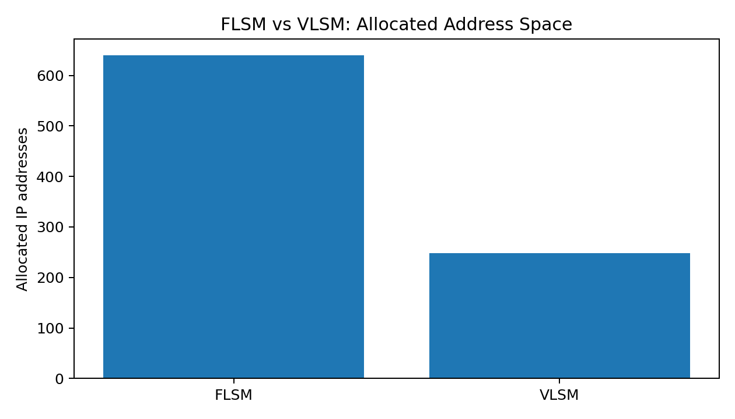
Observation: VLSM allocates 248 addresses compared with 640 for FLSM, saving 392 addresses (61.25%).

6. Network Performance Measurements
Three ping commands were run from PC1 to a destination PC in each configuration. The values below are transcribed from the supplied Packet Tracer screenshots.
Method | Run | Sent | Received | Packet loss
FLSM | 1 | 4 | 3 | 25%
FLSM | 2 | 4 | 4 | 0%
FLSM | 3 | 4 | 4 | 0%
VLSM | 1 | 4 | 3 | 25%
VLSM | 2 | 4 | 4 | 0%
VLSM | 3 | 4 | 4 | 0%
Combined results for each method: 12 packets sent, 11 received and 1 lost. Overall packet loss = (1 ÷ 12) × 100 = 8.33%. Packet Tracer displayed minimum, maximum and average round-trip times of 0 ms in both configurations, while individual replies were shown as time<1ms.
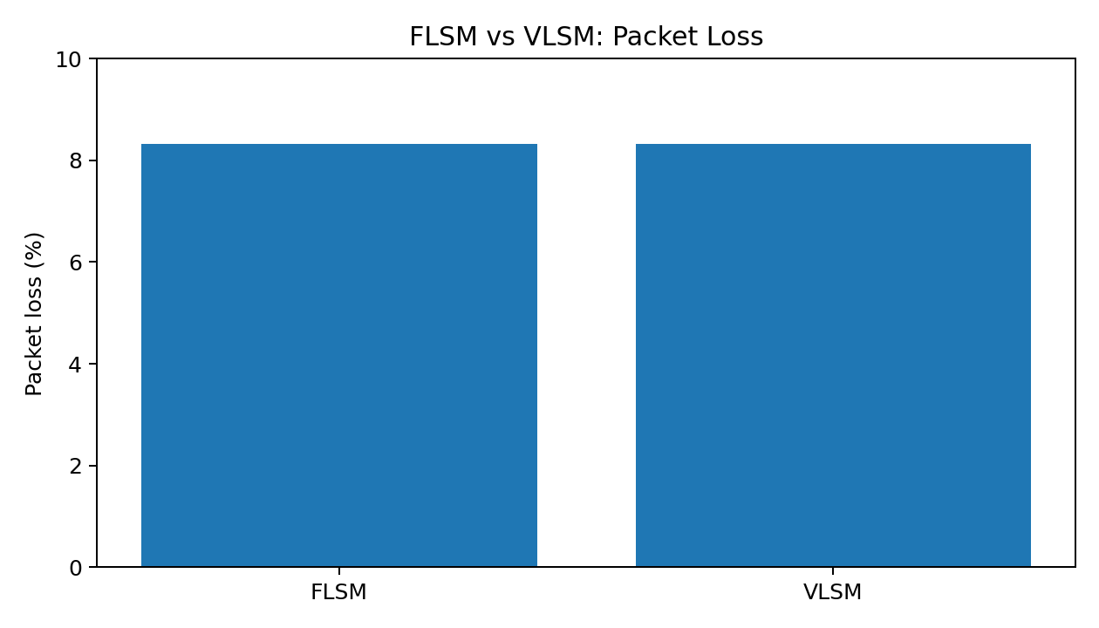
Observation: both methods produced the same results in these tests. The first ping in each set timed out, while the next two ping commands succeeded completely. These measurements do not demonstrate a difference in packet loss or displayed RTT.

7. Conclusion
The experiment shows that VLSM is more efficient in address allocation for the given five departments. FLSM allocates 640 addresses, while VLSM allocates 248, saving 392 addresses or 61.25%. In the ping tests, both configurations had 11 successful replies out of 12 packets and a displayed average RTT of 0 ms. Thus, the collected tests show improved address utilisation with VLSM, but do not show a measurable network-performance difference.
s

