Department-wise FLSM vs VLSM Graphs
These graphs compare the five departments' requested host counts with their allocated IPv4 block sizes. FLSM assigns a /25 block (128 total addresses) to each department. VLSM assigns /25, /26, /27, /28, and /29 blocks (128, 64, 32, 16, and 8 total addresses) respectively.

Figure 1. Address Allocation by Department
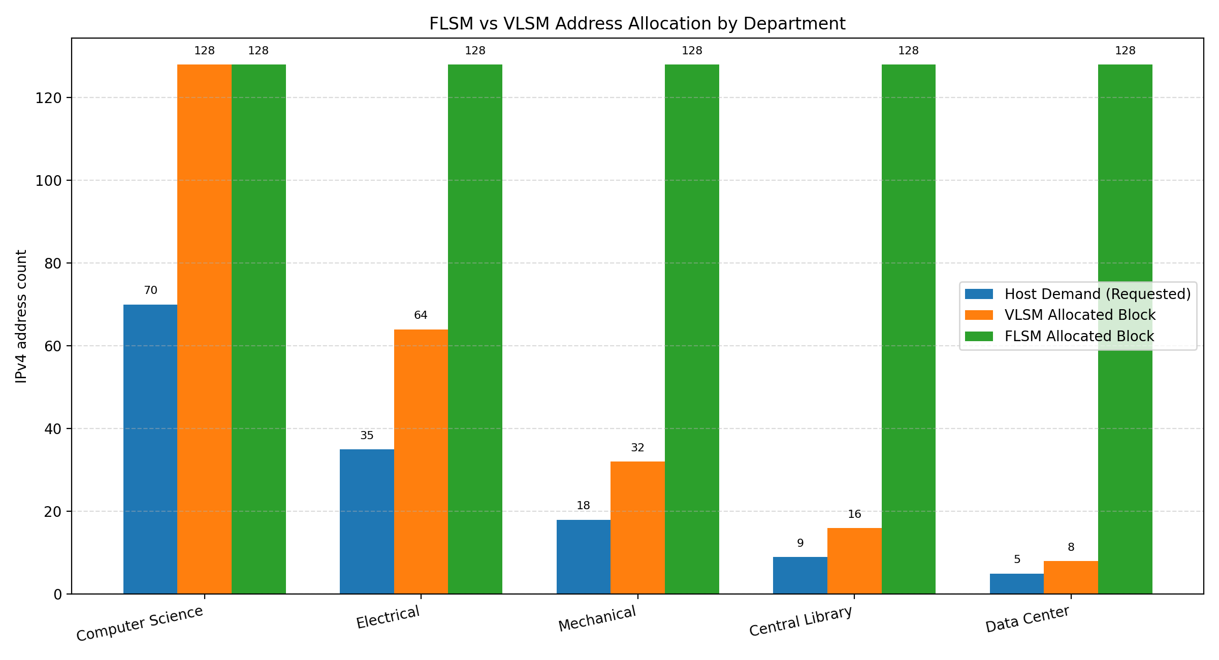
Observation: FLSM allocates 128 addresses to every department. VLSM allocates smaller blocks where fewer hosts are needed, reducing the total allocated addresses from 640 to 248.

Figure 2. Address Utilization Efficiency by Department
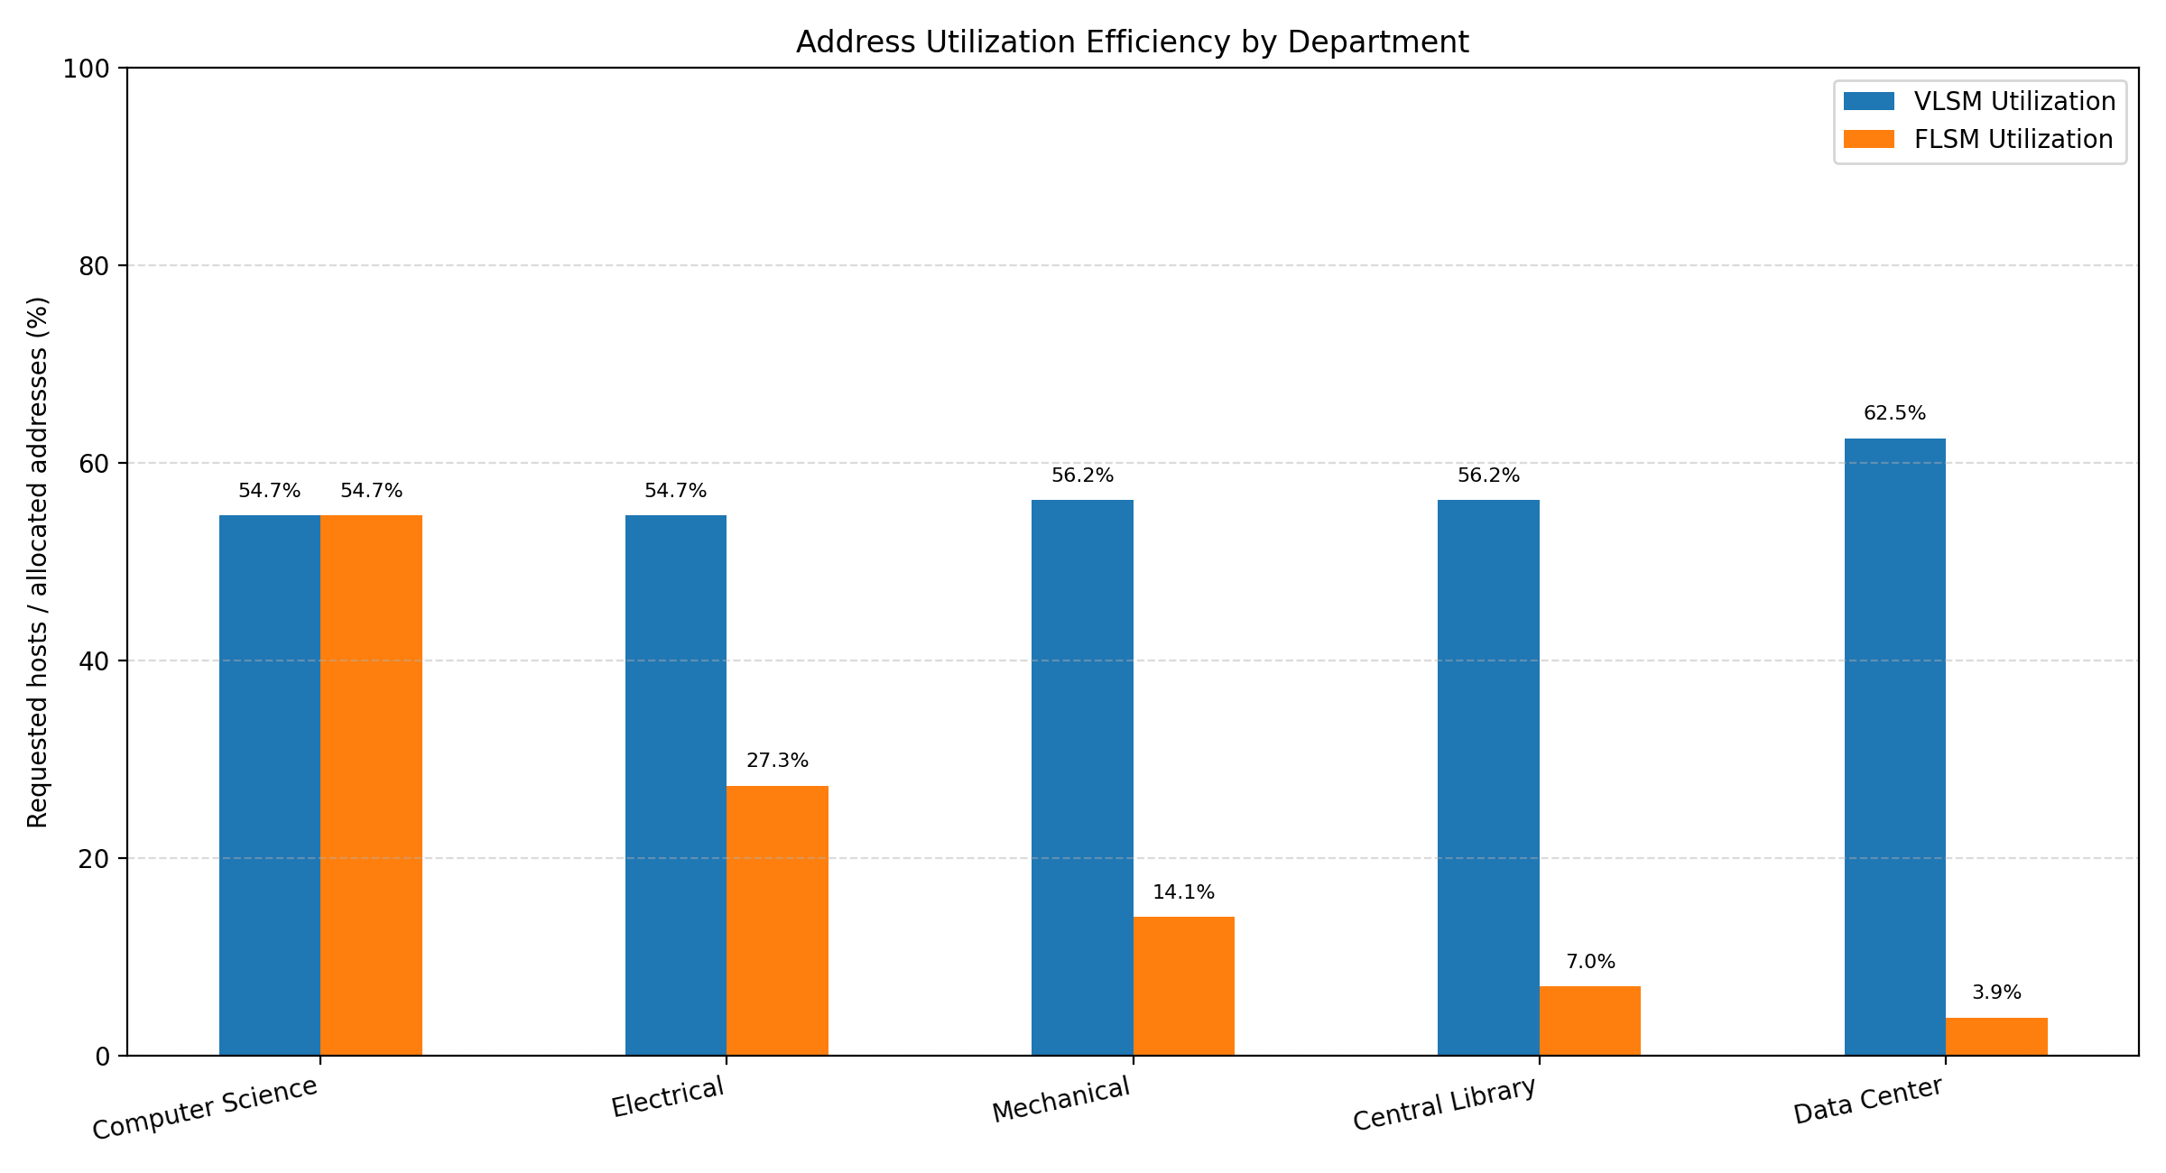
Utilization is calculated as requested host count divided by total allocated block addresses, multiplied by 100. This is an address-block efficiency comparison; usable-host capacity excludes network and broadcast addresses.

Summary
Across all five departments, FLSM allocates 640 total addresses and VLSM allocates 248. VLSM therefore saves 392 addresses, equal to 61.25% of the FLSM allocation.

