**ACKNOWLEDGEMENT**

We are very thankful to everyone who supported us for this Project and gave their guidance to computer and thesis work effectively and moreover on time.

We are equally grateful to our faculty Pooja Gandhi and Pooja Jain, Who gave us moral support and guided us in different matters and solutions regarding the topic.

We feel immensely proud in extending our heartiest thanks to Jayraj Pandya, Director of university, for providing us a platform to improve in various fields. They have been a source of inspiration for us and their experience and knowledge have helped us in learning and giving this project the shape it has assumed.

**SCOPE:**

The Recruitment process is very long and tedious for companies as well as the candidates. Every company want best employee for their organization and every jobseeker want the best job. This software will make this process much easier and smooth.

The companies will register themselves as well as the jobseekers will also register. Companies will be able to search the employee according to their requirements. They will be able to search by education, experience of the candidate. Jobseekers will put their profile and will be able to update the profile. They will be able to search the job according to location, education, field to get their dream job.

If company selects any candidate, first they will conduct the online MCQ test. If the candidate will be selected then the company will conduct online interview and at last interview through Skype. All the updates about the recruitment process will be given to the candidate through mails. So they do not need to explicitly login to check updates. This is how the entire process of the recruitment will become easy and fast for companies as well as jobseekers.

**OBJECTIVE:**

The main objective of this system is to make the long and tedious recruitment process much easier, time saving and faster for companies as well as the jobseekers.

Candidates can give online MCQ test from anywhere. We also provide the result of the test by emails to them. They will be updated about the results easily.

**STACKHOLDER OF THE SYSTEM**

In this system there are mainly three Stakeholders. Which are divided into following:

1] **Company:**

Company will get itself registered on our system to get employees according to their requirements. They will be able to update their profiles and vacancies.

The company will be able to search the employees according to location, education, field and experience. If the company selects any candidate for the interview process there will be three stages for the interview held by company.

1. MCQ test
2. Online Telephonic interview
3. Interview through Skype

The result of the MCQ test will be provide on candidates login id as well as they will be informed through email also. Even if any candidate will be fail in the test, they will also be updated about their result. The selected candidate will be provided next date of telephonic interview. The last stage of the interview process will be interview through Skype. Then if needed company will call the candidate for one-on-one interview.

2] **Jobseeker:**

Jobseekers will also be able to register. They will also be able to update their profile according to their need. They will be able to search their dream job according to location, technology, salary.

They have to go through all three stages of the recruitment process which is MCQ test, telephonic interview and interview through Skype.

They will be updated about the results regularly during recruitment process and also through e-mail.

3] **Admin:**

The admin will be able to handle following things.

* can allow/not allow companies to register
* can see all the companies who have register
* can see all the candidates who have apply

**REQUIREMENT GATHERING TECHNIQUE USED:**

It is critical to capture the necessary facts to build the required database application. These facts are captured using fact-finding techniques. The formal process of using techniques such as interviews and questionnaires to collect facts about systems, requirements, and preferences.

A database developer normally uses several fact-finding techniques during a single database project including:

* Examining documentation
* Interviewing
* Observing the organization in operation
* Research
* Questionnaires

In Requirement gathering we use Different type of Fact-Finding Techniques like interview observation etc.

With using of Fact-Finding Technique we get Following Questions and Answers:

Q - Why you want to computerize the system?

A - Because in Existing system candidates can only search companies and vacancies online but the interview process is offline and manual so it becomes very long and tedious. In proposed system entire recruitment process will be online. So it will be very easy and time saving for both company as well as candidate.

Q - What was problem in current system?

A – As said above in existing system for interview process candidates have to go physically for the interview process so the process becomes long and tedious for company as well as candidate.

Q - What the Functionality you want in your proposed system?

A - The proposed system must be computerize in which user can access the system from anywhere. In the proposed system all the process for recruitment will be online. The candidates have to go through three stages which are MCQ test, telephonic interview and interview through Skype. They will also be updated through e-mails. Using proposed system company and candidates will be able to search according to experience, location and education.

**CONSOLIDATED LIST OF REQUIREMENT:**

1. **Tasks for Administration:**

* can allow/not allow companies to register
* can see all the companies who have register
* can see all the candidates who have apply
* View all feedback

1. **Tasks for Company:**

* Registration
* Updates vacancy
* Search for the Employee
* View profiles of candidates applied for the job
* Accepts/rejects application
* Conduct online MCQ test
* Conduct telephonic interview
* Conduct technical interview by Skype
* Inform the Candidate
* Give feedback

1. **Tasks for Jobseeker:**

* Register /Login
* Search for job
* Application
* Get updates
* Give MCQ test
* Give telephonic Interview
* Give technical interview
* Give feedback

**PROJECT DEFINITION:**

**Job Destiny** is java based web Application. It is an online recruitment system.

The Recruitment process is very long and tedious for companies as well as the candidates. Every company want best employee for their organization and every jobseeker want the best job. This software will make this process much easier and smooth.

The companies will register themselves as well as the jobseekers will also register. Companies will be able to search the employee according to their requirements. They will be able to search by education, experience of the candidate. Jobseekers will put their profile and will be able to update the profile. They will be able to search the job according to location, education, field to get their dream job.

If company selects any candidate, first they will conduct the online MCQ test. If the candidate will be selected then the company will conduct online interview and at last interview through Skype. All the updates about the recruitment process will be given to the candidate through mails. So they do not need to explicitly login to check updates. This is how the entire process of the recruitment will become easy and fast for companies as well as jobseekers.

* 1. **FEASIBLITY STUDY:**

Whatever we think need not be feasible .It is wise to think about the feasibility of any problem we undertake. Feasibility is the study of impact, which happens in the organization by the development of a system. The impact can be either positive or negative. When the positives nominate the negatives, then the system is considered feasible.

The main objective of the feasibility study is to test the Technical, Operational and Economical feasibility for adding new modules and debugging old running system. There are aspects in the feasibility study portion of the preliminary investigation:

•         Technical Feasibility

•         Operation Feasibility

•         Economic Feasibility

**3.1.1 Technical Feasibility:**

* The technical feasibility study focuses on how you will deliver a product or service how you will deliver a product or service through which technology?
* The current system developed is technically feasible.
* It is a web based user interface. Thus it provides an easy access to the users.
* To access the system, internet connectivity is must require, because it is web Based websites.

**3.2.1 Economical Feasibility:**

* Economic feasibility is based on cost and be benefits.
* The cost of hardware and software for the class of application being considered.
* The benefits in the form of reduced costs of fewer costly errors.
* The cost if nothing change (i.e. the proposed system is not developed).
* We are using the open source platform to build our system.
* Thus, the project is economically feasible for both client and us.
  + 1. **Operational feasibility:**
* Operational feasibility states how the requirements are satisfied and also provides possible solutions.
* By doing so there is no need for the company either to recruit some special individual to run the system or spend a huge amount to train some individual.
* Thus, the project is operationally individual.
* This project well-planned design would ensure the optimal utilization of the resources and would help in the improvement of performance status.

**3.2 HARDWARE-SOFTWARE REQUIRMENT**

**3.2.1 Hardware (Recommended)**

* Processor: Minimum Pentium
* Hard Disk: 80 GB
* RAM: 512 MB or More
* An Internet Connection

**3.2.2 Software (Recommended)**

* Windows XP,7,8,8.1,10 or any higher versions of OS
* My SQL
* Any Web Browser

**3.2.3 Technology Used**

Frontend Technology:

* JSP-Servlet:
* HTML:
* CSS:
* JQUERY:

Frontend Tools:

* Photoshop CS6
* Eclipse

Backend Technology:

* JAVA

Backend Framework:

* + Spring
  + Hibernate

**UML(UNIFIED MODELING LANGUAGE) :-**

4.1.1:- Usecase Diagram :-

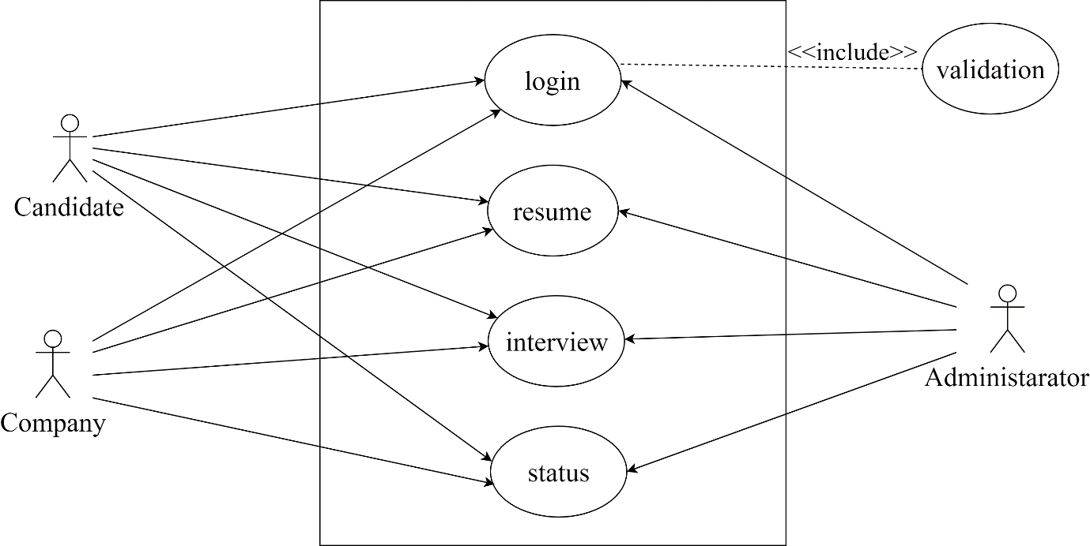

1. System

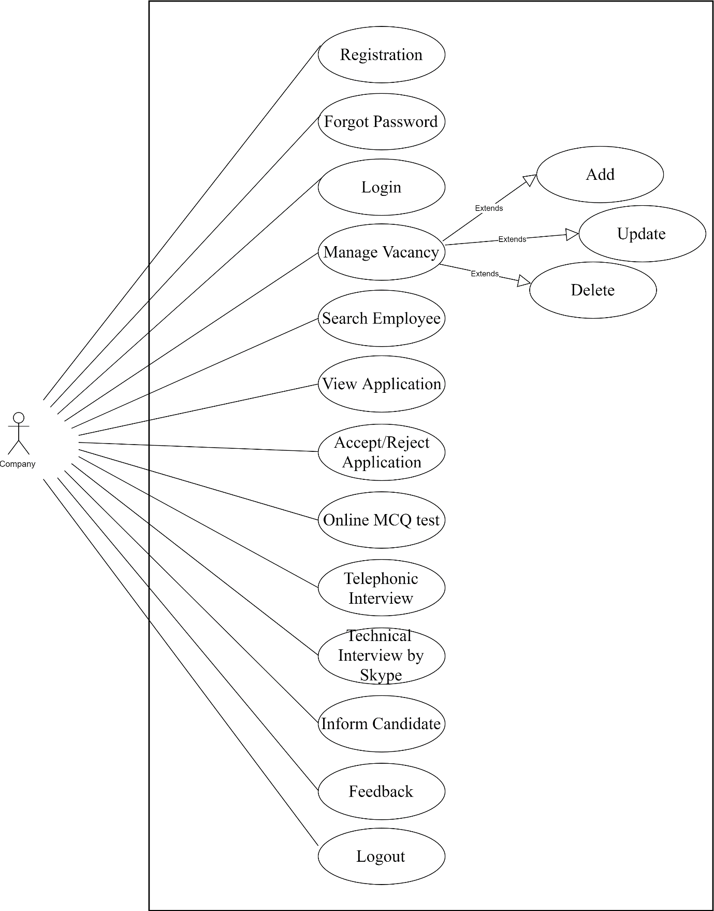

1. Company

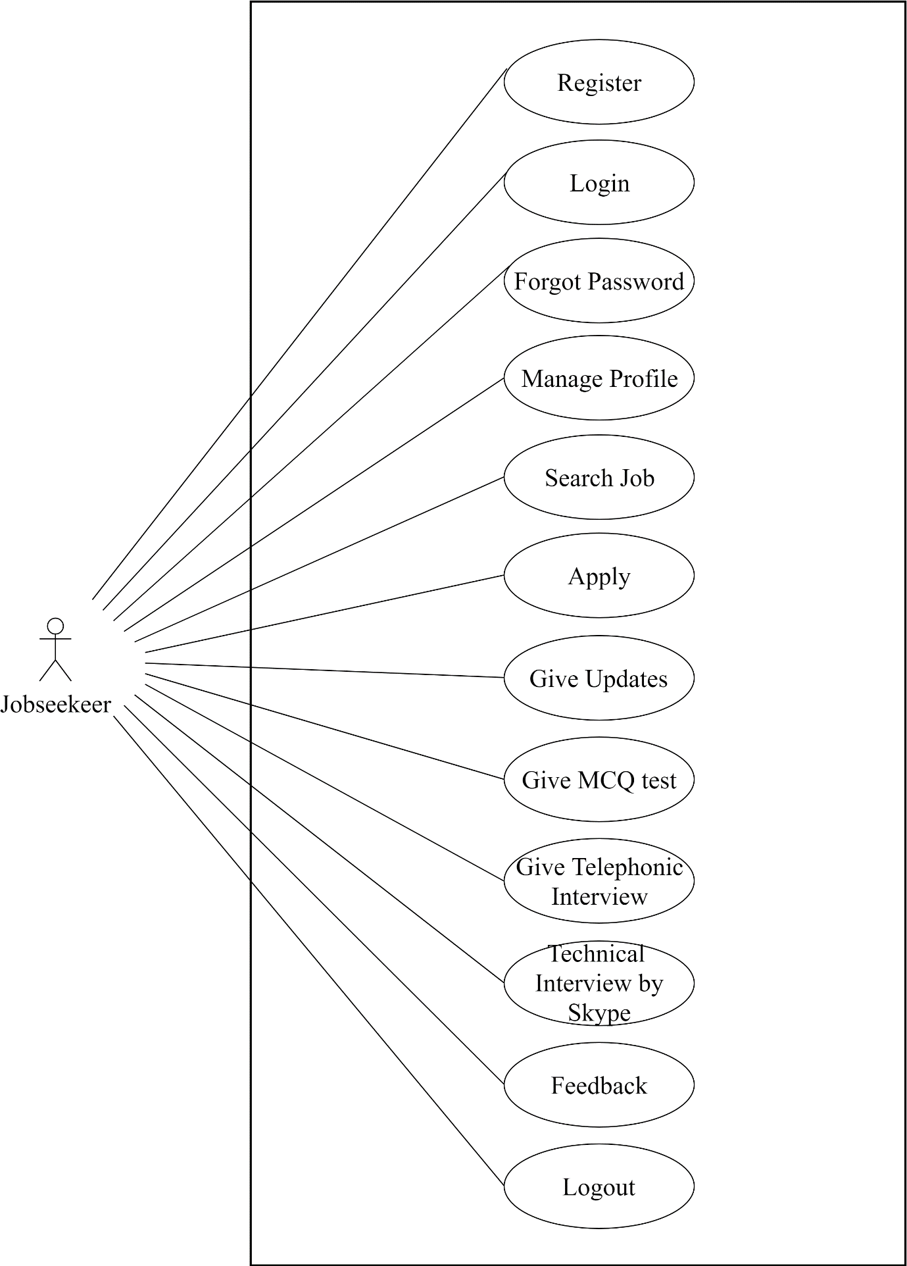

1. Jobseekeer

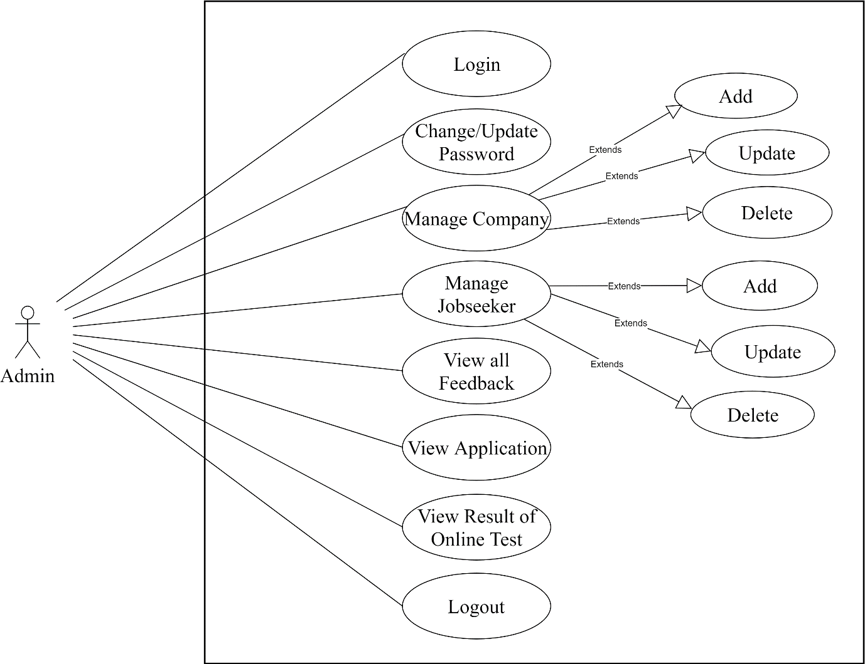

1. Admin

Activity Diagram :-

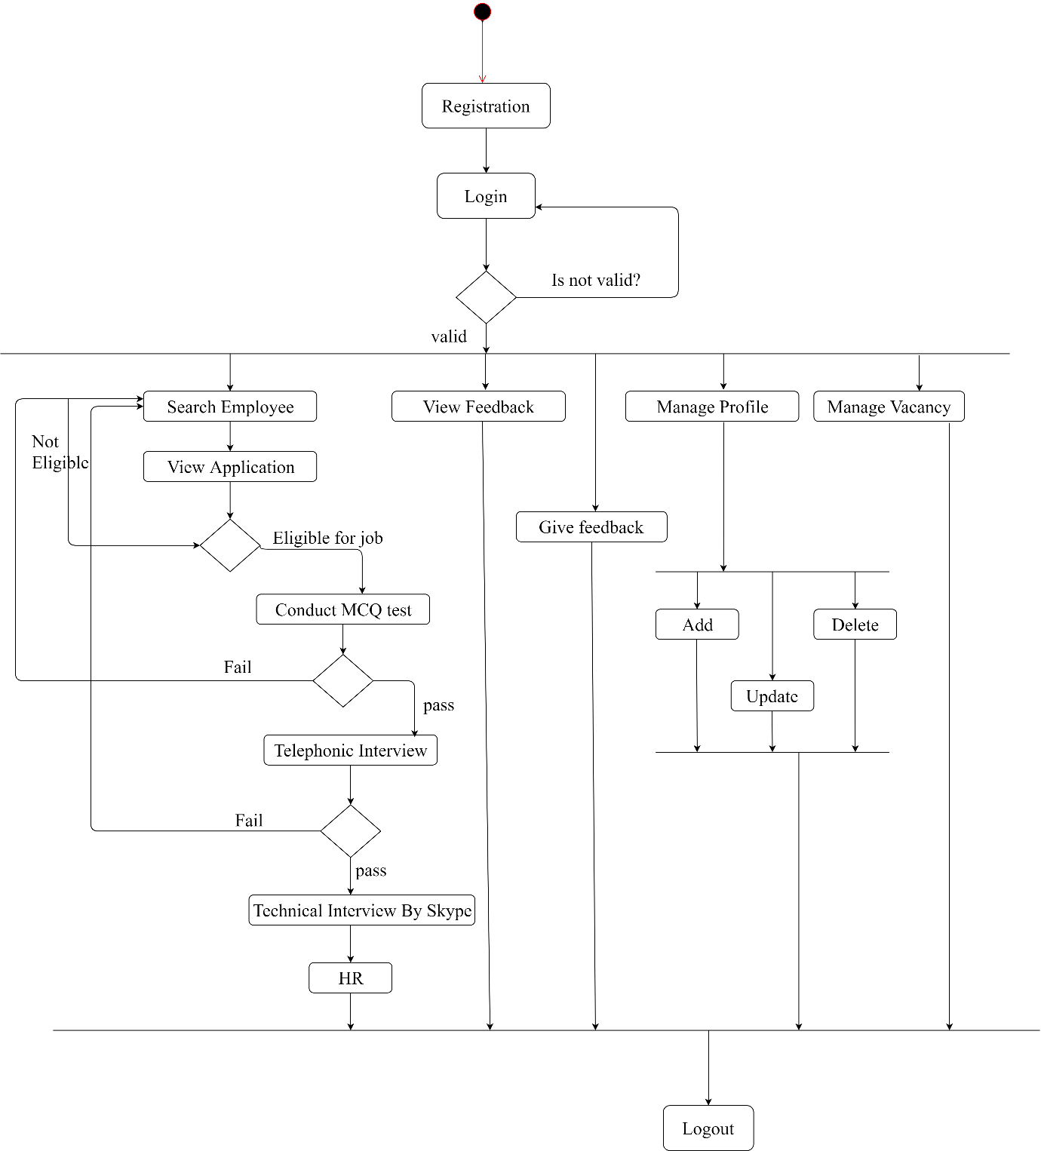

1. Company

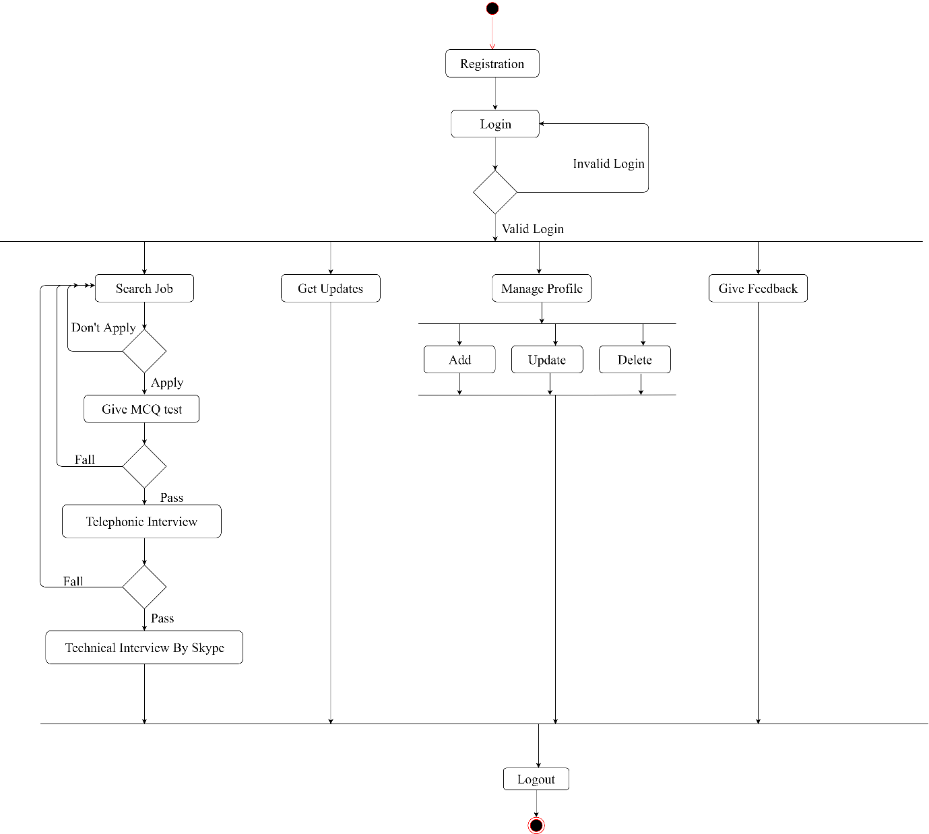

1. Jobseekeer

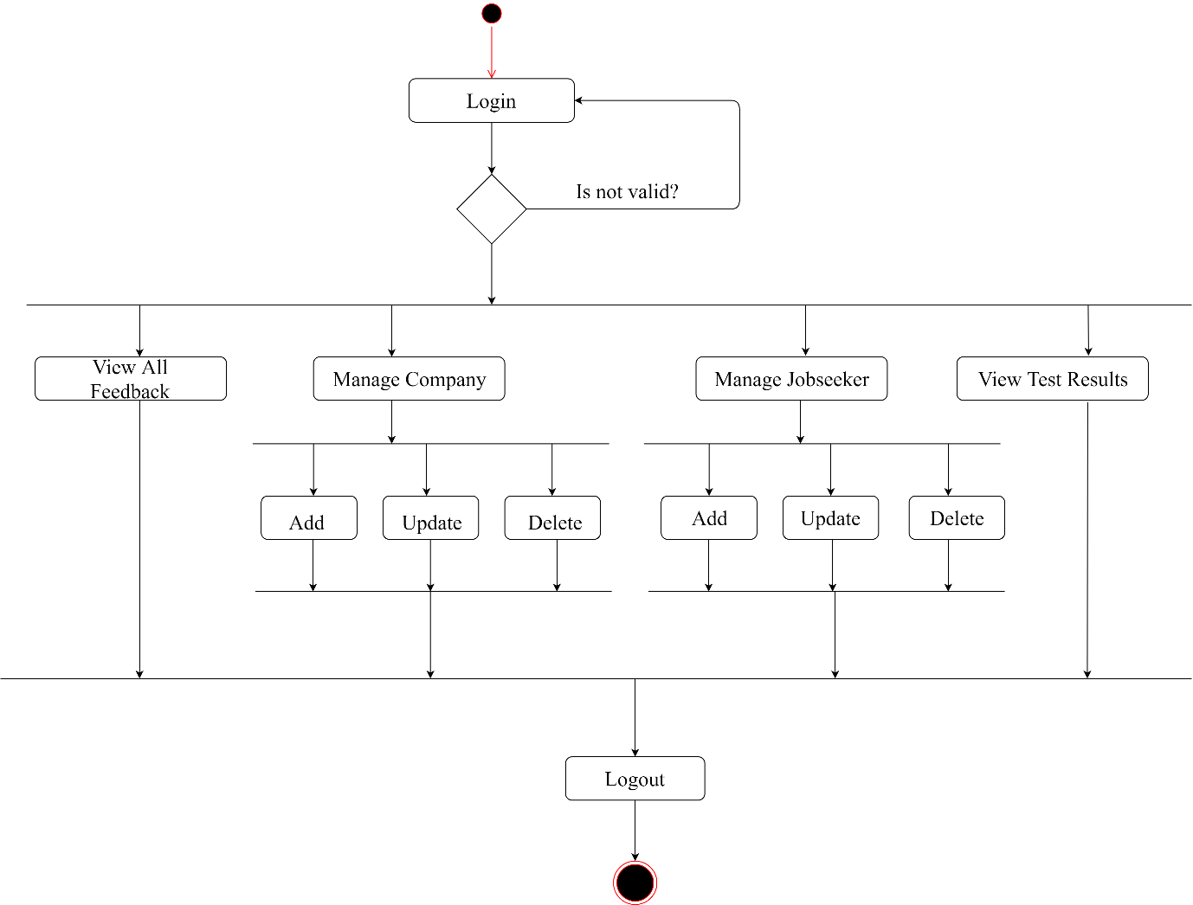

1. Admin

Class Diagram :-

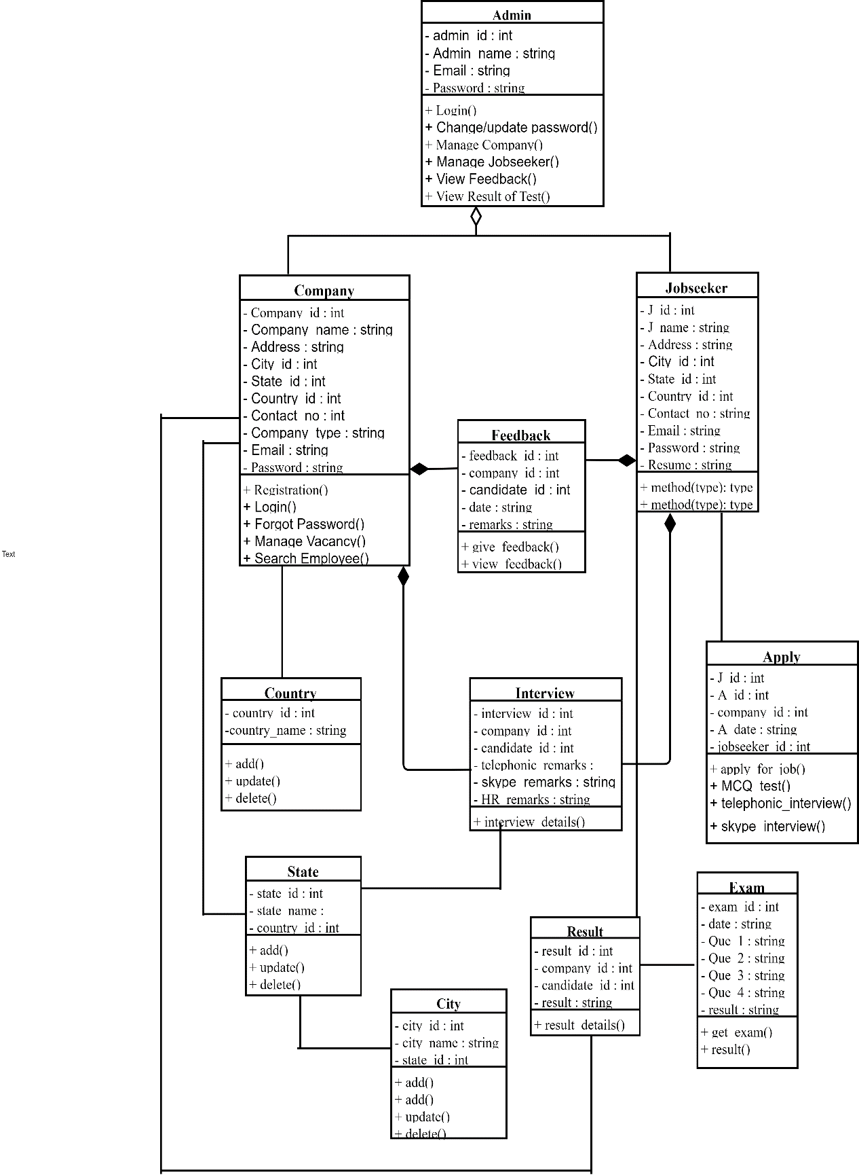

Sequence Diagram :-

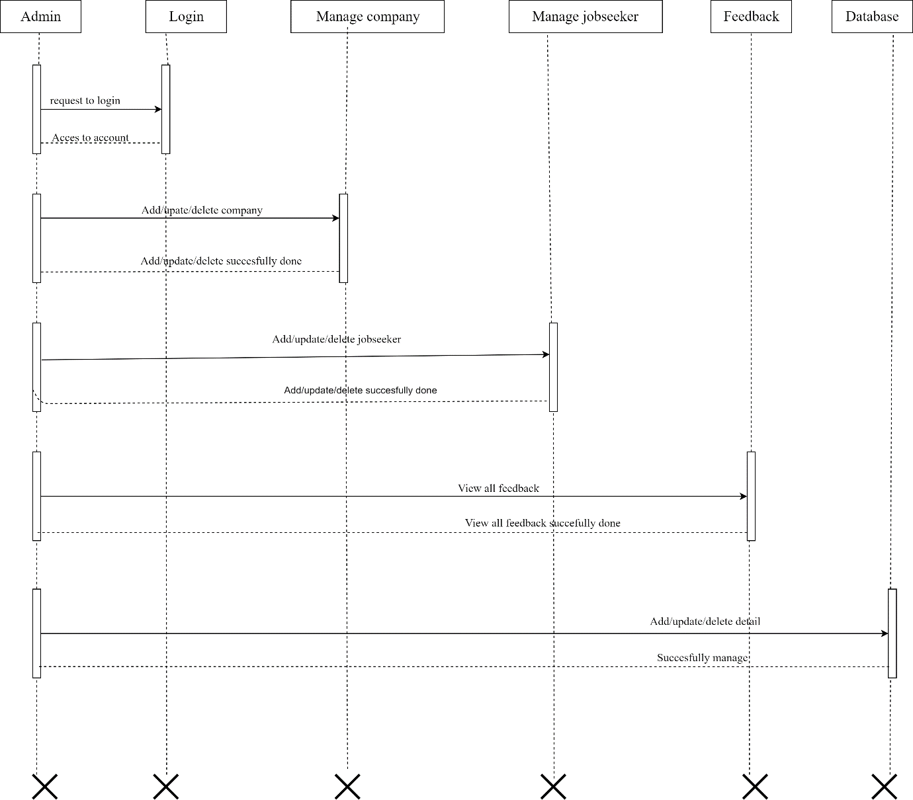

1. Admin

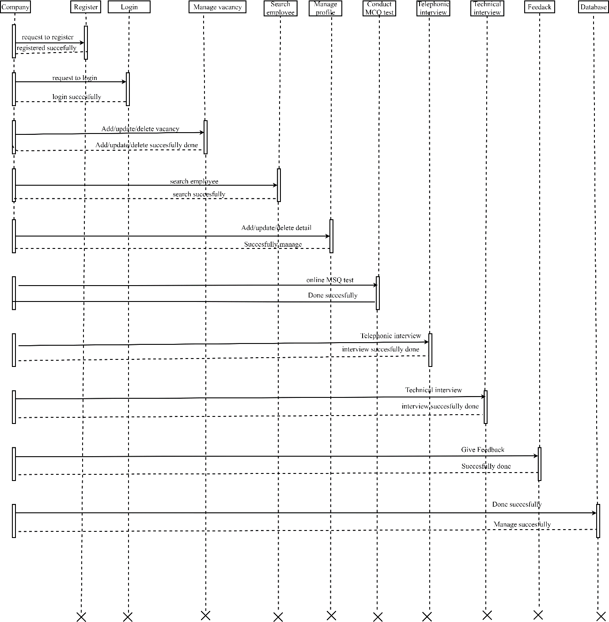

1. Company