

**Programming: Array**

**Dhruvin Dholiya**



1. **Write a C program to print all negative element from static array.**

* **Code:**

#include<stdio.h>

int main() {

int i, roll[5] = {-90, -89, 39, -8, 11};

for (i = 0; i <= 4; i++) {

if (roll[i] < 0) {

printf("%d\n", roll[i]);

}

}

return 0;

}

* **Output:**

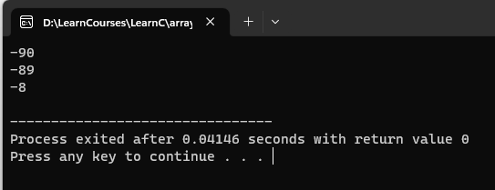

1. **Write a C program to print all negative element from dynamic array.**

* **Code:**

#include<stdio.h>

int main() {

int i, n;

int arr[100];

printf("Please enter size of an array: ");

scanf("%d", &n);

for (i = 0; i < n; i++) {

printf("Array value no.%d: ", i);

scanf("%d", &arr[i]);

}

printf("\nArray values are: ");

for (i = 0; i < n; i++) {

if (arr[i] < 0) {

printf("\n%d", arr[i]);

}

}

return 0;

}

* **Output:**

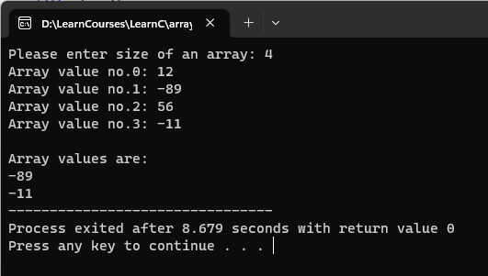

1. **Write a C program to print all even element from static array.**

* **Code:**

#include<stdio.h>

int main() {

int i, num[10] = { 23, 4, 67, 56, 78, 45, 3, 30, 89, 50};

for (i = 0; i <= 10; i++) {

if (num[i] % 2 == 0) {

printf("%d\n", num[i]);

}

}

return 0;

}

* **Output:**

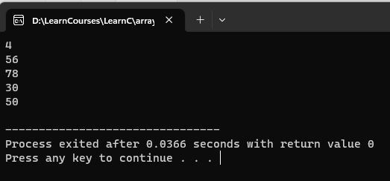

1. **Write a C program to print all odd element from dynamic array.**

* **Code:**

#include<stdio.h>

int main () {

int i, n;

int arr[100];

printf("Please enter the size of an array: ");

scanf("%d", &n);

for (i = 0; i < n; i++) {

printf("Array value no.%d: ", i);

scanf("%d", &arr[i]);

}

printf("\nArray values are: ");

for (i = 0; i < n; i++) {

if (arr[i] % 2 == 1) {

printf("\n%d", arr[i]);

}

}

}

* **Output:**

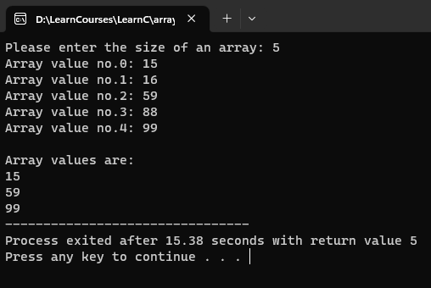

1. **Write a C program to print all element that are divisible by 3 from dynamic array.**

* **Code:**

#include<stdio.h>

int main() {

int i, n;

int arr[100];

printf("Please enter size of an array: ");

scanf("%d", &n);

for (i = 0; i < n; i++) {

printf("Array value no.%d: ", i);

scanf("%d", &arr[i]);

}

printf("\nArray values are: ");

for (i = 0; i < n; i++) {

if (arr[i] % 3 == 0) {

printf("\n%d", arr[i]);

}

}

return 0;

}

* **Output:**

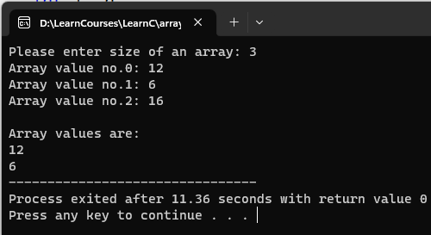

1. **Write a C program to find max element from an dynamic array.**

* **Code:**

#include <stdio.h>

int main() {

int i, n, arr[i], max=0;

printf("Please enter size of an array: ");

scanf("%d", &n);

for (i = 0; i < n; i++) {

printf("Array element no.%d: ", i);

scanf("%d", &arr[i]);

}

for (i = 0; i < n; i++) {

if (arr[i] > max) {

max = arr[i];

}

}

printf("\nmax: %d", max);

return 0;

}

* **Output:**

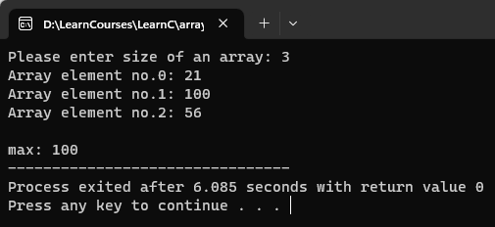

1. **Write C program to find second largest number in array.**

* **Code:**

#include <stdio.h>

#define MAX_SIZE 1000

int main() {

int i, n, arr[MAX_SIZE], temp=0, max2=0;

printf("Please enter size of an array: ");

scanf("%d", &n);

for (i = 0; i < n; i++) {

printf("Array element no.%d: ", i);

scanf("%d", &arr[i]);

}

for (i = 0; i < n; i++) {

if (arr[i] > temp) {

max2 = temp;

temp = arr[i];

} else if (arr[i] > max2 && arr[i] < temp) {

arr[i] = max2;

}

}

printf("\nsecond max: %d\n", max2);

return 0;

}

* **Output:**

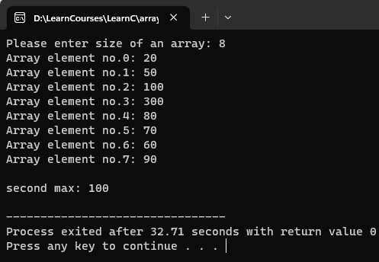

1. **Write C program to Update the element into array.**

* **Code:**

#include <stdio.h>

int main() {

int i, n, arr[i], ind, newEle;

printf("Please enter size of an array: ");

scanf("%d", &n);

for (i = 0; i < n; i++) {

printf("Array element no.%d: ", i);

scanf("%d", &arr[i]);

}

printf("\nWhich element do you want to change?: ");

scanf("%d", &ind);

printf("Please add new number.: ");

scanf("%d", &newEle);

arr[ind - 1] = newEle;

printf("\nnew array is: ");

for(i = 0; i < n; i++) {

printf("%d, ", arr[i]);

}

return 0;

}

* **Output:**

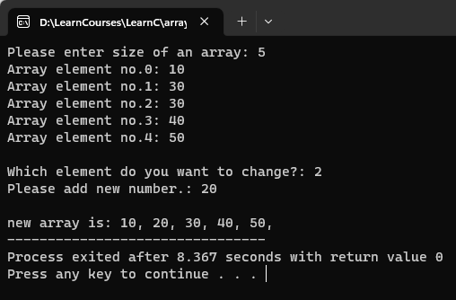

1. **Write C program to Insert the element into array.**

* **Code:**

#include <stdio.h>

int main() {

int i, n, arr[i], ind, newEle;

printf("Please enter size of an array: ");

scanf("%d", &n);

for (i = 0; i < n; i++) {

printf("Array ele no.%d: ", i);

scanf("%d", &arr[i]);

}

printf("Where do you want to add element?: ");

scanf("%d", &ind);

printf("Please add new element.: ");

scanf("%d", &newEle);

n++;

for (i = n - 1; i >= ind; i--) {

arr[i] = arr[i - 1];

}

arr[ind - 1] = newEle;

printf("\nnew array is: ");

for(i = 0; i < n; i++) {

printf("%d, ", arr[i]);

}

return 0;

}

* **Output:**

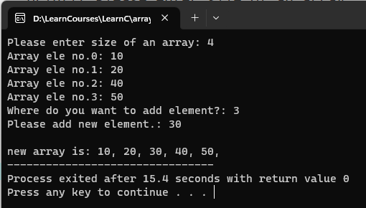

1. **Write C program to Delete the element into array.**

* **Code:**

#include <stdio.h>

int main() {

int i, n, arr[100], ind;

printf("Please enter size of an array: ");

scanf("%d", &n);

for (i = 0; i < n; i++) {

printf("Array ele no.%d: ", i);

scanf("%d", &arr[i]);

}

printf("Which element do you want to remove?: ");

scanf("%d", &ind);

n--;

for (i = ind - 1; i <= n; i++) {

arr[i] = arr[i + 1];

}

printf("\nnew array is: ");

for(i = 0; i < n; i++) {

printf("%d ", arr[i]);

}

return 0;

}

* **Output:**

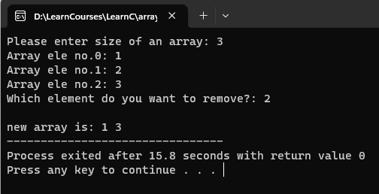

1. **Write C program to left rotate an array element.**

* **Code:**

#include <stdio.h>

int main() {

int i, n, arr[100], first;

printf("Please enter size of an array: ");

scanf("%d", &n);

for (i = 0; i < n; i++) {

printf("Please enter element no.%d: ", i);

scanf("%d", &arr[i]);

}

first = arr[0];

for (i = 0; i < n; i++) {

arr[i] = arr[i + 1];

}

arr[n - 1] = first;

printf("\nNew array is: ");

for (i = 0; i < n; i++) {

printf("%d ", arr[i]);

}

return 0;

}

* **Output:**

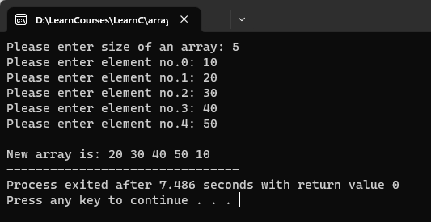

1. **Write C program to right rotate an array element.**

* **Code:**

#include <stdio.h>

int main() {

int i, n, arr[100], last;

printf("Please enter size of an array: ");

scanf("%d", &n);

for (i = 0; i < n; i++) {

printf("Please enter element no.%d: ", i);

scanf("%d", &arr[i]);

}

last = arr[n - 1];

for (i = n - 1; i >= 0; i--) {

arr[i] = arr[i - 1];

}

arr[0] = last;

printf("\nNew array is: ");

for (i = 0; i < n; i++) {

printf("%d ", arr[i]);

}

return 0;

}

* **Output:**

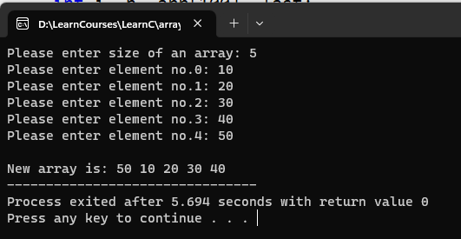

1. **Write C program to addition of two matrices.**

* **Code:**

#include<stdio.h>

int main() {

int arr1[3][3] = {

{10, 20, 30},

{30, 50, 60},

{70, 80, 90}

};

int arr2[3][3] = {

{1, 2, 3},

{4, 5, 6},

{7, 8, 9}

};

int i, x;

int res[3][3] = {0};

for (i = 0; i < 3; i++) {

for(x = 0; x < 3; x++) {

res[i][x] = arr1[i][x] + arr2[i][x];

}

}

for (i = 0; i < 3; i++) {

for(x = 0; x < 3; x++) {

printf("%d ", res[i][x]);

}

printf("\n");

}

return 0;

}

* **Output:**

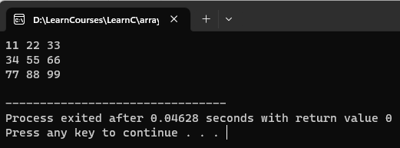

1. **Write C program matrix convert into transpose matrix.**

* **Code:**

#include<stdio.h>

int main() {

int arr[3][3] = {

{10, 20, 30},

{30, 50, 60},

{70, 80, 90}

};

int i, x, trans[3][3] = {0};

for (i = 0; i < 3; i++) {

for(x = 0; x < 3; x++) {

trans[x][i] = arr[i][x];

}

}

for (i = 0; i < 3; i++) {

for(x = 0; x < 3; x++) {

printf("%d ", trans[i][x]);

}

printf("\n");

}

return 0;

}

* **Output:**

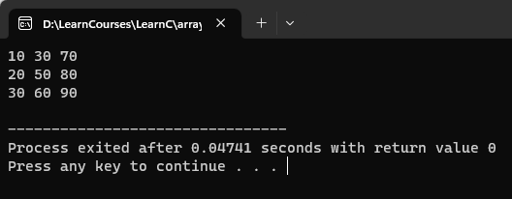

1. **Write C program to find sum of diagonal elements of a matrix.**

* **Code:**

#include<stdio.h>

int main() {

int arr[3][3] = {

{10, 20, 30},

{30, 50, 60},

{70, 80, 90}

};

int i, x, sum = 0;

for (i = 0; i < 3; i++) {

for(x = 0; x < 3; x++) {

if(i == x) {

sum = sum + arr[i][x];

}

}

}

printf("%d", sum);

return 0;

}

* **Output:**

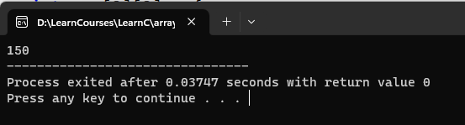

1. **Write a C program to sum of all even element from an array.**

* **Code:**

#include <stdio.h>

int main() {

int i, n, arr[i], sum=0;

printf("Please enter size of an array: ");

scanf("%d", &n);

for (i = 0; i < n; i++) {

printf("Please enter element no.%d: ", i);

scanf("%d", &arr[i]);

}

for(i = 0; i < n; i++) {

if(arr[i] % 2 == 0) {

sum = sum + arr[i];

}

}

printf("\nThe sum of all even array is: %d", sum);

return 0;

}

* **Output:**

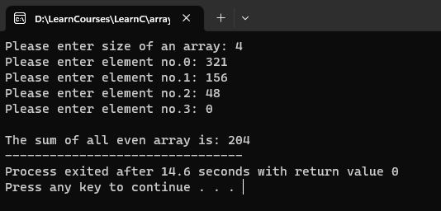

1. **Write a C program to find average of an element from an array.**

* **Code:**

#include <stdio.h>

int main() {

int i, n, arr[i], sum=0, avg=0;

printf("Please enter size of an array: ");

scanf("%d", &n);

for (i = 0; i < n; i++) {

printf("Please enter element no.%d: ", i);

scanf("%d", &arr[i]);

}

for(i = 0; i < n; i++) {

sum = sum + arr[i];

avg = sum / n;

}

printf("\nThe average of this array is: %d", avg);

return 0;

}

* **Output:**

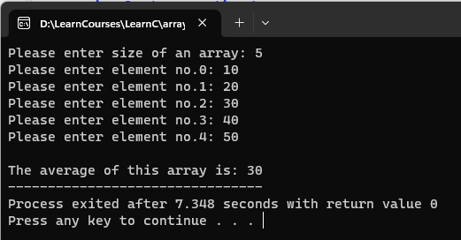

1. **Write a C program to count number of students in each group (0-9, 10- 19, 20-29 .... 90-99, 100-100) for the given students marks.  
   Marks: 85, 66, 37, 45, 68, 23, 99, 100, 81, 70, 42, 55, 68, 77, 96, 18**

* **Code:**

#include <stdio.h>

int main() {

int marks[100], i, n, group, count[11] = {0};

printf("How many students: ");

scanf("%d", &n);

for (i = 0; i < n; i++) {

printf("Please enter marks of student's no.%d: ", i + 1);

scanf("%d", &marks[i]);

}

for (i=0; i<n; i++) {

group = marks[i] / 10;

count[group]++;

}

printf("\nGroup\tNumber of Students\n");

for (i=0; i<10; i++) {

printf("%d-%d\t%d\n", i * 10, i * 10 + 9, count[i]);

}

printf("100\t%d\n", count[10]);

return 0;

}

* **Output:**

