

**c(Programming : String)**

**Dhruvin Dholiya**



1. **Write a C program that demonstrate static string and add - (dash) after each character except last character.**

* **Input:**

#include <stdio.h>

int main() {

int i;

char name[13] = {'S', 'u', 'r', 'a', 't', ' ', 'S', 'u', 'n', 'd', 'a', 'r'};

puts(name);

for (i = 0; i < name[i]; i++) {

if ((name[i + 1] == ' ') || (name[i] == ' ') || (name[i + 1] == '\0')) {

printf("%c", name[i]);

} else {

printf("%c - ", name[i]);

}

}

return 0;

}

* **Output:**

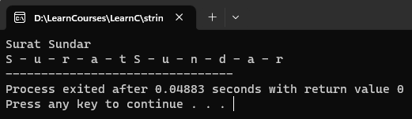

1. **Write a C program that demonstrate all string functions**.

* **Input:**

#include <stdio.h>

int main() {

int l;

char str[100], str1[100];

printf("Please enter any string: ");

gets(str);

printf("Please enter second string: ");

gets(str1);

l = strlen(str);

printf("%d", l);

strcpy(str1, str);

puts(str1);

strcat(str, str1);

puts(str);

strcmp(str, str1);

if (strcmp(str, str1) == 0) {

printf("Your added both strings are same.");

} else {

printf("Your added both strings are not same. ");

}

strrev(str);

puts(str);

strlwr(str);

puts(str);

strupr(str);

puts(str);

return 0;

}

* **Output:**

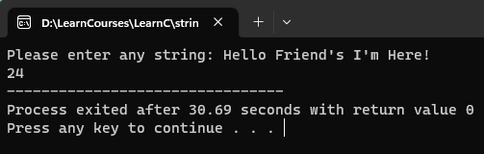

1. **Write a C program that remove white space from given string.**

* **Input:**

#include<stdio.h>

int main() {

int i, j;

char str[100];

printf("Please enter your full name: ");

gets(str);

while (str[i] != '\0') {

if (str[i] == ' ') {

for (j = i; str[j] != '\0'; j++) {

str[j] = str[j + 1];

}

}

i++;

}

puts(str);

return 0;

}

* **Output:**

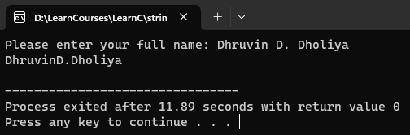

1. **Write a C program that remove repeated character from given string**.

* **Input:**

#include<stdio.h>

int main() {

int i, j, k;

char str[100];

printf("please enter your full name: ");

gets(str);

for (i = 0; str[i] != '\0'; i++) {

for (j = i + 1; str[j] != '\0'; j++) {

if (str[j] == str[i]) {

for (k = j; str[k] != '\0'; k++) {

str[k] = str[k + 1];

}

}

}

}

puts(str);

return 0;

}

* **Output:**

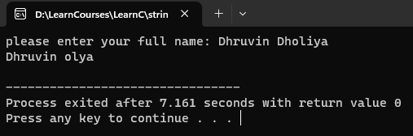

1. **Write any two C program that demonstrate string without string function.**

* **Input:**

#include <stdio.h>

int main() {

char keyword[150];

int i, charactor = 0, digit = 0, space = 0, spacialChar = 0;

printf("Enter any keyword: ");

gets(keyword);

for (i = 0; keyword[i] != '\0'; i++) {

if (((keyword[i] >= 'a') && (keyword[i] <= 'z')) || ((keyword[i] >= 'A') && (keyword[i] <= 'Z'))) {

charactor++;

} else if (keyword[i] >= '0' && keyword[i] <= '9') {

digit++;

} else if (keyword[i] == ' ') {

space++;

} else {

spacialChar++;

}

}

printf("\nCharactor: %d", charactor);

printf("\nDigits: %d", digit);

printf("\nWhite Spaces: %d", space);

printf("\nSpecial Charactor: %d", spacialChar);

return 0;

}

* **Output:**

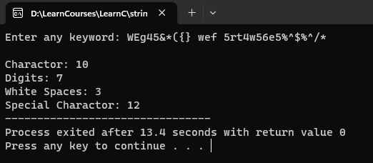

1. **Write any two C program that demonstrate string without string function**.

* **Input:**

#include <stdio.h>

int main() {

char string1[5] = {'S', 'u', 'r', 'a', 't'}, reversed_string[5];

int i, j, count = 0;

printf("\n Given String = %s", string1);

while (string1[count] != '\0') {

count++;

}

j = count - 1;

for (i = 0; i < count; i++) {

reversed_string[i] = string1[j];

j--;

}

printf("\n Reversed String = %s", reversed_string);

return 0;

}

* **Output:**

