

**c(Programming : UDF)**

**Dhruvin Dholiya**



1. **Write a C program to print your introduction using type-1 function.**

* **Input:**

// ====== no parameters, no return value. =======

#include<stdio.h>

void intro() {

printf("NAME: Dhruvin Dholiya\n");

printf("FROM: Surat(Gujrat)\n");

printf("TEL : +91 81406 91801\n\n");

}

int main() {

printf("-------------------------------\n");

printf("Intro function call first time:\n");

printf("-------------------------------\n");

intro();

printf("-----------------------------------");

printf("\nIntro function call Secound time:\n");

printf("-----------------------------------\n");

intro();

printf("---------------------------------");

printf("\nIntro function call third time:\n");

printf("---------------------------------\n");

intro();

return 0;

}

* **Output:**

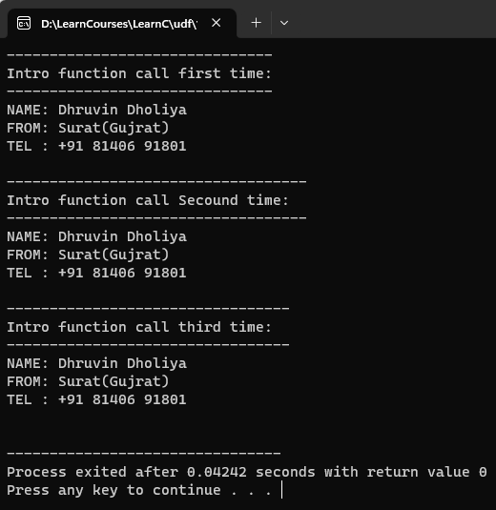

1. **Write a C program to find area of circle using type-2 function.**

* **Input:**

//========== with parameters, no return value.========

#include<stdio.h>

void areaOfCircle(float r) {

float area;

area = 3.14 * r * r;

printf("Area of this circle is: %f\n", area);

}

int main() {

printf("'areaOfCircle' function call first time with int:\n");

areaOfCircle(5);

printf("\n'areaOfCircle' function call first time with float:\n");

areaOfCircle(8.5);

return 0;

}

* **Output:**

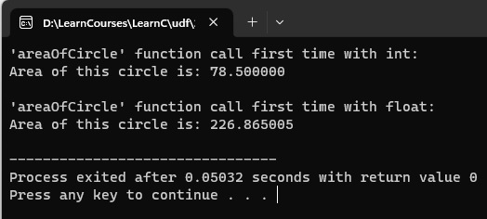

1. **Write a C program to find area of rectangle using type-3 function.**

* **Input:**

// =========== no parameters, with return value. ===========

#include<stdio.h>

float areaOfrect() {

float area, h, l;

printf("\nPlease enter height and length of rectangle: ");

scanf("%f %f", &h, &l);

area = h * l;

return area;

}

int main() {

float res, res1;

res = areaOfrect();

printf("\nArea of rectangle is: %f\n", res);

res1 = areaOfrect();

printf("\nArea of rectangle is: %f", res1);

return 0;

}

* **Output:**

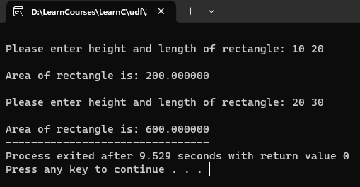

1. **Write a C program to create a calculator using type-4 function.**

* **Input:**

// =========== with parameters, with return value. =========

#include<stdio.h>

int add(int a, int b) {

int val;

val = a + b;

return val;

}

int sub(int a, int b) {

int val;

val = a - b;

return val;

}

int mul(int a, int b) {

int val;

val = a * b;

return val;

}

int div(int a, int b) {

int val;

val = a / b;

return val;

}

int main() {

int res, a, b;

char op;

printf("Please enter two values: ");

scanf("%d %d", &a, &b);

printf("Please enter opprator: ");

scanf(" %c", &op);

switch(op) {

case '+':

res = add(a, b);

break;

case '-':

res = sub(a, b);

break;

case '*':

res = mul(a, b);

break;

case '/':

res = div(a, b);

break;

default:

printf("\n\nINVALID - Please check your added input.\n\n");

break;

}

printf("Result: %d", res);

return 0;

}

* **Output:**

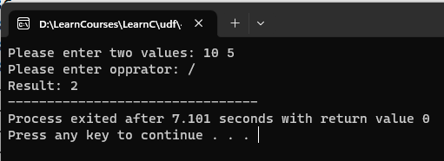

1. **Write a C program to find number is even or odd using type-1 function.**

* **Input:**

#include <stdio.h>

void evenOdd() {

int i, n, num, res;

printf("How many numbers do you want to check that are odd or even? : ");

scanf("%d", &n);

for(i = 1; i <= n; i++) {

printf("\nAdd number for check: ");

scanf("%d", &num);

res = num % 2;

if (res == 0) {

printf("ANS: %d is Even\n", num);

} else {

printf("ANS: %d is Odd\n", num);

}

}

}

int main() {

evenOdd();

return 0;

}

* **Output:**

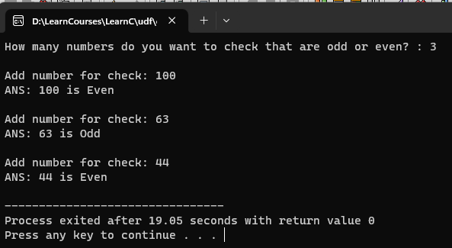

1. **Write a C program to find average of 4 numbers using type-2 function.**

* **Input:**

#include<stdio.h>

void average(int arr[]) {

int i;

float sum = 0, avg = 0;

for(i = 0; i < 4; i++) {

sum = (sum + arr[i]);

}

avg = sum/4;

printf("ANS: %f", avg);

}

int main() {

int arr[4], n, i;

for (i = 0; i < 4; i++) {

printf("No.%d: ", i);

scanf("%d", &arr[i]);

}

average(arr);

return 0;

}

* **Output:**

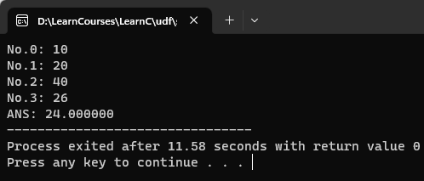

1. **Write a C program to find given number is prime or not using type-3 function.**

* **Input:**

#include<stdio.h>

int primeNum() {

int num, i, prime = 0;

printf("Please enter any number: ");

scanf("%d", &num);

if (num > 1) {

if (num == 2) {

printf("prime number = ");

} else {

for (i = 2; i < num; i++) {

if (num % i == 0) {

prime = 1;

break;

}

}

if (prime == 0) {

printf("\nprime number = ");

} else {

printf("\nnot prime number = ");

}

}

} else {

printf("Added number is should more than 1.");

}

return num;

}

int main() {

int res = primeNum();

printf("%d", res);

return 0;

}

* **Output:**

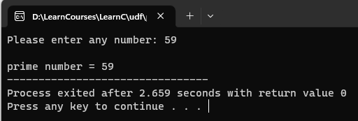

1. **Write a C program to find given number is Armstrong or not using type-4 function.**

* **Input:**

#include<stdio.h>

int armstrongNum(int num){

int i, rem=0, res=0, originalNum;

originalNum = num;

for (i = 0; i < num; i++) {

rem = num % 10;

res = res + (rem * rem * rem);

num = num / 10;

}

if (originalNum == res) {

printf("Added number is armstrong number.");

} else {

printf("Added number is not armstrong number.");

}

return res;

}

int main () {

int num;

printf("Please enter any number: ");

scanf("%d", &num);

armstrongNum(num);

return 0;

}

* **Output:**

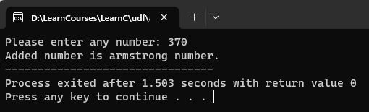

1. **C program to find Sum of all Array Elements by passing array as an argument using User Define Functions.**

* **Input:**

#include <stdio.h>

int sumArr(int arr[], int n) {

int sum = 0, i;

for (i=0; i<=n; i++) {

sum = sum + arr[i];

}

return sum;

}

int main() {

int n, i, arr[100], res;

printf("Please enter size of an array: ");

scanf("%d", &n);

for (i=0; i < n; i++) {

printf("Arry no. %d: ", i + 1);

scanf("%d", &arr[i]);

}

res = sumArr(arr, n);

printf("Sum of your added array is: %d", res);

return 0;

}

* **Output:**

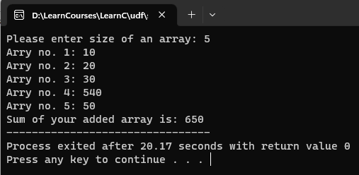

1. **C program to find Length of the String by passing String/ Character Array as an Argument using User Define Functions.**

* **Input:**
* **Output:**

1. **C program to find factorial of number using recursion.**

* **Input:**

#include <stdio.h>

int findFectNum(int num) {

if (num > 1) {

return num * findFectNum(num - 1);

} else {

return 1;

}

}

int main() {

int num, i, res;

printf("Please enter any number for find fectorial: ");

scanf("%d", &num);

res = findFectNum(num);

printf("Fectorial number: %d", res);

return 0;

**}**

* **Output:**

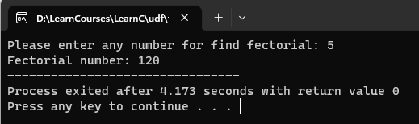

1. **Write C program to print prime number of between two any number.**

* **Output:**

#include <stdio.h>

int checkPrimeNumber(int i) {

int j, flag = 1;

for (j = 2; j <= i / 2; j++) {

if (i % j == 0) {

flag = 0;

break;

}

}

return flag;

}

int main() {

int i, flag, arr[2];

printf("Enter two positive integers: ");

scanf("%d %d", &arr[0], &arr[1]);

printf("Prime numbers between %d and %d are: ", arr[0], arr[1]);

for (i = arr[0] + 1; i < arr[1]; i++) {

flag = checkPrimeNumber(i);

if (flag == 1) {

printf("%d ", i);

}

}

return 0;

}

* **Output:**

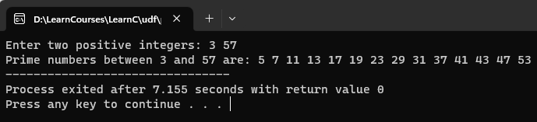

1. **Write a C program to count number of students in each group (0-9, 10- 19, 20-29 .... 90-99, 100-100) for the given students marks by funcation and array.**  
   **Marks: 85, 66, 37, 45, 68, 23, 99, 100, 81, 70, 42, 55, 68, 77, 96, 18**

* **Output:**

#include <stdio.h>

void countStudent(int n) {

int marks[100], i, group, count[11] = {0};

for (i = 0; i < n; i++) {

printf("Please enter marks of student's no.%d: ", i + 1);

scanf("%d", &marks[i]);

}

for (i=0; i<n; i++) {

group = marks[i] / 10;

count[group]++;

}

printf("\nGroup\tNumber of Students\n");

for (i=0; i<10; i++) {

printf("%d-%d\t%d\n", i * 10, i * 10 + 9, count[i]);

}

printf("100\t%d\n", count[10]);

}

int main () {

int n;

printf("How many students: ");

scanf("%d", &n);

countStudent(n);

}

* **Output:**

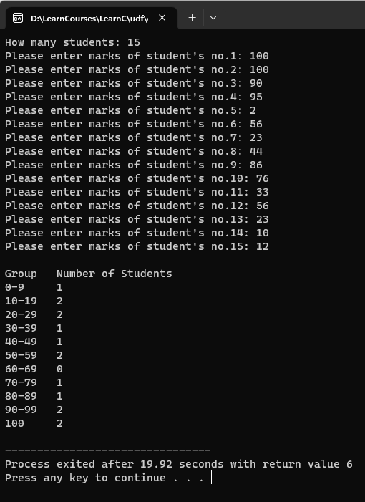

1. **Write C program to calculate sum of n odd elements.**

* **Output:**

#include <stdio.h>

int oddSum() {

int i, n, arr[i], sum=0;

printf("Please enter size of an array: ");

scanf("%d", &n);

for (i = 0; i < n; i++) {

printf("Please enter element no.%d: ", i);

scanf("%d", &arr[i]);

}

for(i = 0; i < n; i++) {

if(arr[i] % 2 == 1) {

sum = sum + arr[i];

}

}

return sum;

}

int main() {

int sum;

sum = oddSum();

printf("\nThe sum of all Odd array is: %d", sum);

}

* **Output:**

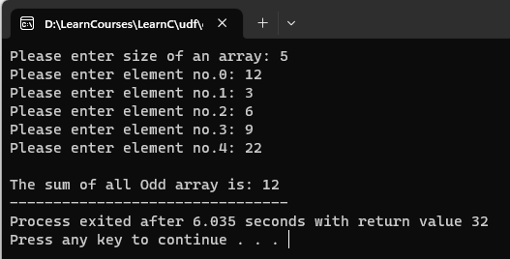

1. **Write C program to print smallest element of array.**

* **Output:**

#include <stdio.h>

void smallestNum() {

int i, n, arr[i], max=0;

printf("Please enter size of an array: ");

scanf("%d", &n);

for (i = 0; i < n; i++) {

printf("Array element no.%d: ", i);

scanf("%d", &arr[i]);

}

for (i = 0; i < n; i++) {

if (arr[i] < max) {

max = arr[i];

}

}

printf("\nmax: %d", max);

}

int main() {

smallestNum();

}

* **Output:**

