HPC- HW1 Solution:

Q1.

Predicted performance for fc with 99%:

average cycles/ word access = 2.98.

performance = flops/sec = processor speed * machine balance * (word access/average cycles)
= 2 * 2 /2.98
= 1.34 GHz

Predicted performance for fc with 1%

average cycles/ word access = 99.02

performance = flops/sec = processor speed * machine balance * (word access/average cycles)
= 2 * 2 /99.02
= 0.04039 GHz

Q2.

With INTEL compiler:
1. With no optimization: Matrix addition by row major: time is milliseconds on y axis and dimension of matrix on x axis.

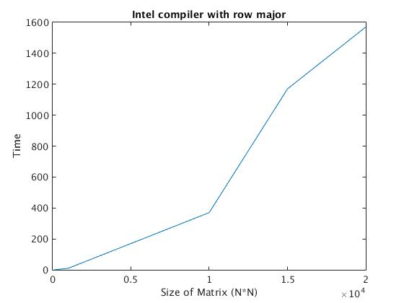

2. With optimization: Matrix addition by row major: time is milliseconds on y axis and dimension of matrix on x axis.

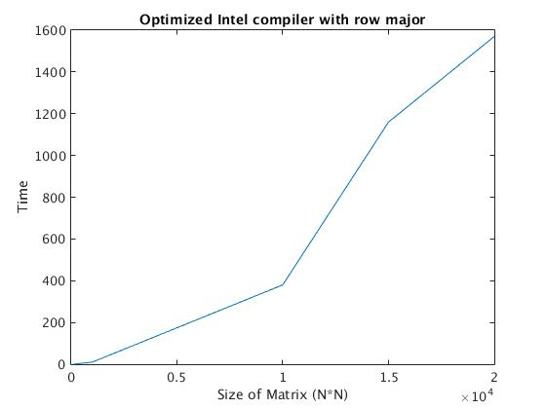

3. With optimization: Matrix addition by column major: time is milliseconds on y axis and dimension of matrix on x axis.

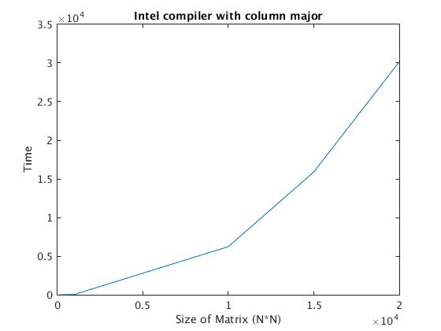

4. With no optimization: Matrix addition by column major: time is milliseconds on y axis and dimension of matrix on x axis.

A[i][j] has better cache hits than A[j][i], since A[i][j] has more continuous memory accessing chances.when we access A[i][j] , the cache loads a continuous segment of memory containing , A[i][j] thus, accessing A[1][j]...A[4][j] will benefit from caching speed.
However, when we do column wise A[j][0] , it is far from A[j+1][0] and may not been cached, and can not benefit from caching speed.
That's why A[i][j] is faster.

Q3.

1. With GCC compiler: Dot product. With No optimization

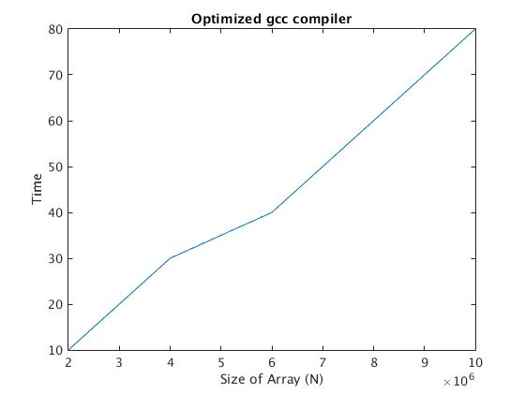

2. With GCC compiler: Dot product. With Optimization O3

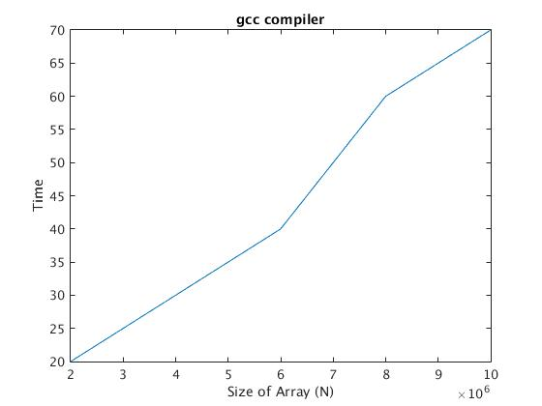

3. With GCC compiler using Openblas ddot function.

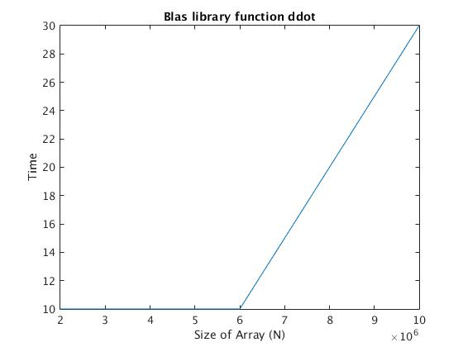

4. With Intel compiler using MKL ddot function.
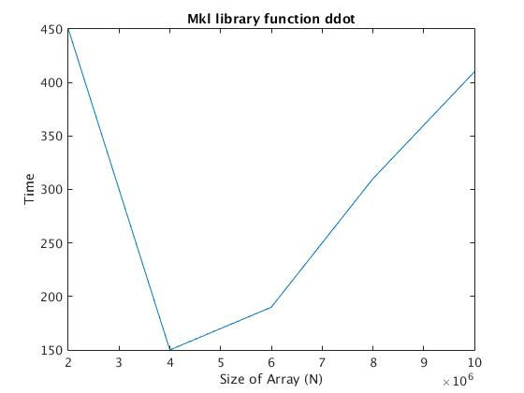

Theoretical Peak Performance:
CPU speed = 2.40 GHz
CPU cores = 1
CPU instructions per cycle= 8*2 = 16

Theoretical Peak Performance = 2.40*8*8*2 = 38.2 Gflops/secs.

My Machine Performance:

performance = 2* 6000000/ 0.04 = 0.3 Gflops/secs

Ratio = 0.007

Q4.

1. With GCC compiler: Matrix product. With optimization O3

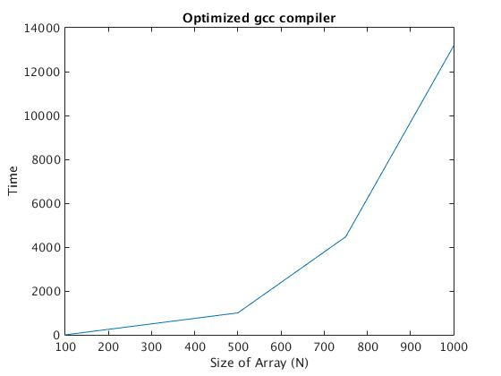

2. With GCC compiler: Matrix product. With no Optimization

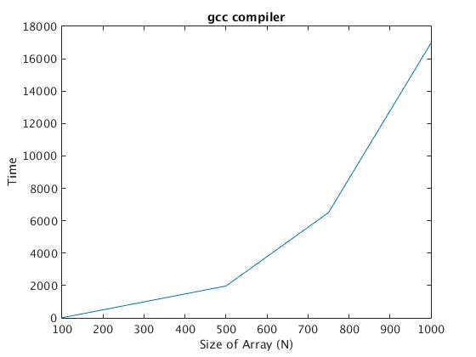

3. 2. With intel compiler: Matrix product. With dgemm
