1,. Create C3 app which has following design

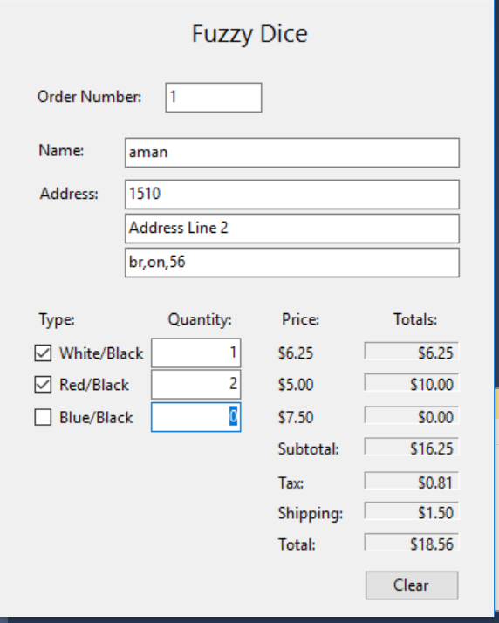

When user enter quantity and hit enter at same time prices should be updated. If someone tries to enter quantity in unselected type item, warning message should come and donot let user enter anything.

In Quantity box make sure no characters can be entered.

2. Create Drawing panel given below so that user can select color and size before drawing over mouse move.

