# Java Programming – Assignment 1

## Goals

To use JavaFX to develop a business oriented forms application.

## Description

You are to develop a JavaFX application that displays an employee expense form. The form should look like the example below.

Expense Form

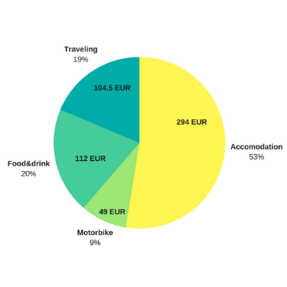

Employee

ID



Date

Destination

Category

Description

Amount

**Submit**

Total

If there is a text file called “employee_info.txt”, then this will be read and used to fill in the employee name and ID. If the file does not exist, the user can enter the information and it will be saved to the file. The date will use the JavaFX DataPicker class to specify the date. Categories are one of food, transportation, lodging or other. They should be selectable from a choice box for each row. The total should be calculated in real time as the entries are entered and recalculated if any entry is changed. When the form is submitted, all of the information should be written to a text file “expenses.txt” and a pie chart of the expenses for each category displayed.

## Deliverables

A zip file containing the entire NetBeans project directory for the project and a file “students.txt” containing the names of the students who worked on the project.