Session:-9
1.Create a Bootstrap layout for a Flipkart-style product card page: use a container with a row, and display three product cards side by side using the grid system's columns.
Ans:-
olumns.
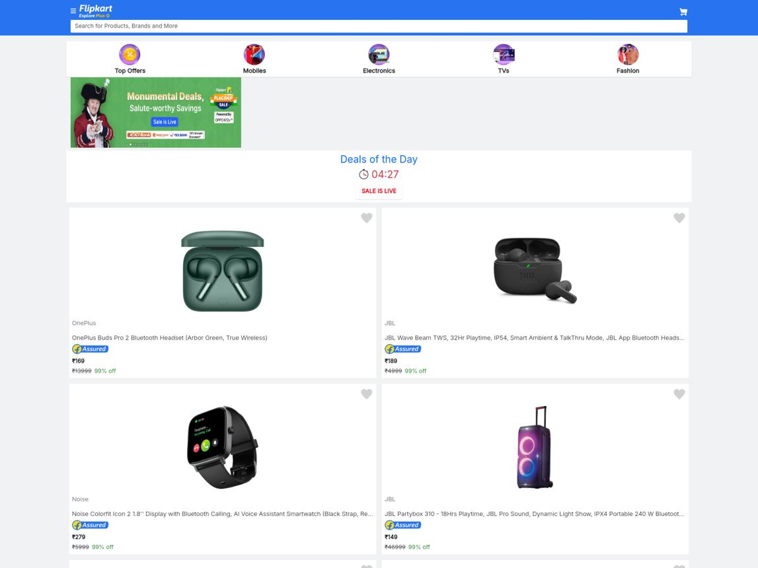
Bootstrap
3 Columns
Product Cards

HTML Code

<!DOCTYPE html>
<html lang="en">
<head>
<meta charset="UTF-8">
<meta name="viewport" content="width=device-width, initial-scale=1.0">
<title>Flipkart Product Cards</title>

<link href="https://cdn.jsdelivr.net/npm/bootstrap@5.3.3/dist/css/bootstrap.min.css" rel="stylesheet">
</head>
<body>

<div class="container mt-4">
<h2 class="text-center mb-4">Flipkart Products</h2>

<div class="row g-4">

<!-- Product 1 -->
<div class="col-md-4">
<div class="card h-100">
<img src="https://placehold.co/400x250?text=Headphones"
class="card-img-top"
alt="Headphones">

<div class="card-body">
<h5 class="card-title">Wireless Headphones</h5>
<p class="card-text">High quality sound and comfortable design.</p>
<h6>₹999</h6>
<button class="btn btn-primary">Buy Now</button>
</div>
</div>
</div>

<!-- Product 2 -->
<div class="col-md-4">
<div class="card h-100">
<img src="https://placehold.co/400x250?text=Shoes"
class="card-img-top"
alt="Shoes">

<div class="card-body">
<h5 class="card-title">Sports Shoes</h5>
<p class="card-text">Stylish and comfortable shoes for daily use.</p>
<h6>₹1499</h6>
<button class="btn btn-primary">Buy Now</button>
</div>
</div>
</div>

<!-- Product 3 -->
<div class="col-md-4">
<div class="card h-100">
<img src="https://placehold.co/400x250?text=Smartwatch"
class="card-img-top"
alt="Smartwatch">

<div class="card-body">
<h5 class="card-title">Smart Watch</h5>
<p class="card-text">Track your fitness and daily activities.</p>
<h6>₹1999</h6>
<button class="btn btn-primary">Buy Now</button>
</div>
</div>
</div>

</div>
</div>

</body>
</html>

Output Layout

Flipkart Products
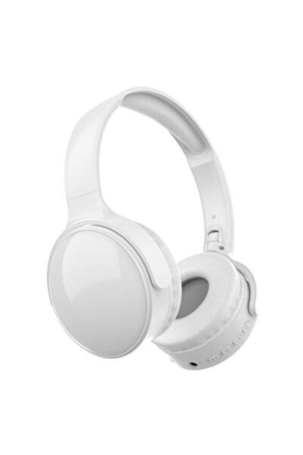
Headphones
₹999
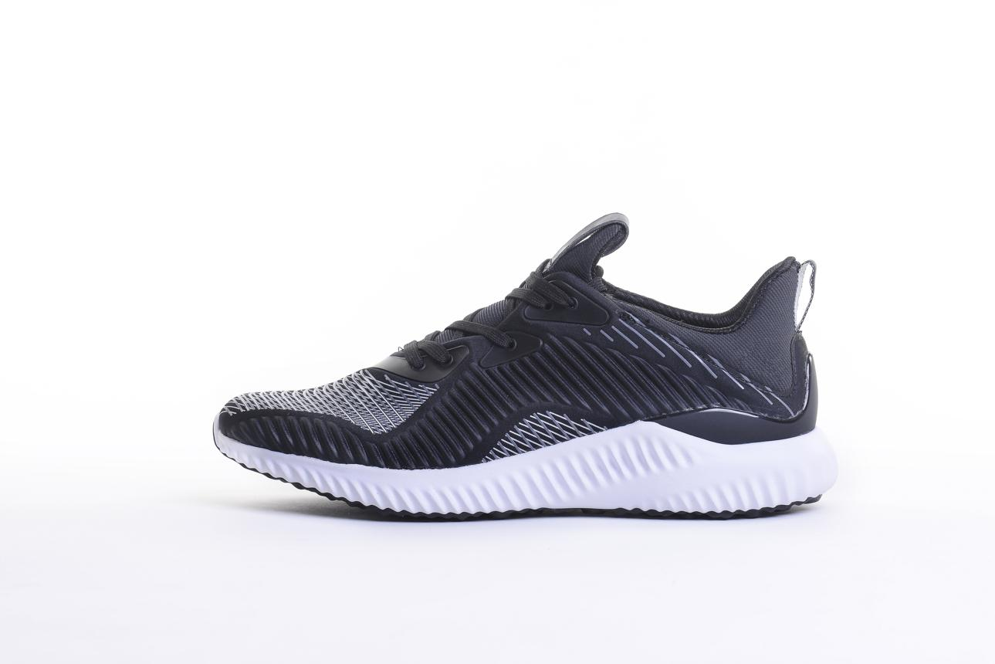Buy Now

Sports Shoes
₹1499
Buy Now
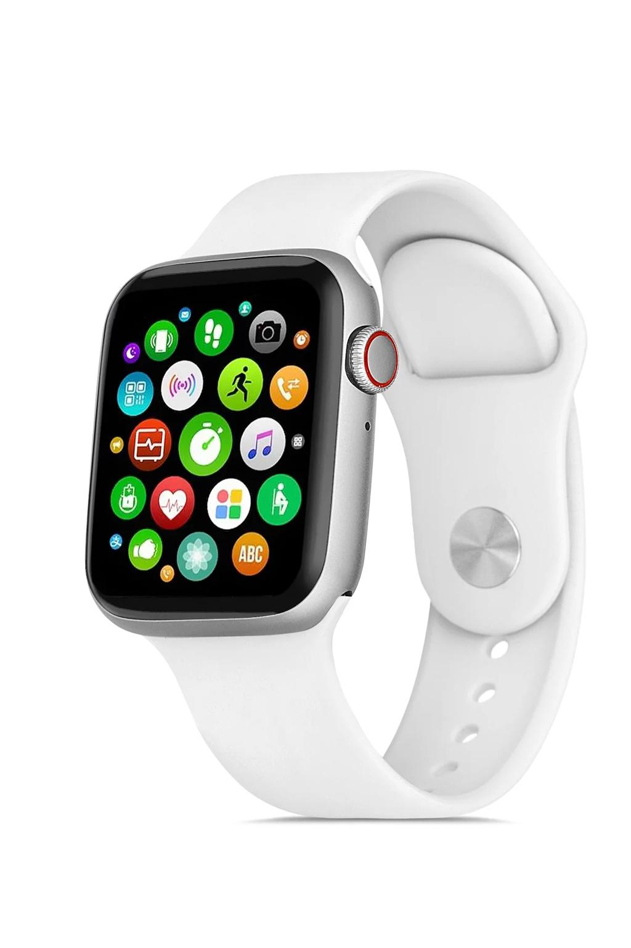
Smart Watch
₹1999
Buy Now
Three product cards in one row on medium and larger screens.
Important Bootstrap classes:
Class | Meaning
container | Creates a centered container
row | Creates a row
col-md-4 | Takes 4 of 12 columns
card | Creates a card
card-body | Card content area
btn btn-primary | Blue Bootstrap button
g-4 | Adds spacing between columns

2.Build a Zomato restaurant listing page using Bootstrap grid: arrange two restaurant cards per row, each card showing a restaurant name and a short description.<br><br><em><strong>Hint:</strong> Use col-6 inside a row to get two equal columns per row.</em>
Ans:-

Arrange two restaurant cards per row using col-6.
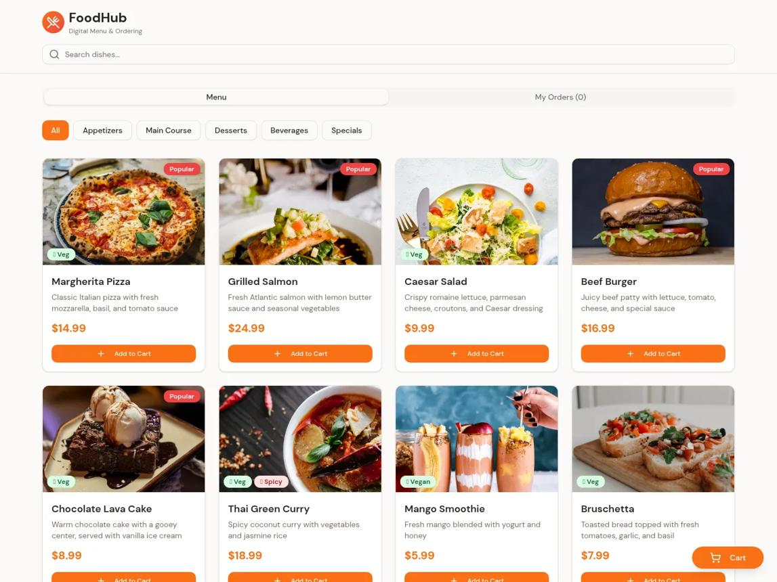

HTML Code

<!DOCTYPE html>
<html lang="en">
<head>
<meta charset="UTF-8">
<meta name="viewport" content="width=device-width, initial-scale=1.0">
<title>Zomato Restaurant Listing</title>

<link href="https://cdn.jsdelivr.net/npm/bootstrap@5.3.3/dist/css/bootstrap.min.css" rel="stylesheet">
</head>
<body>

<div class="container mt-4">

<h2 class="text-center mb-4">Zomato Restaurants</h2>

<div class="row g-3">

<!-- Restaurant 1 -->
<div class="col-6">
<div class="card h-100">
<div class="card-body">
<h5 class="card-title">Spice Villa</h5>
<p class="card-text">
Delicious Indian food and spicy dishes.
</p>
<span class="badge bg-success">4.5 ★</span>
</div>
</div>
</div>

<!-- Restaurant 2 -->
<div class="col-6">
<div class="card h-100">
<div class="card-body">
<h5 class="card-title">Pizza Palace</h5>
<p class="card-text">
Fresh pizzas with tasty toppings.
</p>
<span class="badge bg-success">4.2 ★</span>
</div>
</div>
</div>

<!-- Restaurant 3 -->
<div class="col-6">
<div class="card h-100">
<div class="card-body">
<h5 class="card-title">Dosa Corner</h5>
<p class="card-text">
South Indian dosa and traditional meals.
</p>
<span class="badge bg-success">4.4 ★</span>
</div>
</div>
</div>

<!-- Restaurant 4 -->
<div class="col-6">
<div class="card h-100">
<div class="card-body">
<h5 class="card-title">Burger House</h5>
<p class="card-text">
Juicy burgers and delicious snacks.
</p>
<span class="badge bg-success">4.1 ★</span>
</div>
</div>
</div>

</div>
</div>

</body>
</html>

Output Layout

Zomato Restaurants
Spice Villa
Delicious Indian food
4.5 ★
Pizza Palace
Fresh pizzas
4.2 ★
Dosa Corner
South Indian dosa
4.4 ★
Burger House
Juicy burgers
4.1 ★
Two equal-width restaurant cards per row.
Important:
<div class="row">
<div class="col-6">Restaurant 1</div>
<div class="col-6">Restaurant 2</div>
</div>
- col-6 = 6 columns out of 12.
- Two col-6 elements = one complete row.
- Additional cards automatically move to the next row when the total width exceeds 12 columns.

3.Design a BookMyShow-like movie details section using Bootstrap: place a movie poster image in one column and movie details (title, genre, rating, and a 'Book Now' button) in the second column, using the grid system.
Ans:-

Place a movie poster in one column and movie details in another column using Bootstrap grid.
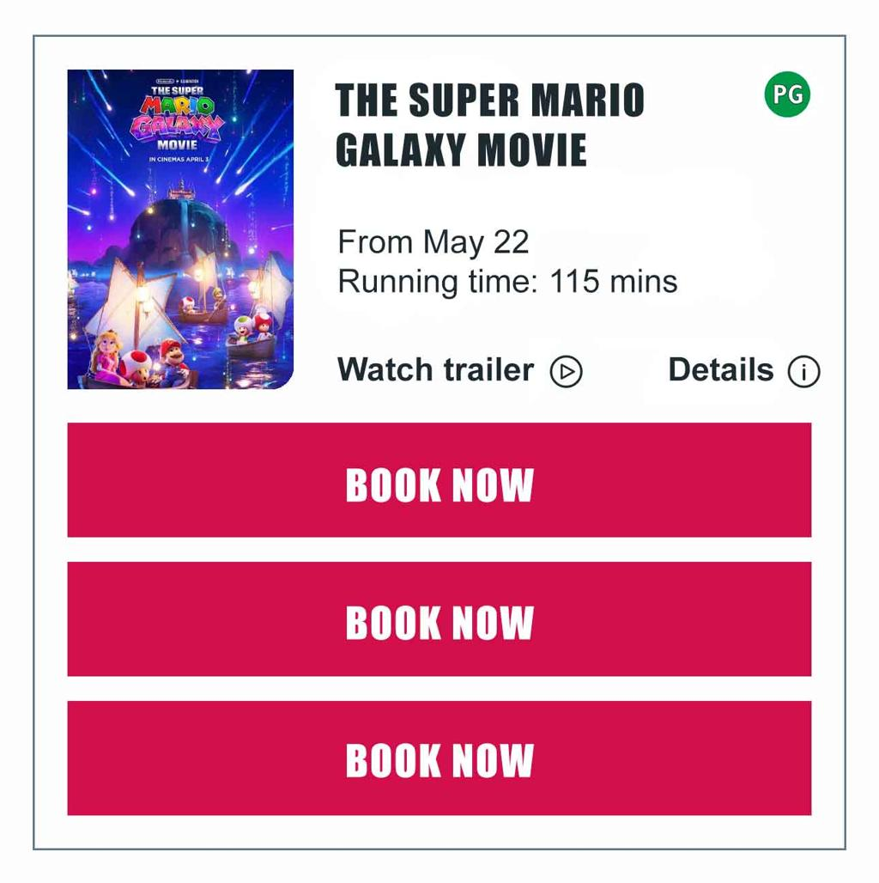

HTML Code

<!DOCTYPE html>
<html lang="en">
<head>
<meta charset="UTF-8">
<meta name="viewport" content="width=device-width, initial-scale=1.0">
<title>Movie Details</title>

<link href="https://cdn.jsdelivr.net/npm/bootstrap@5.3.3/dist/css/bootstrap.min.css" rel="stylesheet">
</head>
<body>

<div class="container mt-5">

<h2 class="text-center mb-4">Movie Details</h2>

<div class="row g-4 align-items-center">

<!-- Movie Poster -->
<div class="col-md-5">
<img src="https://placehold.co/500x650?text=Movie+Poster"
class="img-fluid rounded"
alt="Movie Poster">
</div>

<!-- Movie Details -->
<div class="col-md-7">

<h2>Avengers: Endgame</h2>

<p>
<strong>Genre:</strong> Action, Adventure, Sci-Fi
</p>

<p>
<strong>Rating:</strong>
<span class="badge bg-success">4.8 ★</span>
</p>

<p>
A group of superheroes comes together
for an exciting mission.
</p>

<button class="btn btn-danger">
Book Now
</button>

</div>

</div>
</div>

</body>
</html>

Output Layout

Avengers: Endgame
Action
Adventure
Sci-Fi
4.8 ★
A group of superheroes comes together for an exciting mission.
Book Now
Poster and movie information are displayed in two columns.
Important Bootstrap classes:
Class | Meaning
col-md-5 | Poster takes 5 columns on medium+ screens
col-md-7 | Details take 7 columns on medium+ screens
img-fluid | Makes image responsive
Rounded | Adds rounded corners
align-items-center | Vertically aligns content

4.Refactor your 2-column layout to be mobile-friendly: make the columns stack vertically on screens smaller than 576px using Bootstrap's responsive grid classes.<br><br><em><strong>Hint:</strong> Try using col-12 for xs and col-6 for md and above.</em>
Ans:-

Bootstrap Responsive Grid
Class | Screen size | Layout
col-12 | All screens by default | Full width
col-md-6 | Medium (≥768px) and above | Half width
col-lg-6 | Large (≥992px) and above | Half  - width
Note: Bootstrap 5's md breakpoint starts at 768px. To make columns full width below 576px and half width from 576px, use col-12 col-sm-6.

HTML Code (Mobile-Friendly)

<!DOCTYPE html>
<html lang="en">
<head>
<meta charset="UTF-8">
<meta name="viewport" content="width=device-width, initial-scale=1.0">
<title>Responsive Movie Layout</title>

<link href="https://cdn.jsdelivr.net/npm/bootstrap@5.3.3/dist/css/bootstrap.min.css" rel="stylesheet">
</head>
<body>

<div class="container mt-4">

<h2 class="text-center mb-4">Responsive Movie Section</h2>

<div class="row g-4">

<!-- Movie Poster -->
<div class="col-12 col-md-6">
<img src="https://placehold.co/500x350?text=Movie+Poster"
class="img-fluid rounded w-100"
alt="Movie Poster">
</div>

<!-- Movie Details -->
<div class="col-12 col-md-6">

<h2>Avengers: Endgame</h2>

<p><strong>Genre:</strong> Action, Adventure</p>

<p><strong>Rating:</strong> 4.8 ★</p>

<p>
Enjoy an exciting movie experience.
</p>

<button class="btn btn-danger">
Book Now
</button>

</div>

</div>

</div>

</body>
</html>

Responsive Layout Visualization

Preview Layout
Interactive Preview
MobileDesktop
Mobile view (less than 768px)
Movie Poster
Movie Details
Columns stack vertically. Each column takes the full width (col-12).

Key Code to Remember
<div class="row">

<div class="col-12 col-md-6">
Left Column
</div>

<div class="col-12 col-md-6">
Right Column
</div>

</div>

Simple Explanation
- col-12: Takes the full width on small screens.
- col-md-6: Takes half the row width on medium screens and above.
- row: Creates a grid row.
- g-4: Adds space between the columns.
- img-fluid: Makes the image responsive.

