Session:-8
1.Create a Flipkart-style product card in HTML and CSS, then use a meta viewport tag to ensure it scales correctly on mobile devices.
Ans:-

<!DOCTYPE html>
<html lang="en">
<head>
<meta charset="UTF-8">

<!-- Meta Viewport for Mobile -->
<meta name="viewport" content="width=device-width, initial-scale=1.0">

<title>Flipkart Product Card</title>

<style>
/* Basic Reset */
* {
margin: 0;
padding: 0;
box-sizing: border-box;
}

body {
font-family: Arial, sans-serif;
background-color: #f1f3f6;
padding: 20px;
}

/* Product Card */
.product-card {
display: flex;
align-items: center;
gap: 30px;
max-width: 900px;
margin: 20px auto;
padding: 25px;
background-color: white;
border: 1px solid #ddd;
border-radius: 8px;
}

/* Product Image */
.product-image {
width: 300px;
height: 300px;
object-fit: contain;
}

/* Product Details */
.product-details {
flex: 1;
}

.product-details h2 {
font-size: 26px;
margin-bottom: 15px;
color: #212121;
}

.product-details p {
font-size: 16px;
margin-bottom: 10px;
color: #555;
}

.rating {
display: inline-block;
background-color: #388e3c;
color: white;
padding: 5px 10px;
border-radius: 4px;
margin-bottom: 12px;
}

.price {
font-size: 24px;
font-weight: bold;
color: #212121;
margin-bottom: 15px;
}

.buy-button {
background-color: #2874f0;
color: white;
border: none;
padding: 12px 25px;
border-radius: 4px;
cursor: pointer;
font-size: 16px;
}

.buy-button:hover {
background-color: #1255c7;
}

/* 600px Breakpoint */
@media only screen and (max-width: 600px) {
.product-card {
flex-direction: column;
text-align: center;
padding: 15px;
gap: 15px;
}

.product-image {
width: 100%;
max-width: 220px;
height: 220px;
}

.product-details h2 {
font-size: 20px;
}

.product-details p {
font-size: 14px;
}

.price {
font-size: 20px;
}
}

/* 900px Breakpoint */
@media only screen and (min-width: 601px) and (max-width: 900px) {
.product-card {
padding: 20px;
gap: 20px;
}

.product-image {
width: 240px;
height: 240px;
}

.product-details h2 {
font-size: 23px;
}

.product-details p {
font-size: 15px;
}
}

/* 1200px Breakpoint */
@media only screen and (min-width: 901px) and (max-width: 1200px) {
.product-card {
padding: 25px;
}

.product-details h2 {
font-size: 25px;
}

.product-details p {
font-size: 16px;
}
}

/* Large Desktop */
@media only screen and (min-width: 1201px) {
.product-card {
padding: 30px;
}

.product-details h2 {
font-size: 28px;
}

.product-details p {
font-size: 17px;
}
}
</style>
</head>

<body>

<div class="product-card">

<!-- Product Image -->
<img
src="https://images.unsplash.com/photo-1541807084-5c52b6b3adef?w=600"
alt="Laptop"
class="product-image"
>

<!-- Product Details -->
<div class="product-details">

<h2>HP Laptop</h2>

<p>HP 15s Intel Core i5 Laptop</p>

<span class="rating">4.3 ★</span>

<p class="price">₹45,999</p>

<p>8GB RAM | 512GB SSD</p>

<p>Free delivery available</p>

<button class="buy-button">Buy Now</button>

</div>

</div>

</body>
</html>
2.Add media queries to your product card so that when the screen width is 600px or less, the card layout switches from horizontal (image and details side by side) to vertical (image on top, details below).
Ans:-

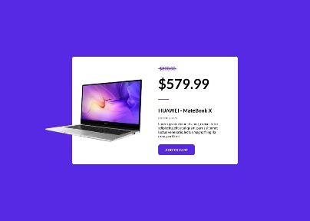
- Image and details appear side by side.
- display: flex is used.
- Product image is on the left.
- Product details are on the right.

Mobile Layout
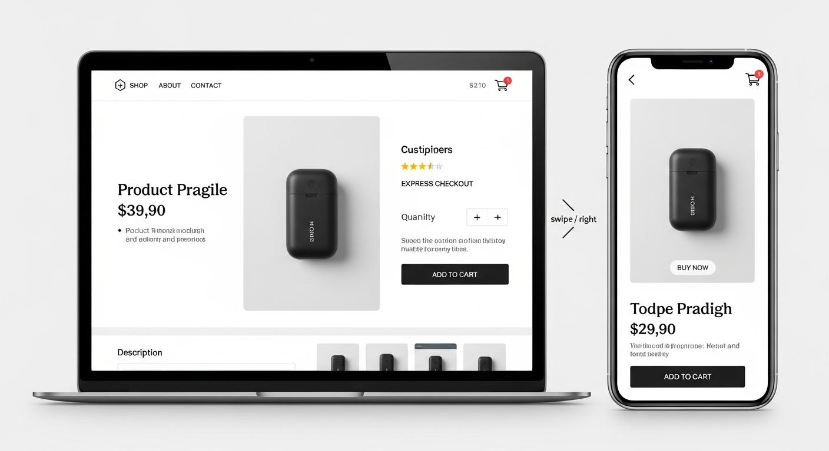
- Image appears on top.
- Product details appear below.
- Text is centered.
- Card padding and font sizes are reduced.

Important CSS
@media only screen and (max-width: 600px) {

.product-card {
flex-direction: column;
text-align: center;
padding: 15px;
}

}
Explanation:
Property | Meaning
@media | Applies CSS based on screen conditions
max-width: 600px | Applies when the screen is 600px or smaller
flex-direction: column | Places items vertically
text-align: center | Centers the text
padding: 15px | Adds space inside the card

3.Set up three breakpoints (600px, 900px, 1200px) for your product card and change the card's font size and padding at each breakpoint to improve readability on different devices.<br><br><em><strong>Hint:</strong> Use @media only screen and (max-width: ...) in your CSS for each breakpoint.</em>
Ans:-

Breakpoint Table
Screen Size | Device | Layout | Font Size | Padding
Up to 600px | Mobile | Vertical | 20px | 15px
601px–900px | Tablet | Horizontal | 23px | 20px
901px–1200px | Small Desktop | Horizontal | 25px | 25px
Above 1200px | Large Desktop | Horizontal | 28px | 30px

Example CSS for Three Breakpoints
/* Mobile */
@media only screen and (max-width: 600px) {
.product-card {
flex-direction: column;
padding: 15px;
}

.product-details h2 {
font-size: 20px;
}
}

/* Tablet */
@media only screen and (min-width: 601px) and (max-width: 900px) {
.product-card {
padding: 20px;
}

.product-details h2 {
font-size: 23px;
}
}

/* Small Desktop */
@media only screen and (min-width: 901px) and (max-width: 1200px) {
.product-card {
padding: 25px;
}

.product-details h2 {
font-size: 25px;
}
}
Note: The min-width and max-width conditions prevent overlapping rules between the breakpoints.

4.Test your responsive product card by resizing your browser window and taking screenshots at mobile, tablet, and desktop widths; submit the screenshots along with a short note on what changes at each size.
Ans:-

Step-by-Step Testing
- Open the HTML file
Open product.html in Google Chrome.
- Open Developer Tools
Press F12 or Ctrl + Shift + I.
- Enable Device Toolbar
Press Ctrl + Shift + M to test mobile screen sizes.
- Select a screen width
Test mobile, tablet, and desktop widths.
- Take screenshots
Use Win + Shift + S on Windows to capture the screen.

Screenshot 1: Mobile (Example width: 375px)
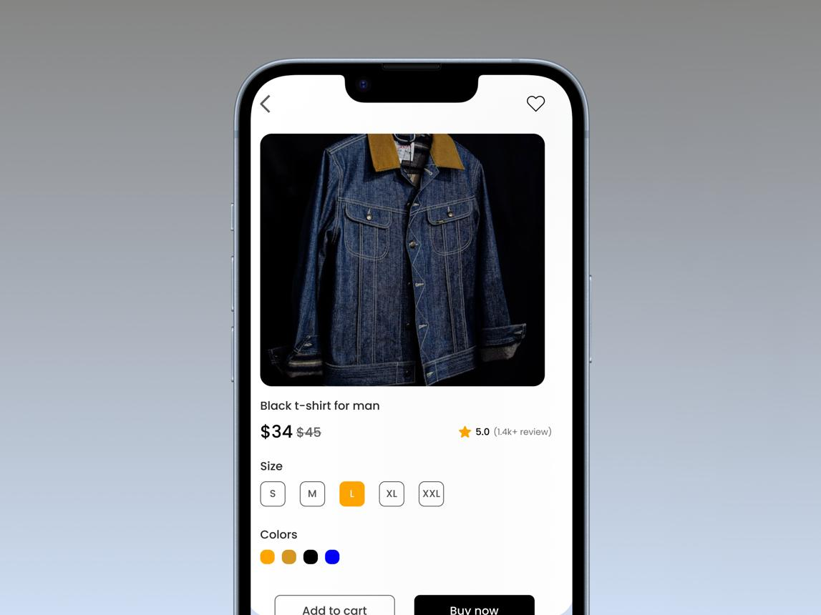
Short Note:
At mobile width (375px), the product card changes from horizontal to vertical. The image appears on top, product details appear below, and the font size and padding are reduced for better readability.

Screenshot 2: Tablet (Example width: 768px)
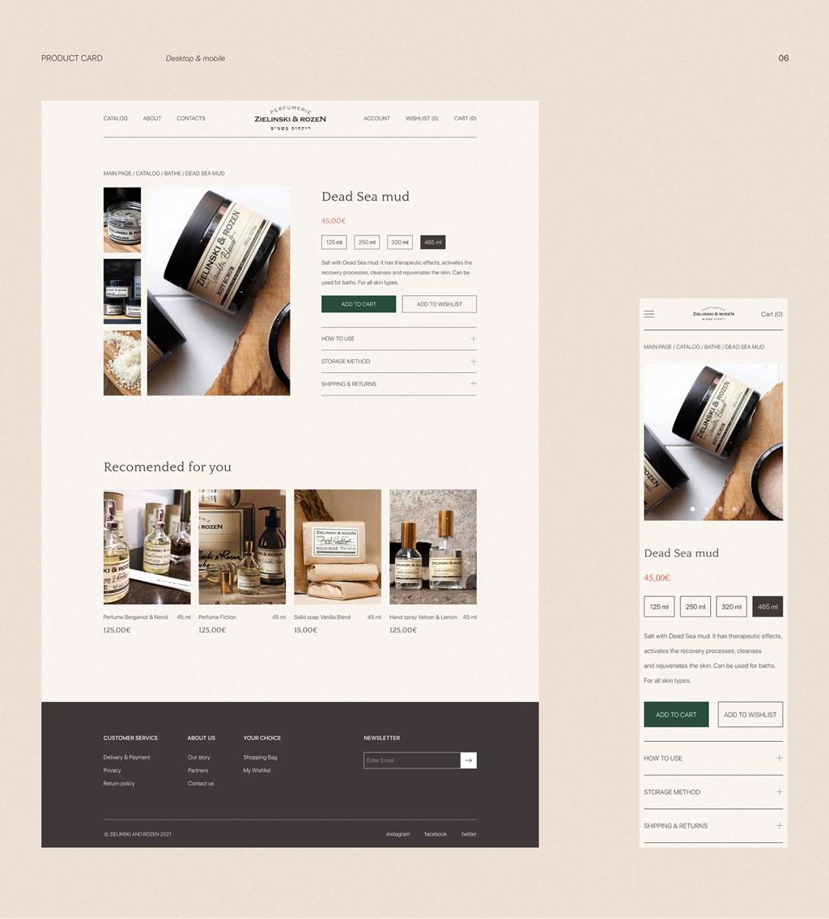
Short Note:
At tablet width (768px), the product card remains horizontal. The image and details are displayed side by side, with medium padding and font sizes.

Screenshot 3: Desktop (Example width: 1440px)
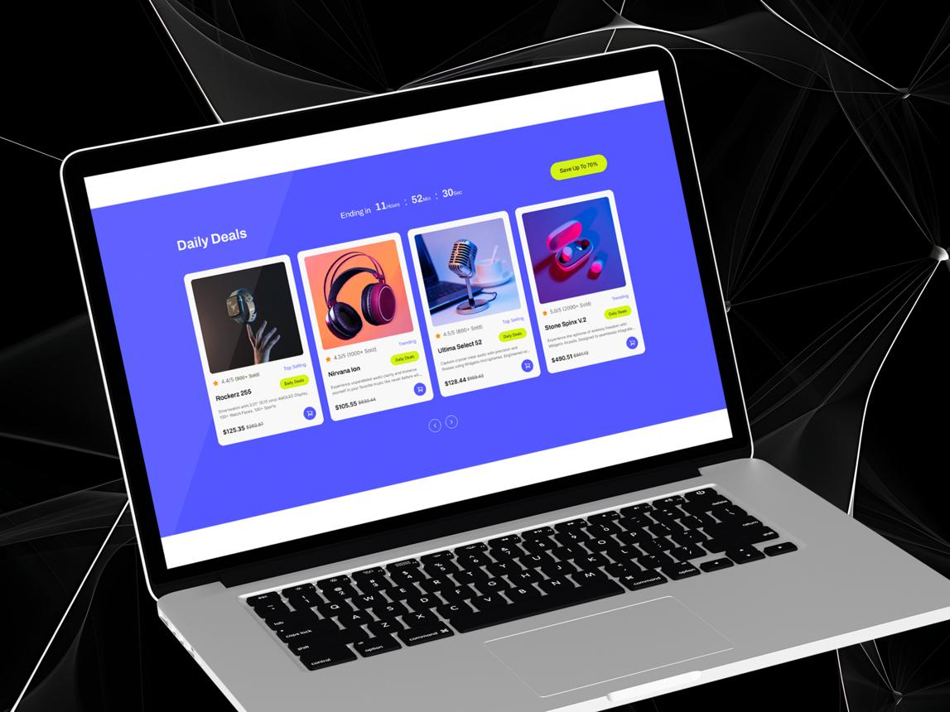
Short Note:
At desktop width (1440px), the product card displays horizontally with larger font sizes and padding. The card is centered on the page, making the content clear and easy to read.

Step-by-Step Testing
- Open the HTML file
Open product.html in Google Chrome.
- Open Developer Tools
Press F12 or Ctrl + Shift + I.
- Enable Device Toolbar
Press Ctrl + Shift + M to test mobile screen sizes.
- Select a screen width
Test mobile, tablet, and desktop widths.
- Take screenshots
Use Win + Shift + S on Windows to capture the screen.

Screenshot 1: Mobile (Example width: 375px)
Short Note:
At mobile width (375px), the product card changes from horizontal to vertical. The image appears on top, product details appear below, and the font size and padding are reduced for better readability.

Screenshot 2: Tablet (Example width: 768px)
Short Note:
At tablet width (768px), the product card remains horizontal. The image and details are displayed side by side, with medium padding and font sizes.

Screenshot 3: Desktop (Example width: 1440px)
Short Note:
At desktop width (1440px), the product card displays horizontally with larger font sizes and padding. The card is centered on the page, making the content clear and easy to read.

