Data Analysis and Visualization
for Agribusiness
Week 3 Internship Task Report
Prepared as a practical sample report
Focus: crop yield, seasonal patterns, farm costs, and market dynamics

1. Introduction
Agribusiness decisions are influenced by several connected factors, including crop productivity, weather, input prices, labour availability, storage, transport, and the selling price received by farmers. Looking at each factor separately can make it difficult to understand what is really happening. A structured analysis helps bring these details together and makes the results easier to discuss with farm managers, buyers, and other stakeholders.
The purpose of this report is to explain a practical workflow for analysing agribusiness data and presenting the findings through charts. The main measures considered are crop yield per hectare, operating cost by category, seasonal changes, and the relationship between market supply and selling price. The report also covers tool selection, interpretation, data limitations, and how the results could inform business decisions.
Important note: the figures and charts in this report are illustrative sample data created to demonstrate the method. They are not verified observations from a particular farm, district, or market. A real analysis should replace them with properly collected farm records and market data before any business decision is made.

2. Data and Analysis Approach
I would begin by collecting data from farm registers, purchase bills, harvest records, local market reports, weather sources, and transport invoices. Before analysing anything, I would check whether the records use consistent dates, units, crop names, and location identifiers. For example, yield should be recorded in tonnes per hectare, while costs should use the same currency and reporting period.
A practical workflow would be:
- Define the business question, such as why yield changed or which cost category is increasing fastest.
- Collect the relevant records and note their source, date range, and level of detail.
- Clean the data by checking missing values, duplicate rows, inconsistent units, and unusual entries.
- Create useful measures, including yield per hectare, cost per hectare, total revenue, gross margin, and average selling price.
- Compare results across months, crops, farms, or market locations where the data allows a fair comparison.
- Create charts, check whether the patterns are supported by enough observations, and explain the practical meaning.

3. Key Agribusiness Metrics
Metric | How it can be measured | Why it matters
Crop yield | Harvested quantity ÷ cultivated area | Shows productivity and supports crop planning.
Cost per hectare | Total relevant farm cost ÷ cultivated area | Helps compare production efficiency across fields.
Gross margin | Sales revenue − variable costs | Indicates how much remains to cover fixed costs and profit.
Seasonal trend | Monthly or seasonal comparison of yield, rainfall, and costs | Helps plan sowing, labour, irrigation, and harvesting.
Market price | Average selling price by date, crop, or market | Supports decisions about when and where to sell.
Supply and demand indicators | Market arrivals, quantity sold, and price movements | Can help explain price changes, but needs contextual data.

4. Methodology for Data Visualization
The chart type should follow the question rather than simply making the report look attractive. I would select a visualization based on the kind of data, the comparison required, the number of categories, and the audience. The chart should have a clear title, labelled axes, units, readable scales, and a short explanation underneath.

4.1 Tool selection
Excel or Google Sheets is useful for a small dataset because data cleaning, formulas, pivot tables, and basic charts can be handled in one place. Python with Pandas and Matplotlib is more suitable when there are many files, repeated monthly reports, or a need to reproduce the same analysis consistently. Power BI or Tableau may be useful when managers need interactive dashboards with filters. The final choice depends on data size, budget, team skills, update frequency, sharing needs, and whether the results must be automated.

4.2 Choosing the right chart
Chart type | Best use in agribusiness | Reason for choosing it
Bar chart | Compare costs across seeds, fertilizer, labour, irrigation, and transport. | Categories are easy to compare side by side.
Line chart | Show crop yield, rainfall, or prices over months. | Makes direction, seasonality, and turning points visible.
Scatter plot | Explore fertilizer spending against crop yield. | Shows whether two numerical variables appear related and highlights unusual observations.
Histogram or box plot | Review variation in yields across farms or fields. | Shows spread and possible outliers, not just the average.
Table or KPI card | Summarise total cost, yield, margin, or price. | Useful when the reader needs exact values quickly.

4.3 Steps to create the visualizations
- Import the cleaned dataset into Excel, Google Sheets, or Python.
- Choose the relevant fields and confirm that numeric columns contain numbers and dates are recognised correctly.
- Create a pivot table or grouped summary when the raw records contain many transactions.
- Insert the chart that best matches the question: line for time, bar for categories, and scatter for two numerical measures.
- Add a meaningful title, axis labels, units, a legend where needed, and a source note.
- Check for misleading scales, crowded labels, unnecessary 3D effects, and colour combinations that are difficult to read.
- Compare the chart with the underlying data and write a short interpretation that distinguishes observation from explanation.

5. Sample Visualizations and Interpretation

5.1 Crop-yield trend
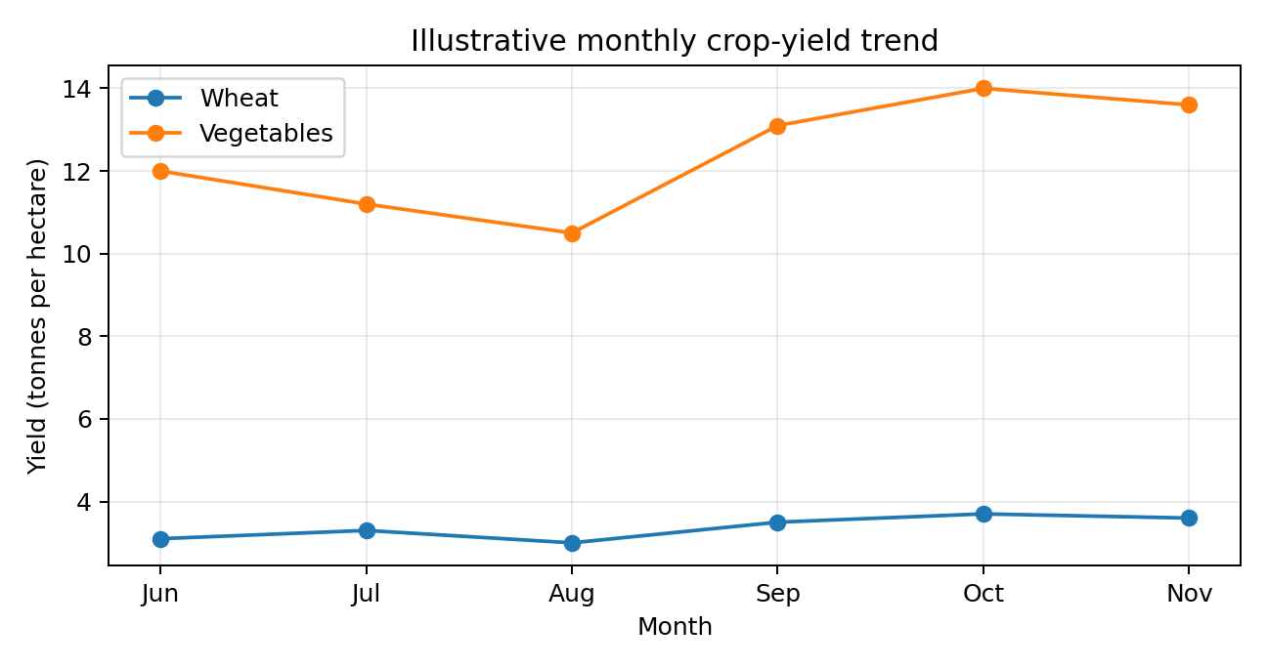
The sample line chart shows wheat yield rising from 3.1 tonnes per hectare in June to 3.7 in October, followed by a small decline in November. The vegetable series also rises after August. If similar patterns appeared in real records, the next step would be to check rainfall, crop variety, sowing dates, irrigation, pest pressure, and the area harvested. The chart shows a pattern, but it does not establish the reason for the change.

5.2 Cost breakdown
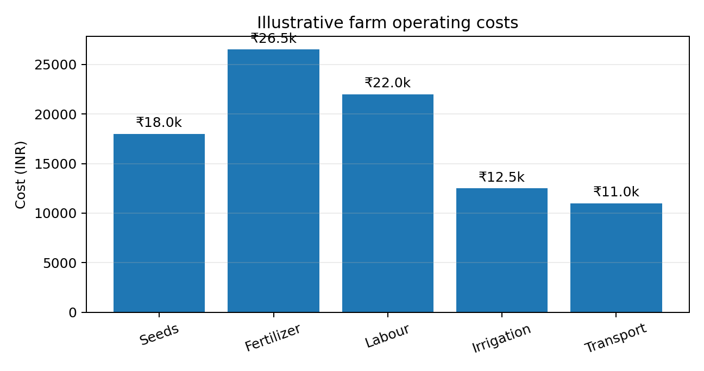
In this illustrative example, fertilizer is the largest listed cost at ₹26,500, followed by labour at ₹22,000. This suggests that fertilizer use and labour planning deserve a closer review. It would not be sensible to cut fertilizer automatically: the farm should first check application rates, soil-test results, crop requirements, and yield outcomes. Costs should also be compared per hectare and across similar crops to avoid unfair comparisons.

5.3 Market price and supply
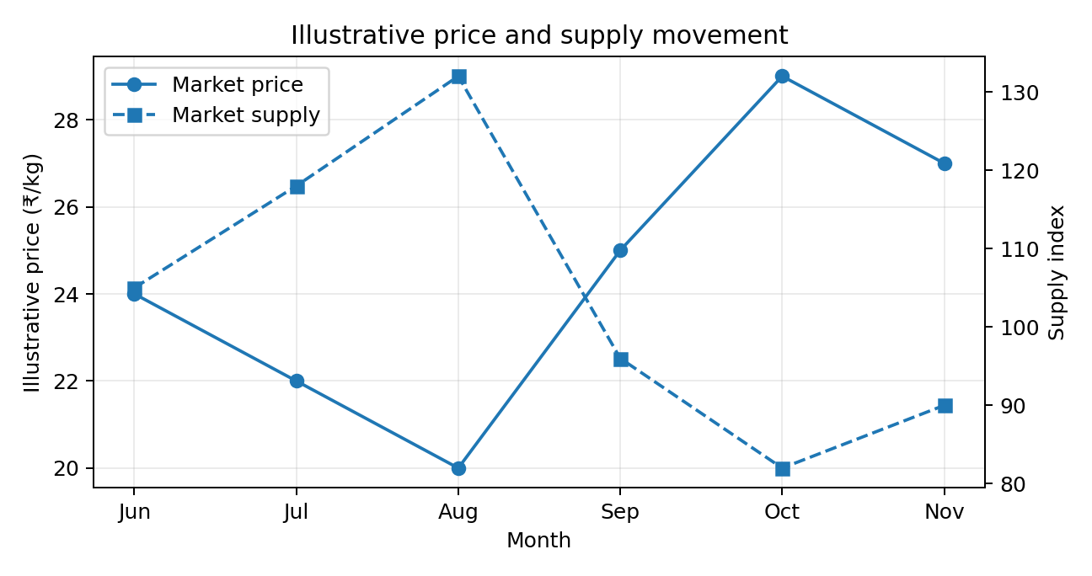
The sample chart shows prices rising as the supply index falls between August and October. This is consistent with a possible supply-price relationship, but it is not proof that supply alone caused the price increase. Quality, demand, competing markets, transport disruptions, festivals, imports, and weather may also affect prices. For a fair analysis, the team should use actual market arrivals and prices for the same crop, market, and dates.

5.4 Fertilizer spending and yield
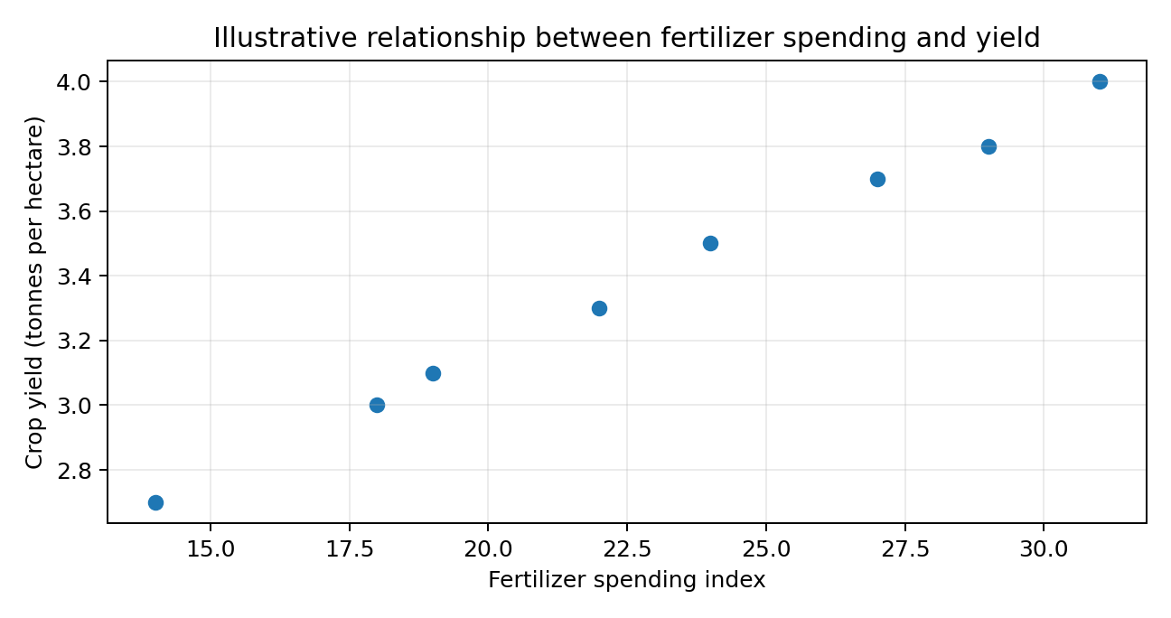
The sample scatter plot has a generally positive pattern: higher fertilizer-spending index values occur alongside higher yields. However, spending is not the same as correct nutrient application. Soil quality, rainfall, crop type, and farm management may influence both measures. A correlation calculation could summarise the association, but it should not be described as a causal effect without a stronger study design.

6. Key Findings and Business Implications
- Productivity should be reviewed by crop and season. A monthly average can hide differences between fields, varieties, or planting dates.
- Input costs should be assessed alongside output and gross margin. A high expense is not automatically wasteful if it improves profitable yield.
- Market prices should be interpreted with supply, demand, quality, and transport information. A single month's price is not enough to set a selling strategy.
- Repeated reporting can help managers plan labour, irrigation, input purchases, storage, and the timing of sales.
- The next practical step is to turn the charts into a small monthly dashboard and review changes with farm staff before changing operations.

7. Limitations and Statistical Significance
The main limitation of this report is that the data is illustrative and intentionally small. It cannot support claims about real farms or markets. Real datasets may have missing invoices, inaccurate field areas, delayed market reports, different measurement methods, or incomplete records from smaller farms. Results may also be affected by weather shocks, crop variety, soil differences, pest outbreaks, government policies, and changing input prices.
Statistical significance should be considered only after collecting enough reliable observations and defining a specific question. For example, a team could compare average yield between two methods, report the difference and confidence interval, and use a suitable statistical test if its assumptions are met. A small p-value alone does not prove that a difference is commercially important. The size of the effect, uncertainty, data quality, and cost of acting on the result all matter. When several crops or months are tested, the risk of finding a chance pattern also increases. Results should therefore be treated as evidence to investigate, not as an automatic instruction.

8. Conclusion
A clear analysis process can help agribusiness teams move from scattered records to useful operational insights. Yield trends can support crop planning, cost charts can identify areas for review, and market charts can help frame selling and storage decisions. Scatter plots and basic statistical measures can identify relationships worth investigating, while careful interpretation helps avoid confusing correlation with cause.
The most important lesson is that visualization is only one part of the process. Reliable decisions depend on accurate data, fair comparisons, suitable methods, and knowledge of the farm or market context. I would use this workflow as a repeatable monthly review: update the data, check its quality, refresh the charts, discuss the results with the people who understand the operation, and record which actions are taken and what happens afterward.

Appendix: Sample data notes
All values shown in the charts are demonstration values created for this report. The cost chart represents sample operating costs in Indian rupees. The market chart uses a simplified supply index rather than actual market arrivals. The fertilizer scatter plot uses an index to show the analytical method. These examples should be replaced with verified, dated, and consistently measured records for a real agribusiness project.

