Check-in 3: L2 & L4 — Dhruv Sachin Jain
Fake Review Detection on Yelp Using Multi-Signal Analysis
CMPE 255 – Data Mining, Spring 2026 — Group 7

6.2 Layer 2: FP-Growth Association Rule Mining (Completed)
For L2, we use reviewer_profiles.csv from the L1 pipeline because it already summarizes each reviewer's behavior into one row. Rather than directly inputting numbers into FP-Growth, we take a small number of key features and encode them into simple categories so that each reviewer is treated as a basket of traits. We use FP-Growth instead of Apriori because reviewer_profiles.csv is large (260,277 rows), and Apriori gets bogged down generating and testing millions of candidate itemsets. FP-Growth, developed by Han, Pei, and Yin [8], compresses the transaction database into a frequent-pattern tree and mines patterns through conditional pattern bases, eliminating the expensive candidate generation process altogether. We then examine support, confidence, and lift to ensure we are finding meaningful combinations of behaviors and check that the top results are associated with higher spam rates, since we are looking for combinations that are actually useful for detecting suspicious reviewers.
The L2 pipeline consists of three sequential scripts. The first script (01_basket_encoding.py) discretizes four numeric reviewer features into categorical basket items:
Feature | Bins
review_count | Low (<=2) / Medium (3-10) / High (>10)
tenure_days | new (<30d) / moderate (30-180d) / established (181-365d) / veteran (>365d)
max_seller_fraction | Low (<0.50) / High (>=0.50)
burst_score | Normal (<=2) / Bursty (>2)
Table 3: Basket Encoding Discretization Scheme
Each reviewer's discretized features form a basket (e.g., "review_count=Low | tenure=new | seller_conc=High | burst=Normal"). All 260,277 reviewers were encoded. The overall dataset spam rate is 13.2%.
The second script (02_fpgrowth_mining.py) one-hot encodes the baskets with mlxtend's TransactionEncoder and runs FP-Growth with min_support = 0.05, meaning an itemset must appear in at least ~13,000 reviewers to be considered frequent. This produced 35 frequent itemsets. The third script (03_rule_analysis.py) extracts association rules with min_lift = 1.2 and correlates each rule's antecedent group with the mean spam rate of reviewers matching that pattern. Rules where the antecedent group's spam rate exceeds 20% (well above the 13.2% baseline) are flagged as spam-correlated.

6.2.1 Results
The dominant basket profile is {review_count=Low, tenure=new, seller_conc=High, burst=Normal}, appearing in 73% of all reviewers with a combined support of 0.73. This profile carries a spam rate of 29.1%, more than double the dataset average. In contrast, the medium-activity profile {review_count=Medium, seller_conc=Low} has 100% confidence association with burst=Normal behavior and carries a much lower spam rate (~8%). Veteran reviewers with diverse seller portfolios consistently appear in low-spam-rate groups (3.6% for tenure=veteran).
24 rules exceeded the 20% spam-rate cutoff. The top rules all involve the combination {tenure=new, review_count=Low, seller_conc=High}, confirming that new, low-volume reviewers concentrated on a single seller form the highest-risk behavioral profile. This finding aligns with the L1 OLAP result that new accounts are 14x more likely to produce spam than veterans.
Antecedent | Consequent | Support | Conf. | Lift | Spam Rate
{tenure=new, review_count=Low} | {burst=Normal, seller_conc=High} | 0.730 | 1.00 | 1.24 | 29.1%
{tenure=new, seller_conc=High} | {burst=Normal, review_count=Low} | 0.730 | 1.00 | 1.24 | 29.1%
{tenure=new, burst=Normal} | {review_count=Low, seller_conc=High} | 0.730 | 0.99 | 1.23 | 29.0%
{seller_conc=High} | {review_count=Low} | 0.808 | 1.00 | 1.24 | 27.2%
{review_count=Low} | {seller_conc=High} | 0.808 | 1.00 | 1.24 | 27.2%
Table 4: Top 5 Spam-Correlated Association Rules

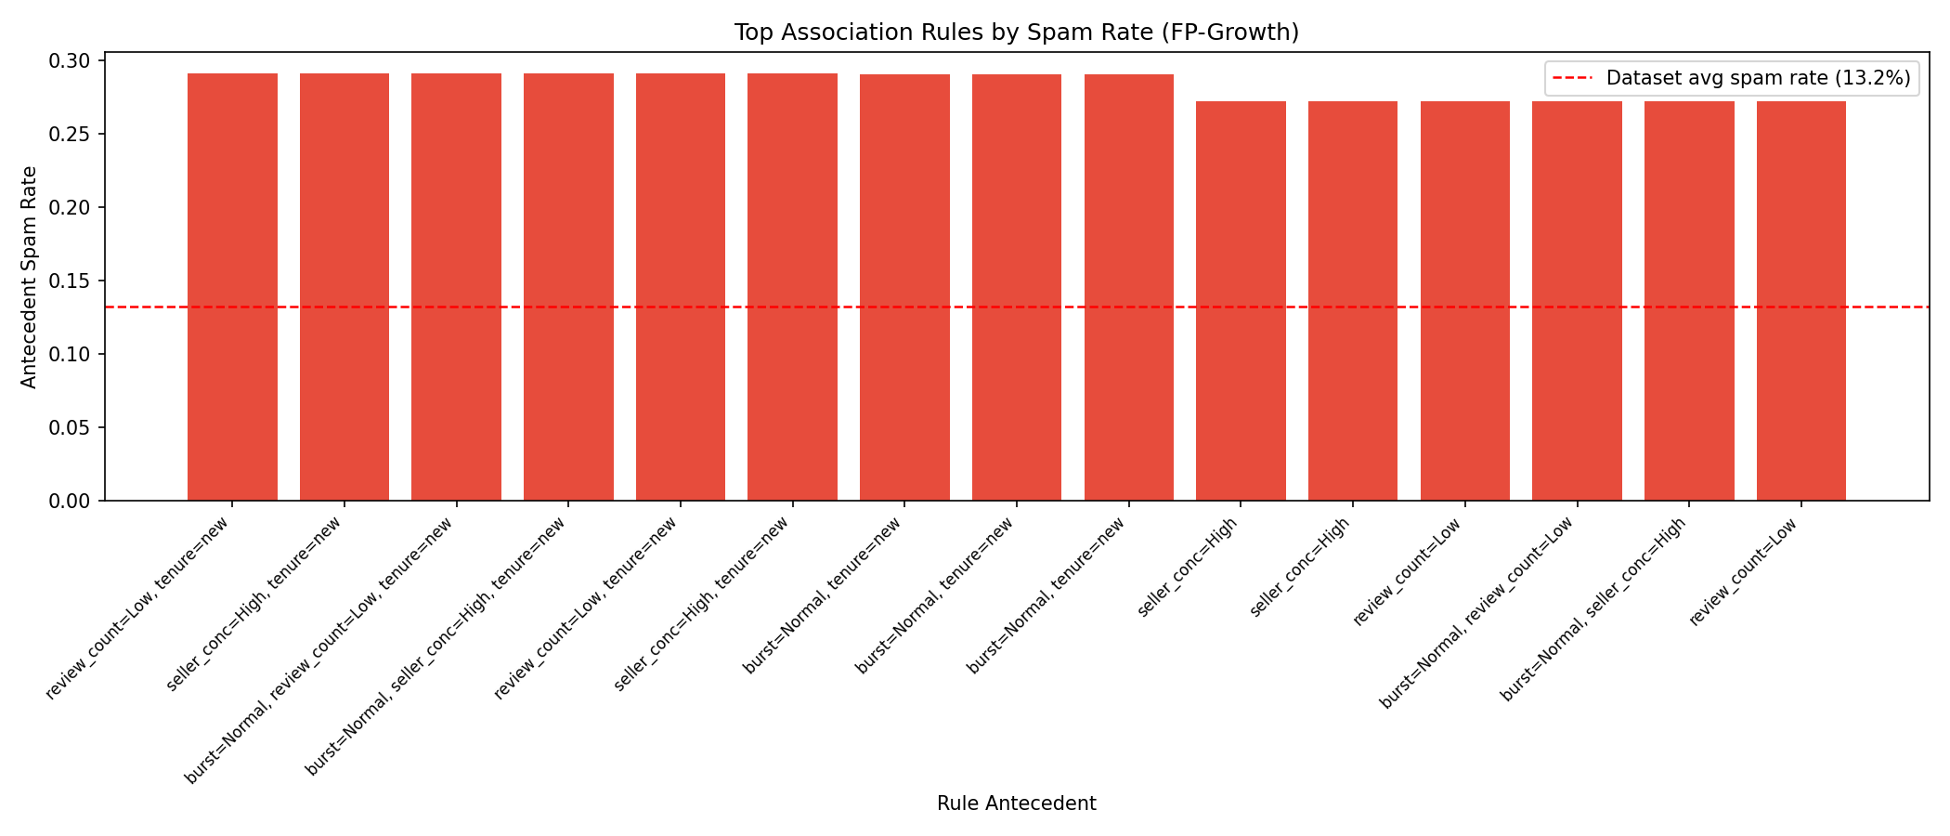
Figure 6: Top association rules by antecedent spam rate. The dashed line marks the 13.2% dataset average.
These rule-based signals are passed to L5 as engineered features (antecedent match scores) to strengthen the final classification model. The key takeaway from L2 is that FP-Growth surfaces a clear spam fingerprint: new, low-volume reviewers concentrated on a single seller are consistently associated with the highest spam rates in the dataset.

6.4 Layer 4: K-Means and DBSCAN Clustering (Completed)
For L4, the same reviewer_profiles.csv from L1 is used, but this time for clustering rather than pattern mining. We select 10 behavioral features and prepare them by first applying log1p transforms to review_count, reviews_per_week, tenure_days, burst_score, and unique_sellers since these tend to be heavily right-skewed, then scaling everything with StandardScaler so no single feature dominates the distance calculations. Importantly, spam_rate is excluded from the clustering inputs to avoid data leakage; it is used only for post-hoc evaluation.
K-Means groups reviewers into broad behavioral clusters, with the value of K chosen using both the elbow method and silhouette analysis to ensure the clusters are not just mathematically compact but also reasonably well-separated. DBSCAN is included alongside K-Means because it catches things K-Means can miss. K-Means forces every reviewer into a cluster regardless of fit, whereas DBSCAN, introduced by Ester et al. [9], can label unusual low-density points as noise, which may correspond to potential spammer outliers. The clustering results are then evaluated by looking at spam rate per cluster and cluster size distribution.
The L4 pipeline consists of four sequential scripts operating on all 260,277 reviewers.

6.4.1 Preprocessing
The first script (01_preprocessing.py) selects 10 behavioral features: review_count, reviews_per_week, tenure_days, avg_rating, rating_std, unique_sellers, max_seller_fraction, burst_score, rating_entropy, and avg_review_length. Five right-skewed features undergo log1p transformation, followed by StandardScaler normalization. A Pearson correlation heatmap is generated to check for redundancy.
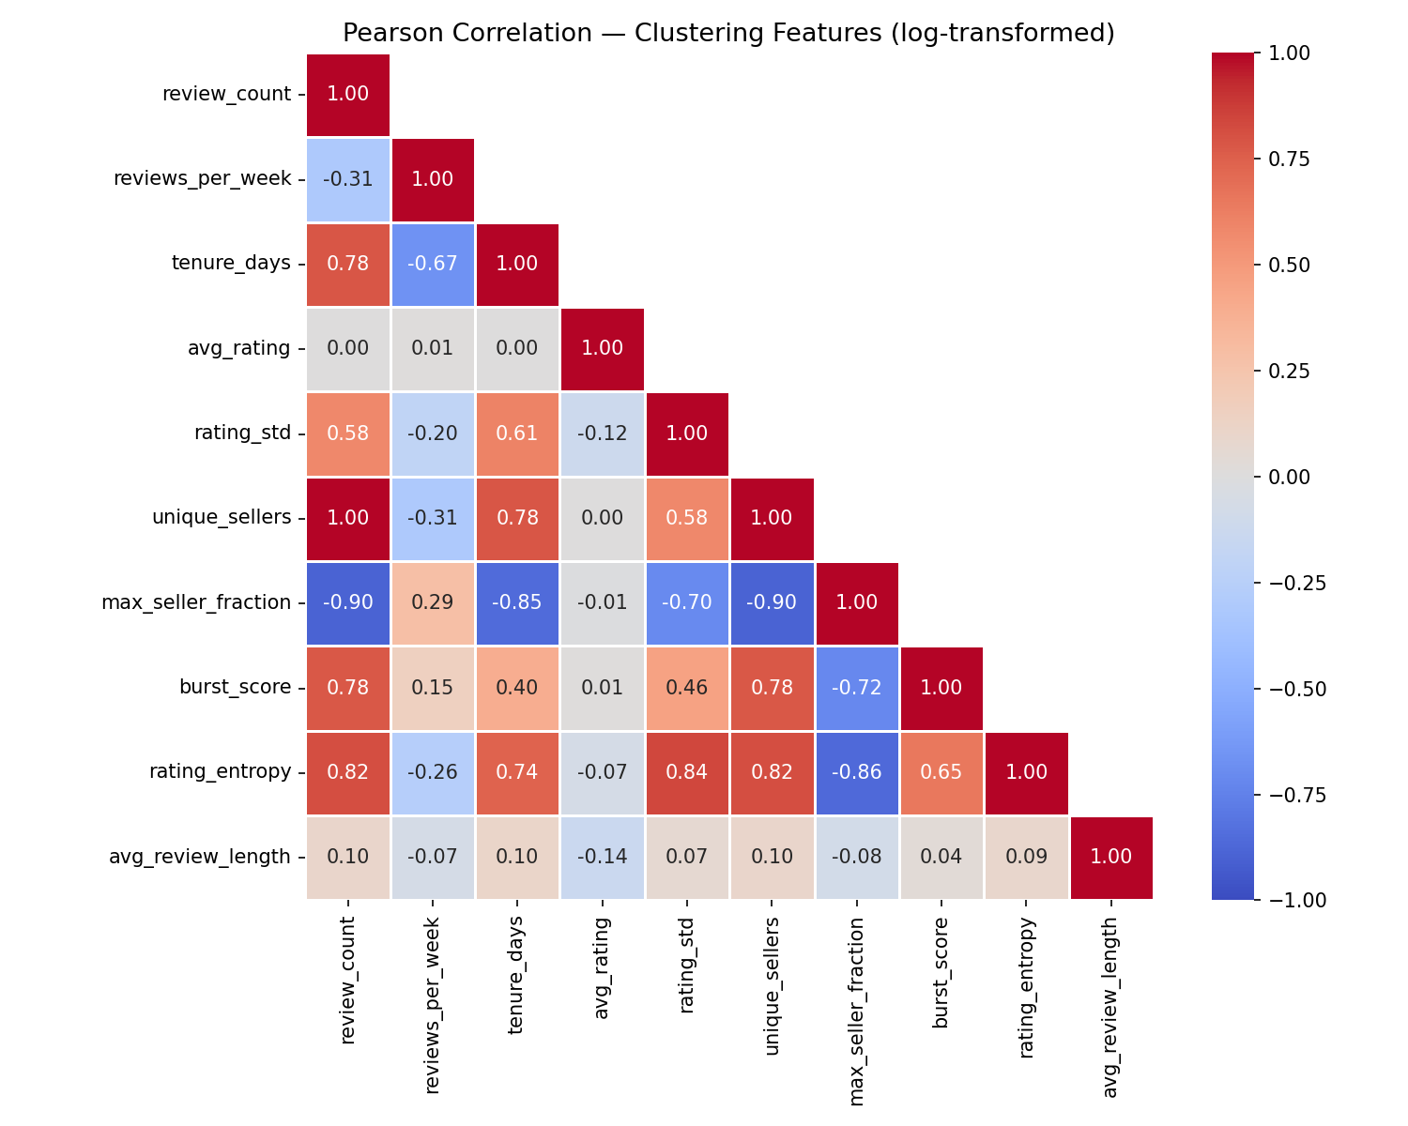
Figure 7: Pearson correlation heatmap of the 10 clustering features (log-transformed). No feature pairs exceed |r| > 0.85.
The heatmap confirms no feature pairs exceed |r| > 0.85, so all 10 features are retained without dimensionality reduction.

6.4.2 K-Means Clustering
The second script (02_kmeans_clustering.py) runs K-Means for K = 2 through 12. Both the elbow method and silhouette analysis converge on K = 5 as the recommended number of clusters.
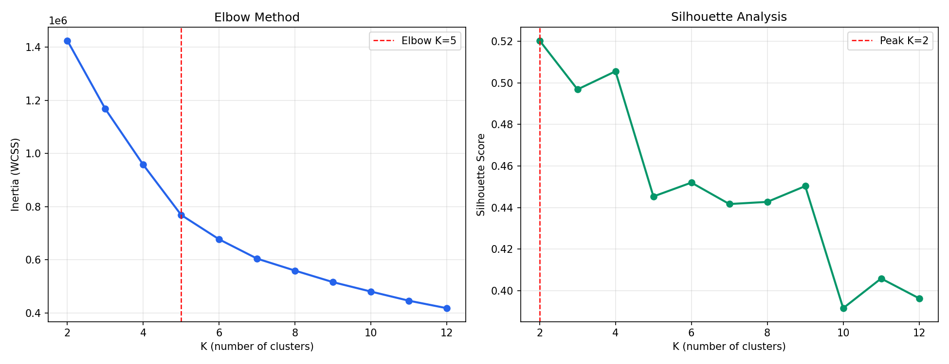
Figure 8: Elbow method (left) and silhouette analysis (right) for K selection. Both point to K = 5.

Cluster | Size | Spam Rate | Behavioral Profile
0 | 131,127 (50.4%) | 27.6% | New, single-review, one-seller, zero entropy
1 | 44,650 (17.2%) | 7.6% | Veteran, diverse sellers, varied ratings
2 | 19,295 (7.4%) | 3.2% | Power reviewers: high activity, multi-seller, bursty
3 | 40,914 (15.7%) | 36.5% | New, single-review, one-seller (highest spam)
4 | 24,291 (9.3%) | 24.0% | New-ish, moderate burst, diverse but short tenure
Table 5: K-Means Cluster Summary (K = 5)
Clusters 0 and 3 together account for 66% of reviewers and carry the highest spam rates (27.6% and 36.5%). Both are characterized by new reviewers with a single review focused on one seller and zero rating entropy, the same profile flagged by L2 association rules. Cluster 2 (veteran power reviewers) has the lowest spam rate at 3.2%.
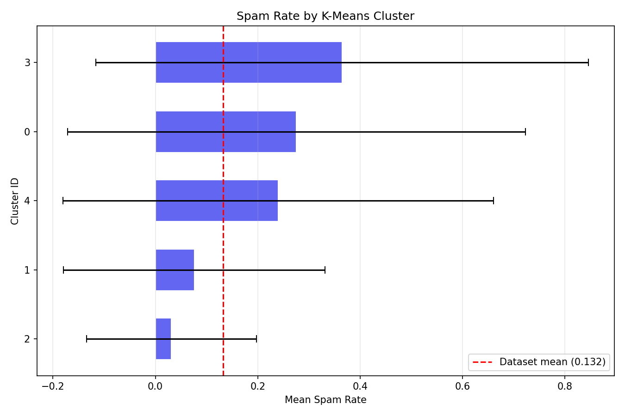
Figure 9: Spam rate by K-Means cluster. Clusters 0 and 3 are well above the dataset mean.

6.4.3 DBSCAN Clustering
The third script (03_dbscan_clustering.py) tunes eps via k-distance analysis (k = 5) and an epsilon sweep over [0.3, 0.4, 0.5, 0.6, 0.7] with min_samples = 10, targeting 1-5% noise. The selected eps yields 196 clusters and 9,021 noise points (3.5% of reviewers).
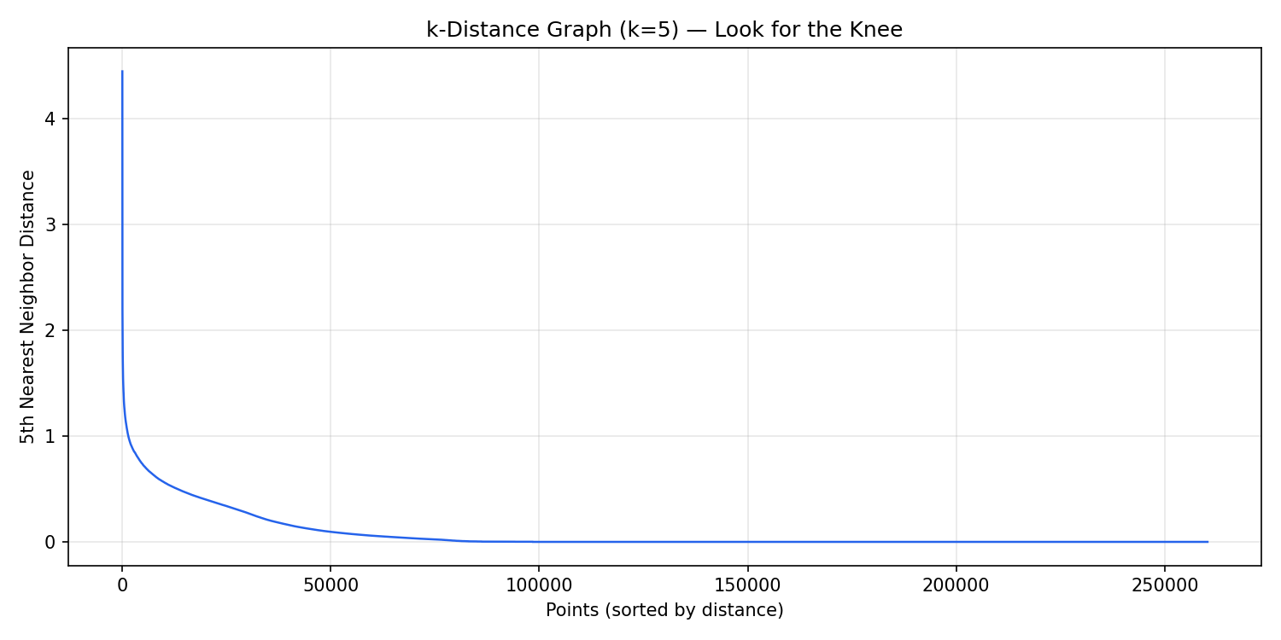
Figure 10: k-distance graph (k = 5) for eps selection. The knee region guides the choice of eps.
The noise group (label = -1) has a spam rate of 11.0%, close to the dataset average, suggesting that DBSCAN noise reviewers are anomalous in behavior but not necessarily spammers. The largest DBSCAN cluster (cluster 0, 81K reviewers) mirrors K-Means cluster 0 with a 29.3% spam rate. Cluster 13 (19K reviewers) has the highest spam rate at 47.7%. This confirms that density-based grouping can surface concentrated pockets of suspicious accounts.
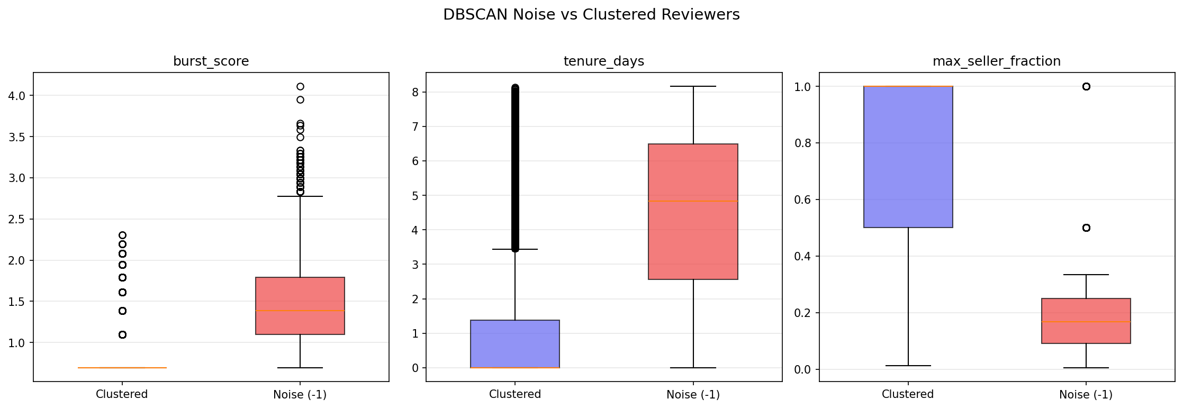
Figure 11: Feature comparison between DBSCAN noise and clustered reviewers.

6.4.4 Cluster Characterization
The final script (04_cluster_analysis.py) merges K-Means and DBSCAN results with the raw feature values to produce a consolidated cluster-spam summary, a K-Means feature heatmap, and a side-by-side comparison chart.
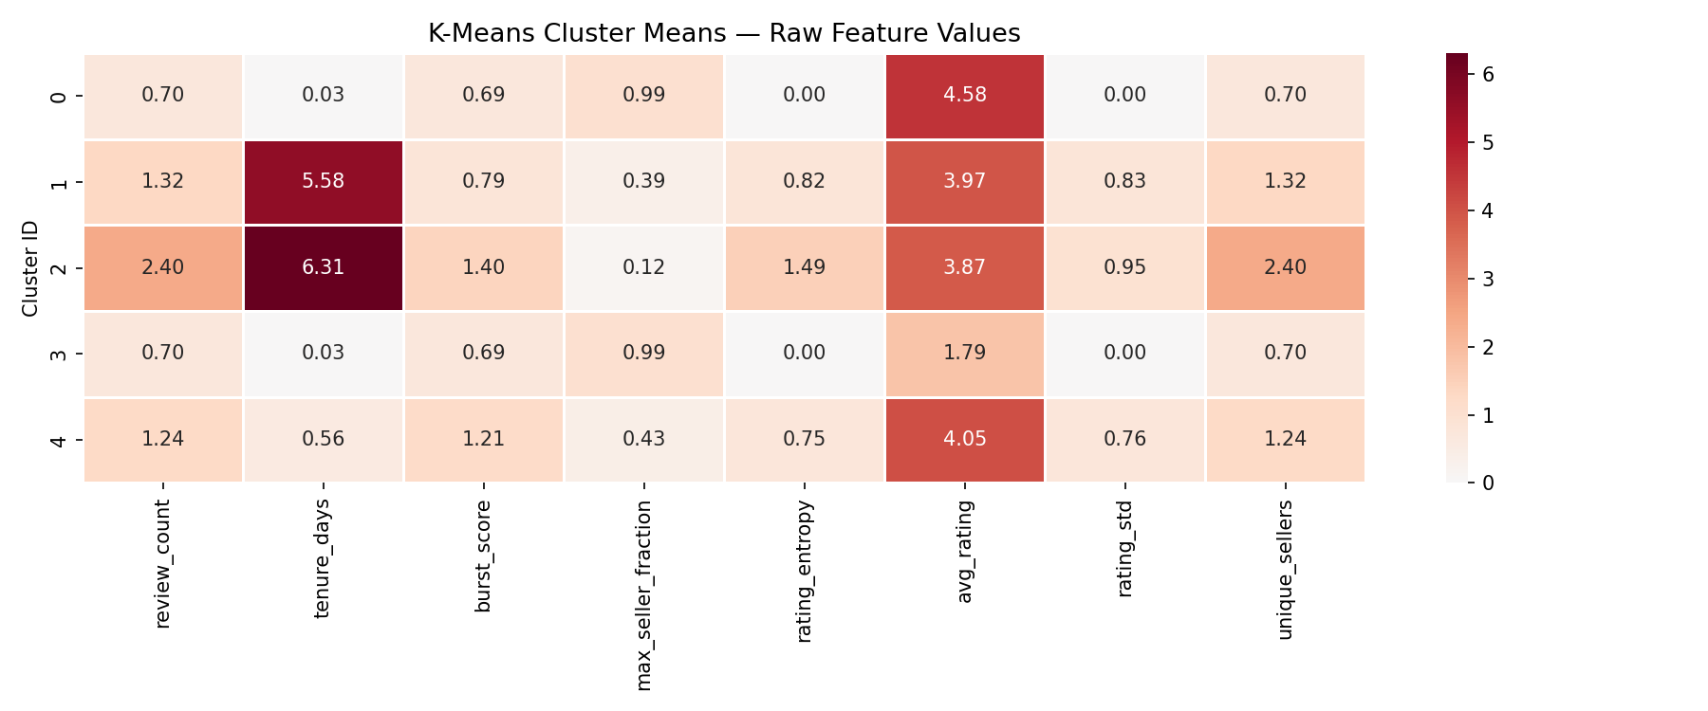
Figure 12: K-Means cluster heatmap showing mean feature values per cluster.
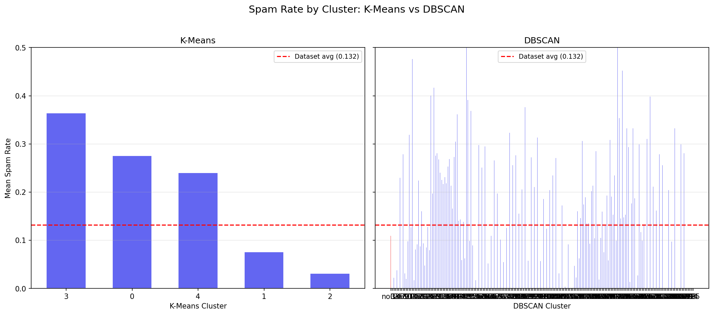
Figure 13: Spam rate comparison across K-Means clusters (left) and DBSCAN clusters (right).
Both clustering methods independently confirm that new, single-review, single-seller reviewers with zero rating diversity form the highest-risk segment. K-Means provides clean, interpretable segments for profiling, while DBSCAN captures finer-grained density structure and identifies outlier reviewers. Cluster IDs and DBSCAN noise flags from L4 are passed to L5 as structural features that complement L2's rule-based signals.

References for this section
[8] J. Han, J. Pei, and Y. Yin, "Mining frequent patterns without candidate generation," in Proceedings of the 2000 ACM SIGMOD International Conference on Management of Data, 2000, pp. 1-12. https://doi.org/10.1145/342009.335372
[9] M. Ester, H.-P. Kriegel, J. Sander, and X. Xu, "A density-based algorithm for discovering clusters in large spatial databases with noise," in Proceedings of the 2nd International Conference on Knowledge Discovery and Data Mining (KDD), 1996, pp. 226-231.

