Validation of the Composite Surgical Metrics Score

Executive Summary:
The composite surgical metrics score is moderately correlated with its underlying tool‑tracking metrics, but its weighting favours path efficiency and heavily penalises tool switching and speed. When tested against clinical outcomes in the available subset (n=120), the composite score showed no statistically significant association with complications, complete resection, or hospital stay. Although a 10‑point increase in the score pointed to 2.5 times higher odds of complication (counter‑intuitive), this finding had a p‑value of 0.11 and was not robust. Accounting for procedure length and surgeon‑level clustering did not change these conclusions. However, a full model using all individual metrics outperformed the composite (AUC 0.78 vs 0.66) in predicting complications, suggesting that valuable information is lost in the current aggregation. We recommend revising the composite formula, gathering more outcome data, and prospectively validating the score before relying on it for clinical decisions.
Section 1.1 About Data
Two excel files were provided, one is clinical outcome and other is the procedure matrices.
Procedure metrics contains 300 rows and 12 variables. Clinical outcome contains 120 rows in five variables.
Finally creating one .CSV file using the left join for further analysis
Data collection or its source is still a mystery.
Section 1.2 Data Cleaning
There are no duplicate values found in the data set.
Overall there is 15.7% NA values in the data set.
These values doesn't mean much at this point because it makes all sense.
Since the data is highly fluctuate and have a lot of na values we're gonna stand days each matrix assuming the mean zero and standard deviation 1 this will help us give much better results while doing any sort of analysis or regression model.

Section 1.3 Correlation with Individual Metrics
A heat map of eight matrices and composite score was observed.
- Moderate positive contribution: path efficiency(0.60), Movement smoothness (0.37), Site visibility percentage(0.37)
- Weak positive contribution: workspace coverage(0.29)
- Weak negative contribution: speed (0.28)
- Moderate negative contribution: ideal time percentage (0.34) and tool switching per minute (0.47)
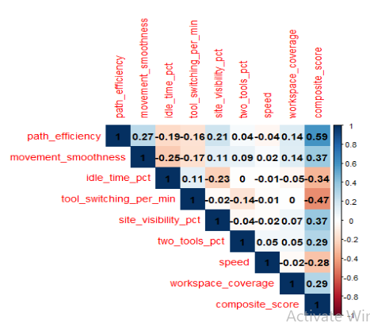
This indicates how there is some correlation shape among the variables with composite score. The path efficiency of .6 is directly proportional. Whereas tools switching per minute is inversely proportional which directly reflects one increases the other will decrease.

Section 1.4 Standardised Regression
Now estimating the effective weight of each matrix by regressing the composite score on all 8 standardized metrics with no intercept.
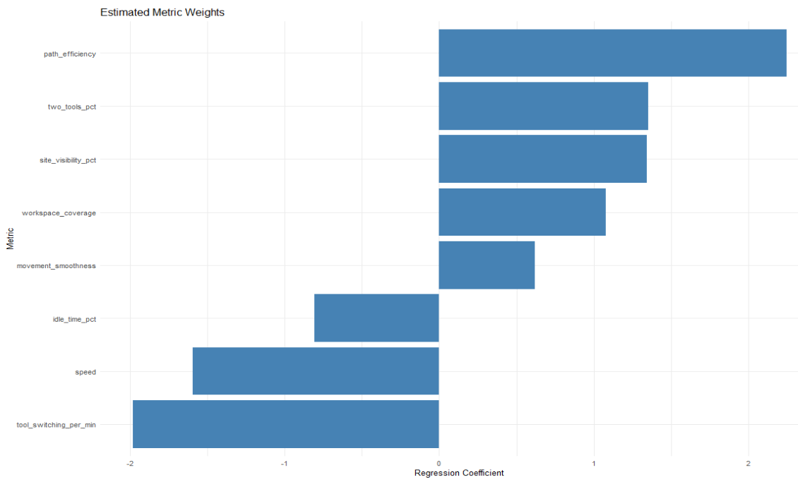
Does standardized coefficients can be interpreted as the number of standard deviation change in the composite score per one standard deviation increase in the matrix.
For example one unit increase in path efficiency will increase the overall composite score by 0.385 unit. Similarly for tool switching per minute 1 unit increase will result in decrease of overall composite score by 0.339.
Now I'm checking variance influence factor (VIF)
Not a single one was greater than two in this case none of them have multicollinearity.
Section 1.5 Association with Clinical Outcomes
Now I'm testing 3 outcomes using 120 cases with the clinical data set all the models were adjusted for the procedural length were noted.
1.1a ) complication occurrence (logistic regression)
One unit increase in the composite result in increase of complication by 0 .09 . Because this value is positive high schoolers are associated with higher risk of complications

The P value is 0.1055 which means it is statistically not significant therefore there is not even evidence in the data set to confidently say that the composite score influence the risk of complication.
1.5a ) Complete resection (logistic regression)
Coefficient is 0.106 per composite unit, p = 0.070. Again not significant at α = 0.05. Many records had missing resection status (NA for inapplicable cases), reducing effective sample size.
1.5b ) Hospital stay (linear regression)
Each composite unit added 0.11 days (p = 0.15). The effect size is tiny and non‑significant.
When surgeon ID was added as a random intercept (mixed‑effects logistic regression for complications), the between‑surgeon variance was only 0.37, and the composite score remained non‑significant.
Overall, No outcome showed a statistically significant, clinically intuitive relationship with the composite score in this dataset
Part 2: Deeper Analysis
Section 2.1 Surgeon‑Level Nesting
Here we have 10 surgeons in the procedure id. Now here I'm trying mixed effect model because that will give me much better result accounting for the N values and the lower number of sample size I have in the existing data set.
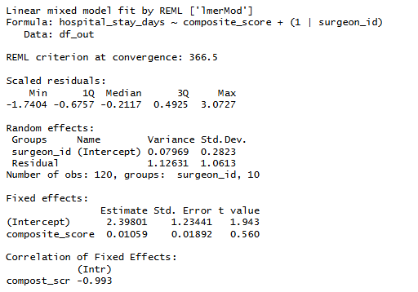
Intraclass correlation coefficient (ICC) is 6.6% of the variation in hospital stays is due to which surgeon performed the procedure. The remaining 93.4% is due to individual patient differences or random factors.
The composite score remained a non‑significant predictor.
The model suggests that neither the composite score nor the specific surgeon has a massive impact on the length of the hospital stay in this specific dataset.
Section 2.2 Most Predictive Individual Metrics
Building a full logistic regression model using the 8 standardized matrix plus the procedure length and comparing that with the second model which introduces complication and composite score. The overall Roc value is 0.78 for the full model and for the reduced model we are getting 0.66 that does mean the full model performs much better compared to the reduced model.
The top predictors (by absolute z‑value) were:
Procedure Length (positive)
Path efficiency (positive)
Two tool pct (negative)
Speed (negative)

This pattern mirrors the composite’s own weights but also hints that a refined weighting or even non‑linear terms might produce a more predictive score. Given the small number of complication events (11 in the outcome subset), standard significance tests are underpowered.
Section 2.3 Considerations for a Revised Composite
Re‑weighting: Use coefficients from a regularised (e.g., ridge) regression predicting a clinical outcome, rather than an internal algorithm.
Non‑linearity: Explore whether moderate speed is beneficial but extremes are harmful.
Metric replacement: Idle time and workspace coverage contributed little to outcome prediction and might be down‑weighted or removed.
Part 3: Recommendations & Limitations
Section 3.1 Clinical Validity – Evidence For and Against
Evidence against current validity:
- There is no statistically significant association with any of the three clinical endpoints.
- The composites own internal weight penalizes the behavior for high speed or fast tool changes that could be neutral or even desirable by assuming the situation for the hospital
- Group Significantly outperform the composite prediction complication for the AUC which is 0.78 versus 0.66.
Evidence then warns further investigation
- There is a strong core relationship between the path efficiency and the visibility and it does make sense
- There might be some complication odds with the higher score due to the chance of finding less data which is 11 out of 120.
Section 3.2 Limitations
So the data actually consists of 300 procedures out of which only 120 they are able to get it after merging the data set and out of there only 11 complications and 11 incomplete resections statistically the data is very low.
There might be some real world noise or missingness mechanism or cofounding variables which we are not able to account for
Surgeon procedure selections add this biased or unbiased they are absent in the data set
Section 3.3 Future work
- Getting the actual source or the outcome for all the procedures and getting a Reacher risk adjustment variables like patient S core procedure type tumor size will give us much better results
- Using the individual matrices in a penalized regression to predict the relevant endpoints and create a new outcome weighted source valid on a held out sample or existing in some sort of research paper
- I would also like to try fit generalized additive model games to check whether the optimal range exists for the speed and the tool switching
- Increasing the sample size roughly 400 to 600 cases with outcomes

In summary the composite score is not yet clinically valid but underlying tracking the platform shows promises with targeted improvements in the scoring formula more complete outcome data and prospective validation study the system could evolve into a meaningful tool for surgical quality assessment
Section 4 Appendix (Visualize)
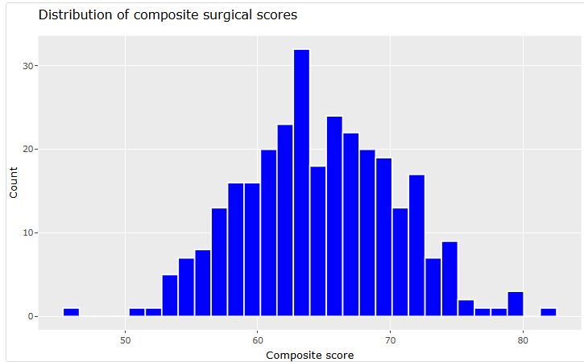
One can clearly see that I'm plotting the histogram for a composite score and it's almost like a bell shaped curve a normal distribution

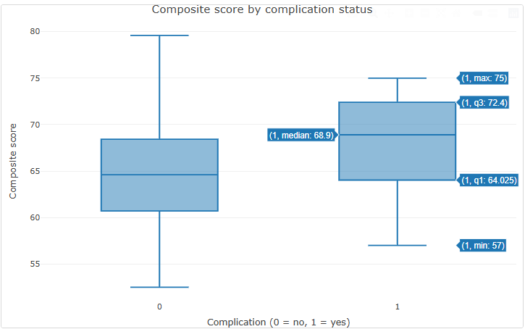
I'm trying to plot complication versus the composite score to C whether they have any sort of skewness or outliers in the data set which there are absent
This clearly states that even when they have the complication the composite score still remains high compared to the no complication and in some cases it goes up to 75.

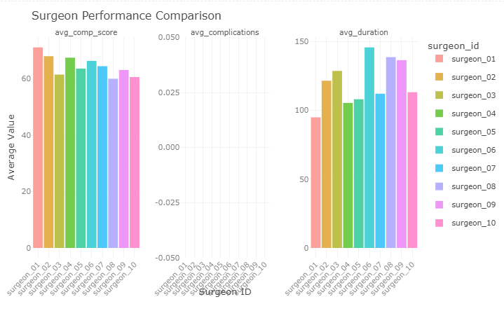

This graph represents the surgeon performance comparison that average value with the surgeon ID compared to the average completion score complications and the average duration one can clearly see that for surgeon one the average duration time is less than 100 minutes however his composite score is much higher than any other surgeon.
This way we can actually see what kind of surgeon can deal with what kind of complications and what is their composite score
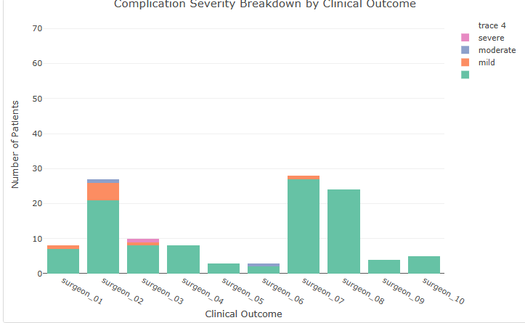
The one can clearly see I am identifying all the labor level of complexity by surgeon which surgeon is responsible for the complication severity.

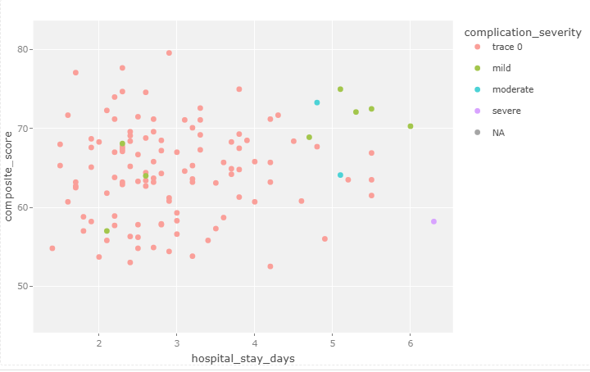
The X axis represents the hospital stays days the Y axis represent the composite score higher the number of hospital days lower the composite score can go. However in the further analysis we are determining that this kind of analysis does not hold the true relationship or the values for a specific surgeon we have to look from all sorts of perspectives

