Weight Estimation on a Bridge:

# Concept:

## For a new bridge:

1. We will be using load cells for measuring the weight on the bridge.
2. The load cells will be placed under the bridge and load cells being transducers convert the strain measured into an electric signal.
3. Now to use the electrical signal, we will be setting up a NodeMCU ESP8266 microcontroller, this will be interfaced using HX711 module to the loadcell.
4. The microcontroller once interfaced with loadcell can be used for the tasks we want it to perform.
5. Then the microcontroller will be programmed to open and shut the gate on reaching a threshold weight. Also, there will be a traffic signal which will turn red when the bridge has a certain weight less than the threshold so as the motorists stop and after a delay of 3/5 seconds the gate will be closed.
6. Also, the wireless module of NodeMCU creates its own Wi-Fi network and acts as a hub (just like Wi-Fi router), this will be used for the manual override through progressive web app and this PWA will also be used for statistical analysis of the vehicles on the bridge such as the peak hours, maximum weight, current weight, graphs of weight throughout the day etc.

## For an existing bridge

1. For an already existing bridge we will be following the same idea. Only changes that need to be done are for measuring the weight on bridge as it is not possible and rather not viable to place load cells below the bridge.
2. So, for this backdrop we will be using loadcells at start and end of the bridge where we will place the loadcells by removing a certain patch from the road at both start and end.
3. And then the remaining process would be the same.

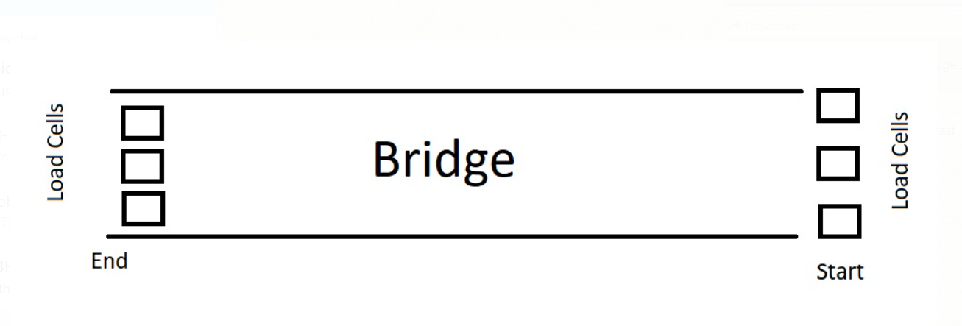

# Wireframes for the PWA

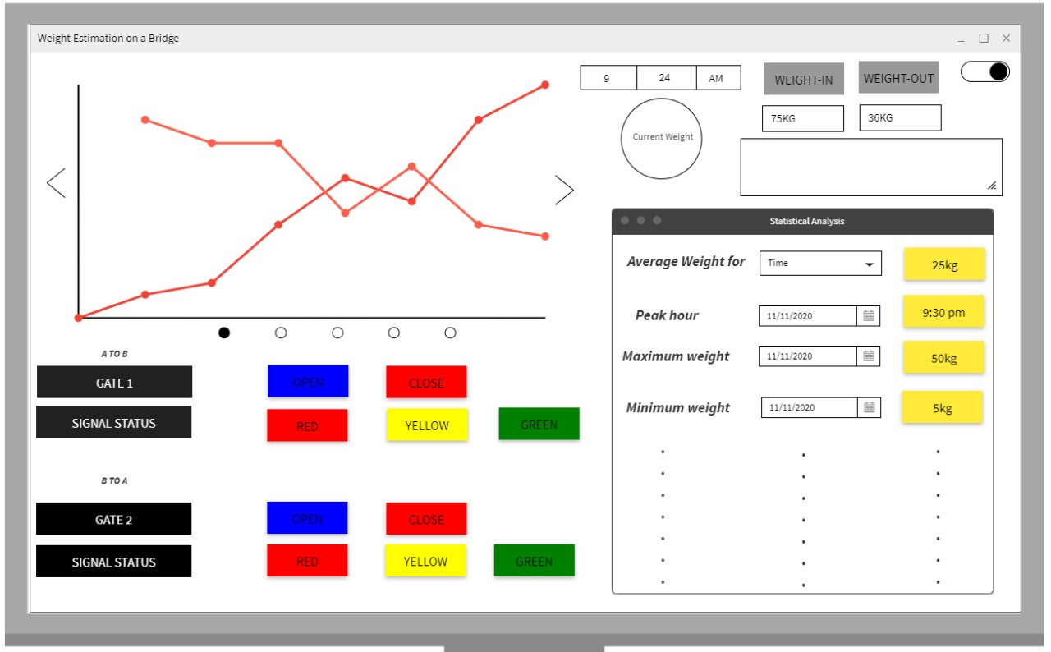

# Functionalities:

* At first, the total weight estimation on the bridge will be carried out.
* If the weight limit of the bridge is exceeded then the gates will be closed.
* A Signal will be placed ahead of the gates to stop the vehicles/humans in advance.
* All the data will be continuously displayed on the PWA.
* Statistical Analysis will be conducted on the data. For example, Measuring peak hours, average weight, etc.
* An option will be provided, to manually close and open the gates at any given time, and also to turn the signal red.

# Modules:

* Connecting bridge and Load Cell
* Interfacing Load Cell with Node MCU
* Setting up the Actuators and Swinging Gates
* Setting Up LED Signals using Node MCU
* Creating a skeleton model for PWA
* Constructing the PWA
* Providing the output of the system to PWA as input
* Statistical Data Analysis

# Hardware/Software Requirements

## List of Components:

|  |  |
| --- | --- |
| Components | Implementation |
| Load Cell/s | Sensing weight on the bridge |
| HX711 Module/s | Interfacing Load cell with Microcontroller |
| Node MCU ESP8266 | Controlling, implementing different tasks and monitoring |
| Servo Motor | Actuation of the gate |
| Gates | Preventing Vehicles to enter the bridge |
| 16x2 LCD Screen | Displaying the Weight |
| Breadboard | For Connections |
| Jumpers | For Connections |
| LEDS | As a traffic light (Red, Green, Yellow) |

* If any other component is required at later stages we will inform that.
* Number of loadcells and HX711 module should be same.