Final Exam Instructions: BAN 672 Fall 2025
Remember to submit this workbook as an Excel enabled workbook,
so the macros in part 2 will function.

- Part 1 Pivot Table: Sheet 1 and 2: 20 points
Using the data in Sheet 1, create a Pivot Table is Sheet 2. 10 points
Create a Pivot Table report in Sheet 2 that looks like this. 10 points (Hint: Use Pivot Fields Site, Topic, and Followers.
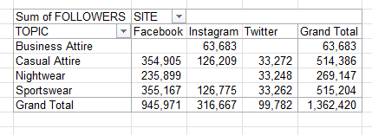

2. Part 2 Spreadsheet: Sheet 3 and Sheet 4: 20 points

Create a button anywhere in Sheet 3 that brings you to cell A1 in Sheet 4. 10 points.
Create a button anywhere in Sheet 4 that brings you to cell A1 in Sheet 3. 10 points.

- Part 3 Spreadsheet: Product Mix: 30 points

Using the spreadsheet named Product Mix, use Solver to maximize Net Income percent difference (E24) by changing optimal product mix for all models (B11:E11), with the following constraints:
- the values in B11:E11 must be integers and greater than or equal to 2000 for all cells in the range.
- the total number of units sold is 12,000 (C19).
- All parts must be in inventory (J28:J46 >=1). 20 points
Save the Solver Solution in Answer Reports (default) to a new sheet called Answer Report 1. 10 points

4. Part 4 Spreadsheet: Gobbledygook Industries: 15 points

In the Gobbledygook Industries sheet determine the source of error for cell Q12.
Using Formula Tab, trace the error. 5 points.
Resolve the error. 5 points.
Do not Remove the arrows. 5 points.

5. Part 5 Power Query: 10 points

Download the Customer-100.csv file from the following link. 2 points
https://www.datablist.com/learn/csv/download-sample-csv-files#download-customers-sample-csv-files\
Get the data and use Transform to Remove the first column 3 points
Close and Load the data into a Table in a new worksheet. 4 points
Rename the Worksheet to be Customers. 1 point

6. Part 6 Documentation Sheet: 5 points

Create a Documentation Sheet with Name, Date, and Topic: Final Exam as the first (leftmost) sheet in the workbook. 5 points

