- Dhruva Khanna
- 2675251
- Spring 26
- BAN 650
- Assignment 3
- Assignment Open Date: February 18, 2026
- Assignment Due Date: February 25, 2026

Task 1: Efficiency Across States
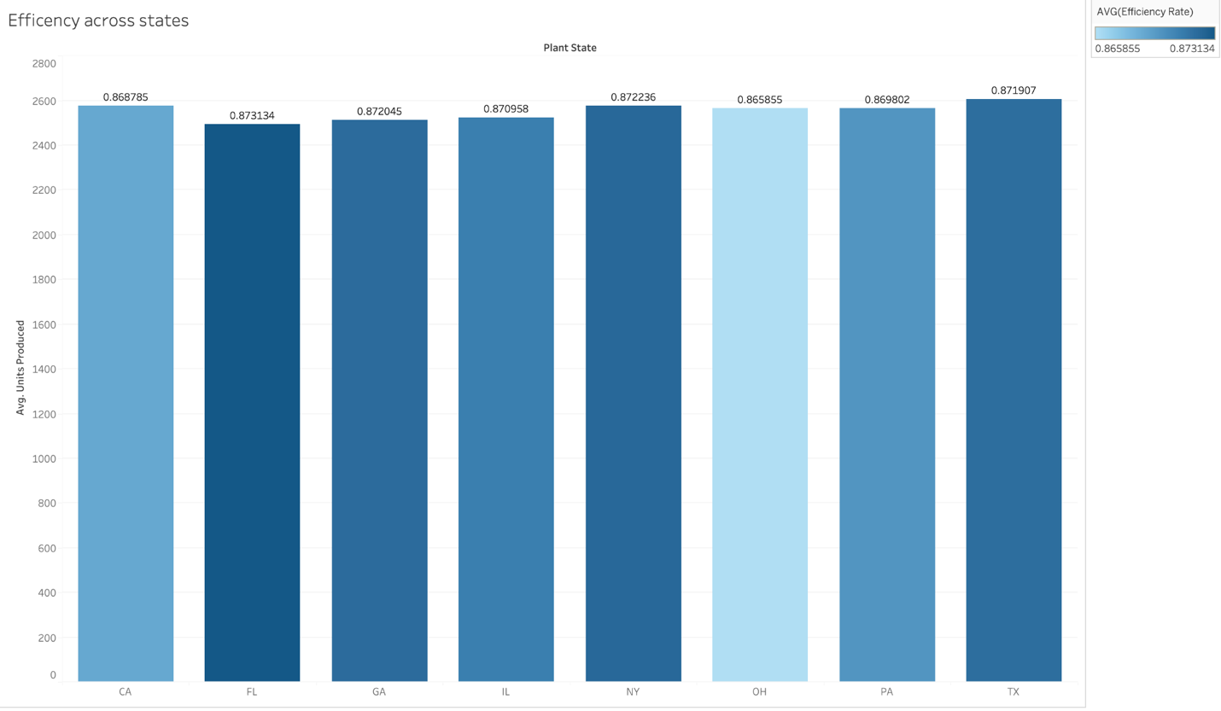
Difference between quantitative and qualitative data
This visualization uses quantitative data in the form of average efficiency rates and average units produced, which are numerical measures that indicate how well each plant is performing. It also uses qualitative data through plant state, which serves as a categorical label identifying where production occurs. The qualitative categories provide grouping, while the quantitative values supply measurable performance, allowing meaningful comparison across locations.
Why this visualization type was selected
A bar chart was selected because it is one of the most effective ways to compare numerical values across discrete categories. It allows managers to quickly observe differences in efficiency between states without requiring complex interpretation. The visual simplicity makes it well-suited for operational reporting and executive summaries.
Managerial insight
Efficiency levels are relatively consistent across all states, suggesting that standard operating procedures are working effectively across locations. No plant appears to be significantly underperforming. However, states with slightly higher efficiency can be examined to identify best practices that may be replicated across other plants. The primary opportunity lies in incremental improvement rather than large-scale corrective action.

Task 2 – Night Shift Inefficiency
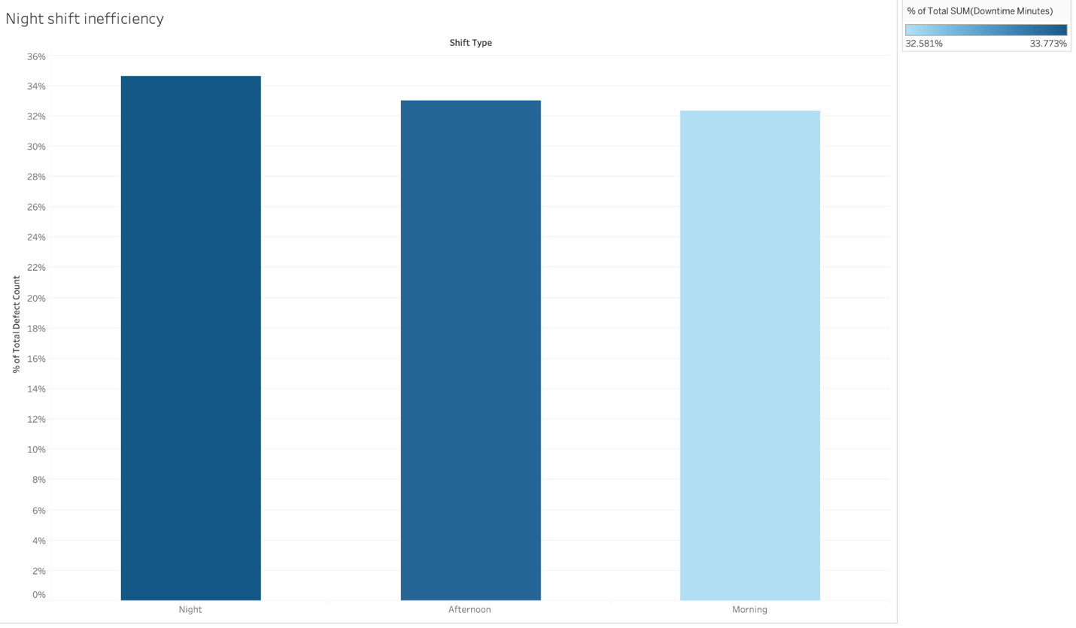
Difference between quantitative and qualitative data
This chart combines quantitative data, represented by the percentage of total downtime and defects, with qualitative data, represented by shift type (Morning, Afternoon, Night). The quantitative values show the magnitude of operational losses, while the qualitative categories indicate when those losses occur during the production day.
Why this visualization type was selected
A bar chart was chosen because it clearly compares the proportion of downtime across shifts and makes differences immediately visible. This format supports fast decision-making and is commonly used in operations dashboards to highlight performance gaps between categories.
Managerial insight
The night shift accounts for the highest proportion of downtime and defects, indicating a consistent performance issue during overnight operations. Management should prioritize investigating root causes on the night shift, such as staffing levels, employee fatigue, training quality, equipment availability, or maintenance scheduling. Improvements in this shift are likely to deliver the largest reduction in downtime and the greatest overall productivity gains.

