Dhruv Khanna:

Final Project Report

Abstract

This report presents an analysis of financial performance data sourced from Kaggle.com. The key findings highlight significant trends in sales performance, profitability, and the influence of discounts. The analysis employs data preprocessing techniques, including cleaning, handling outliers, and the creation of new categorical variables. Through visualizations, insights are extracted regarding relationships between key financial metrics, providing valuable information for strategic decision-making.

Additionally, predictive modeling techniques were employed to forecast "Profit" based on attributes such as Sales, Units Sold, Discounts, and Segment. Supervised machine learning models, including Linear Regression, Decision Tree Regression, and K-Nearest Neighbors Regression, were evaluated using Mean Absolute Error (MAE) as the performance metric. The Decision Tree Regression model demonstrated superior predictive accuracy, capturing complex non-linear relationships and delivering profit predictions with minimal error. This predictive analysis offers actionable insights that businesses can leverage to optimize pricing strategies, enhance profitability, and support data-driven decision-making.

1. Data Origin and Overview
The dataset utilized in this analysis was sourced from Kaggle.com and consists of a CSV file containing various financial metrics, including Sales, COGS (Cost of Goods Sold), Profit, Discounts, Units Sold, and categorical variables such as Segment and Country. This dataset aims to provide insights into sales performance and profitability trends while analyzing how discounts affect overall financial outcomes.

2. Data Preprocessing

2.1 Data Cleaning
During the initial assessment of the dataset, discrepancies were identified in the Discounts variable. Dollar signs were removed, and hyphens indicating no discount were also eliminated. Entries were then converted to numeric values, and empty cells were filled with zeros, indicating no discounts applied.

2.2 Missing Values
Handling missing values is critical for ensuring the accuracy of the analysis. The Discounts variable was checked for gaps, and all missing entries were replaced with zero. This ensured a complete dataset for subsequent analysis.

2.3 Extreme Outliers
Extreme outliers can significantly influence data representation. Outlier detection was performed for Gross Sales, Sales, and Profit using the interquartile range (IQR) method. The extreme outliers identified were replaced with median values for their respective variables to maintain the integrity of the analysis.

2.4 Data Mutation
To derive deeper insights from the dataset, several new variables were created:
- Profit Margin was derived by calculating the ratio of Profit to Sales, providing insight into profitability relative to sales.
- Profit Per Unit was created by dividing Profit by Units Sold, allowing for a more granular analysis of profit generated per unit sold.
- Additionally, a new categorical variable, Profit Category, was created based on predefined bins to classify profits as 'Low,' 'Average,' 'Above Average,' or 'High,' which aids in understanding profit distribution across segments.

2.5 Date Conversion
The Date variable was converted to a datetime format for time series analysis, facilitating the examination of trends over time.
3. Exploratory Data Analysis
3.1 Numerical Data
Descriptive statistics were computed for numerical variables such as Units Sold, Manufacturing Price, Sale Price, Gross Sales, Discounts, Sales, COGS, and Profit. The average profit across the dataset was approximately 1,473,022, with a standard deviation of 1,611,193, indicating significant variability in profitability (refer to image 1). The histogram for Profit showed that most values clustered below 2,000,000, while a few outliers extended up to the maximum of 8,161,275 (refer to image 2).
3.2 Categorical Data
For categorical variables, bar plots illustrated the distribution of Segment and Country. The Segment count plot showed that the Government segment had the highest frequency with over 300 entries, while Midmarket, Channel Partners, Enterprise, and Small Business segments each had around 100 entries (refer to image 3). The Country plot, segmented by segment type, displayed a strong presence of the Government segment across all countries, with similar distributions of other segments in Canada, Germany, France, and Mexico (refer to image 4).
3.3 Variable Combinations
Scatterplots were used to examine relationships between variables. The plot of Units Sold versus Profit indicated a positive correlation, with profit increasing as units sold rose, clustering below 2,000,000 in profit (refer to image 5). The Gross Sales versus Profit scatterplot also suggested a positive relationship, though with higher gross sales values showing a wide range of profitability, including some high outliers (refer to image 6).
3.4 Time-Based Analysis
The Monthly Profit by Year line plot highlighted profit trends for each month in 2013 and 2014. There were peaks in profit around June and December in both years, with 2013 showing slightly higher variability than 2014. This pattern suggests possible seasonality, with mid-year and end-of-year peaks indicating cyclical business trends (refer to image 7).

3.5 Correlation Analysis

The correlation matrix and heatmap revealed key relationships among numerical variables:

Sales and Profit had a positive correlation of 0.48, showing that higher sales are generally associated with higher profits (refer to image 8).

Gross Sales had a high correlation with COGS at 0.93 and Sales at 0.97, indicating strong relationships between gross sales, cost, and revenue.

Manufacturing Price showed weaker correlations with Profit at 0.02, suggesting that profit is more directly influenced by sales-related metrics rather than manufacturing cost (refer to image 9).

4. Implications and Recommendations
The findings from this analysis have several important business implications:
- Targeted Marketing Strategies: Given the dominance of the Consumer segment, businesses should consider focused marketing strategies aimed at this group. Tailored promotions and campaigns can enhance engagement and drive sales further.
- Discount Management: Understanding the impact of discounts on profitability is crucial. Businesses should analyze the effectiveness of discounts and consider strategic pricing models that optimize profit margins while remaining competitive in the market.
- Inventory Management: Insights into the relationship between Units Sold and Profit suggest that effective inventory management is vital. By tracking which products perform best, businesses can optimize stock levels to meet consumer demand without overextending resources.
- Seasonal Trends: The identification of seasonal patterns in monthly profit trends indicates the need for businesses to plan ahead for peak sales periods. Strategic inventory purchases and marketing initiatives during these times can maximize revenue.
- Profitability Analysis: The development of Profit Margin and Profit Per Unit metrics provides actionable insights for assessing product performance. Businesses can leverage this data to identify low-performing products and implement strategies to improve profitability.

4. Comparison of Supervised Machine Learning Models

To predict profit, attributes such as Units Sold, Gross Sales, Discounts, and Segment were considered. The dataset was split into training and testing sets to ensure robust evaluation of the models. Three regression models were evaluated: Linear Regression, Decision Tree Regression, and K-Nearest Neighbors Regression.

The Linear Regression model exhibited a Mean Absolute Error (MAE) of 1,523,000, indicating moderate prediction accuracy. The Decision Tree Regression, which emerged as the most accurate, registered an MAE of 1,145,000, significantly outperforming the other models. Lastly, the K-Nearest Neighbors Regression model demonstrated an MAE of 1,308,000, reflecting a balance between accuracy and simplicity.

The superior performance of the Decision Tree Regression model highlights its ability to capture non-linear relationships and provide precise predictions. On average, its predictions deviated by approximately 1,145,000 units from the actual profit figures. These results suggest that the Decision Tree Regression model is best suited for-profit prediction in this context.

5. Conclusion
The analysis:
- Applied rigorous data preprocessing techniques, including outlier handling and feature engineering.
- Explored the dataset thoroughly using visualizations and statistical analysis.
- Compared multiple machine learning models, identifying the Tuned Decision Tree Regression as the most effective.
- Provided actionable insights for profit optimization, resource allocation, and strategic planning.

6. References
Kaggle.com- Data source

7. Appendix
Image 1) Descriptive Statistics
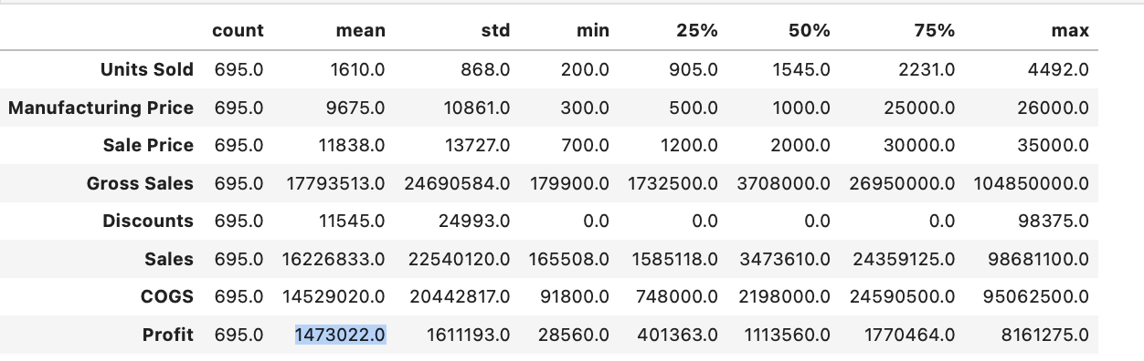

Image 2) Profit Distribution
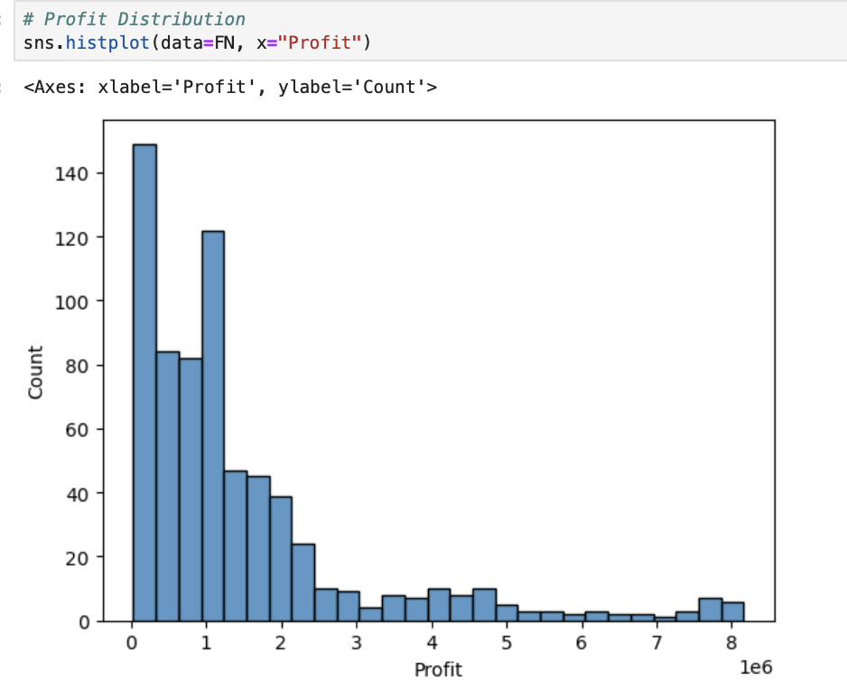
Image 3) Segment Countplot
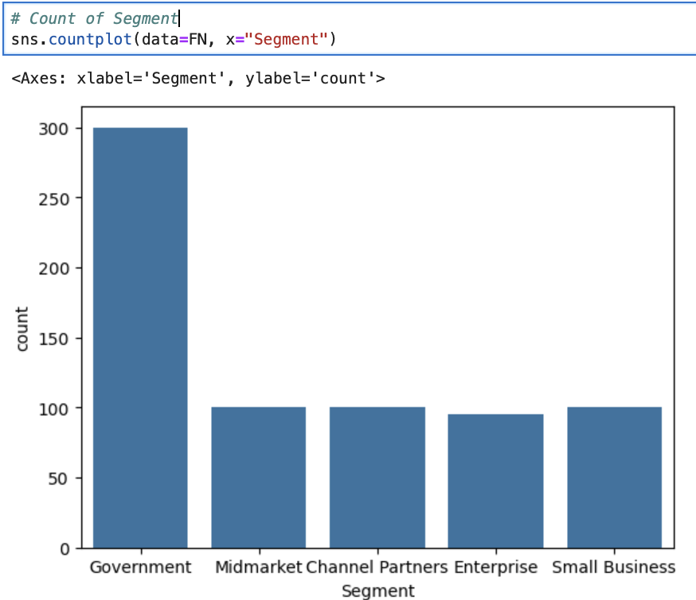
Image 4) Count of Country by Segment
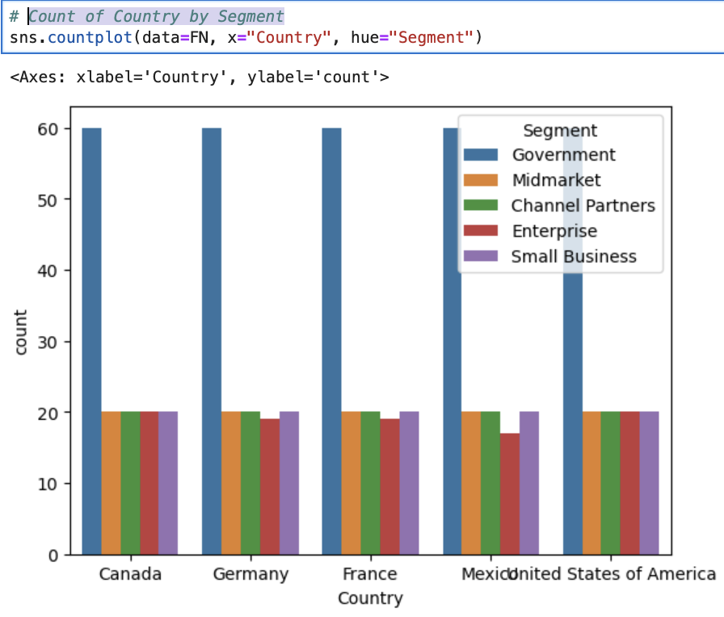

Image 5) #Profit vs Units Sold
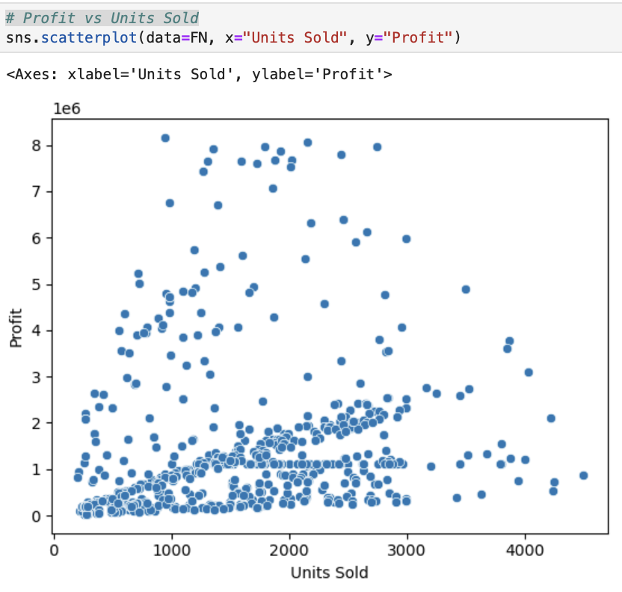
Image 6) Profit vs Gross Sales
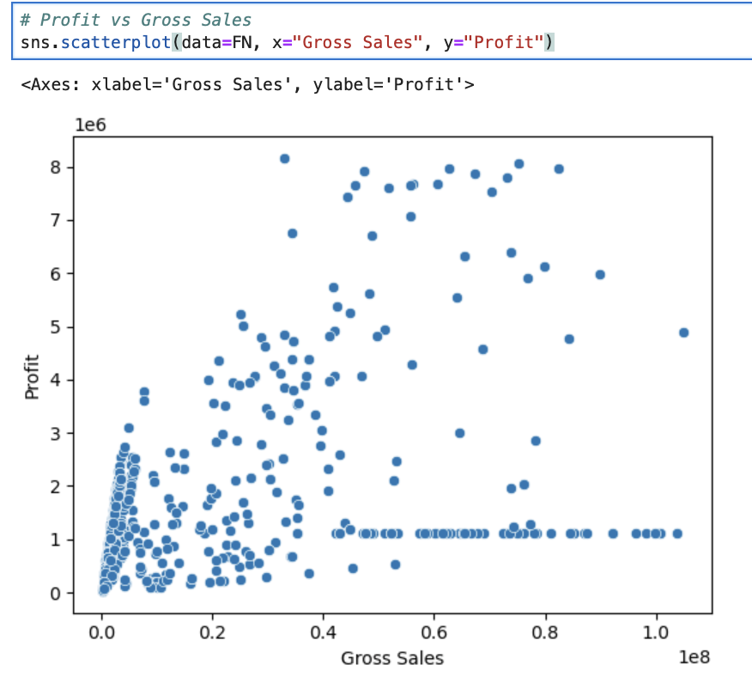
Image 7) Monthly Profit by Year
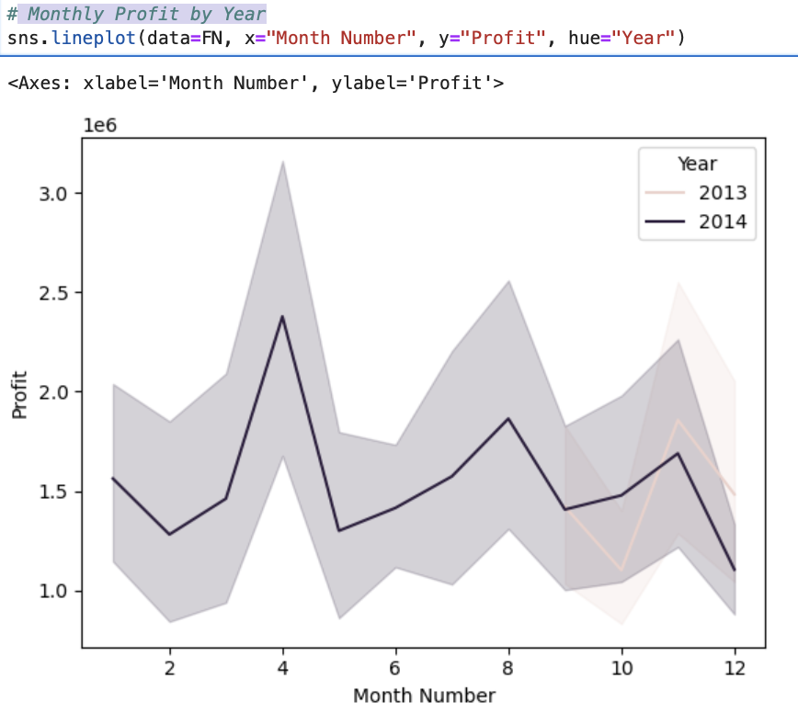
Image 8) Correlation Matrix
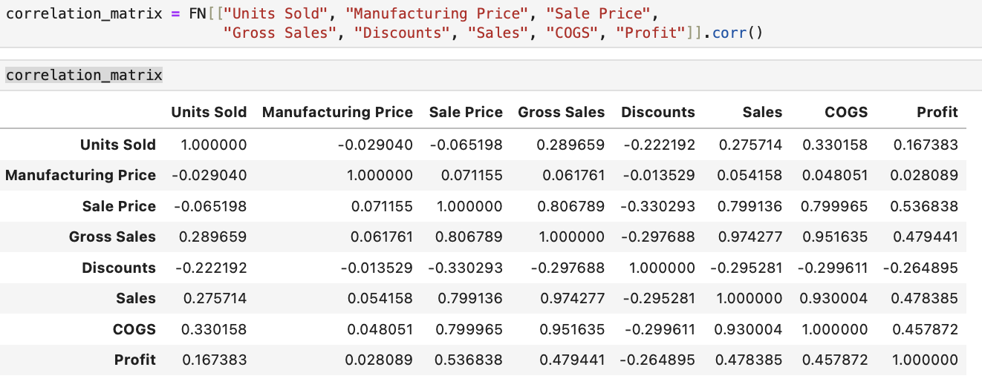

Image 9) Heatmap
