Correlation-Exercise-Start.R
dhruv
2025-02-20
# Exercise: Correlation Test
#
# Please answer the following questions about Correlation-Exercise-Data.csv and
# include your code below the last question. When you are done, click on File >
# Compile Report > MS Word and submit the resulting Word document.
#
# Q: Are "Alpha" and "Bravo" correlated?
# (Yes/No, include r and p values, and interpretation if appropriate.)
# A: No, "Alpha" and "Bravo" are not significantly correlated (r = 0.01, p = 0.8448).
# Since p ≥ 0.05, we fail to reject the null hypothesis,
# meaning there is no evidence of a meaningful relationship between "Alpha" and "Bravo"
#
# Q: Are "Alpha" and "Charlie" correlated?
# (Yes/No, include r and p values, and interpretation if appropriate.)
# A: Yes, "Alpha" and "Charlie" are moderately positively correlated (r = 0.37, p < 0.05).
# Thus, as "Alpha" increases, "Charlie" also increases, and vice versa.
#
# Q: Are "Alpha" and "Delta" correlated?
# (Yes/No, include r and p values, and interpretation if appropriate.)
# A: No, "Alpha" and "Delta" are not significantly correlated (r = -0.004, p = 0.9457).
# Since p ≥ 0.05, we fail to reject the null hypothesis,
# meaning there is no evidence of a meaningful relationship between "Alpha" and "Delta".
#
# Q: Are "Bravo" and "Charlie" correlated?
# (Yes/No, include r and p values, and interpretation if appropriate.)
# A: No, "Bravo" and "Charlie" are not significantly correlated (r = 0.04, p = 0.4542).
# Since p ≥ 0.05, we fail to reject the null hypothesis,
# meaning there is no evidence of a meaningful relationship between "Bravo" and "Charlie".
#
# Q: Are "Bravo" and "Delta" correlated?
# (Yes/No, include r and p values, and interpretation if appropriate.)
# A: Yes, "Bravo" and "Delta" are moderately negatively correlated (r = -0.40, p = 0.00000000000143).
# Thus, as "Bravo" increases, "Delta" tends to decrease, and vice versa
#
# Q: Are "Charlie" and "Delta" correlated?
# (Yes/No, include r and p values, and interpretation if appropriate.)
# A: No, "Charlie" and "Delta" are not significantly correlated (r = -0.05, p = 0.3939).
# Since p ≥ 0.05, we fail to reject the null hypothesis,
# meaning there is no evidence of a meaningful relationship between "Charlie" and "Delta".
#
library(tidyverse)
## ── Attaching core tidyverse packages ──────────────────────── tidyverse 2.0.0 ──
## ✔ dplyr 1.1.4 ✔ readr 2.1.5
## ✔ forcats 1.0.0 ✔ stringr 1.5.1
## ✔ ggplot2 3.5.1 ✔ tibble 3.2.1
## ✔ lubridate 1.9.4 ✔ tidyr 1.3.1
## ✔ purrr 1.0.2
## ── Conflicts ────────────────────────────────────────── tidyverse_conflicts() ──
## ✖ dplyr::filter() masks stats::filter()
## ✖ dplyr::lag() masks stats::lag()
## ℹ Use the conflicted package (<http://conflicted.r-lib.org/>) to force all conflicts to become errors
library(here)
## here() starts at /Users/dhruv/BAN663/BAN663 Code&Data
# Load "Correlation-Exercise-Data.csv" in "07- Correlation" folder
Data <- read_csv(here("07- Correlation", "Correlation-Exercise-Data.csv"))
## Rows: 331 Columns: 4
## ── Column specification ────────────────────────────────────────────────────────
## Delimiter: ","
## dbl (4): Alpha, Bravo, Charlie, Delta
##
## ℹ Use `spec()` to retrieve the full column specification for this data.
## ℹ Specify the column types or set `show_col_types = FALSE` to quiet this message.
summary(Data)
## Alpha Bravo Charlie Delta
## Min. : -43.9 Min. :-5030 Min. :-1076.1 Min. : 93.38
## 1st Qu.: 373.5 1st Qu.:-2605 1st Qu.: 220.2 1st Qu.: 5360.51
## Median : 528.4 Median :-1969 Median : 790.3 Median : 7616.26
## Mean : 513.6 Mean :-1963 Mean : 782.0 Mean : 7729.77
## 3rd Qu.: 653.5 3rd Qu.:-1292 3rd Qu.: 1311.3 3rd Qu.:10188.78
## Max. :1040.0 Max. : 1623 Max. : 2785.6 Max. :15915.77
## NA's :14 NA's :28 NA's :14 NA's :21
#Are "Alpha" and "Bravo" correlated?
ggplot(data = Data, aes(x = Alpha, y = Bravo)) + geom_point()
## Warning: Removed 40 rows containing missing values or values outside the scale range
## (`geom_point()`).
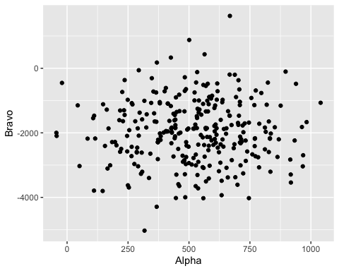
cor.test(Data$Alpha, Data$Bravo)
##
## Pearson's product-moment correlation
##
## data: Data$Alpha and Data$Bravo
## t = 0.19596, df = 289, p-value = 0.8448
## alternative hypothesis: true correlation is not equal to 0
## 95 percent confidence interval:
## -0.1035920 0.1263403
## sample estimates:
## cor
## 0.01152651
#Are "Alpha" and "Charlie" correlated?
ggplot(data = Data, aes(x = Alpha, y = Charlie)) + geom_point()
## Warning: Removed 28 rows containing missing values or values outside the scale range
## (`geom_point()`).
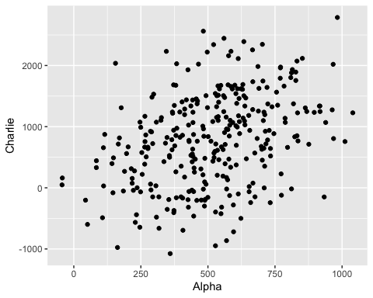
cor.test(Data$Alpha, Data$Charlie)
##
## Pearson's product-moment correlation
##
## data: Data$Alpha and Data$Charlie
## t = 6.8297, df = 301, p-value = 4.71e-11
## alternative hypothesis: true correlation is not equal to 0
## 95 percent confidence interval:
## 0.2645366 0.4599889
## sample estimates:
## cor
## 0.3662963
#Are "Alpha" and "Delta" correlated?
ggplot(data = Data, aes(x = Alpha, y = Delta)) + geom_point()
## Warning: Removed 33 rows containing missing values or values outside the scale range
## (`geom_point()`).
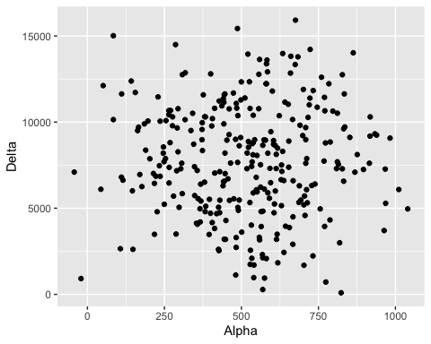
cor.test(Data$Alpha, Data$Delta)
##
## Pearson's product-moment correlation
##
## data: Data$Alpha and Data$Delta
## t = -0.068126, df = 296, p-value = 0.9457
## alternative hypothesis: true correlation is not equal to 0
## 95 percent confidence interval:
## -0.1175276 0.1097104
## sample estimates:
## cor
## -0.003959705
#Are "Bravo" and "Charlie" correlated?
ggplot(data = Data, aes(x = Bravo, y = Charlie)) + geom_point()
## Warning: Removed 42 rows containing missing values or values outside the scale range
## (`geom_point()`).
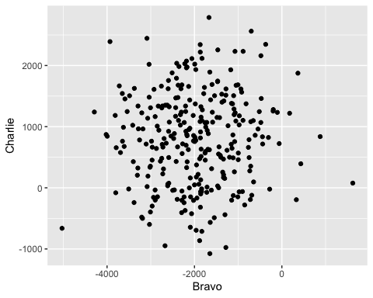
cor.test(Data$Bravo, Data$Charlie)
##
## Pearson's product-moment correlation
##
## data: Data$Bravo and Data$Charlie
## t = 0.74939, df = 287, p-value = 0.4542
## alternative hypothesis: true correlation is not equal to 0
## 95 percent confidence interval:
## -0.07155214 0.15876116
## sample estimates:
## cor
## 0.04419167
#Are "Bravo" and "Delta" correlated?
ggplot(data = Data, aes(x = Bravo, y = Delta)) + geom_point()
## Warning: Removed 47 rows containing missing values or values outside the scale range
## (`geom_point()`).
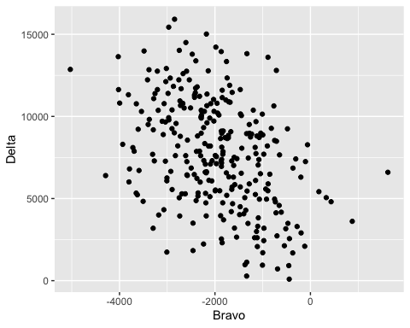
cor.test(Data$Bravo, Data$Delta)
##
## Pearson's product-moment correlation
##
## data: Data$Bravo and Data$Delta
## t = -7.415, df = 282, p-value = 1.429e-12
## alternative hypothesis: true correlation is not equal to 0
## 95 percent confidence interval:
## -0.4969591 -0.3017252
## sample estimates:
## cor
## -0.4039316
#Are "Charlie" and "Delta" correlated?
ggplot(data = Data, aes(x = Charlie, y = Delta)) + geom_point()
## Warning: Removed 33 rows containing missing values or values outside the scale range
## (`geom_point()`).
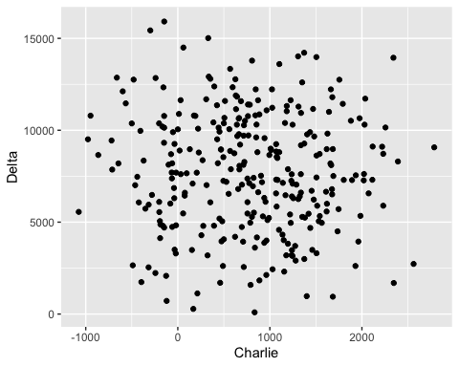
cor.test(Data$Charlie, Data$Delta)
##
## Pearson's product-moment correlation
##
## data: Data$Charlie and Data$Delta
## t = -0.85374, df = 296, p-value = 0.3939
## alternative hypothesis: true correlation is not equal to 0
## 95 percent confidence interval:
## -0.16226854 0.06442198
## sample estimates:
## cor
## -0.04956155

