Decomposition-Exercise-Start.R
dhruv
2025-04-08
# Exercise: Time Series Decomposition
#
# Please answer the following questions and include your final code below.
# When you are done, click on File > Compile Report > MS Word and submit the
# resulting Word document.
#
# Q: Load Decomposition-Exercise-Data1.csv. The file contains brick production
# output in Australia in million bricks. Perform an STL decomposition. How would
# you describe the trend, seasonality, and remainder?
# A: The trend shows a rise until the mid-1980s, followed by a gradual decline and stabilization.
#. Seasonality is strong and regular, peaking in amplitude mid-series, while the remainder shows small, irregular fluctuations.
#
# Q: Load Decomposition-Exercise-Data2.csv. The file contains sales of
# new one-family houses in thousand units. Perform an STL decomposition. How
# would you describe the trend, seasonality, and remainder?
# A: The trend of Foxtrot declines until 1991, then steadily increases through 1996.
#. Seasonality is strong and consistent throughout, while the remainder shows short-term irregularities centered around zero.
#
#
# Q: Load Decomposition-Exercise-Data3.csv. The file contains the stock price
# of Apple Inc (AAPL). Perform an STL decomposition. How would you describe the
# trend, seasonality, and remainder?
# A: The trend shows steady growth from 2014 to late 2018 before a sharp drop.
#. There are clear yearly and weekly seasonal patterns, while the remainder captures irregular spikes, especially in 2018.
# Q: Load Decomposition-Exercise-Data4.csv. The file contains beer production
# output in Australia in million liters. Perform an STL decomposition. How would
# you describe the trend, seasonality, and remainder?
# A: The trend shows slight fluctuations with a dip around 2005 and recovery afterward.
#. Seasonality is strong and consistent every year, while the remainder shows moderate, mostly centered variation.
#
# Q: Load Decomposition-Exercise-Data5.csv. The file contains natural gas
# consumption in Connecticut in million cubic feet. Perform an STL decomposition.
# How would you describe the trend, seasonality, and remainder?
# A: The trend shows steady and strong growth in Delta across the entire period.
#. There is no seasonal component modeled, and the remainder captures yearly deviations, with spikes both above and below the trend line.
#
# Load library "tidyverse", "here", and "tsibble" fabletools
library(tidyverse)
## ── Attaching core tidyverse packages ──────────────────────── tidyverse 2.0.0 ──
## ✔ dplyr 1.1.4 ✔ readr 2.1.5
## ✔ forcats 1.0.0 ✔ stringr 1.5.1
## ✔ ggplot2 3.5.1 ✔ tibble 3.2.1
## ✔ lubridate 1.9.4 ✔ tidyr 1.3.1
## ✔ purrr 1.0.2
## ── Conflicts ────────────────────────────────────────── tidyverse_conflicts() ──
## ✖ dplyr::filter() masks stats::filter()
## ✖ dplyr::lag() masks stats::lag()
## ℹ Use the conflicted package (<http://conflicted.r-lib.org/>) to force all conflicts to become errors
library(here)
## here() starts at /Users/dhruv/BAN663/BAN663 Code&Data
library(tsibble)
## Registered S3 method overwritten by 'tsibble':
## method from
## as_tibble.grouped_df dplyr
##
## Attaching package: 'tsibble'
##
## The following object is masked from 'package:lubridate':
##
## interval
##
## The following objects are masked from 'package:base':
##
## intersect, setdiff, union
library(fabletools)
library(feasts)
# load Ex data 1
data1 <- read_csv(here("Time Series", "Decomposition-Exercise-Data1.csv"))
## Rows: 198 Columns: 2
## ── Column specification ────────────────────────────────────────────────────────
## Delimiter: ","
## dbl (1): Alpha
## date (1): Charlie
##
## ℹ Use `spec()` to retrieve the full column specification for this data.
## ℹ Specify the column types or set `show_col_types = FALSE` to quiet this message.
# convert Charlie in this format "%m %d, %Y"
data1$Charlie <- as.Date(data1$Charlie, format = "%Y-%m-%d")
# convert Charlie to Quarterly data
data1$Charlie <- yearquarter(data1$Charlie)
# convert to time series
data1 <- as_tsibble(data1, index = Charlie)
# Plot the time series data# Plot talpha()he time series data
autoplot(data1, Alpha)
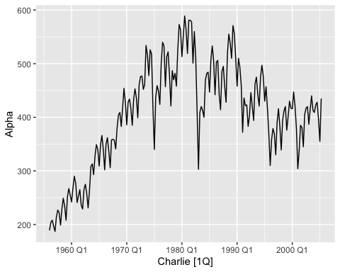
# Perform STL decomposition
autoplot(components(model(data1, STL(Alpha))))
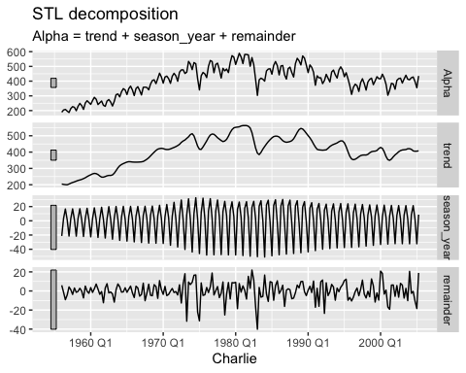
# load Ex data
data2 <- read_csv(here("Time Series", "Decomposition-Exercise-Data2.csv"))
## Rows: 107 Columns: 2
## ── Column specification ────────────────────────────────────────────────────────
## Delimiter: ","
## chr (1): Bravo
## dbl (1): Foxtrot
##
## ℹ Use `spec()` to retrieve the full column specification for this data.
## ℹ Specify the column types or set `show_col_types = FALSE` to quiet this message.
# convert Bravo in date frmat
data2$Bravo <- as.Date(data2$Bravo, format = "%d %B %Y")
# convert Bravo to monthly data
data2$Bravo <- yearmonth(data2$Bravo)
# convert to time series
data2 <- as_tsibble(data2, index = Bravo)
# Plot the time series data# Plot talpha()he time series data
autoplot(data2, Foxtrot)
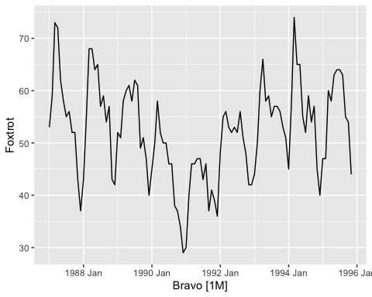
# Perform STL decomposition
autoplot(components(model(data2, STL(Foxtrot))))
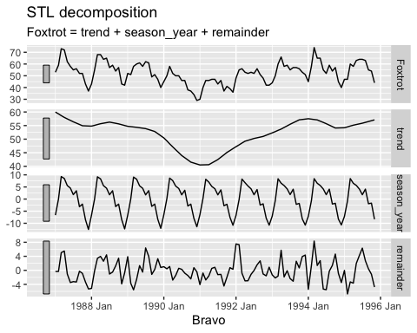
# load Ex data
data3 <- read_csv(here("Time Series", "Decomposition-Exercise-Data3.csv"))
## Rows: 1825 Columns: 2
## ── Column specification ────────────────────────────────────────────────────────
## Delimiter: ","
## chr (1): Delta
## dbl (1): Echo
##
## ℹ Use `spec()` to retrieve the full column specification for this data.
## ℹ Specify the column types or set `show_col_types = FALSE` to quiet this message.
# convert Delta in date frmat
data3$Delta <- as.Date(data3$Delta, format = "%d-%m-%Y")
# convert to time series
data3 <- as_tsibble(data3, index = Delta)
# Plot the time series data# Plot talpha()he time series data
autoplot(data3, Echo)
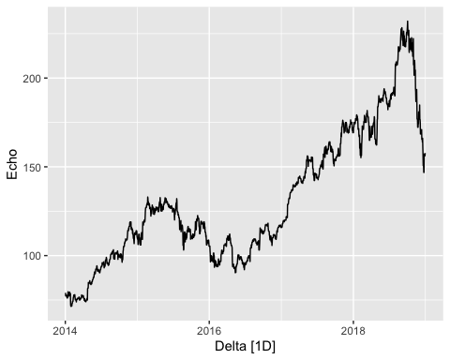
# Perform STL decomposition
autoplot(components(model(data3, STL(Echo))))
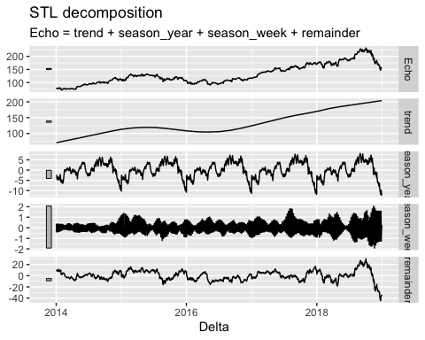
# load ex data 4
data4 <- read_csv(here("Time Series", "Decomposition-Exercise-Data4.csv"))
## Rows: 42 Columns: 2
## ── Column specification ────────────────────────────────────────────────────────
## Delimiter: ","
## chr (1): Foxtrot
## dbl (1): Bravo
##
## ℹ Use `spec()` to retrieve the full column specification for this data.
## ℹ Specify the column types or set `show_col_types = FALSE` to quiet this message.
# convert foxtrot in date frmat
data4$Foxtrot <- as.Date(trimws(as.character(data4$Foxtrot)), format = "%Y %m %d")
# converrt to quarterly data
data4$Foxtrot <- yearquarter(data4$Foxtrot)
# convert to time series
data4 <- as_tsibble(data4, index = Foxtrot)
# Plot the time series data# Plot talpha()he time series data
autoplot(data4, Bravo)
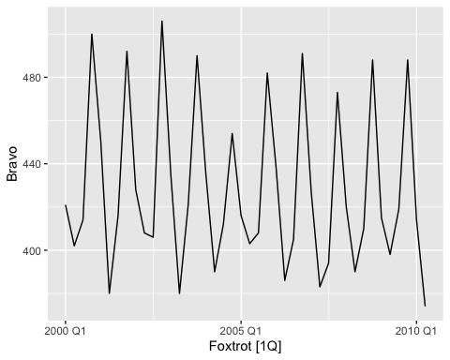
# Perform STL decomposition
autoplot(components(model(data4, STL(Bravo))))
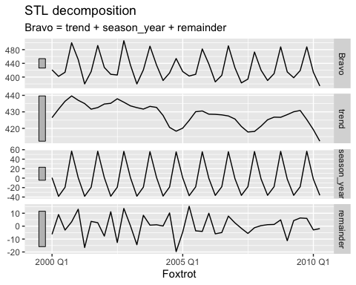
# load ex data 5
data5 <- read_csv(here("Time Series", "Decomposition-Exercise-Data5.csv"))
## Rows: 23 Columns: 2
## ── Column specification ────────────────────────────────────────────────────────
## Delimiter: ","
## dbl (2): Alpha, Delta
##
## ℹ Use `spec()` to retrieve the full column specification for this data.
## ℹ Specify the column types or set `show_col_types = FALSE` to quiet this message.
# convert Alpha in date frmat
data5$Alpha <- as.Date(paste0(data5$Alpha, "-01-01"))
data5$Alpha <- year(data5$Alpha)
# convert to time series`
data5 <- as_tsibble(data5, index = Alpha)
# Plot talpha()he time series data
autoplot(data5, Delta)
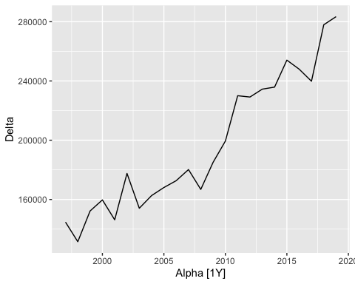
# Perform STL decomposition
autoplot(components(model(data5, STL(Delta))))
