Executive Summary

Data Overview:
This dataset comprises responses from 65,437 developers across 48 variables, collected through a comprehensive survey. The data captures a diverse global population, providing insights into compensation, professional experience, learning preferences, job satisfaction, and attitudes toward AI in software development.

Key Highlights:
- Demographics & Professional Profile:
  - Respondents represent a broad spectrum of experience levels, with coding experience ranging from 0 to 50 years.
  - A significant portion are professionally employed developers, while others are students or self-taught learners.
- Compensation Trends:
  - The average reported total compensation (CompTotalUSD) is $86,041, with a median of $66,000.
  - The presence of extreme outliers (up to $13.8 million) suggests substantial skewness in salary data.
- Skill & Experience Indicators:
  - Developers report a median of 12 years of general coding experience and 8 years of professional experience.
  - The dataset captures both early-career individuals and seasoned professionals, offering a balanced view of the industry.
- Job Satisfaction:
  - The mean satisfaction score is 6.99 out of 10, with most developers rating their satisfaction between 6 and 8, indicating overall positive sentiment.
- Data Quality & Missingness:
  - Some fields—especially those related to AI opinions—exhibit high levels of missing data (40–60%), likely due to optional questions or conditional survey paths.
  - Numeric fields like compensation and experience have relatively lower but notable missingness (~20–35%).

Data Cleaning
This data preparation process focused on filtering, transforming, and enriching the Developer Survey Results dataset to ensure consistency and analytical readiness.

Key Cleaning Steps:
- Filtering Invalid Entries:
  - Removed responses where CompTotalUSD ≤ 0 or JobSat ≤ 0 to retain only meaningful compensation and satisfaction data.
- Standardizing Experience Fields:
  - Replaced ambiguous strings in YearsCode and YearsCodePro:
    - "Less than 1 year" → 0
    - "More than 50 years" → 50
  - Converted these fields to numeric for statistical operations.
- Data Type Conversions:
  - Converted key categorical variables to factors:
    - Country, RemoteWork, EdLevel, LearnCode, LearnCodeOnline, PurchaseInfluence, Industry
- Expanding Employment Categories:
  - Separated multi-response values in the Employment column using, as the delimiter.
  - Transformed the result into dummy variables (e.g., Employment_Employed, full-time, Employment_Student, full-time) for analysis.
- Final Dataset Structure:
  - The dataset is now clean, with properly typed variables and structured responses.
  - Summary statistics confirm numeric ranges are valid and categorical variables are formatted consistently.

Data Analysis
Descriptive Statistics for numeric Variables.
• Total Compensation (CompTotalUSD):
The average total compensation is approximately $86,041, with a median of $66,000, indicating a right-skewed distribution due to high outliers (maximum value exceeds $13 million). Most professionals earn between $33K and $108K.
• Coding Experience (YearsCode):
Respondents have a mean of 15 years of coding experience, with a median of 12 years. Experience ranges from 0 to 50 years, suggesting a diverse pool including both beginners and seasoned developers. 22 entries are missing.
• Professional Coding Experience (YearsCodePro):
On average, professionals report 10 years of paid coding experience, with a median of 8 years. The interquartile range (4–14 years) reflects a moderately experienced workforce. 34 values are missing.
• Job Satisfaction (JobSat):
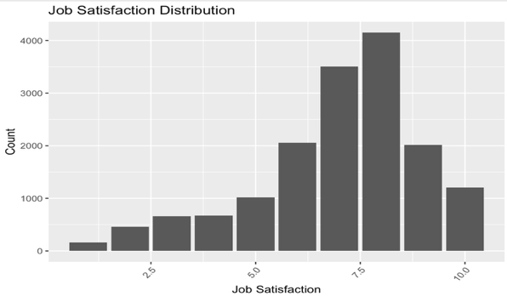
The average satisfaction level is nearly 7 out of 10, with 50% of respondents scoring between 6 and 8, indicating generally positive sentiment among professionals.

Demographic & Categorical Insights

1. Developer Profile
The majority of respondents identify as professional developers:
- 94% (14,943) report being developers by profession.
- 6% (960) write code occasionally as part of their job or studies.

2. Geographic Distribution
The dataset includes responses from over 150 countries, reflecting global participation:
- Top countries by respondent count:
  - United States: 3,179
  - Germany: 1,421
  - India: 783
  - United Kingdom: 909
  - Ukraine: 826
- Additional contributions from Brazil, France, Canada, Australia, and Poland.

3. Remote Work Arrangement

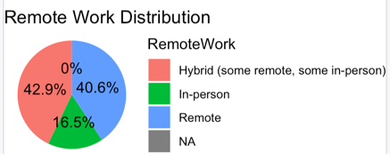
Respondents reported the following work formats:
- Hybrid (some remote, some in-person): 6,819 (46%)
- Fully Remote: 6,460 (43%)
- Fully In-Person: 2,619 (11%)

4. Educational Background
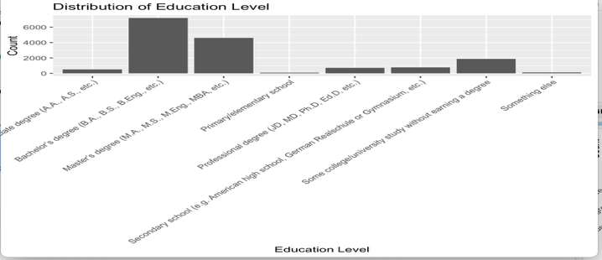
Developers reported a range of education levels:
- Bachelor’s Degree: 7,188
- Master’s Degree: 4,598
- Some College (no degree): 1,882
- Others included:
  - Secondary school (786)
  - Professional degrees (714)
  - Associate degrees (512)
  - Primary education or other (223 combined)

5. Technology Purchase Influence
Participants noted varying levels of influence in technical procurement decisions:
- Some influence: 6,865
- Little or no influence: 6,016
- Strong influence: 3,006

6. Industry Representation
The survey spans various sectors:
- Software Development: 6,384
- Fintech: 936
- Information Services / IT: 904
- Banking / Finance: 745
- Healthcare: 733
- Other industries include government, manufacturing, media, and education.

7. Employment Status (Multi-Select Responses)
After parsing multi-response data, key employment statuses include:
- Employed, Full-Time: 14,448
- Student, Full-Time: 484
- Retired: 7 Note: These categories are not mutually exclusive, as respondents could select multiple roles.

Chi-Square Independence Test Summary

1. Education Level × Purchase Influence
- H₀: Education level and purchase influence are independent
- H₁: Education level and purchase influence are associated
- Test Result: χ² = 114.01, df = 14, p < 0.001
- Conclusion: Education level is significantly associated with influence over tech purchases.

2. Country × Remote Work Arrangement
- H₀: Country and remote work setup are independent
- H₁: Country and remote work setup are associated
- Test Result: χ² = 3402.5, df = 308, p < 0.001
- Conclusion: Remote work adoption significantly varies across countries.

Mean Difference Test Summary (ANOVA)

1. Compensation × Remote Work Setup
- H₀: Mean CompTotalUSD is equal across all RemoteWork types
- H₁: At least one RemoteWork group has a different mean CompTotalUSD
- Test Result: F(2, 15895) = 35.32, p < 0.001
- Conclusion: There is a statistically significant difference in compensation across remote work setups. Remote status appears to influence earnings.

2. Job Satisfaction × Education Level
- H₀: Mean JobSat is equal across all EdLevel categories
- H₁: At least one education group has a different mean JobSat
- Test Result: F(7, 15895) = 2.35, p = 0.0212
- Conclusion: Job satisfaction significantly varies across education levels, although the effect is modest.

Correlation Test Summary

1. Years of Coding × Compensation
- H₀: There is no correlation between YearsCode and CompTotalUSD
- H₁: There is a correlation between YearsCode and CompTotalUSD
- Result: r = 0.15
- Conclusion: A weak positive correlation exists between coding experience and compensation, suggesting more experience is slightly associated with higher earnings.

2. Professional Experience × Job Satisfaction
- H₀: No correlation between YearsCodePro and JobSat
- H₁: A correlation exists between YearsCodePro and JobSat
- Result: r = 0.10, p < 0.001
- Conclusion: A small but statistically significant positive correlation suggests professionals with more experience report slightly higher job satisfaction.

3. Years of Coding × Job Satisfaction
- H₀: No correlation between YearsCode and JobSat
- H₁: A correlation exists between YearsCode and JobSat
- Result: r = 0.095, p < 0.001
- Conclusion: Similar to above, there is a weak positive correlation indicating a slight upward trend in satisfaction with more coding experience.

Conclusion
The developer survey data offers rich insights into the global tech workforce, capturing a wide range of experiences, compensation levels, work styles, and satisfaction levels. After thorough cleaning and analysis, several patterns emerged:
- Experience and compensation are positively associated, though the effect size is modest. More years of coding generally relate to slightly higher earnings.
- Remote work status has a statistically significant impact on compensation, with differences observed across remote, hybrid, and in-person roles.
- Job satisfaction also varies slightly across education levels and shows weak but significant positive correlations with experience.
- Education level and geographic location play a key role in shaping both purchasing influence and work flexibility, as evidenced by significant Chi-Square test results.
While most relationships are statistically significant, effect sizes are generally small highlighting the complexity and multifactorial nature of developer experiences. These findings can inform organizational strategies around workforce policy, compensation equity, and professional development planning in tech industries.

