Forecasting-Exercise-Start.R
dhruv
2025-04-10
# Exercise: Time Series Forecasting
#
# Please answer the following questions and include your final code below.
# When you are done, click on File > Compile Report > MS Word and submit the
# resulting Word document.
#
# Q: Load Decomposition-Exercise-Data1.csv. The file contains the stock price
# of Apple Inc (AAPL). Estimate the best-fitting ETS model and use it to forecast
# the next 500 days. What is the error, trend, and seasonality in the model?
# (No/Additive/Multiplicative)
# A: ETS(M,N,N)
#
# Q: How would you interpret the smoothing parameter(s)?
# A: very quickly
#
# Q: What is the value of the final forecast?
# A: 157.7399
#
# Q: Load Decomposition-Exercise-Data2.csv. The file contains beer production
# output in Australia in million liters. Estimate the best-fitting ETS model and
# use it to forecast the next 10 quarters. What is the error, trend, and
# seasonality in the model? (No/Additive/Multiplicative)
# A: ETS(M,N,A)
#
# Q: How would you interpret the smoothing parameter(s)?
# A: Alpha and gama very slowly
#
# Q: What is the value of the final forecast?
# A: 484.5584
#
# Q: Load Decomposition-Exercise-Data3.csv. The file contains brick production
# output in Australia in million bricks. Estimate the best-fitting ETS model and
# use it to forecast the next 50 quarters. What is the error, trend, and
# seasonality in the model? (No/Additive/Multiplicative)
# A: ETS(M,N,M)
#
# Q: How would you interpret the smoothing parameter(s)?
# A: Alpha= very Quickly, Beta= very slowly
#
# Q: What is the value of the final forecast?
# A: 426.1748
#
# Q: Load Decomposition-Exercise-Data4.csv. The file contains natural gas
# consumption in Connecticut in million cubic feet. Estimate the best-fitting
# ETS model and use it to forecast the next 5 years. What is the error, trend,
# and seasonality in the model? (No/Additive/Multiplicative)
# A: ETS(A,A,N)
#
# Q: How would you interpret the smoothing parameter(s)?
# A: Alpha= Slowly, beta= very slowly
#
# Q: What is the value of the final forecast?
# A: 308264.3
#
# Q: Load Decomposition-Exercise-Data5.csv. The file contains sales of
# new one-family houses in thousand units. Estimate the best-fitting ETS model
# and use it to forecast the next 20 months. What is the error, trend, and
# seasonality in the model? (No/Additive/Multiplicative)
# A: TS(M,N,A)
#
# Q: How would you interpret the smoothing parameter(s)?
# A: Alpha= Quick, Gamma= Very Slow
#
# Q: What is the value of the final forecast?
# A: 54.98061
#
library(tidyverse)
## ── Attaching core tidyverse packages ──────────────────────── tidyverse 2.0.0 ──
## ✔ dplyr 1.1.4 ✔ readr 2.1.5
## ✔ forcats 1.0.0 ✔ stringr 1.5.1
## ✔ ggplot2 3.5.1 ✔ tibble 3.2.1
## ✔ lubridate 1.9.4 ✔ tidyr 1.3.1
## ✔ purrr 1.0.2
## ── Conflicts ────────────────────────────────────────── tidyverse_conflicts() ──
## ✖ dplyr::filter() masks stats::filter()
## ✖ dplyr::lag() masks stats::lag()
## ℹ Use the conflicted package (<http://conflicted.r-lib.org/>) to force all conflicts to become errors
library(here)
## here() starts at /Users/dhruv/BAN663/BAN663 Code&Data
library(tsibble)
## Registered S3 method overwritten by 'tsibble':
## method from
## as_tibble.grouped_df dplyr
##
## Attaching package: 'tsibble'
##
## The following object is masked from 'package:lubridate':
##
## interval
##
## The following objects are masked from 'package:base':
##
## intersect, setdiff, union
library(fable)
## Loading required package: fabletools
library(feasts)
# load data Forecasting-Exercise-Data1.csv from folder "Time Series Forecasting"
data1 <- read_csv(here("Time Series Forecasting", "Forecasting-Exercise-Data1.csv"))
## Rows: 1825 Columns: 2
## ── Column specification ────────────────────────────────────────────────────────
## Delimiter: ","
## chr (1): Alpha
## dbl (1): Foxtrot
##
## ℹ Use `spec()` to retrieve the full column specification for this data.
## ℹ Specify the column types or set `show_col_types = FALSE` to quiet this message.
# convert Charlie in this format "%m %d, %Y"
data1$Alpha <- as.Date(data1$Alpha, format = "%d-%m-%Y")
# convert to time series
data1 <- as_tsibble(data1, index = Alpha)
# Plot the time series data# Plot talpha()he time series data
autoplot(data1, Foxtrot)
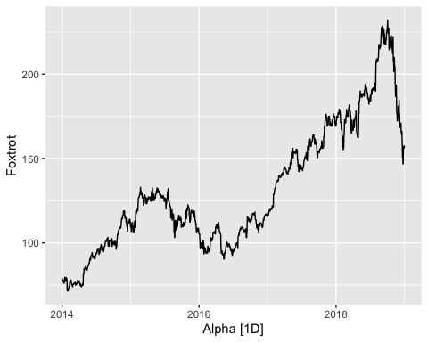
# Perform STL decomposition
autoplot(components(model(data1, STL(Foxtrot))))
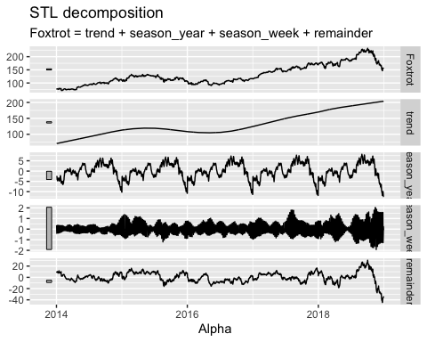
# Estimate the best-fitting exponential smoothing (ETS) model
fit <- model(data1, ETS(Foxtrot))
# View the estimated model parameters
report(fit)
## Series: Foxtrot
## Model: ETS(M,N,N)
## Smoothing parameters:
## alpha = 0.9998986
##
## Initial states:
## l[0]
## 78.99617
##
## sigma^2: 2e-04
##
## AIC AICc BIC
## 15379.33 15379.34 15395.86
# Forecast 500 days using the estimated model
forecasts <- forecast(fit, h=500)
# Plot the forecasts along with the original time series data
autoplot(forecasts, data1)
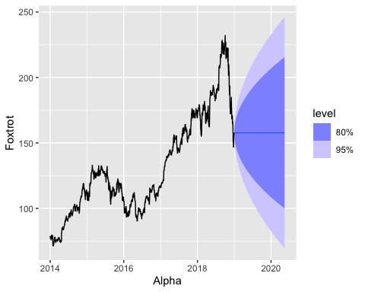
# load data Forecasting-Exercise-Data2.csv from folder "Time Series Forecasting"
data2 <- read_csv(here("Time Series Forecasting", "Forecasting-Exercise-Data2.csv"))
## Rows: 42 Columns: 2
## ── Column specification ────────────────────────────────────────────────────────
## Delimiter: ","
## chr (1): Alpha
## dbl (1): Charlie
##
## ℹ Use `spec()` to retrieve the full column specification for this data.
## ℹ Specify the column types or set `show_col_types = FALSE` to quiet this message.
# convert alpha
data2$Alpha <- as.Date(data2$Alpha, format = "%Y %m %d")
data2$Alpha <- yearquarter(data2$Alpha)
data2 <- as_tsibble(data2, index = Alpha)
# Plot the time series data
autoplot(data2, Charlie)
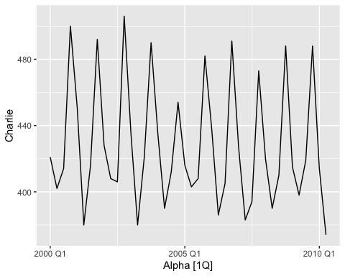
# Perform STL decomposition
autoplot(components(model(data2, STL(Charlie))))
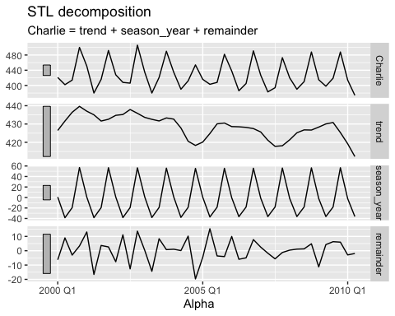
# Estimate the best-fitting exponential smoothing (ETS) model
fit <- model(data2, ETS(Charlie))
# View the estimated model parameters
report(fit)
## Series: Charlie
## Model: ETS(M,N,A)
## Smoothing parameters:
## alpha = 0.08295946
## gamma = 0.0001000015
##
## Initial states:
## l[0] s[0] s[-1] s[-2] s[-3]
## 432.171 59.06264 -18.96162 -38.7245 -1.37653
##
## sigma^2: 7e-04
##
## AIC AICc BIC
## 369.9583 373.2524 382.1220
# Forecast 10 quarters using the estimated model
forecasts <- forecast(fit, h=10)
# Plot the forecasts along with the original time series data
autoplot(forecasts, data2)
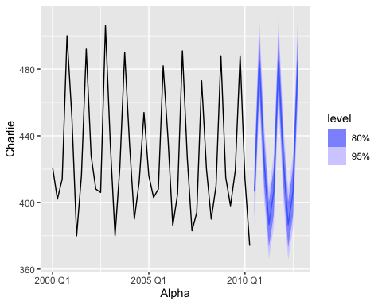
#load data Forecasting-Exercise-Data3.csv from folder "Time Series Forecasting"
data3 <- read_csv(here("Time Series Forecasting", "Forecasting-Exercise-Data3.csv"))
## Rows: 198 Columns: 2
## ── Column specification ────────────────────────────────────────────────────────
## Delimiter: ","
## dbl (1): Delta
## date (1): Bravo
##
## ℹ Use `spec()` to retrieve the full column specification for this data.
## ℹ Specify the column types or set `show_col_types = FALSE` to quiet this message.
data3$Bravo <- as.Date(data3$Bravo, format = "%Y %m %d")
data3$Bravo <- yearquarter(data3$Bravo)
data3 <- as_tsibble(data3, index = Bravo)
# Plot the time series data
autoplot(data3, Delta)
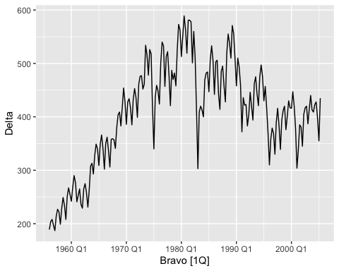
# Perform STL decomposition
autoplot(components(model(data3, STL(Delta))))
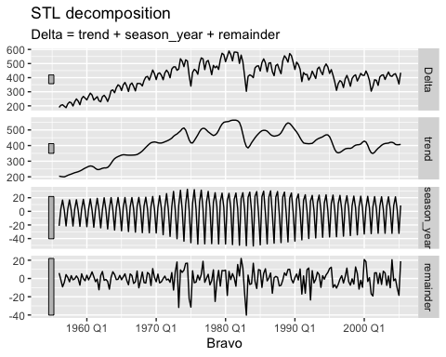
# Estimate the best-fitting exponential smoothing (ETS) model
fit <- model(data3, ETS(Delta))
# View the estimated model parameters
report(fit)
## Series: Delta
## Model: ETS(M,N,M)
## Smoothing parameters:
## alpha = 0.9998736
## gamma = 0.0001244637
##
## Initial states:
## l[0] s[0] s[-1] s[-2] s[-3]
## 231.1371 1.005315 1.061299 1.026146 0.90724
##
## sigma^2: 0.0028
##
## AIC AICc BIC
## 2255.279 2255.869 2278.297
# Forecast 50 quarters using the estimated model
forecasts <- forecast(fit, h=50)
# Plot the forecasts along with the original time series data
autoplot(forecasts, data3)
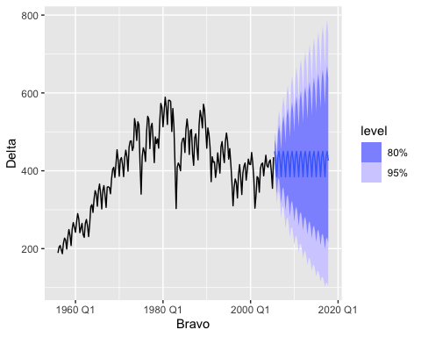
#load data Forecasting-Exercise-Data4.csv from folder "Time Series Forecasting"
data4 <- read_csv(here("Time Series Forecasting", "Forecasting-Exercise-Data4.csv"))
## Rows: 23 Columns: 2
## ── Column specification ────────────────────────────────────────────────────────
## Delimiter: ","
## dbl (2): Echo, Bravo
##
## ℹ Use `spec()` to retrieve the full column specification for this data.
## ℹ Specify the column types or set `show_col_types = FALSE` to quiet this message.
data4 <- as_tsibble(data4, index = Echo)
# Plot the time series data
autoplot(data4, Bravo)
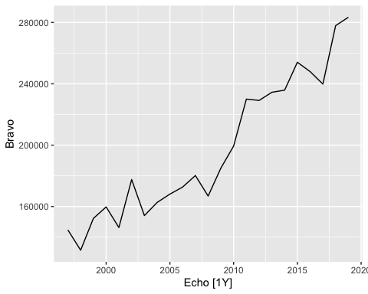
# Perform STL decomposition
autoplot(components(model(data4, STL(Bravo))))
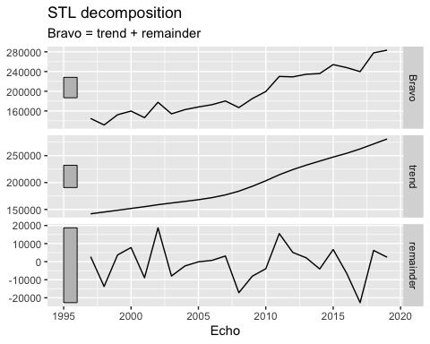
# Estimate the best-fitting exponential smoothing (ETS) model
fit <- model(data4, ETS(Bravo))
# View the estimated model parameters
report(fit)
## Series: Bravo
## Model: ETS(A,A,N)
## Smoothing parameters:
## alpha = 0.4519459
## beta = 0.0001921326
##
## Initial states:
## l[0] b[0]
## 137418.1 6217.643
##
## sigma^2: 214172138
##
## AIC AICc BIC
## 518.9148 522.4442 524.5923
# Forecast 5 years using the estimated model
forecasts <- forecast(fit, h=5)
# Plot the forecasts along with the original time series data
autoplot(forecasts, data4)
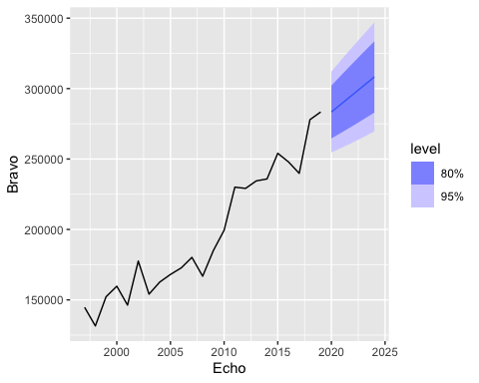
#load data Forecasting-Exercise-Data5.csv from folder "Time Series Forecasting"
data5 <- read_csv(here("Time Series Forecasting", "Forecasting-Exercise-Data5.csv"))
## Rows: 107 Columns: 2
## ── Column specification ────────────────────────────────────────────────────────
## Delimiter: ","
## chr (1): Charlie
## dbl (1): Echo
##
## ℹ Use `spec()` to retrieve the full column specification for this data.
## ℹ Specify the column types or set `show_col_types = FALSE` to quiet this message.
data5$Charlie <- as.Date(data5$Charlie , "%d %B %Y")
#convert to montly
data5$Charlie <- yearmonth(data5$Charlie)
data5 <- as_tsibble(data5, index = Charlie)
# Plot the time series data
autoplot(data5, Echo)
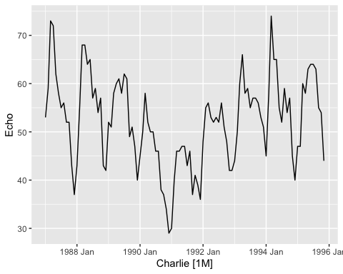
# Perform STL decomposition
autoplot(components(model(data5, STL(Echo))))
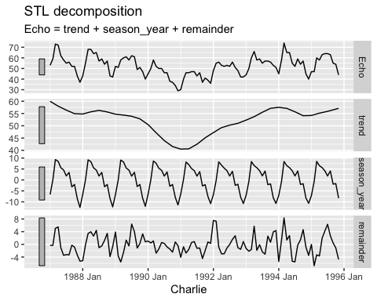
# Estimate the best-fitting exponential smoothing (ETS) model
fit <- model(data5, ETS(Echo))
# View the estimated model parameters
report(fit)
## Series: Echo
## Model: ETS(M,N,A)
## Smoothing parameters:
## alpha = 0.7896288
## gamma = 0.0001001332
##
## Initial states:
## l[0] s[0] s[-1] s[-2] s[-3] s[-4] s[-5] s[-6]
## 57.54172 -12.08221 -7.967633 -1.802108 -2.497058 3.975566 2.112749 4.620941
## s[-7] s[-8] s[-9] s[-10] s[-11]
## 5.581429 7.215741 8.85996 -0.9603209 -7.057058
##
## sigma^2: 0.0057
##
## AIC AICc BIC
## 805.1425 810.4172 845.2349
# Forecast 20 months using the estimated model
forecasts <- forecast(fit, h=20)
# Plot the forecasts along with the original time series data
autoplot(forecasts, data5)
