Geospatial-Exercise-Start.R
dhruv
2025-04-23
# Exercise: Geospatial Data Analysis
#
# Open https://citibikenyc.com/system-data and click on the link to "downloadable
# files of Citi Bike trip data." Then scroll down and click on the most recent
# file (JC-2025030-citibike-tripdata.csv.zip). Unzip the file after it has been
# downloaded. Load the file in R and write code to answer the following questions.
# When you are done, click on File > Compile Report > MS Word and submit the
# resulting Word document.
#
# Q: How many unique start locations are in the dataset?
# A: 83
#
# Q: Map the start locations. Do more trips start in New York or in New Jersey?
# A: New Jersey
#
# Q: Calculate the distance between the start and end locations. What is the
# average distance (in miles)?
# A: 0.7386 miles
#
# Q: How many rides have the same start and end locations (so a distance of 0)?
# A: 2308
#
# Q: Is there a statistically significant difference in average distance between
# classic and electric bikes? If so, which bike has a higher average distance?
# A: Electric bike 0.7941 miles
#
# Q: Is there a statistically significant difference in average distance between
# member and casual riders? If so, which rider has a higher average distance?
# A: There is a statistically significant difference in average distance traveled between casual and member riders,
# with casual riders traveling farther on average (p < 0.001).
#
# Load required libraries
library(tidyverse)
## ── Attaching core tidyverse packages ──────────────────────── tidyverse 2.0.0 ──
## ✔ dplyr 1.1.4 ✔ readr 2.1.5
## ✔ forcats 1.0.0 ✔ stringr 1.5.1
## ✔ ggplot2 3.5.1 ✔ tibble 3.2.1
## ✔ lubridate 1.9.4 ✔ tidyr 1.3.1
## ✔ purrr 1.0.2
## ── Conflicts ────────────────────────────────────────── tidyverse_conflicts() ──
## ✖ dplyr::filter() masks stats::filter()
## ✖ dplyr::lag() masks stats::lag()
## ℹ Use the conflicted package (<http://conflicted.r-lib.org/>) to force all conflicts to become errors
library(here)
## here() starts at /Users/dhruv/BAN663/BAN663 Code&Data
library(leaflet)
library(geosphere)
# Load the dataset "JC-2025030-citibike-tripdata.csv" from "20-Geospatial"
data <- read_csv(here("20-Geospatial", "JC-202503-citibike-tripdata.csv"))
## Rows: 73293 Columns: 13
## ── Column specification ────────────────────────────────────────────────────────
## Delimiter: ","
## chr (7): ride_id, rideable_type, start_station_name, start_station_id, end_...
## dbl (4): start_lat, start_lng, end_lat, end_lng
## dttm (2): started_at, ended_at
##
## ℹ Use `spec()` to retrieve the full column specification for this data.
## ℹ Specify the column types or set `show_col_types = FALSE` to quiet this message.
# No. Of unique start locations nrow
nrow(unique(data[c("start_lng", "start_lat")]))
## [1] 83
#Map strart locations
m <- leaflet(data)
m <- addProviderTiles(m, providers$CartoDB.Positron)
m <- addCircleMarkers(
map = m,
lng = data$start_lng,
lat = data$start_lat,
radius = 1,
label = data$ride_id
)
m
## PhantomJS not found. You can install it with webshot::install_phantomjs(). If it is installed, please make sure the phantomjs executable can be found via the PATH variable.
## file:////private/var/folders/_4/b9s2hms900bfwkkw9c61rv4w0000gn/T/Rtmp8MBBby/filec6fd641b5a7a/widgetc6fd3fd132ee.html screenshot completed
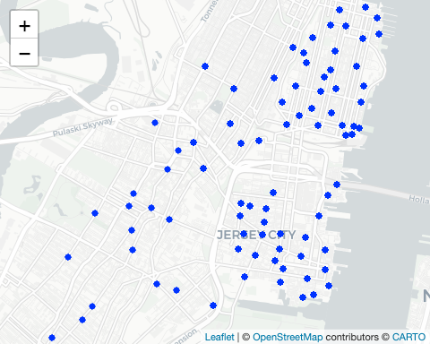
# Calculate the distance between the Start and End locations
data$distance <- distHaversine(
cbind(data$start_lng, data$start_lat),
cbind(data$end_lng, data$end_lat)
)
# Convert distance from meters to miles
data$distance <- data$distance / 1609
# Calculate the average distance
summary(data$distance)
## Min. 1st Qu. Median Mean 3rd Qu. Max. NA's
## 0.0000 0.4263 0.6415 0.7386 0.9596 6.3257 11
# Count the number of rides with the same start and end locations
nrow(data[data$start_lng == data$end_lng & data$start_lat == data$end_lat, ])
## [1] 2308
# Calculate descriptive statistics for each ridable type
tapply(data$distance, data$rideable_type, summary)
## $classic_bike
## Min. 1st Qu. Median Mean 3rd Qu. Max. NA's
## 0.0000 0.3342 0.5309 0.6302 0.8547 4.3763 11
##
## $electric_bike
## Min. 1st Qu. Median Mean 3rd Qu. Max.
## 0.0000 0.4838 0.7038 0.7941 1.0042 6.3257
# Perform t-test to compare average distance between casual riders and members
t.test(data = data, distance ~ member_casual)
##
## Welch Two Sample t-test
##
## data: distance by member_casual
## t = 19.82, df = 19154, p-value < 2.2e-16
## alternative hypothesis: true difference in means between group casual and group member is not equal to 0
## 95 percent confidence interval:
## 0.08266631 0.10081134
## sample estimates:
## mean in group casual mean in group member
## 0.8134288 0.7216900

